Application Name:Zonions

Technologies Used:

Front End :React Js

In Frontend I have Used Class Component for user Part As Restaurant Details Part

As well as I have used Function Component in Admin Part

Backend:MongoDB

Middleware:Sails Js

This is My Home page

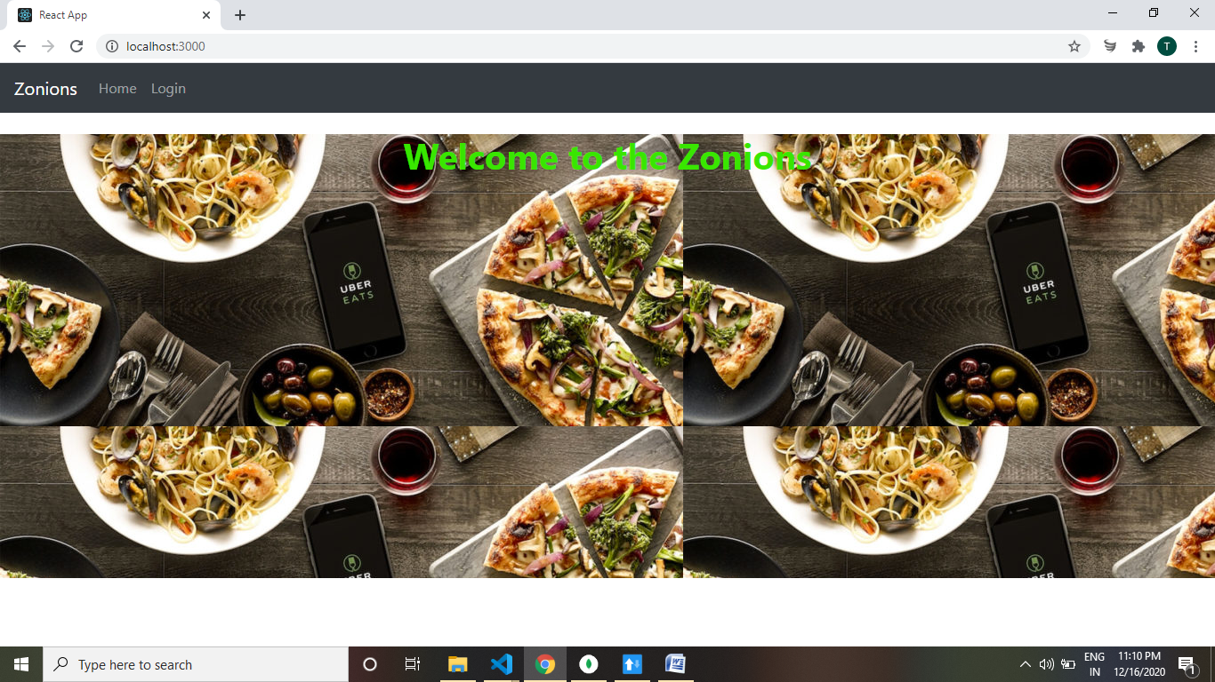

Now when I click On Login link it Will Go to the Admin Login .

We have to enter Username Password.(when I click to Login Button It will give me All restaurant Details)

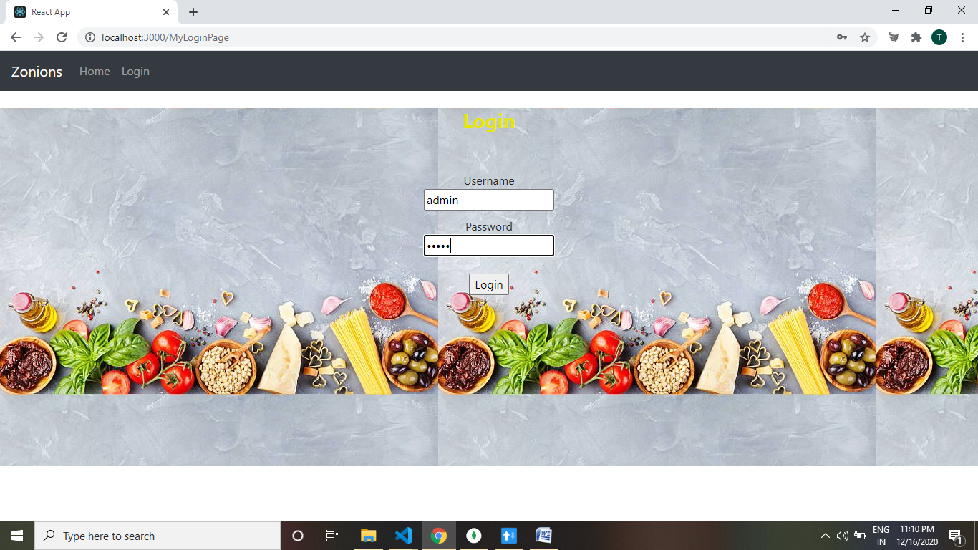

Here ,Add Restaurant will Add new restaurant to the table.Added Restaurant Screenshot in given below

In next Screenshot.

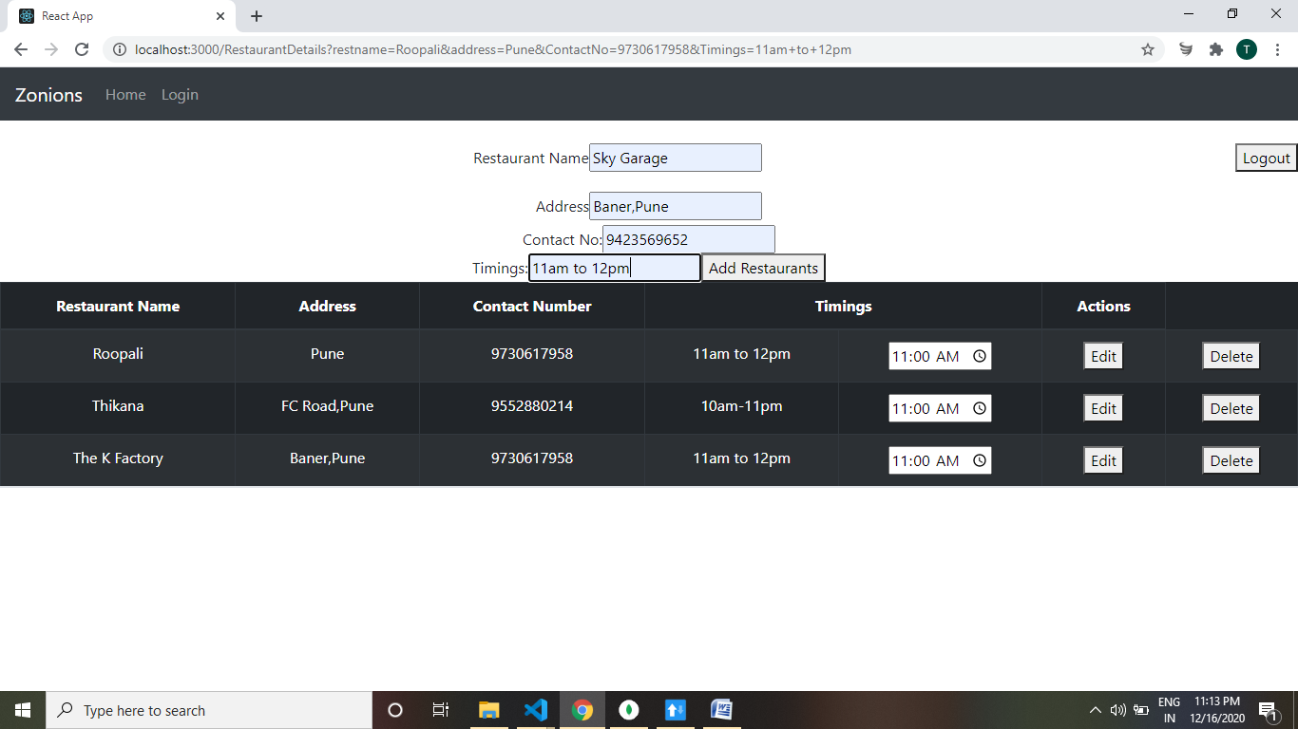

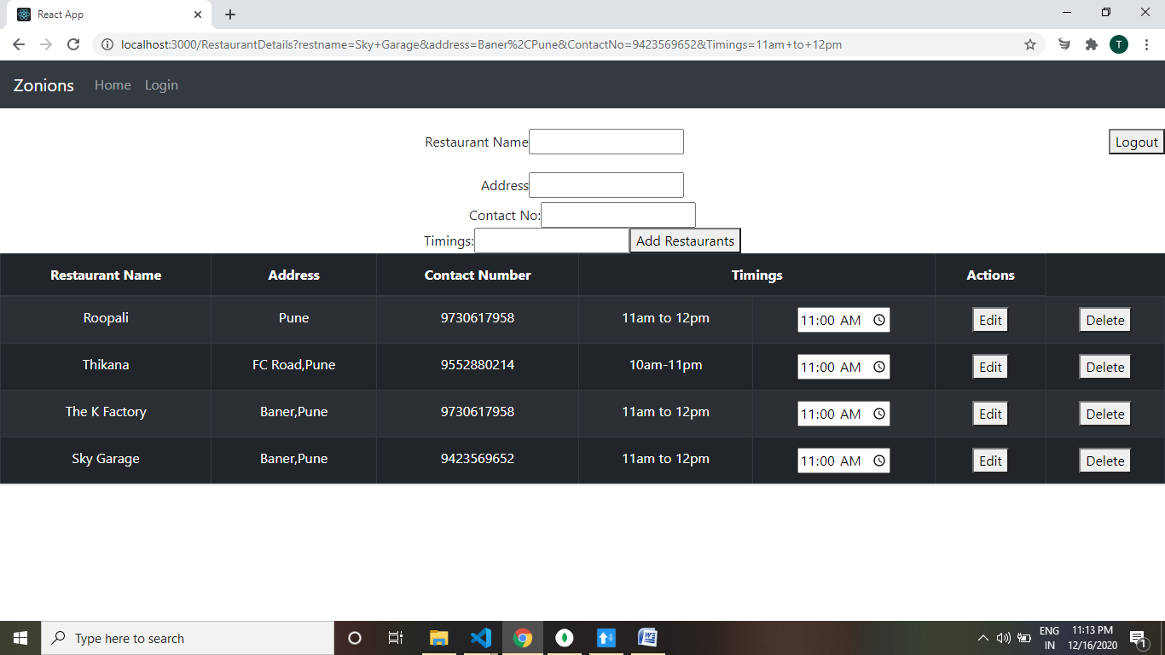

Here ,Editing The Restaurant Name Roopali as Goodluck.

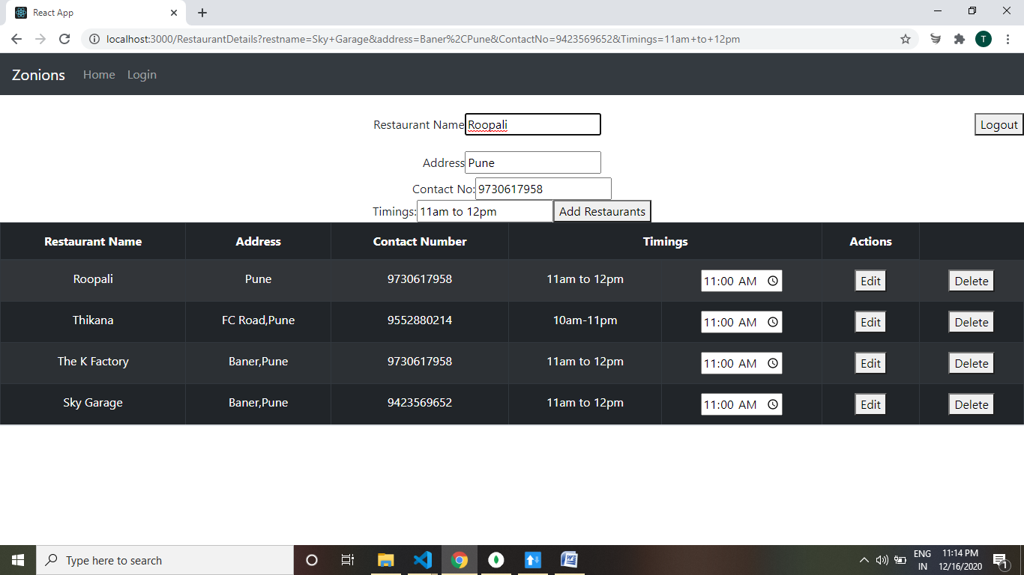

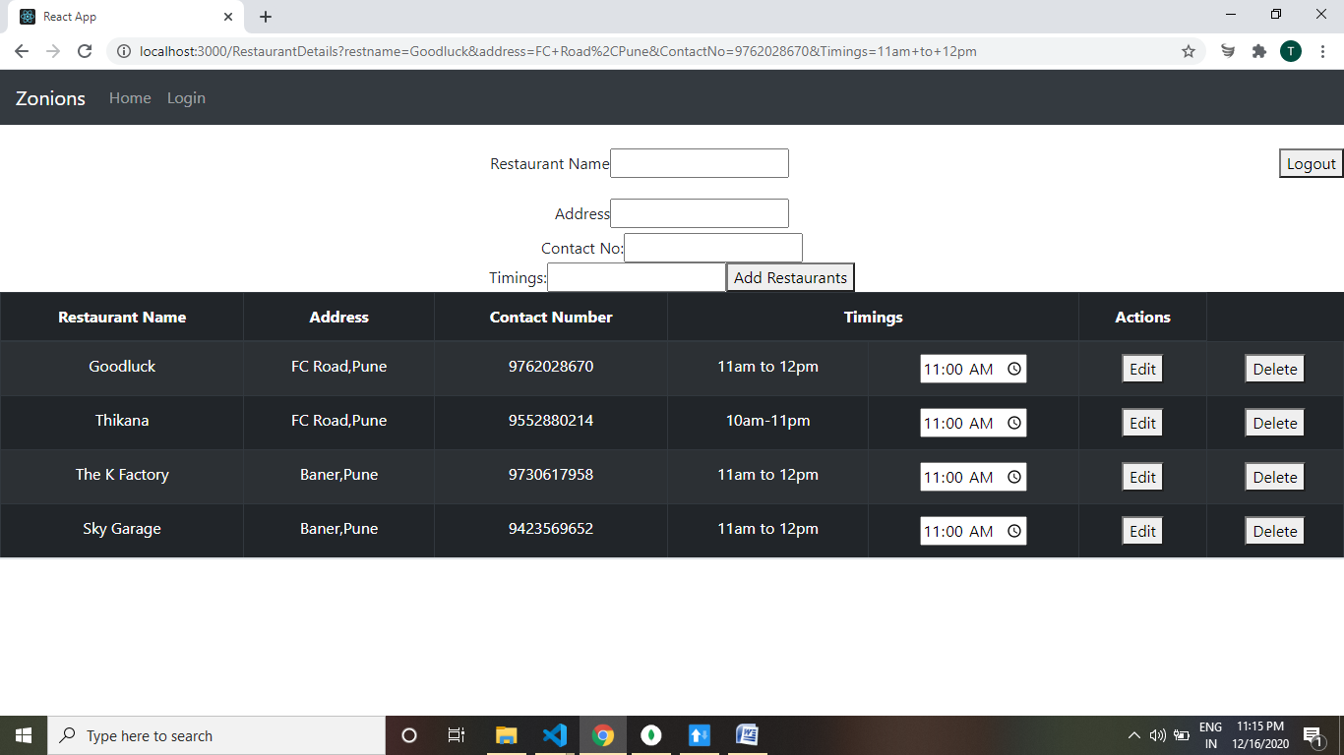

Now I am Deleting One of the Restaurant Which is Edited Before as Godluck.

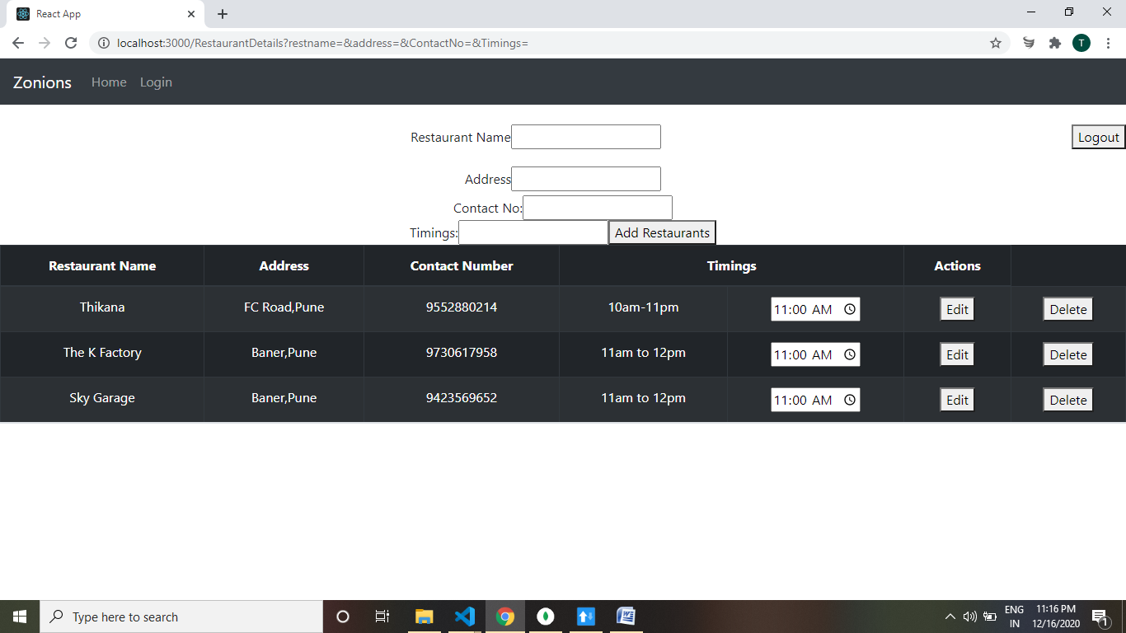

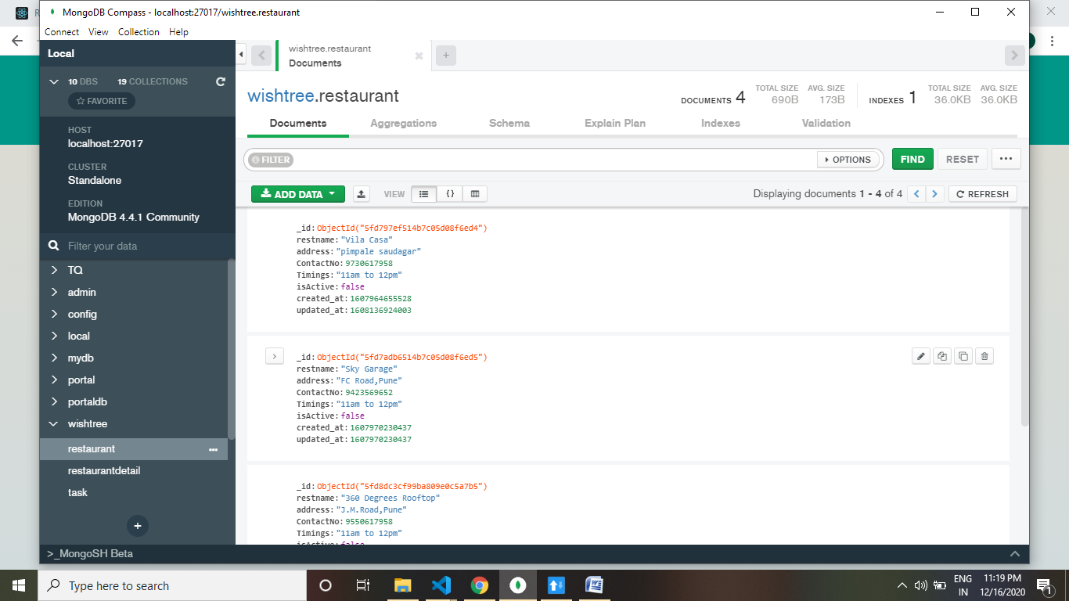

The Above image shows the storage in MongoDB Database.

Things which are Didn’t Done by me:

Menu Image Storage In Database which I will try to upgrade my application.