BANKING MANAGEMENT SYSTEM

1. Problem Statement
The bank wanted to manage and store customer information, bank accounts, financial transactions, loans, employees and bank branches..
2. Objectives
- Maintain customer details in a centralized database.
- Store account types and account balances.
- Record credit and debit transactions for accounts.
- Maintain loan details for customers.
- Maintain branch and employee information.
- Use SQL queries to retrieve and analyze banking data.
- Provide a database structure that can be executed in MySQL Workbench.

3.Modules /Entities
Entity | Important attribute
Customers | customer_id (PK), customer_name, gender, phone, email, city, date_of_birth
Branches | branch_id (PK), branch_name, location, phone
Accounts | account_id (PK), customer_id (FK), branch_id (FK), account_type, balance, opened_date
Transactions | transaction_id (PK), account_id (FK), transaction_amount, transaction_type, transaction_date
Loans | loan_id (PK), customer_id (FK), loan_type, loan_amount, interest_rate, loan_date
Employees | employee_id (PK), branch_id (FK), employee_name, designation, salary

4. ER Diagram
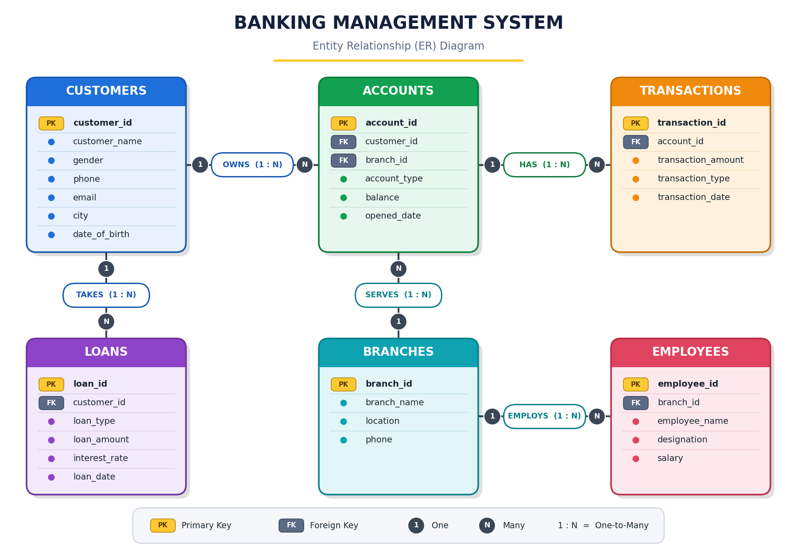
Relationships:
Parent Table (1) | Relationship | Child Table (N) | Cardinality | Foreign Key
Customers | OWNS | Accounts | 1 : N | Accounts.customer_id → Customers.customer_id
Accounts | HAS | Transactions | 1 : N | Transactions.account_id → Accounts.account_id
Customers | TAKES | Loans | 1 : N | Loans.customer_id → Customers.customer_id
Branches | SERVES | Accounts | 1 : N | Accounts.branch_id → Branches.branch_id
Branches | EMPLOYS | Employees | 1 : N | Employees.branch_id → Branches.branch_id

Relational Schema
Customers(customer_id PK, customer_name, gender, phone, email, city, date_of_birth)
- Branches(branch_id PK, branch_name, location, phone
- Transactions(transaction_id PK, account_id FK, transaction_amount, transaction_type, transaction_date)
- Loans(loan_id PK, customer_id FK, loan_type, loan_amount, interest_rate, loan_date)
- Employees(employee_id PK, branch_id FK, employee_name, designation, salary)

5.Sample Data

1. Customers Table
Customer_ID | Customer_Name | Gender | Phone | Email | City | Date_Of_Birth
1 | Bhuvanesh | M | 9276543551 | bhuvanesh@email.com | Guntur | 1997-05-14
2 | Chani | F | 9971575410 | chani@email.com | Hyderabad | 2000-02-11
3 | Vikram | M | 9571575457 | vikram@email.com | Hyderabad | 1996-08-21
4 | Anakin Skywaker | M | 9876153285 | rahul.sharma@email.com | Vadodara | 1999-03-15
5 | Padma | F | 5776453570 | padma@email.com | Bangalore | 1998-11-02
6 | Paul Atreides | M | 9871575553 | paulatreides@email.com | Vadodara | 1995-06-17
7 | Obi Wan | M | 4876453570 | obiwan@email.com | Bangalore | 2001-01-25
8 | Dean Winchester | M | 5215452357 | deanwinchester@email.com | Vijayawada | 1994-09-30

2. Branches Table
Branch_ID | Branch_Name | City | Phone
1 | Guntur Main Branch | Guntur | 0863-2221111
2 | Hyderabad Central | Hyderabad | 040-22222222
3 | Bangalore City Branch | Bangalore | 080-33333333
4 | Vadodara Main Branch | Vadodara | 0265-4444444

3. Accounts Table
Account_ID | Custome_ ID | Branch_ID | Account_Type | Balance | Opening Date
101 | 1 | 1 | Savings | 65000 | 2024-01-15
102 | 2 | 2 | Savings | 82000 | 2023-08-10
103 | 3 | 2 | Current | 45000 | 2024-02-12
104 | 4 | 4 | Savings | 120000 | 2022-06-20
105 | 5 | 3 | Current | 55000 | 2024-04-05
106 | 6 | 4 | Savings | 95000 | 2023-11-11
107 | 7 | 3 | Savings | 35000 | 2025-01-10
108 | 8 | 1 | Current | 72000 | 2024-09-09

4. Transactions Table
TransactionID | AccountID | Amount | TransactionType | TransactionDate
1001 | 101 | 10000 | Credit | 2026-09-01
1002 | 101 | 2500 | Debit | 2026-09-03
1003 | 102 | 15000 | Credit | 2026-09-02
1004 | 103 | 5000 | Debit | 2026-09-04
1005 | 104 | 25000 | Credit | 2026-09-05
1006 | 105 | 8000 | Credit | 2026-09-06
1007 | 106 | 12000 | Debit | 2026-09-07
1008 | 108 | 9000 | Credit | 2026-09-08

5. Loans Table
LoanID | CustomerID | LoanType | LoanAmount | InterestRate | LoanDate
501 | 1 | Home Loan | 4500000 | 8.50% | 2025-01-20
502 | 2 | Education Loan | 800000 | 7.25% | 2025-03-15
503 | 4 | Car Loan | 900000 | 9.10% | 2024-12-10
504 | 6 | Personal Loan | 500000 | 10.50% | 2026-02-01

6. Employees Table
Employee_ID | Branch_ID | Employee_Name | Designation | Salary
201 | 1 | Ravi Kumar | Manager | 65000
202 | 2 | Priya Sharma | Officer | 45000
203 | 2 | Arjun Rao | Manager | 70000
204 | 3 | Sneha Reddy | Clerk | 35000
205 | 4 | Kiran Patel | Officer | 48000

7. Summary of Sample Data
Table Name | Number of Records
Customers | 8
Branches | 4
Accounts | 8
Transactions | 8
Loans | 4
Employees | 5

6. SQL Queries and Outputs

Query 1: Display all records from the Customers table.
SQL Query:
SELECT * FROM Customers;
Output (8 rows):
customer_id | customer_name | gender | phone | email | city | date_of_birth
1 | Bhuvanesh | M | 9276543551 | bhuvanesh@email.com | Guntur | 1997-05-14
2 | Chani | F | 9971575410 | chani@email.com | Hyderabad | 2000-02-11
3 | Vikram | M | 9571575457 | vikram@email.com | Hyderabad | 1996-08-21
4 | Anakin Skywaker | M | 9876153285 | rahul.sharma@email.com | Vadodara | 1999-03-15
5 | Padma | F | 5776453570 | padma@email.com | Bangalore | 1998-11-02
6 | Paul Atreides | M | 9871575553 | paulatreides@email.com | Vadodara | 1995-06-17
7 | Obi Wan | M | 4876453570 | obiwan@email.com | Bangalore | 2001-01-25
8 | Dean Winchester | M | 5215452357 | deanwinchester@email.com | Vijayawada | 1994-09-30

Query 2: Display the name, phone number, and email of all customers.
SQL Query:
SELECT customer_name, phone, email
FROM Customers;
Output (8 rows):
customer_name | phone | email
Bhuvanesh | 9276543551 | bhuvanesh@email.com
Chani | 9971575410 | chani@email.com
Vikram | 9571575457 | vikram@email.com
Anakin Skywaker | 9876153285 | rahul.sharma@email.com
Padma | 5776453570 | padma@email.com
Paul Atreides | 9871575553 | paulatreides@email.com
Obi Wan | 4876453570 | obiwan@email.com
Dean Winchester | 5215452357 | deanwinchester@email.com

Query 3: Display all customers who are from Hyderabad.
SQL Query:
SELECT *
FROM Customers
WHERE city = 'Hyderabad';
Output (2 rows):
customer_id | customer_name | gender | phone | email | city | date_of_birth
2 | Chani | F | 9971575410 | chani@email.com | Hyderabad | 2000-02-11
3 | Vikram | M | 9571575457 | vikram@email.com | Hyderabad | 1996-08-21

Query 4: Display all accounts whose account_type is Savings.
SQL Query:
SELECT *
FROM Accounts
WHERE account_type = 'Savings';
Output (5 rows):
account_id | customer_id | branch_id | account_type | balance | opened_date
101 | 1 | 1 | Savings | 65000 | 2024-01-15
102 | 2 | 2 | Savings | 82000 | 2023-08-10
104 | 4 | 4 | Savings | 120000 | 2022-06-20
106 | 6 | 4 | Savings | 95000 | 2023-11-11
107 | 7 | 3 | Savings | 35000 | 2025-01-10

Query 5: Display all accounts having a balance greater than 50,000.
SQL Query:
SELECT *
FROM Accounts
WHERE balance > 50000;
Output (6 rows):
account_id | customer_id | branch_id | account_type | balance | opened_date
101 | 1 | 1 | Savings | 65000 | 2024-01-15
102 | 2 | 2 | Savings | 82000 | 2023-08-10
104 | 4 | 4 | Savings | 120000 | 2022-06-20
105 | 5 | 3 | Current | 55000 | 2024-04-05
106 | 6 | 4 | Savings | 95000 | 2023-11-11
108 | 8 | 1 | Current | 72000 | 2024-09-09

Query 6: Display all transactions where the transaction type is credit.
SQL Query:
SELECT *
FROM Transactions
WHERE transaction_type = 'Credit';
Output (5 rows):
transaction_id | account_id | transaction_amount | transaction_type | transaction_date
1001 | 101 | 10000 | Credit | 2026-09-01
1003 | 102 | 15000 | Credit | 2026-09-02
1005 | 104 | 25000 | Credit | 2026-09-05
1006 | 105 | 8000 | Credit | 2026-09-06
1008 | 108 | 9000 | Credit | 2026-09-08

Query 7: Display all employees whose salary is greater than 40,000.
SQL Query:
SELECT *
FROM Employees
WHERE salary > 40000;
Output (4 rows):
employee_id | branch_id | employee_name | designation | salary
201 | 1 | Ravi Kumar | Manager | 65000
202 | 2 | Priya Sharma | Officer | 45000
203 | 2 | Arjun Rao | Manager | 70000
205 | 4 | Kiran Patel | Officer | 48000

Query 8: Display all customers born after 1998-01-01.
SQL Query:
SELECT *
FROM Customers
WHERE date_of_birth > '1998-01-01';
Output (4 rows):
customer_id | customer_name | gender | phone | email | city | date_of_birth
2 | Chani | F | 9971575410 | chani@email.com | Hyderabad | 2000-02-11
4 | Anakin Skywaker | M | 9876153285 | rahul.sharma@email.com | Vadodara | 1999-03-15
5 | Padma | F | 5776453570 | padma@email.com | Bangalore | 1998-11-02
7 | Obi Wan | M | 4876453570 | obiwan@email.com | Bangalore | 2001-01-25

Query 9: Display all accounts in descending order of their balance.
SQL Query:
SELECT *
FROM Accounts
ORDER BY balance DESC;
Output (8 rows):
account_id | customer_id | branch_id | account_type | balance | opened_date
104 | 4 | 4 | Savings | 120000 | 2022-06-20
106 | 6 | 4 | Savings | 95000 | 2023-11-11
102 | 2 | 2 | Savings | 82000 | 2023-08-10
108 | 8 | 1 | Current | 72000 | 2024-09-09
101 | 1 | 1 | Savings | 65000 | 2024-01-15
105 | 5 | 3 | Current | 55000 | 2024-04-05
103 | 3 | 2 | Current | 45000 | 2024-02-12
107 | 7 | 3 | Savings | 35000 | 2025-01-10

Query 10: Find the total number of customers in the bank.
SQL Query:
SELECT COUNT(*) AS total_customers
FROM Customers;
Output (1 row):
total_customers
8

Query 11: Find the total balance of all accounts.
SQL Query:
SELECT SUM(balance) AS total_balance
FROM Accounts;
Output (1 row):
total_balance
569000

Query 12: Find the average account balance.
SQL Query:
SELECT ROUND(AVG(balance), 2) AS average_balance
FROM Accounts;
Output (1 row):
average_balance
71125

Query 13: Find the highest and lowest account balance.
SQL Query:
SELECT MAX(balance) AS highest_balance,
MIN(balance) AS lowest_balance
FROM Accounts;
Output (1 row):
highest_balance | lowest_balance
120000 | 35000

Query 14: Display the number of accounts for each account_type.
SQL Query:
SELECT account_type, COUNT(*) AS account_count
FROM Accounts
GROUP BY account_type;
Output (2 rows):
account_type | account_count
Current | 3
Savings | 5

Query 15: Display each account type and its total balance,
SQL Query:
SELECT account_type, SUM(balance) AS total_balance
FROM Accounts
GROUP BY account_type
HAVING SUM(balance) > 80000;
Output (2 rows):
account_type | total_balance
Current | 172000
Savings | 397000

Query 16: Display customer name, account ID, account type, and balance.
SQL Query:
SELECT c.customer_name, a.account_id, a.account_type, a.balance
FROM Customers c
JOIN Accounts a ON c.customer_id = a.customer_id;
Output (8 rows):
customer_name | account_id | account_type | balance
Bhuvanesh | 101 | Savings | 65000
Chani | 102 | Savings | 82000
Vikram | 103 | Current | 45000
Anakin Skywaker | 104 | Savings | 120000
Padma | 105 | Current | 55000
Paul Atreides | 106 | Savings | 95000
Obi Wan | 107 | Savings | 35000
Dean Winchester | 108 | Current | 72000

Query 17: Display customer name, transaction ID, transaction amount,
SQL Query:
SELECT c.customer_name, t.transaction_id,
t.transaction_amount, t.transaction_type
FROM Customers c
JOIN Accounts a ON c.customer_id = a.customer_id
JOIN Transactions t ON a.account_id = t.account_id;
Output (8 rows):
customer_name | transaction_id | transaction_amount | transaction_type
Bhuvanesh | 1001 | 10000 | Credit
Bhuvanesh | 1002 | 2500 | Debit
Chani | 1003 | 15000 | Credit
Vikram | 1004 | 5000 | Debit
Anakin Skywaker | 1005 | 25000 | Credit
Padma | 1006 | 8000 | Credit
Paul Atreides | 1007 | 12000 | Debit
Dean Winchester | 1008 | 9000 | Credit

Query 18: Display customer name, loan type, loan amount, and interest rate.
SQL Query:
SELECT c.customer_name, l.loan_type,
l.loan_amount, l.interest_rate
FROM Customers c
JOIN Loans l ON c.customer_id = l.customer_id;
Output (4 rows):
customer_name | loan_type | loan_amount | interest_rate
Bhuvanesh | Home Loan | 4500000 | 8.5
Chani | Education Loan | 800000 | 7.25
Anakin Skywaker | Car Loan | 900000 | 9.1
Paul Atreides | Personal Loan | 500000 | 10.5

Query 19: Display employee name, designation, branch name, and branch location.
SQL Query:
SELECT e.employee_name, e.designation,
b.branch_name, b.location
FROM Employees e
JOIN Branches b ON e.branch_id = b.branch_id;
Output (5 rows):
employee_name | designation | branch_name | location
Ravi Kumar | Manager | Guntur Main Branch | Guntur
Priya Sharma | Officer | Hyderabad Central | Hyderabad
Arjun Rao | Manager | Hyderabad Central | Hyderabad
Sneha Reddy | Clerk | Bangalore City Branch | Bangalore
Kiran Patel | Officer | Vadodara Main Branch | Vadodara

Query 20: Display names of customers whose account balance is greater
SQL Query:
SELECT DISTINCT c.customer_name
FROM Customers c
JOIN Accounts a ON c.customer_id = a.customer_id
WHERE a.balance > (SELECT AVG(balance) FROM Accounts);
Output (4 rows):
customer_name
Chani
Anakin Skywaker
Paul Atreides
Dean Winchester

