AI CLUB REPORT Department: CSE (AI&ML). Sec :A. Year: III. DATE: 18/07/26 Time:3:10PM
EVENT TITLE: NOSTALGIA AI
Bringing Generations Together
TAGLINE:
“Memories Today, Heritage Tomorrow.”

EVENT DETAILS:
. Event Title: Nostalgia AI – Bringing Generations Together
. Faculty Mentor: Mrs. Adhilakshmi . Technical Team Leader: Ms. D. Poojitha
.Team Members: Ms. G. Mounika, Ms. B. Anusha, Ms. I. Neha
.Venue: Class Room No. 418
Mode: Offline
.Target Audience: Students, aspiring developers, technology enthusiasts, faculty members, and anyone interested in Artificial Intelligence, innovative problem-solving, digital innovation, cultural preservation, and practical project development through hackathons and AI-based applications. The event aims to inspire participants to explore AI technologies while developing innovative solutions that solve real-world problems and create a positive social impact.

ABSTRACT: Nostalgia AI is an innovative Artificial Intelligence (AI)-based application developed to reconnect families by preserving memories, traditions, and cultural heritage. In today’s digital era, children spend most of their time using smartphones, while grandparents possess valuable life experiences, traditions, and stories that are gradually disappearing. Nostalgia AI bridges this generation gap by using modern AI technologies such as Speech Recognition, Natural Language Processing (NLP), Machine Learning, Computer Vision, and Generative AI to preserve these memories in an engaging and interactive manner.

The application transforms voice recordings into digital stories, animated videos, audiobooks, quizzes, and memory albums. It encourages children to participate in traditional games, outdoor activities, and meaningful family interactions, reducing excessive screen time while strengthening relationships. Nostalgia AI combines advanced technology with cultural preservation to ensure that our heritage is passed on to future generations.

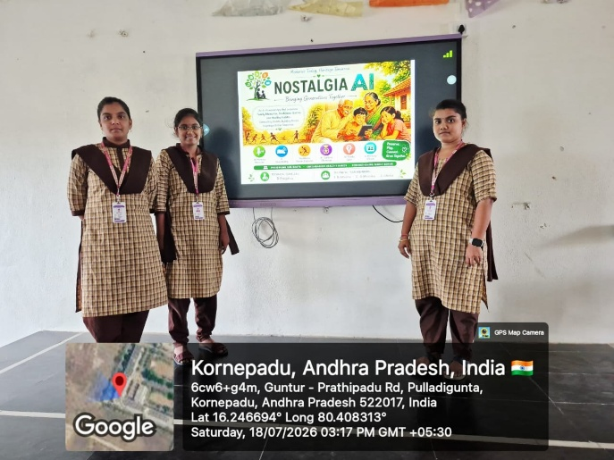
- INTRODUCTION: Technology has become an inseparable part of modern life. Smartphones, social media, online gaming, and digital entertainment have significantly changed the way people communicate and spend their leisure time. While these technological advancements have made life more convenient, they have also reduced face-to-face interactions among family members.
Grandparents possess a wealth of knowledge, traditions, moral values, and life experiences. Unfortunately, many of these precious memories are never recorded and gradually disappear over time. Children today are highly connected To digital devices but often know very little about their family history, traditional festivals, village life, or cultural customs.
Nostalgia AI addresses this challenge by providing an AI-powered platform that preserves family memories while strengthening relationships between grandparents, parents, and children. The application transforms spoken memories into digital stories, animated videos, audio narrations, quizzes, and digital albums while promoting outdoor activities and traditional games.
Rather than replacing human relationships, Nostalgia AI uses Artificial Intelligence to reconnect families and preserve cultural heritage for future generations.

PROBLEM STATEMENT:
The rapid growth of digital technology has created several challenges within modern families and society.
The major problems include:
- Excessive smartphone and social media usage among children.
- Declining interest in outdoor and traditional games.
- Reduced communication between grandparents and grandchildren.
- Loss of traditional customs, family values, and cultural heritage.
- Valuable family memories disappearing because they are not recorded.
- Increased loneliness among senior citizens.
- Children having greater knowledge of internet content than their own family history.
.Example
A grandfather remembers celebrating Sankranti in his village 40 years ago. He has many stories about farming, festivals, traditional games, and village life. However, his grandchildren spend most of their free time watching YouTube or playing online games.
Nostalgia AI records these memories, converts them into animated videos and digital storybooks, making them engaging and educational for younger generations.

OBJECTIVE OF THE EVENT:
The objectives of Nostalgia AI are:
- Preserve family memories digitally.
- Strengthen relationships among grandparents, parents, and children.
- Reduce excessive smartphone usage.
- Encourage outdoor games and healthy
Lifestyle
- Preserve Indian traditions and cultural heritage.
- Create a digital family heritage library.
- Promote storytelling as a learning tool.
- Encourage value-based education.
- Inspire younger generations to respect their cultural roots.

PROPOSED SOLUTION:
Nostalgia AI provides a single intelligent platform where families can:
- Record family memories.
- Convert voice recordings into digital stories.
- Listen to AI-generated storytelling.
- Learn traditional games.
- Participate in outdoor challenges.
- Play family quizzes.
- Create digital memory albums. - Preserve photographs, videos, and historical documents. Artificial Intelligence transforms ordinary memories into interactive educational experiences while strengthening family relationships.

TECHNOLOGIES USED:
Artificial Intelligence (AI)
Processes family memories and creates personalized digital experiences.
Machine Learning (ML)
Learns user preferences and recommends stories, games, and activities.
Natural Language Processing (NLP)
Converts spoken language into meaningful text and summarizes stories.
Speech Recognition
Converts voice recordings into digital text accurately.
Text-to-Speech (TTS)
Reads stories using natural human-like voices.
Computer Vision
Enhances old photographs and recognizes family members.
Generative AI
Creates animated stories, illustrations, and personalized content.
Cloud Computing
Stores memories securely and enables access from anywhere.
Mobile Application Development
Developed using Flutter, Android Studio, and Firebase.

KEY FEATURES:
AI Memory Recorder :Allows grandparents to record voice, video, or text memories. AI automatically converts these memories into digital stories and securely stores them.

AI Storytelling:
Transforms real family memories into animated stories using narration, background music, and illustrations, making learning enjoyable for children.
Traditional Games Explorer
The application introduces traditional Indian games such as Kabaddi, Kho-Kho, Seven Stones, Gilli Danda , Hopscotch, and Marbles. Each game includes rules, demonstrations, health benefits, and safety guidelines.
AI Outdoor Challenge:
Provides daily challenges such as playing Kabaddi, walking with grandparents, planting trees, learning traditional songs, and spending one hour without using a mobile phone. Children receive badges, rewards, and certificates.
AI Family Quiz:
Generates quizzes based on family memories.
Example: Which village did your grandfather grow up in?
This makes learning family history enjoyable and interactive.
AI Memory Album:
Stores old photographs, videos, audio recordings, and family documents. AI restores damaged photographs, removes scratches, organizes them chronologically, and automatically generates captions.
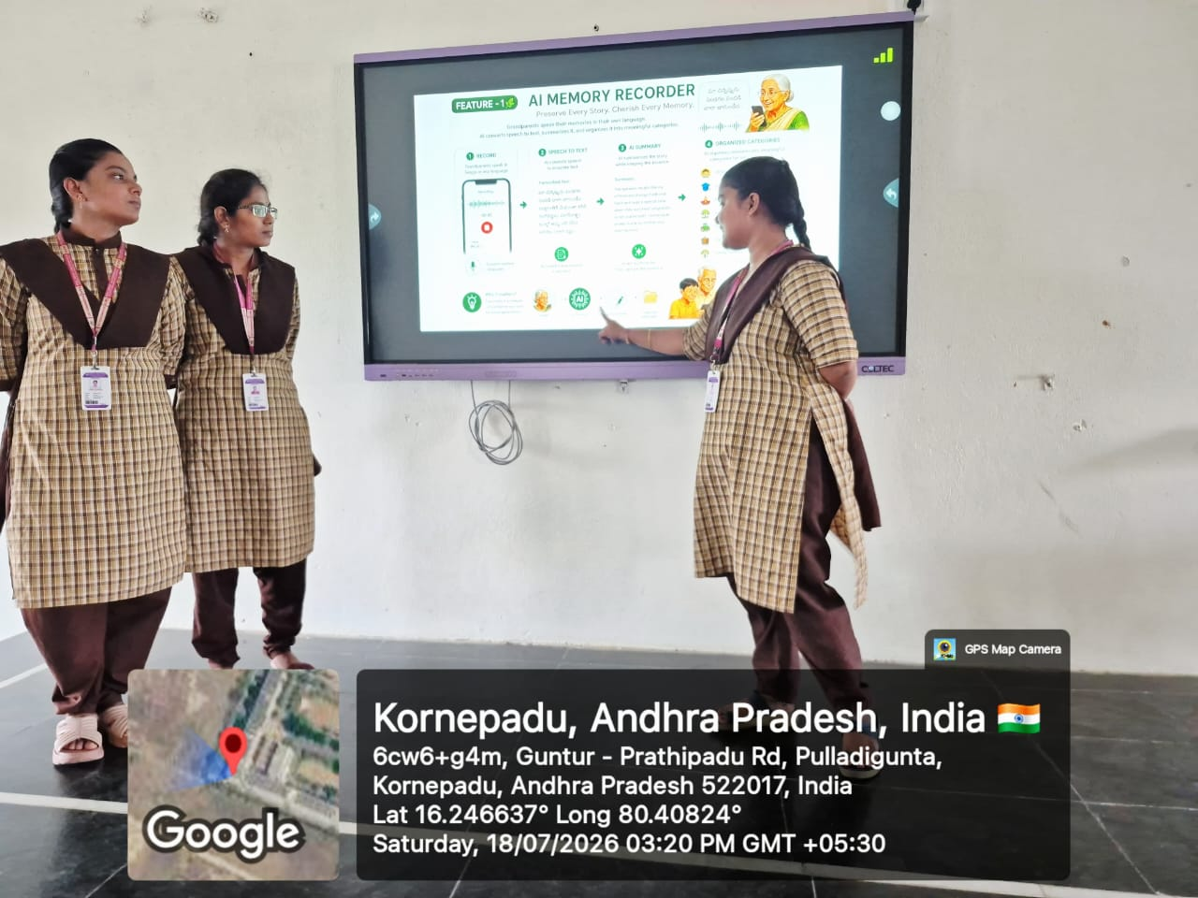

SYSTEM WORKFLOW:
1. User Registration
2. Grandparents Record Memories
3. AI Converts Voice into Text
4. Stories are Organized Automatically
5. AI Generates Narrations and Animations 6. Children Watch Stories and Attempt Quizzes
7. Outdoor Challenges are Assigned 8. Rewards are Given
9. Memories are Stored Securely in the Cloud

APPLICATIONS:
Nostalgia AI can be used in educational institutions, families, museums, cultural heritage organizations, community centers, libraries, senior citizen communities, digital heritage projects, AI hackathons, and innovation competitions.

BENEFITS:
For Children:
- Reduces screen addiction.
- Improves communication skills.
- Encourages outdoor activities.
- Teaches family values.
For Grandparents:
- Reduces loneliness.
- Preserves life experiences.
- Strengthens family interaction.
For Parents:
- Preserves family history.
- Encourages healthy lifestyles.
- Improves family bonding.
For Society
- Preserves cultural heritage.
- Promotes responsible AI usage.
- Protects traditional knowledge.
- Strengthens community relationships.

1.REAL-LIFE SCENARIO
A grandmother records stories about celebrating Sankranti during her childhood. Artificial Intelligence converts these recordings into colourful animated videos. Her grandchildren watch the stories, answer quizzes, and complete outdoor challenges by playing Kho-Kho with friends. The family uploads old festival photographs into the AI Memory Album. Years later, future generations continue to learn and celebrate these traditions.

2.FUTURE SCOPE

Future enhancements include AI Chatbot trained on family memories, AI-generated family tree, Virtual Reality village experience, emotion detection during storytelling, multi-language support, heritage location maps, smart wearable integration, festival reminders, block chain-based secure memory storage, and an AI-powered family timeline.

3.EXPECTED OUTCOMES

- Stronger family relationships.
- Reduced smartphone addiction.
- Better emotional well-being.
- Increased outdoor activities.
- Preservation of Indian traditions.
- Digital preservation of family memories.
- Greater appreciation of cultural heritage.
- Better understanding between generations.

CONCLUSION:
Nostalgia AI is much more than an Artificial Intelligence application. It is a meaningful initiative that combines technology with human emotions, family values, and cultural preservation. By connecting grandparents, parents, and children through storytelling, traditional games, quizzes, and digital memory preservation, the application transforms technology into a bridge between generations rather than a barrier.

With its vision of “Memories Today, Heritage Tomorrow,” Nostalgia AI ensures that every family’s stories, traditions, and values continue to inspire future generations. The project demonstrates how Artificial Intelligence can create a positive social impact while preserving cultural heritage, encouraging healthy lifestyles, and strengthening family relationships.

ACKNOWLEDGEMENT:
We sincerely thank Mrs. Adhi Lakshmi mam, our Faculty Mentor, for her valuable guidance, encouragement, and continuous support throughout the development and presentation of the Nostalgia AI project. We also extend our gratitude to our department, faculty members, teammates, and everyone who supported us in making this project successful. Their motivation and constructive suggestions helped us transform our idea into an innovative AI-based solution for preserving family memories and cultural heritage.
Prepared by:
Name: D. poojitha
AI Club section: A

