AI Club Event Report
Department: AIML Section: A Year:3rd Year Date & Time: - 19/09/26 , 3:10-3:50
Event Title: AI Local business Growth Advisor
Event Details:
- Faculty Mentor: Mrs .O. Adhilakshmi
- Event Organizer (Student): Ms. K. Vaishnavi
- Technical Team Leader: K. Rohitha
- Team Members:
Ms. I. Neha, Ms. G. Keerthi
- Venue: Class Room No: 553 Mode: offline
- Target Audience: Students, aspiring developers, and tech enthusiasts interested in Artificial Intelligence, innovative problem solving, and practical project development through hackathons.

Objective of the Event:
The objective of the AI Local Business Growth Advisor event was to introduce an AI-based approach for helping small and local businesses make better business decisions and improve their growth. The event aimed to demonstrate how business data such as customer information, sales, revenue, products, offers, and reviews can be analyzed using Artificial Intelligence to identify business trends, challenges, and growth opportunities. It also focused on providing AI-based suggestions for improving marketing strategies, customer engagement, offers, and overall business performance, thereby helping local businesses make data-driven decisions and achieve sustainable growth
Topics covered:
The topics covered in the event included AI for local business growth, business data collection and analysis, data preprocessing, customer and sales analysis, revenue and product analysis, customer review analysis, identification of business challenges and opportunities, AI-based growth recommendations, marketing and promotional strategies, personalized offers, customer engagement, and AI-powered business decision-making. The event also demonstrated how Generative AI can be used to provide practical solutions
Description of the Event :
The AI Local Business Growth Advisor event focused on the use of Artificial Intelligence and Generative AI to support small and local businesses in improving their business performance and growth. The project demonstrated how business data such as sales, revenue, customer details, products, offers, and customer reviews can be uploaded and analyzed using AI. The system identifies business trends, challenges, and potential growth opportunities and provides AI-based recommendations for improving sales, customer engagement, marketing, and business strategies. It also demonstrates how Generative AI can provide personalized suggestions and practical solutions based on the specific needs of a business.
Outcome of the Event :
Generative AI can be applied to real-world business problems. Participants learned how different business data sources such as sales, revenue, customers, products, and reviews can be analyzed to identify business challenges and opportunities. They also understood how AI-generThe event helped participants understand how Artificial Intelligence and ated recommendations can support businesses in improving marketing strategies, creating offers, attracting customers, analyzing reviews, and making data-driven decisions for business growth.
Number of Participants & Interaction:
The event featured 8 participants and was attended by approximately 70 attendees, who actively interacted, reflecting strong engagement and interest.
Roles and Contributions:
- Faculty Mentor:
Provided guidance, technical support, and mentorship throughout the project development, helping refine ideas and ensure successful implementation.
- AI Club Members:
Assisted in organizing the event, supporting technical development, and encouraging collaboration among participants.
- Student Presenters:
Developed and presented the project, explained the implementation, and demonstrated the working model effectively.
- Student Attendees
Actively participated by observing, learning, and engaging through questions and feedback.

Photographs :

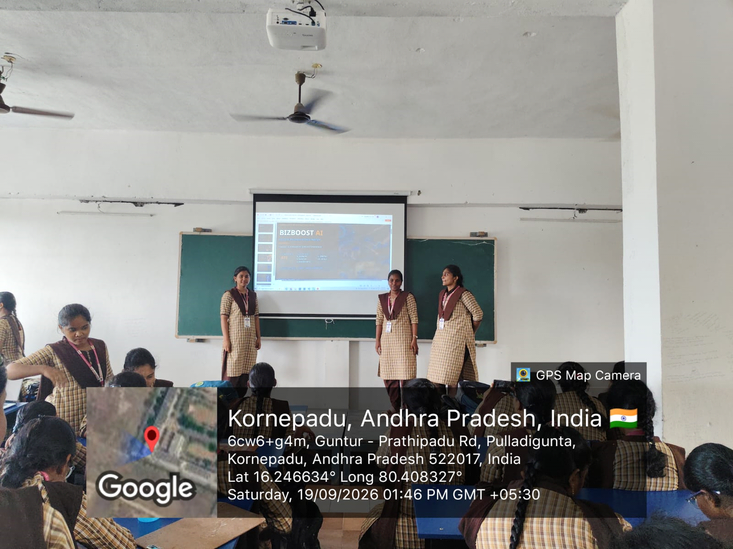

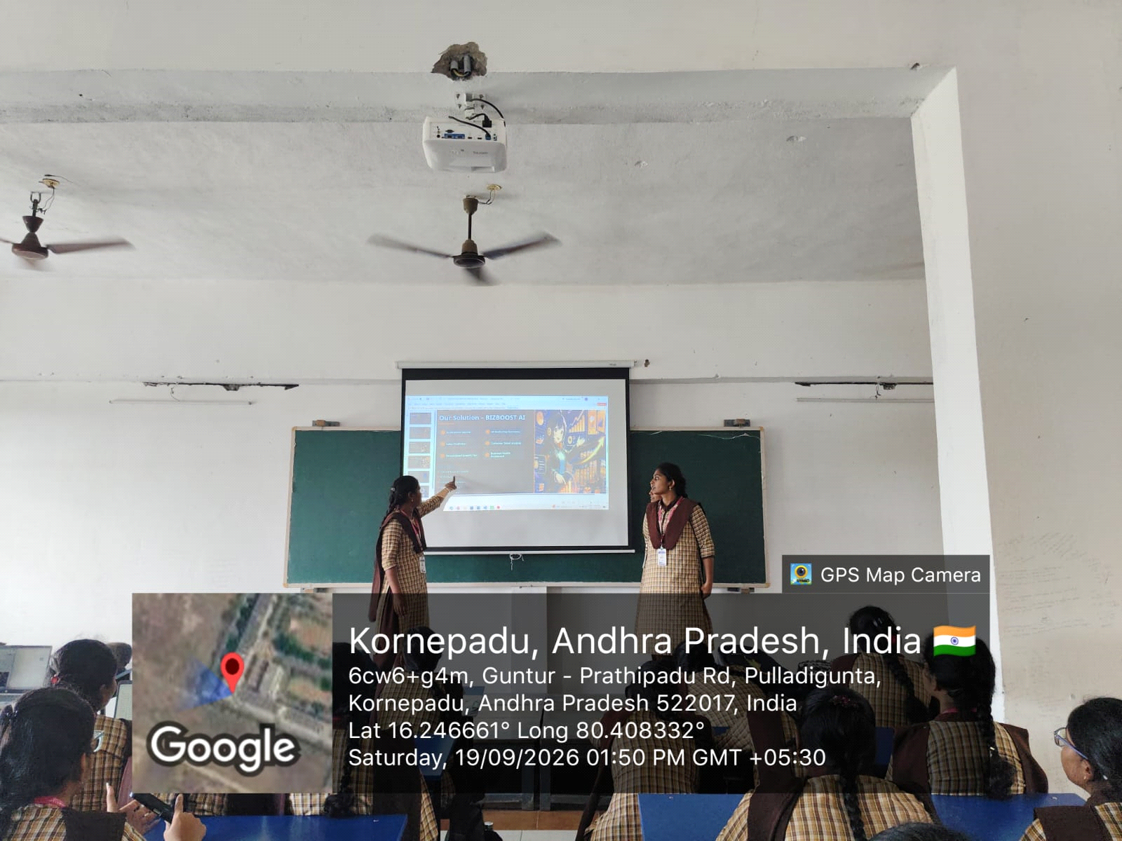
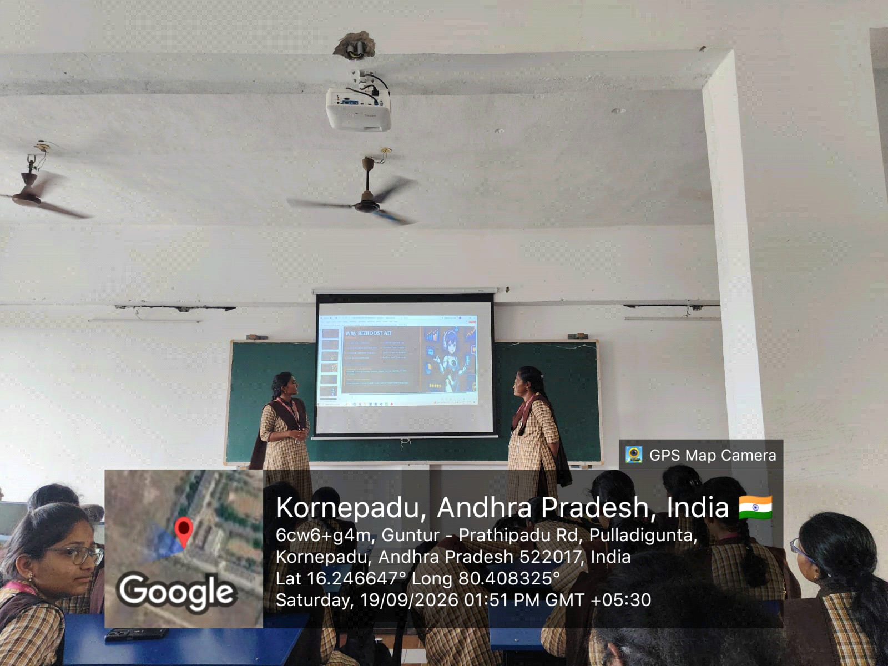
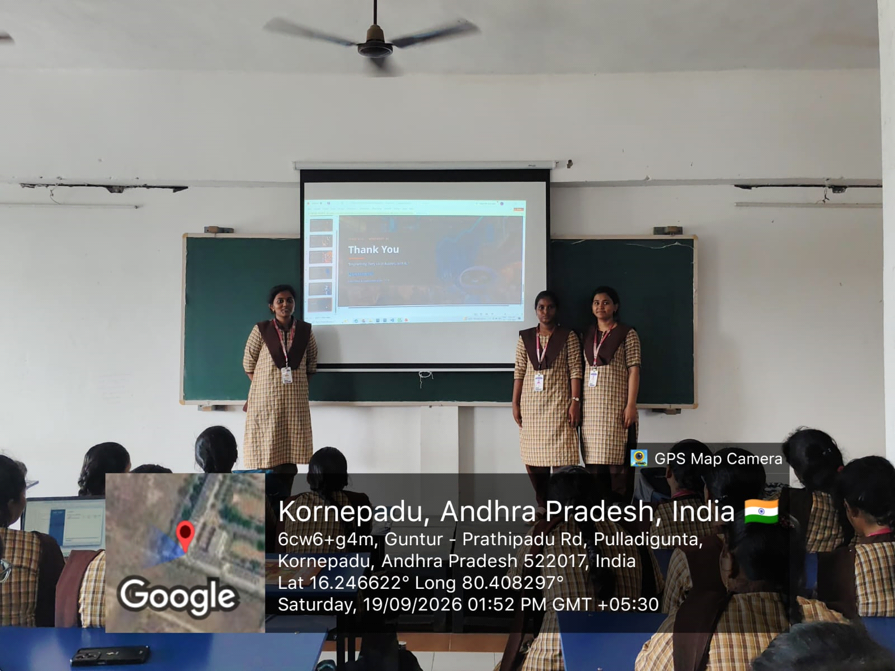

Conclusion:
The Bit Booze AI – AI Local Business Growth Advisor event demonstrated the practical use of Artificial Intelligence and Generative AI in solving real-world business challenges. Participants gained an understanding of how business data can be analyzed to identify challenges, opportunities, and growth strategies. The event also highlighted how AI can support small and local businesses through personalized recommendations, marketing ideas, customer engagement, and data-driven decision-making. Overall, the event encouraged participants to explore innovative AI solutions and apply them to practical problems..
Prepared by:
Name: K.Rohitha
Role: Event Coordinator
AI Club Section: A

