**STUDENT FACULTY DATABASE**

create table student(

snum number(10),

sname varchar2(20),

major varchar2(20),

lvl varchar2(20),

age number(10),

primary key(snum)

);

Desc student;

Name Null? Type

----- -------- ------------

SNUM NOT NULL NUMBER(10)

SNAME VARCHAR2(20)

MAJOR VARCHAR2(20)

LVL VARCHAR2(20)

AGE NUMBER(10)

create table class(cname varchar(20),meetsat timestamp,room varchar(10),fid integer,

primary key(cname));

desc class;

Name Null? Type

------- -------- ------------

CNAME NOT NULL VARCHAR2(20)

MEETSAT TIMESTAMP(6)

ROOM VARCHAR2(10)

FID NUMBER(38)

create table enrolled(snum number(10), cname varchar(20),

primary key(snum,cname),

foreign key(snum) references student(snum)on delete cascade,

foreign key(cname) references class(cname)on delete cascade);

desc enrolled;

Name Null? Type

----- -------- ------------

SNUM NOT NULL NUMBER(10)

CNAME NOT NULL VARCHAR2(20)

Name Null? Type

------ -------- ------------

FID NOT NULL NUMBER(38)

FNAME VARCHAR2(20)

DEPTID NUMBER(38)

select *from student;

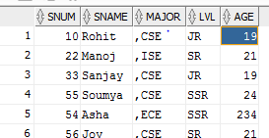

Select * from class;

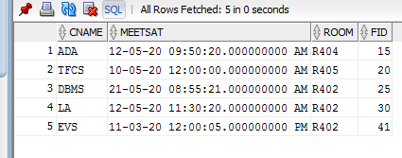

Select * from enrolled;

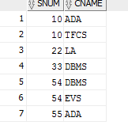

Select * from faculty;

