InvoiceIQ
The Smarter Way to Run Your Business Billing
Built for Indian businesses. Designed to save your time, protect your money,
and keep your GST filing stress-free — every single day.
YOU DESERVE MORE THAN A SPREADSHEET
Picture this: a customer asks for an invoice. You open a spreadsheet, copy last month's format, manually calculate GST, type the customer's address again — only to realise you forgot to update the invoice number.
That ends today.
InvoiceIQ handles the math, remembers your customers, generates your GST reports, and delivers a professional invoice to your customer — in minutes, not an hour.
Who Is This For?
- You bill customers and want to look professional every time
- You deal with GST and want filing day to stop being a nightmare
- You have outstanding payments and want to know exactly who owes you what
- You want one place for all your billing — not scattered files on your desktop

GETTING STARTED — LOGGING IN
Open InvoiceIQ in your browser. Enter your email address and password, then click Login. Check Remember me if you want to stay logged in on your device.
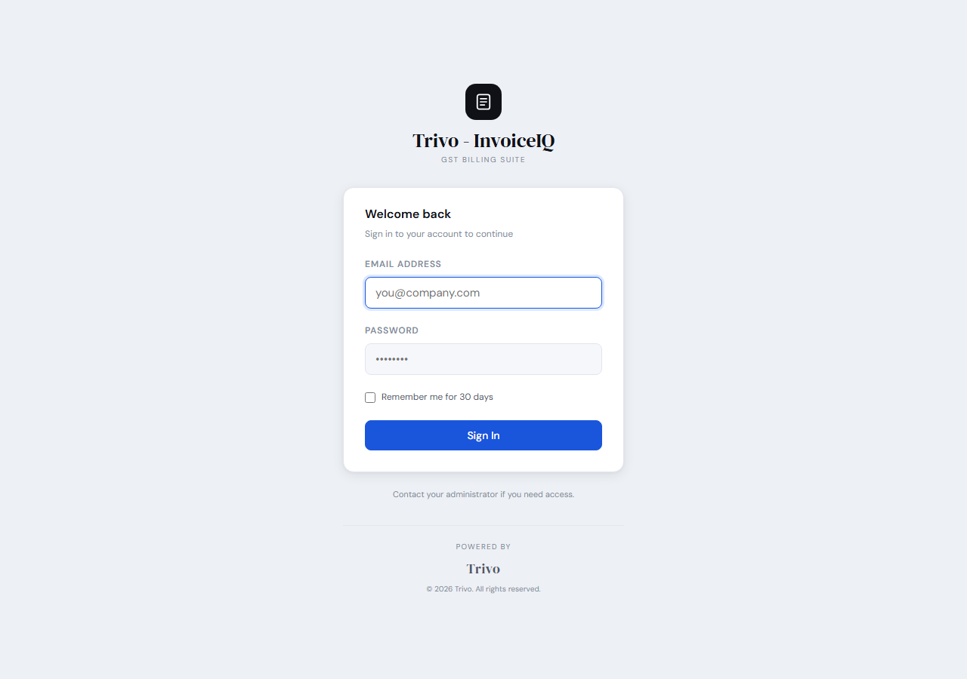
Figure: Login Screen
Your name and role are always visible in the sidebar once you are in.
Role | What They Can Do
Admin | Complete control — invoices, customers, items, reports, settings, user management
Staff | Day-to-day billing — create and manage invoices, customers, and items
Viewer | Read everything, change nothing — perfect for auditors or accountants

THE DASHBOARD — KNOW YOUR BUSINESS BEFORE YOUR MORNING CHAI
The moment you log in, InvoiceIQ shows you everything that matters about your business — no digging, no calculating, no waiting.
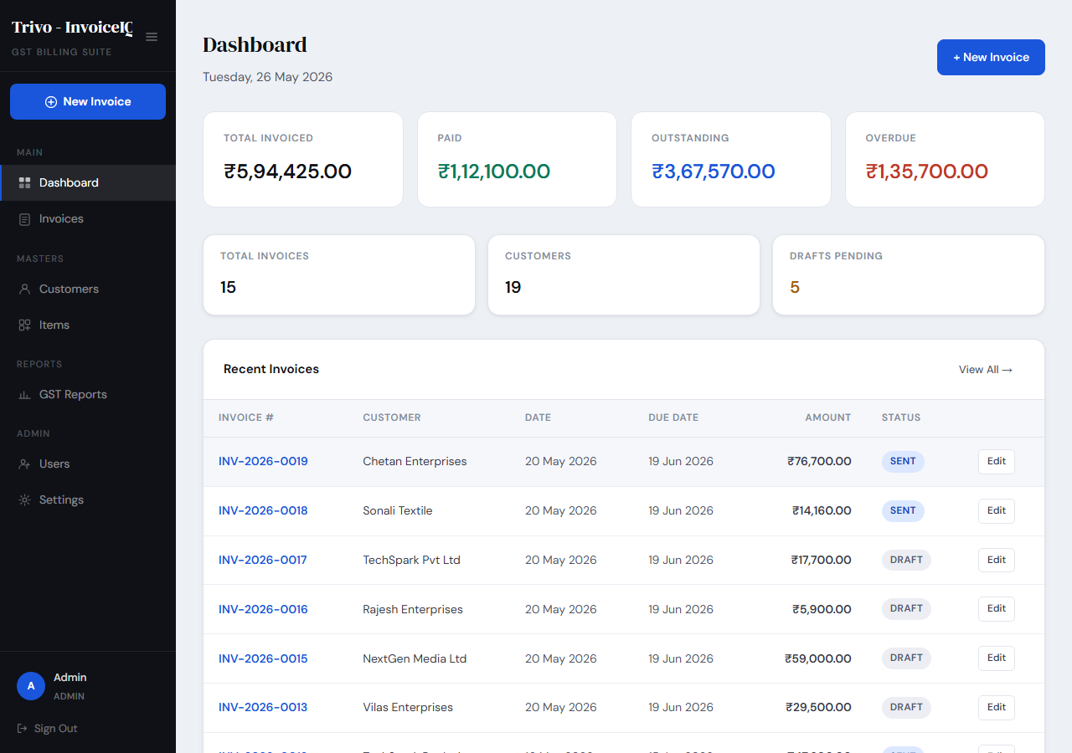
Figure: Dashboard — Business Summary at a Glance
At a Single Glance
What You See | Why It Matters
Total Invoiced | How much business you have generated — ever
Total Paid | Real money collected — your actual revenue
Total Outstanding | What is still owed to you — your follow-up list
Total Overdue | Money past its due date — your urgent list
Invoice Count | Your total volume of work in numbers
Drafts | Invoices prepared but not yet sent
Customers | How large your client base has grown

Below the cards, a 6-month revenue chart shows your monthly billing trend — spot growth, slow seasons, and plan your next push at a glance.

INVOICES — YOUR PROFESSIONALISM, AUTOMATED
An invoice is not just a document. It is how your customer sees your business. InvoiceIQ makes sure every invoice you send looks like it came from a company that means business.
Invoice List
Navigate to Invoices from the sidebar. Every invoice you have ever raised is listed here with status, amount, customer, and date. Use the search box and filters to find any invoice instantly.
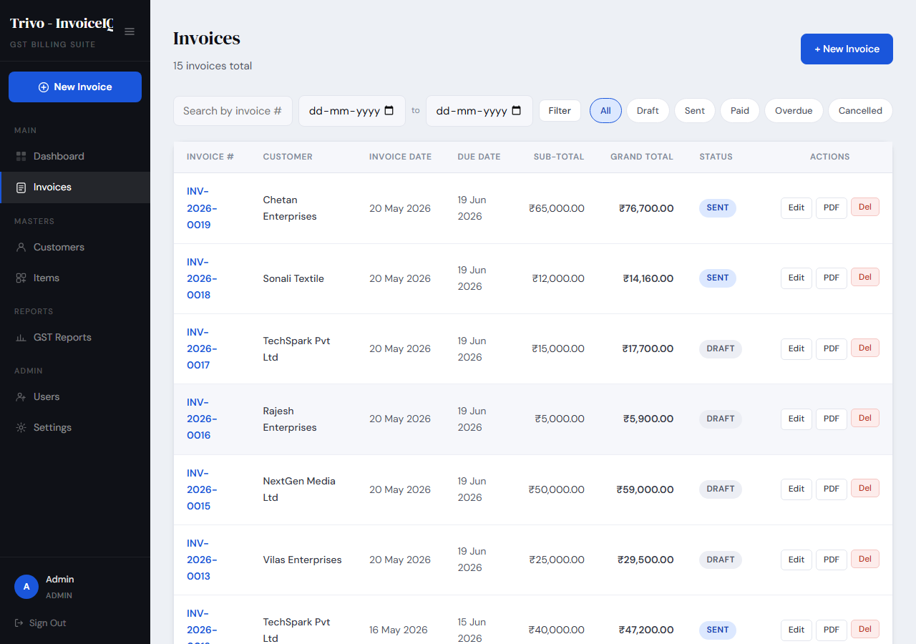
Figure: Invoice List — All Invoices with Status and Filters
Creating a New Invoice
Click New Invoice to open the invoice builder.
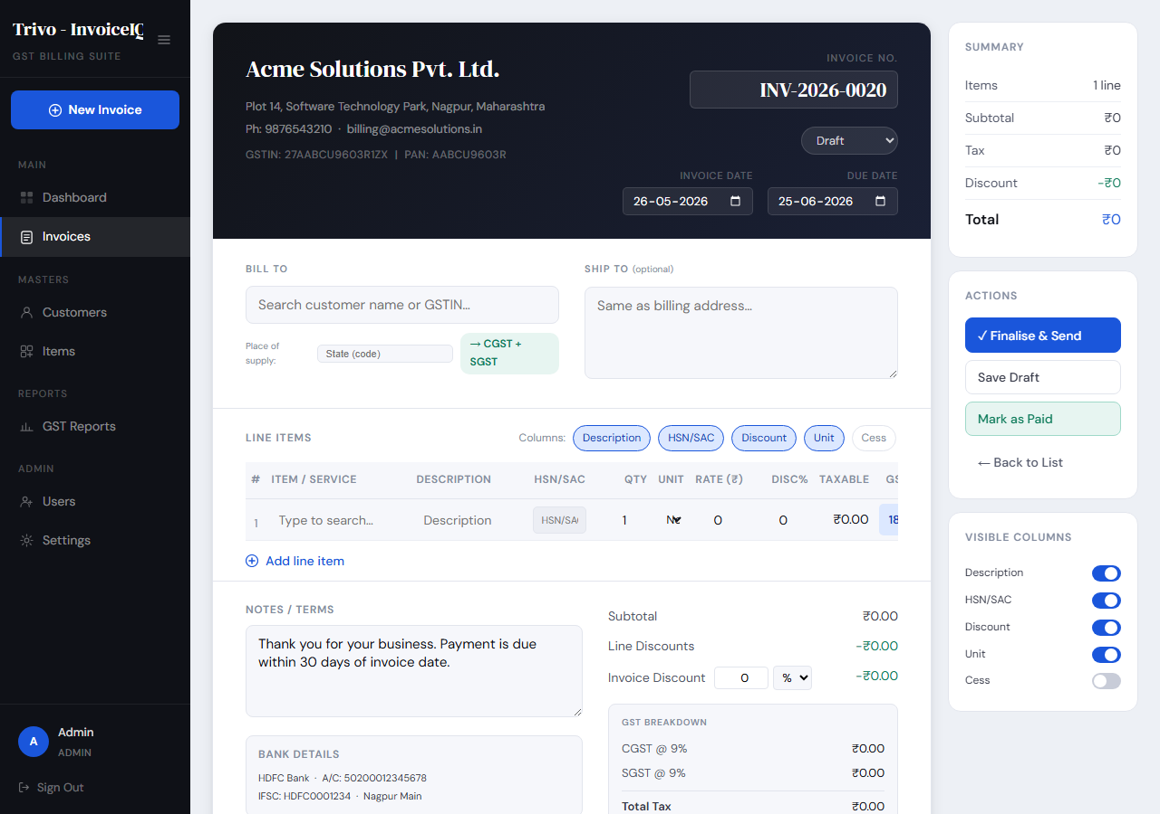
Figure: New Invoice Form — Customer and Invoice Details
Step 1 — Choose Your Customer
Start typing a customer name. InvoiceIQ suggests matches and fills in the address and GSTIN automatically — no copy-paste errors.
Step 2 — Invoice Identity
- Invoice Number — Auto-generated (e.g., INV-2025-0001), unique, never repeated
- Invoice Date — Pre-filled with today
- Due Date — Once passed, the invoice automatically turns Overdue
- Place of Supply — Determines CGST+SGST (same state) or IGST (different state)
Step 3 — Add Line Items
Click Add Item for each product or service. All GST amounts calculate live as you type.
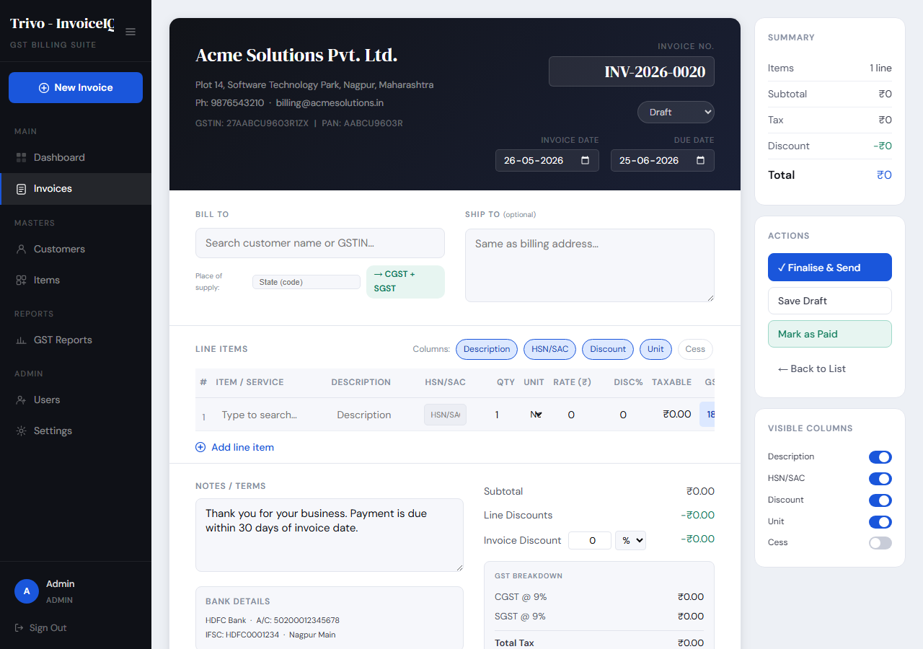
Figure: Invoice Line Items — Live GST Calculation
Step 4 — Totals, Discount & Notes
Apply an invoice-level discount (% or flat rupee), add payment notes and terms. Subtotal, CGST, SGST, IGST, round-off, and grand total all update instantly.
Figure: Invoice Totals — Auto-Calculated GST Breakup
Viewing an Invoice
Click any invoice to open the full detail view — line items, GST breakup, payment history, and action buttons: Edit, Send Email, Download PDF, Record Payment.
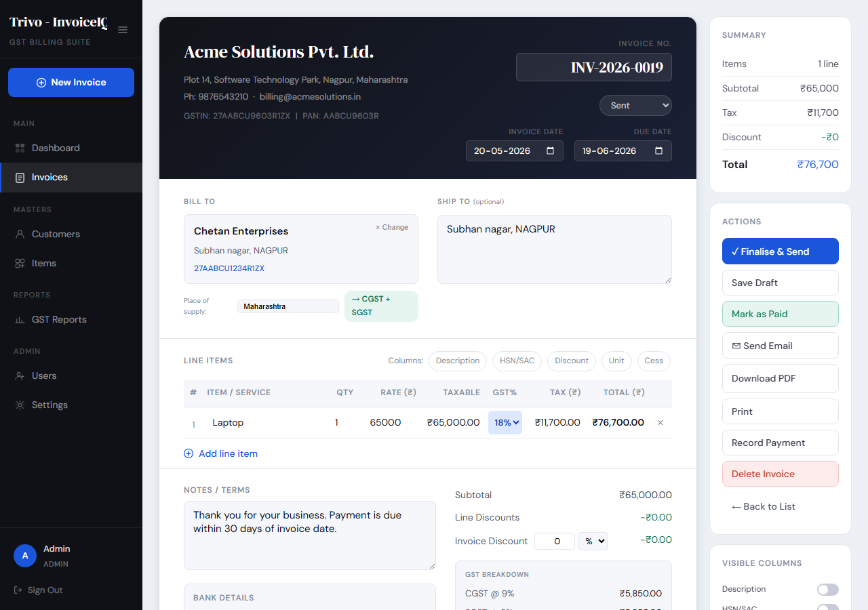
Figure: Invoice Detail View — Full Summary with Actions
Invoice Statuses
Status | What It Means for You
Draft | In progress — customer hasn't seen it yet
Sent | Delivered — awaiting payment
Partial | Some payment received — follow up for the rest
Paid | Collected in full — done!
Overdue | Due date passed, still unpaid — urgent follow-up needed
Cancelled | Voided — excluded from all totals and reports

Recording Payments
Open any invoice and click Record Payment. Enter the amount, date, payment mode (Cash, UPI, NEFT, RTGS, Cheque, Card), and reference number. InvoiceIQ automatically updates the status — Partial or Paid — and keeps the full payment history.
PDF Download & Email
Click Download PDF for a professionally formatted A4 invoice with your logo. Click Send Email to deliver it directly to your customer — the PDF attaches automatically and the invoice status updates to Sent.

CUSTOMERS — YOUR BUSINESS RUNS ON RELATIONSHIPS
Save your clients once — every future invoice fills in their details automatically. No retyping addresses. No wrong GSTIN on a legal document.
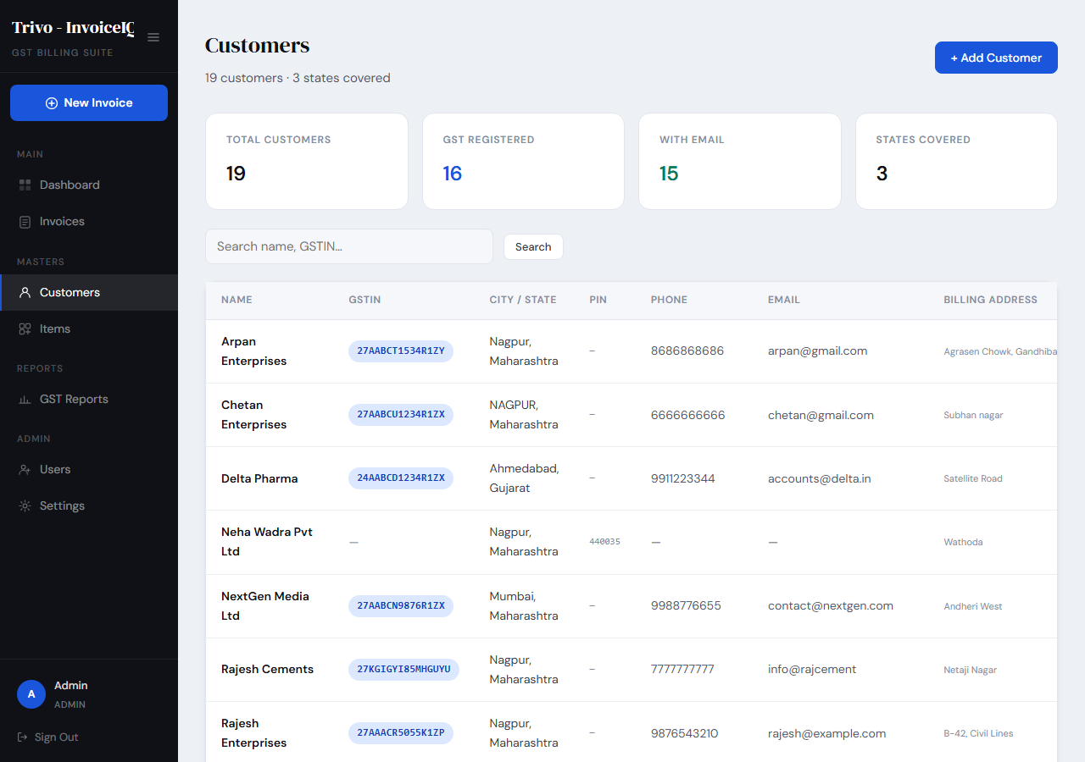
Figure: Customer List — Client Directory with Search
What You Store Per Customer
- Name, email, phone
- GSTIN — Critical for B2B invoices and GST reports
- Billing and shipping addresses (separately if different)
- Default payment terms and credit limit
- Notes — anything important about this relationship
Adding a New Customer
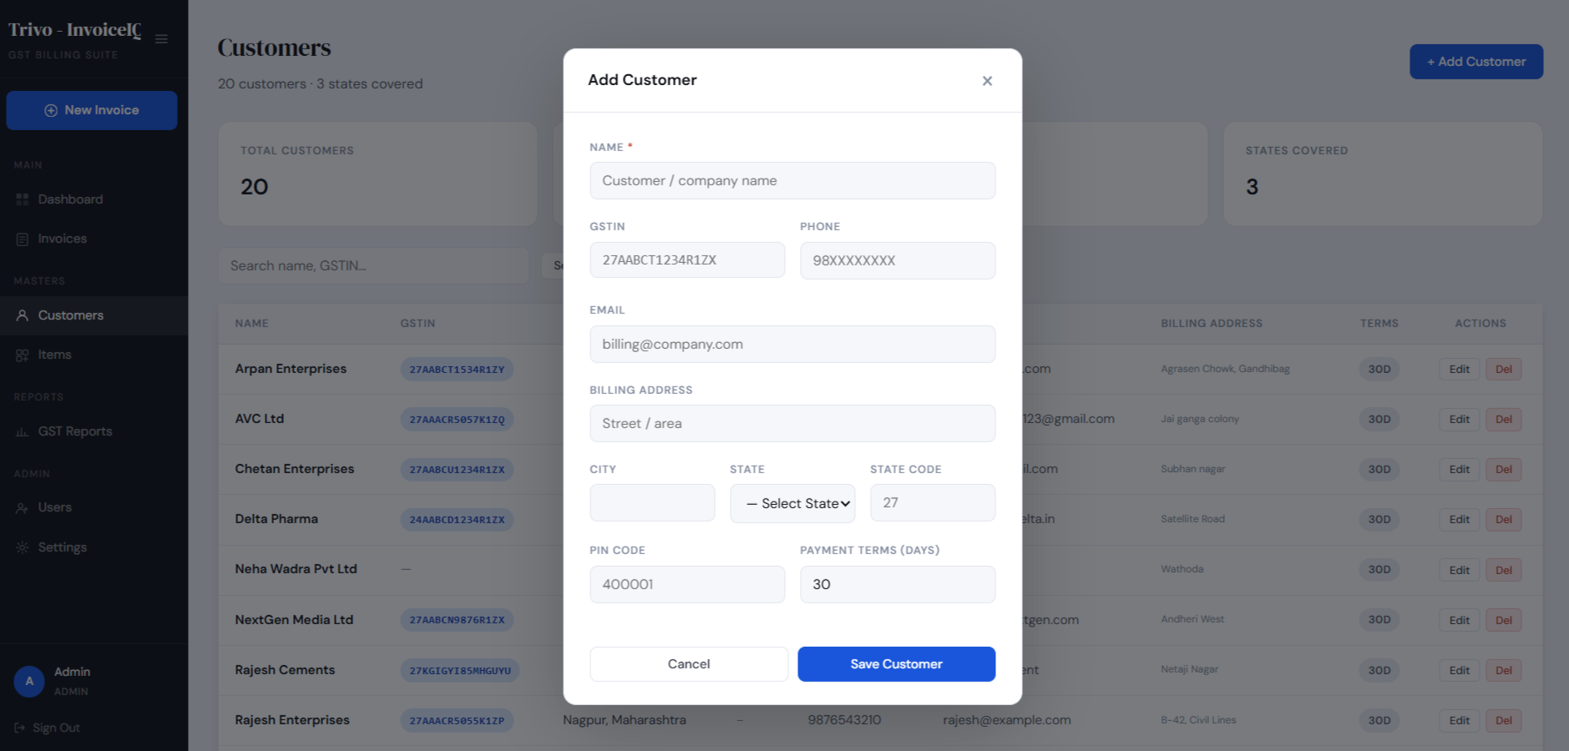
Figure: New Customer Form — Complete Client Profile
Customer Insights
Open any customer to see their total invoiced, total outstanding, and complete invoice history — so every conversation with a client is backed by facts.
“You have ₹45,000 outstanding across three invoices” — said with confidence, not guesswork.

ITEMS — YOUR CATALOG, YOUR SPEED
Build your product and service catalog once. When adding a line item on an invoice, start typing the name — InvoiceIQ fills in the HSN code, rate, and GST rate instantly.
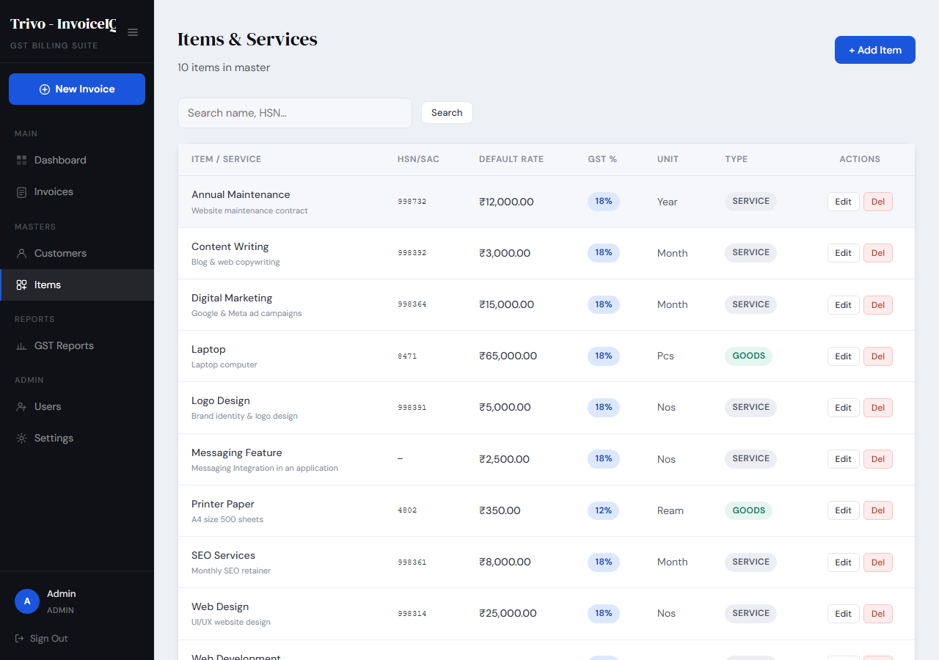
Figure: Items Catalog — Products and Services with Default Rates
What used to take 2 minutes per line item now takes 5 seconds. Multiply that by every invoice you raise this year.
Field | Why It Matters
Name | What appears on the invoice
HSN/SAC Code | Required for GST reports — save it once, never look it up again
Type | Goods or Service — determines GST classification in reports
Default Rate | Your standard price per unit
Default GST Rate | 0%, 5%, 12%, 18%, or 28%
Unit | Nos, KG, Hours, Qty, etc.

GST REPORTS — FILING DAY IS NO LONGER STRESSFUL
InvoiceIQ generates every report your CA needs — GSTR-1 summary, B2B, B2C, HSN/SAC summary, and Tax Liability — in seconds. Export to Excel or PDF.
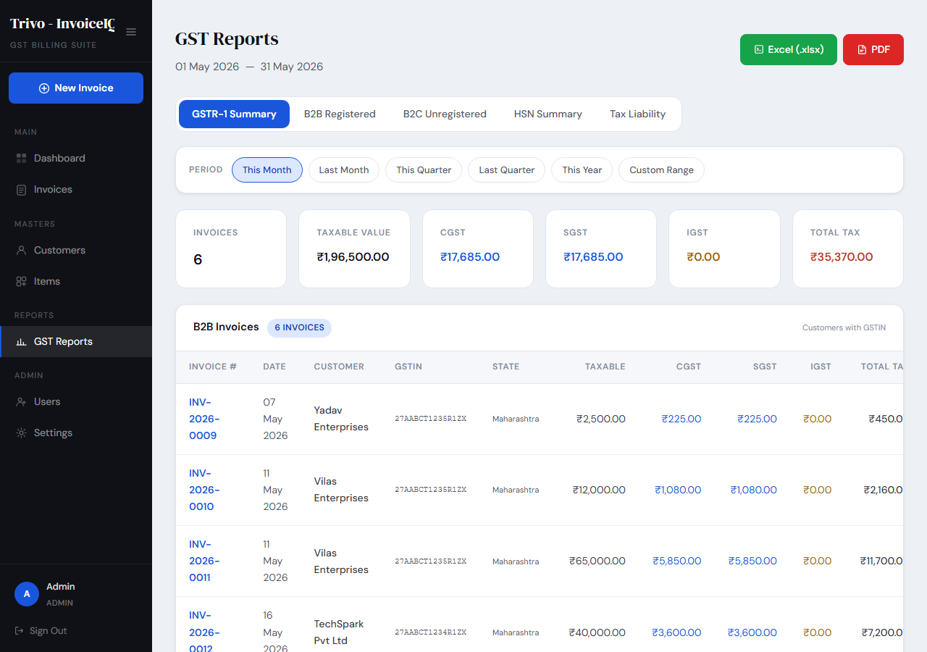
Figure: GST Reports — All Filing Reports in One Place
Available Reports
Report | What It Gives You
GSTR-1 Summary | Complete invoice list split into B2B and B2C — foundation for GSTR-1 filing
B2B Report | One row per registered customer GSTIN — direct input for GSTR-1 B2B section
B2C Report | Unregistered buyer sales grouped by state — for GSTR-1 B2C section
HSN/SAC Summary | Sales by HSN/SAC code with quantity and GST — required for Schedule B
Tax Liability | Tax owed by GST rate, broken down month by month — plan your payments

Filter any report by This month, Last month, This quarter, Last quarter, This year, Last year, or a custom date range. Every report exports to a multi-sheet Excel workbook or a print-ready PDF.

SETTINGS — MAKE INVOICEIQ TRULY YOURS
Spend 10 minutes in Settings once, and every invoice you ever send carries your brand, your details, and your style. Admin access only.
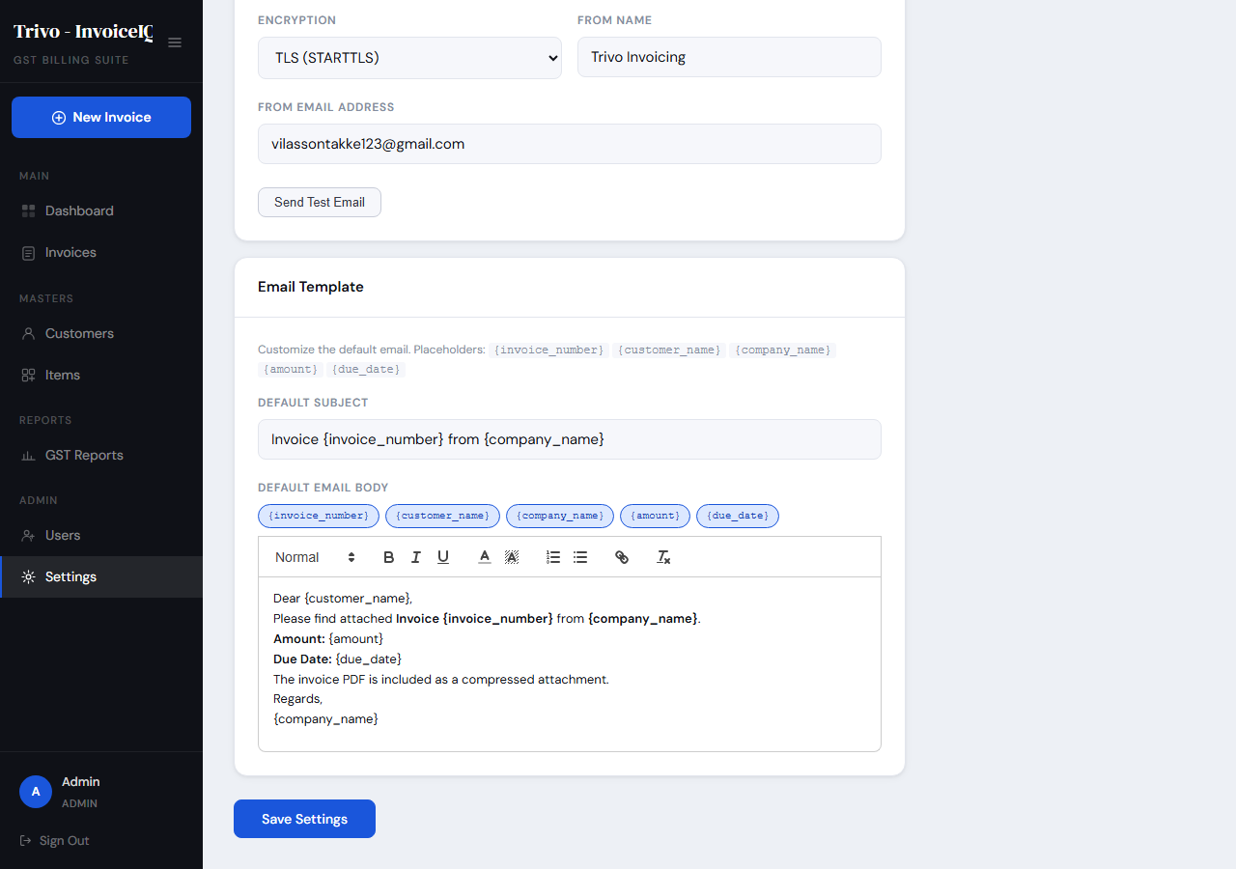
Figure: Settings — Company Information and Invoice Defaults
What You Configure
- Company Information — Name, GSTIN, PAN, address, phone, email, logo
- Bank Details — Account number, IFSC, branch (shown on invoices for bank transfers)
- Invoice Numbering — Prefix + sequence, e.g., INV-2025-0001, INV-2025-0002
- Invoice Defaults — Payment terms and notes pre-filled on every new invoice
- Email / SMTP — Send invoices from your own business email address
Email Configuration
Figure: Settings — SMTP Email Configuration with Test Button
Configure your SMTP host, port, credentials, and from-name once. Click Test SMTP to send a test email and confirm it works before your first invoice goes out.

USER MANAGEMENT — THE RIGHT PEOPLE, THE RIGHT ACCESS
Bring your team in with exactly the access level they need. Admin access only.
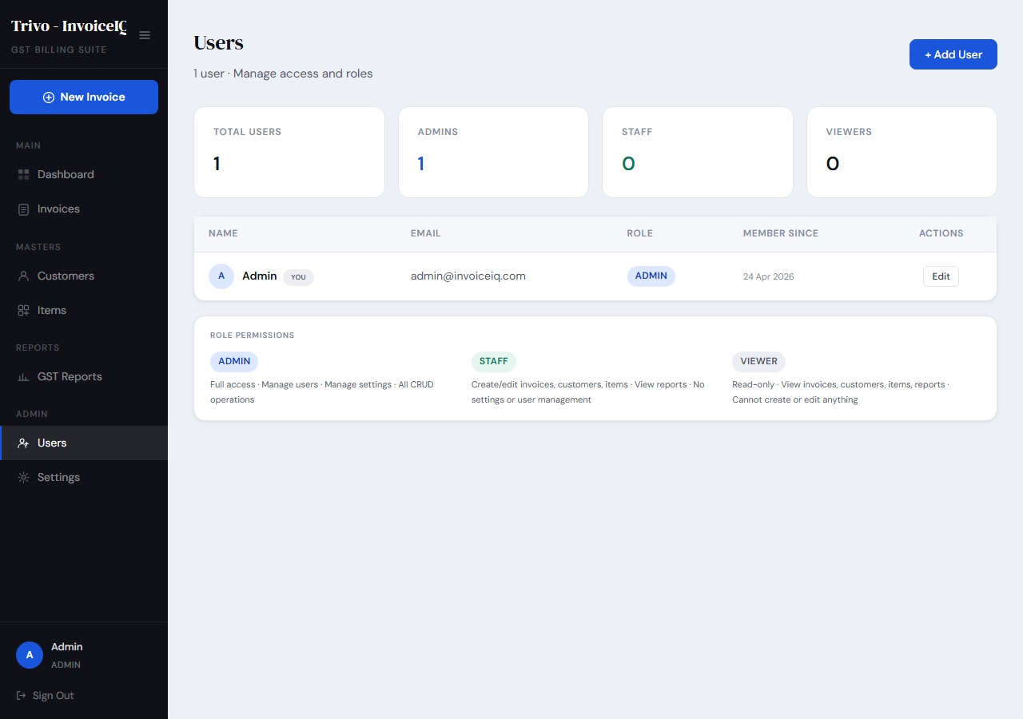
Figure: User Management — Team Roles and Access Control
Role | Perfect For
Admin | Business owner, finance head — full control
Staff | Billing executive, sales team — invoice and client management
Viewer | Accountant, auditor, investor — view everything, change nothing

A built-in protection prevents you from accidentally deleting your own account.

YOUR QUICK-START CHECKLIST
Before your first invoice, spend 10 minutes setting up InvoiceIQ. You will never have to do this again.
☐ Settings → Add company name, GSTIN, logo, and bank details
☐ Settings → Set your invoice prefix and starting number
☐ Settings → Configure email/SMTP and click Test SMTP
☐ Items → Add your regularly sold products/services with HSN codes and GST rates
☐ Customers → Add your regular clients with their GSTIN
Once this is done, a complete GST-compliant invoice takes under two minutes.

TIPS FROM EXPERIENCED USERS
Keep Your Items Catalog Complete
Every HSN code you fill in now saves you from entering it manually 200 times this year — and makes your HSN Summary report accurate without extra work.
Always Record Payments Promptly
The Outstanding and Overdue cards on your dashboard are only as accurate as your payment records. Record the same day you receive — your dashboard always tells the truth.
Save Every Customer — Even One-Time Clients
You never know who comes back. A customer saved today is an invoice raised in 30 seconds next time they call.
Use Draft Status Strategically
Prepare invoices for month-end in advance as drafts. Review together, then send in one session. Organised, professional, efficient.
Export Reports Before Your CA Asks
At the end of every month, export your GSTR-1 Summary and Tax Liability report. When filing time comes, you are ready in five minutes.

COMMON QUESTIONS, STRAIGHT ANSWERS
Q: I sell to customers in other states. How does InvoiceIQ handle that?
Automatically. When your state and the customer's state differ, InvoiceIQ charges IGST instead of CGST+SGST. It detects this from the Place of Supply on each invoice — you configure nothing.
Q: A customer paid in two instalments. What do I do?
Record each payment separately using Record Payment. InvoiceIQ shows Partial after the first and Paid after the final. Full history, full audit trail.
Q: I sent an invoice with a wrong amount. Can I fix it?
Yes. Open the invoice, click Edit, fix it, and save. If you already emailed it, send a revised copy with a note.
Q: I want to cancel an invoice raised by mistake.
Change the status to Cancelled. It stays in the system for records but is excluded from all reports and totals.
Q: My accountant asks for a GST report every month. How fast can I send it?
Under a minute. Open GST Reports, select the period, click Export Excel. A multi-sheet workbook — GSTR-1, B2B, B2C, HSN, Tax Liability — is ready to email.
Q: What is Place of Supply and why does it matter?
It is the state where goods are delivered or services are consumed. GST law requires it on every invoice. InvoiceIQ uses it to automatically apply the correct tax — CGST+SGST or IGST.

InvoiceIQ — Built for Indian businesses. Trusted by people who mean business.

