**Cycling Training Log**

**Application**

**User’s Guide**

December 12, 2024

Version 1.2

Application and User’s Guide written and designed by: John T. Flynn

Copyright 2024 John T. Flynn

Preface-Disclaimer

This document is subject to errors. Newer versions of the document may be available from the document owner. The document owner is not responsible for any errors or lost data that may occur using the Cycling Training Log Application.

Images used in this document may vary from the actual dialogs used.

Document Owner

John Flynn (cycling.log.workbook@gmail.com)

Contributors

References

Microsoft SQL lite

Garmin.com

Revisions: Date: Changes:

Version 1.00 09/14/24 Initial release

**Table of Contents**

1 General Information 3

1.1 License Agreement and Warranty Disclaimer 4

1.2 Requirements 4

2 Tabs 4

2.1 Main 5

2.2 Statistics-Yearly 5

2.3 Statistics -Monthly 5

2.4 Statistics-Weekly 5

2.5 Calendar 5

2.6 Maintenace 5

2.7 Bikes 5

2.8 Routes 6

2.9 Settings 6

2.10 About 6

3 Initial Setup 6

3.1 Add New Log 7

3.2 Select First Day 7

3.3 Add New Route 8

3.4 Add New Bike 8

4 Main 8

4.1 Day Counts 9

4.1.1 Week count 9

4.1.2 Day count 9

4.1.3 Time Change 9

4.2 Data Entry 9

4.3 Data Entry Options 10

4.3.1 Section 1 10

4.3.1.1 Log Entry 11

4.3.1.2 Ride Date 11

4.3.1.3 Retrieve Data From Date 11

4.3.1.4 Add Button 11

4.3.1.5 Update button 11

4.3.1.6 Import button 11

4.3.1.7 Delete button 11

4.3.1.8 Clear Button 11

4.3.2 Section 2 12

4.3.2.1 Route 12

4.3.2.2 Bike 12

4.3.2.3 Time 12

4.3.2.4 Distance 12

4.3.2.5 Average Speed 12

4.3.2.6 Wind 12

4.3.2.7 Temperature 12

4.3.2.8 Bike 12

4.3.2.9 Type 12

4.3.2.10 Location 13

4.3.2.11 Effort 13

4.3.2.12 Comfort Level 13

4.3.2.13 Calories 13

4.3.2.14 Avg Cadence 13

4.3.2.15 Max Cadence 13

4.3.2.16 Avg Heart Rate 13

4.3.2.17 Max Heart Rate 13

4.3.2.18 Total Ascent 14

4.3.2.19 Total Descent 14

4.3.2.20 Max Speed 14

4.3.2.21 Avg Power 14

4.3.2.22 Max Power 14

4.3.2.23 Custom 1 14

4.3.2.24 Custom 2 14

4.3.2.25 Comment Section 14

4.3.2.26 Close Button 14

5 Statistics 14

5.1 Yearly 14

5.2 Monthly 15

5.2.1 Yearly Miles 16

5.2.2 Number of Rides 16

5.2.3 Average per Week 16

5.2.4 Average per Ride 16

5.2.5 High Week 16

5.2.6 Longest Ride 17

5.2.7 Change from previous week 17

5.2.8 Total Miles 17

5.2.9 Refresh Button 17

5.3 Weekly 17

6 Calendar 18

7 Maintenace 19

8 Bike 20

9 Routes 21

10 Settings 22

11 About 28

12 View Ride Data 29

13 Charts 30

14 How do I … 31

14.1 How do I setup my very first log? 31

14.2 How do I enter data for a ride? 32

14.3 How do I remove a Ride entry? 32

14.4 How do I move a Ride entry to a different date? 32

14.5 How do I add a second entry to the same date? 32

14.6 How do I remove a duplicate entry? 33

14.7 How do I modify a Ride entry once it has been submitted? 33

# General Information

## License Agreement and Warranty Disclaimer

The End User License Agreement content (E.U.L.A.) can be found in the following file after the .exe file is extracted; “C:\Cycling_Log\Training_Log_EULA.txt”.

The E.U.L.A must be accepted before you can use the functions within the Cycling Training Workbook file.

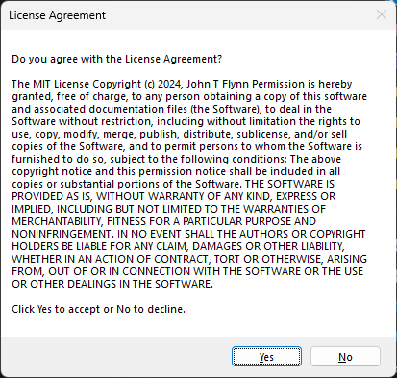

Figure 1 - License Agreement and Warranty Disclaimer

## Requirements

The program requires Windows 10/11 and the free version of Microsoft® SQL Server® 2022 Express to be installed in order to use the SQL database.

# Tabs

The following Tab Pages are available within the Application to control various functions.

* Main
* Statistics-Yearly
* Statistics -Monthly
* Statistics –Weekly
* Calendar
* Maintenance
* Bikes
* Routes
* Settings
* About

## Main

The Main tab is location to enter new ride data, view ride data, plan future rides, or view ride data in chart format. The tab also contains totals for all logs combined.

## Statistics-Yearly

The Statistics-Yearly tab will display statistics for each log year.

## Statistics -Monthly

The Statistics-Monthly tab will display statistics for each month for a selected Log year.

## Statistics-Weekly

The Statistics-Weekly tab will display statistics for all weeks up to the current week.

## Calendar

The Calendar tab allows to view certain data items in a calendar format.

## Maintenace

The Maintenance tab is a place to document changes to any of the bikes.

## Bikes

The Bikes tab is a place to see the total number of miles for each bike.

## Routes

The Routes tab is the place to enter new Routes or to make updates. The tab also includes the number each route is used in all Logs.

## Settings

The Settings tab is used to add or edit Yearly logs, Routes, and Bikes. It also contains some other controls for the application.

## About

The About tab will contain the version number of the application, the license information, and a link to the User’s Guide.

# Initial Setup

In order to start using the Log Application, a Log needs to be created to store ride data. Below is a list of tasks to complete for the initial setup of the application.

* Create a new log for the current year
* Set First day of the week, Sunday or Monday
* Add any common routes names
* Add at least 1 bike to log rides against

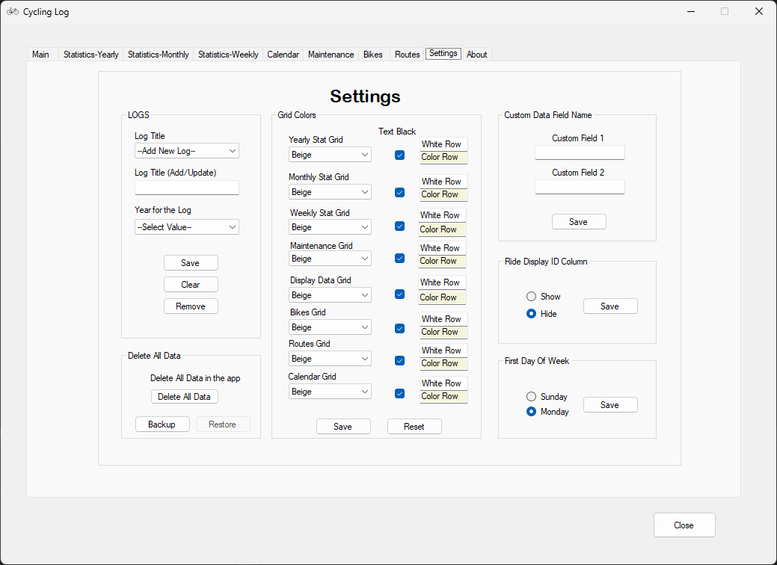

## Add New Log

1. To add a new log, click the Settings tab.
2. The Log Title section should be set to ‘--Add New Log--’
3. Enter a Log name in the ‘Log Title (Add/Update)’ field
4. Select a year for the log from the ‘Year for the Log’ dropdown list.
5. Click the Save button.

## Select First Day

The First Day of Week is used for tracking weekly ride data. The options available are Sunday and Monday for a Sunday to Saturday and Monday to Sunday week respectively.

## Add New Route

To add a new route, click the Routes tab.

Enter a Route name in the ‘New Route Label’ field.

Click the Save button

The new route should now appear in the list and available in the dropdown list in the Ride Data Entry form.

## Add New Bike

To add a new bike, click the Bikes tab.

Enter a Bike name in the ‘New Bike Name’ field

Enter the number of miles for the bike that are not to be included in this log. If none, enter ‘0’. This would be any known miles that been ridden on the bike that will not be added to this log.

Click the Save button.

# Main

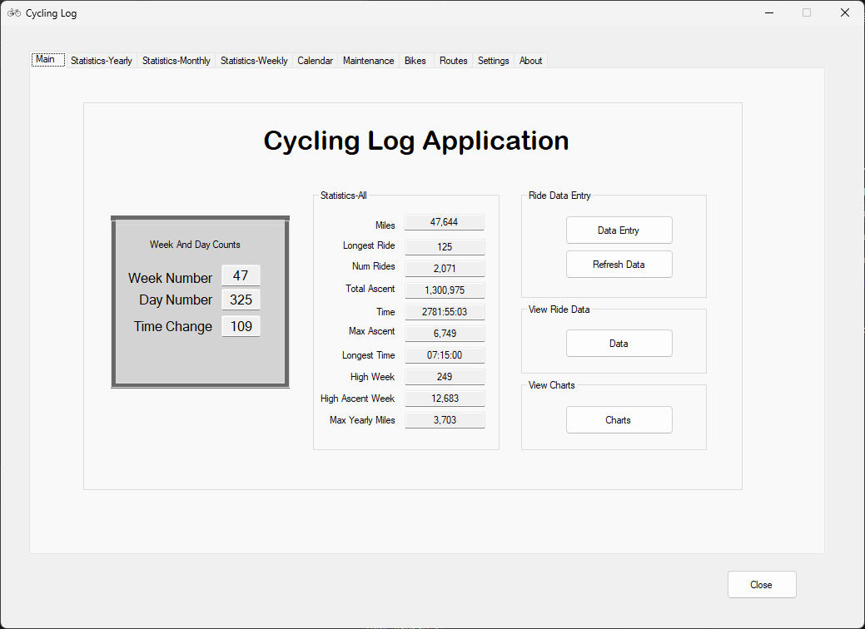

Figure 2 – Main Tab

## Day Counts

### Week Number

The ‘Week Number textbox will display the number of the weeks to the current week from the beginning of the year.

### Day Number

The ‘Day Number textbox will display the number of days from January 1 of the current year to the current date. The value is independent of any log settings.

### Time Change

The Time Change filed will display the number of days until the start or end of Daylight Savings Time (DST) in which the time will change.

From the beginning of the year until mid-March, it will display the number of days until DST starts. Then from that time until the first week of November, it will display the number of days until DST ends. Then from the November time period until the end of the year, it will once again give the number of days until DST starts again.

## Statistics-All

This section contains some statistics from all logs combined.

## Ride Data Entry

### Data Entry

The Data Entry button will open the Ride Data Entry form. The Data Entry form is how ride data is entered or updated to a log.

### Data Refresh

The Data Refresh button will refresh newly entered data for data fields in the application.

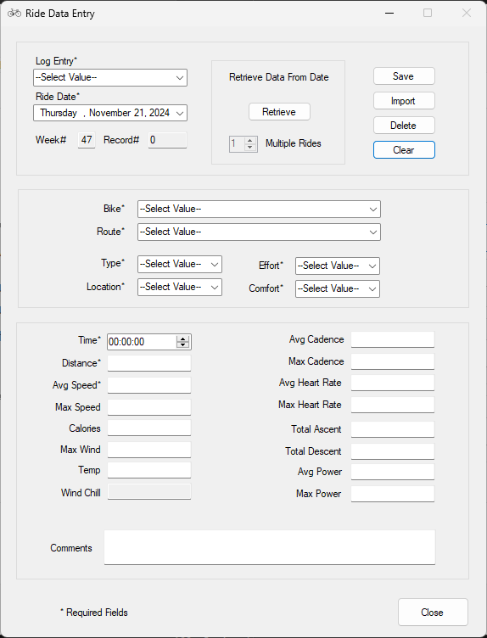

Figure 3 – Ride Data Entry form

## Data Entry Options

### Section 1

#### Log Title

The Log Title field is used to select a Log to submit data to. The drop-down list will contain a list of all the logs that have been created in the application. Any of the logs can be selected to submit data to. If past year log is selected, the Ride Date will start at “01/01/*xx*”.

#### Ride Date

The ‘Ride Date’ field allows changing to any date within the calendar year.

#### Retrieve Data From Date

This option allows to retrieve data for a ride that has already been submitted for a particular date. Select the Ride Date, check the option ‘Retrieve Data From Date’ and then click the Retrieve button. If the date contains data, the form will be populated with its data.

This option is useful with changes need to be make for a ride. Retrieve the data for a ride and then make the necessary changes. When ready, click the Update button.

If a date contains more than 1 ride, the Multiple Rides selector will become active and allow you to move between the rides.

#### Save Button

The Save button will save the data entered in the form into the date selected.

#### Import button

The Import button allows to import data that has been recorded by your Garmin computer. From the Garmin web site, select the ride and then click the gear icon. From that dropdown list, select ‘Export Splits to CSV’. This will download to your downloads folder.

Now click the Import button and select the file just downloaded. This populates the form with data from that ride.

Only one ride’s worth of data can be imported at a time.

#### Delete button

The Delete button allows the option to delete an already submitted ride for a particular ride date. This is useful if you need to remove a ride that has been entered to the wrong date or duplicate ride entered.

To delete a ride, select the ride date for the ride to remove. Then check the ‘Retrieve Data From Date’ checkbox and click the Retrieve button.

#### Clear Button

The ‘Clear’ button will clear and reset all the data that is currently entered in the form.

### Section 2

#### Bike

List of bikes that have been entered into the application.

#### Route

List of common riding routes that have been entered into the application.

#### Type

The ‘Type’ list will contain a list of labels to describe the Type of ride. The list includes the following labels to describe the ride Type.

* Recovery
* Base
* Distance
* Speed
* Race

#### Location

The ‘Location’ list will contain categories to describe where the ride occurred. The list includes the following labels to describe the location of the ride.

* Road
* Rollers
* Trail
* Trainer

#### Effort

The ‘Effort’ list will contain 4 Effort levels to categorize the ride. The list includes the following labels to describe the ride.

* Easy
* Moderate
* Hard
* Race

#### Comfort Level

The ‘Comfort Level’ list will contain 5 levels to categorize how you felt during the ride. The list includes the following labels to describe the ride.

* Weak/Tight
* Average
* Strong

### Section 3

#### Time

The Time field has the time set up as hours, minutes, and seconds (hh:mm:ss).

#### Distance

The Distance field is used to store the distance for the ride.

#### Average Speed

The average miles per hour for the ride will auto calculate if the ridding time and ridding distance value have been entered into the form. The Average Riding Speed can be manually adjusted from 0 up to 30.0 miles per hour average. For average speeds greater than 30 mph, the value must be entered into the textbox instead of using the scrollbar.

#### Max Speed

The maximum speed acquired obtained during the ride

#### Calories

The total calories burned during the ride. This value will depend on the ride weight and effort.

#### Max Wind

#### Temperature

#### Wind Chill

#### Avg Cadence

The Average Cadence is the average cadence calculated for the ride time.

#### Max Cadence

The Maximum Cadence is the maximum value that was measured during the ride.

#### Avg Heart Rate

The Average Heart Rate is the average Heart Rate calculated for the ride time.

#### Max Heart Rate

The Maximum Heart Rate is the maximum value that was set during the ride.

#### Total Ascent

The total positive elevation accumulated during the ride.

#### Total Descent

The total decreasing elevation during the ride.

#### Avg Power

The Average Power field is the average amount of power output delivered during the ride.

#### Max Power

The Maximum Power field is the maximum amount of power output delivered during the ride.

#### Custom 1

This is a custom field that can be used for a unique data point that does not fit in the current fields.

#### Custom 2

This is a custom field that can be used for a unique data point that does not fit in the current fields.

#### Comment Section

The Comment section can contain up to 200 characters including spaces.

#### Close Button

The ‘Close’ button will close the Data Entry Form. All data in the form will be cleared when the ‘Close’ button is clicked.

# Statistics

## Yearly

This tab allows the view of statistically data for each log on a yearly basis.

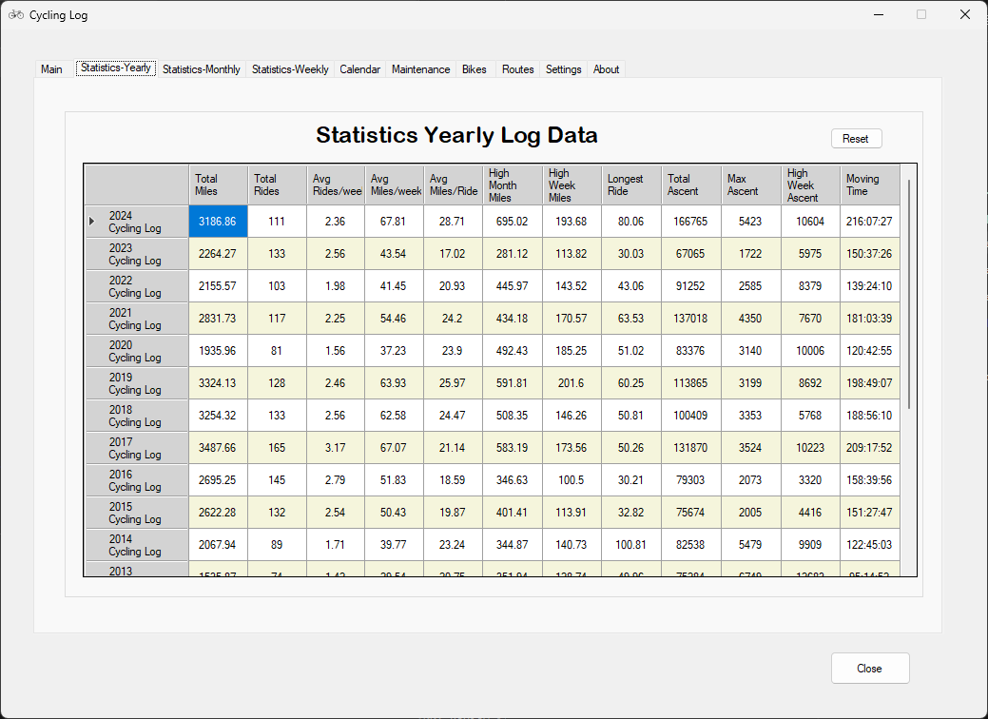

Figure 15 – Yearly Statistics tab

## Monthly

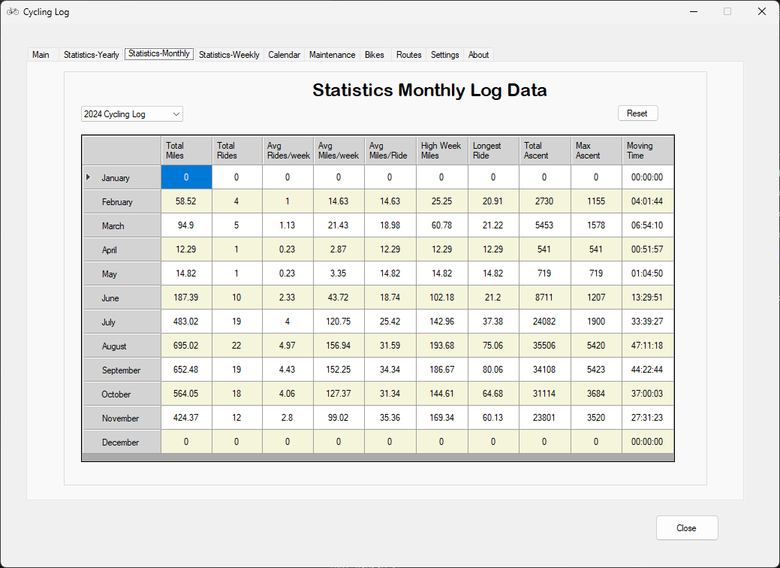

### Yearly Miles

The ‘Yearly Miles” section represents the total miles ridden for the selected log.

### Number of Rides

The ‘Number of Rides” section represents the total number of rides for the selected log.

### Average per Week

The ‘Average per Week’ section represents the average miles ridden up to the current week. For a log that is complete, the total number of miles is divided by 52. If the current week was number 3, then the total miles would be divided by 3 to get the average miles ridden per week.

### Average per Ride

The ‘Average per Ride’ section represents the average miles ridden per ride. The value is represented by the current value for the total miles ridden divided by the number of rides.

### High Week

The ‘High Week’ section represents the date for when the highest weekly ridden miles had occurred.

### Longest Ride

The ‘Longest Ride’ section represents the longest mileage ride that has occurred either for the entire year or up to the current date.

### Change from previous week

The ‘Change from previous week’ section represents a percentage change value in miles ridden. The value is represented by the current week's mileage divided by the previous week’s mileage.

For example, if the current week’s mileage is 50 miles and the previous week was 100, then the percentage value would be a (-50%). This means you are half way to the mileage accumulated from the previous week. A positive value indicates that the current week’s mileage has surpassed the previous week’s mileage. On the other hand, a negative value indicates that you have not yet reached the mileage mark of the previous week.

### Total Miles

The ‘Total Miles’ value is the accumulated miles of all logs that were selected to be included in the ‘Total Miles’ calculation. For more information on ‘Include in Total miles’ refer to Creating a new log section.

### Refresh Button

If any recent data that was entered into the Workbook from the Data Entry form is not being reflected in the Statistics table or the Statistics Worksheet, you can run force a recalculation by clicking the ‘Refresh’ button. This will re-calculate all the statistical data for the current Active log.

## Weekly

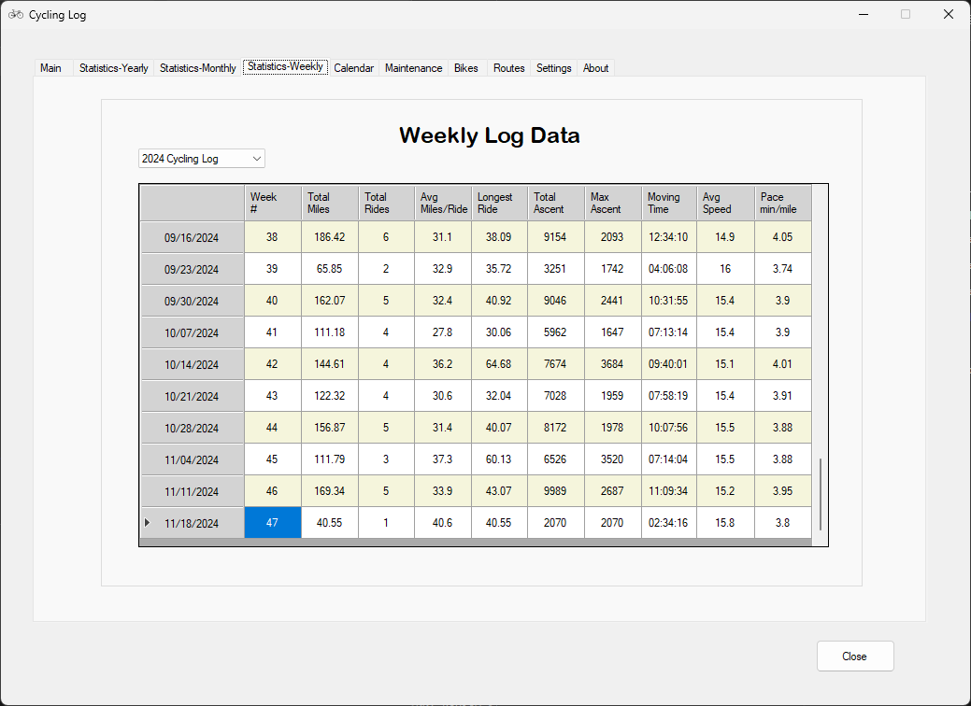

# Calendar

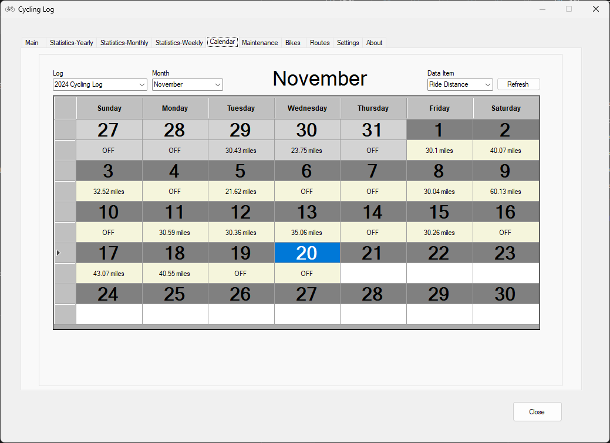

The Calendar view allows to see certain data points from a Calendar perspective.

Data Items available to view:

* Average Power
* Average Speed
* Effort
* Ride Distance
* Moving Time
* Total Ascent
* Wind Chill

# Maintenace

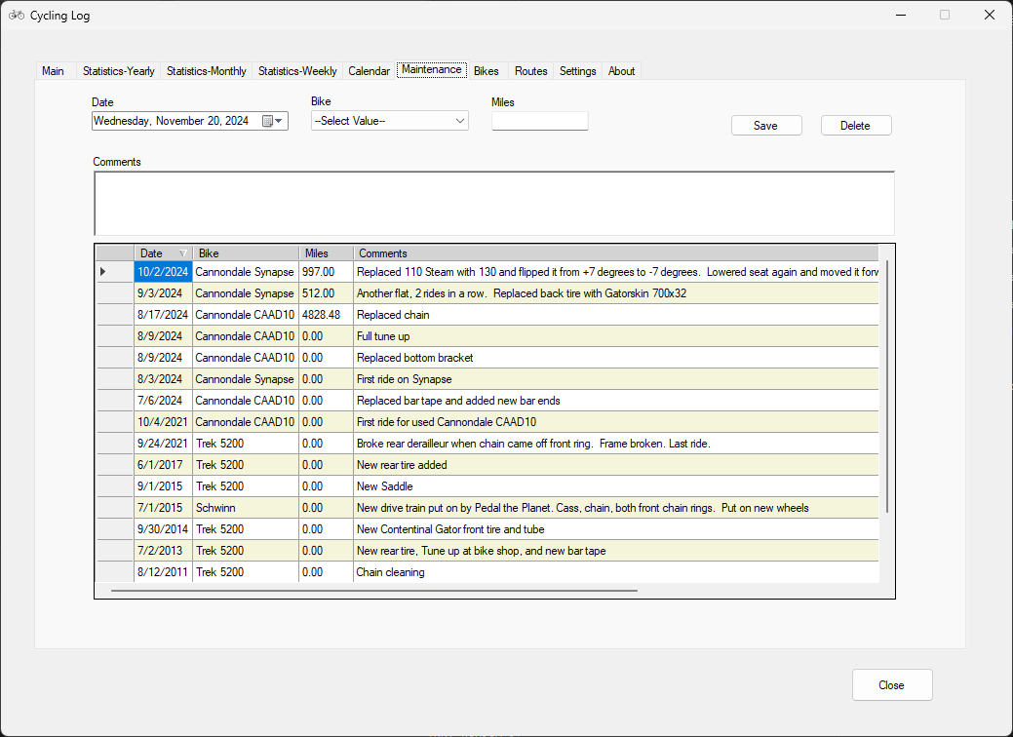

Figure 16- Control Options Data tab

# Bike

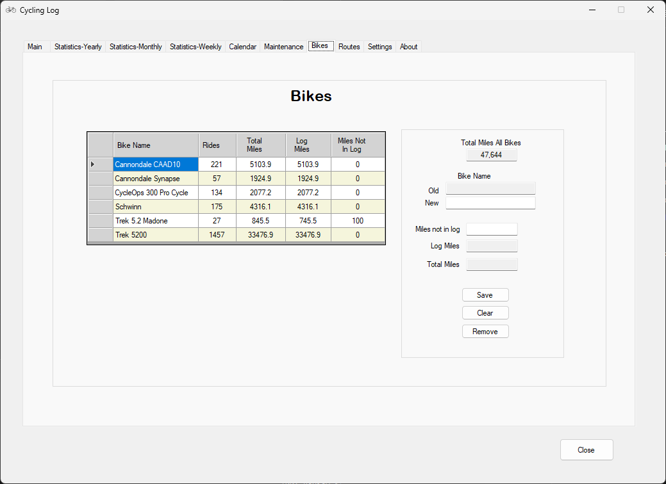

Figure 27 - Control Options - Display and Color tab

# Routes

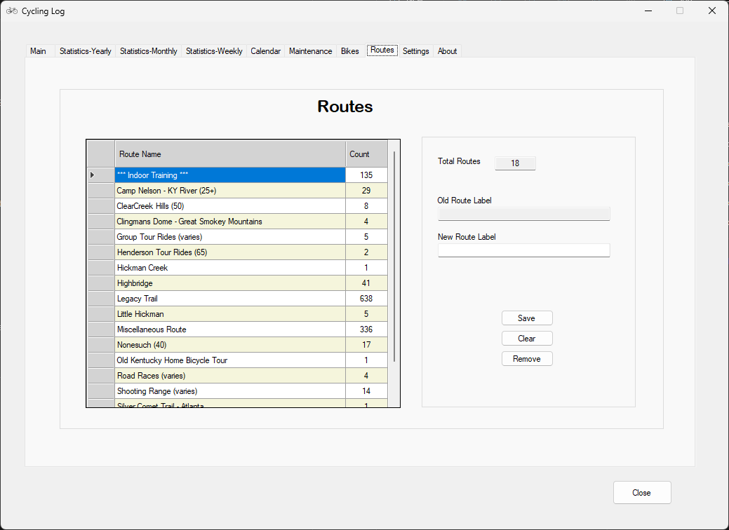

# Settings

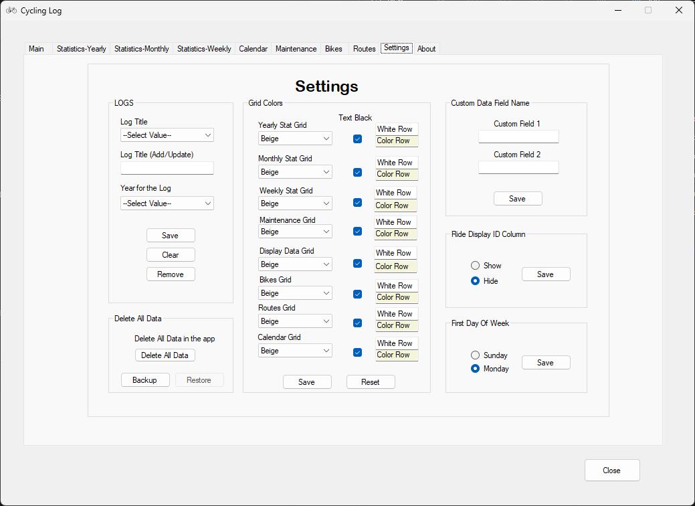

Figure 42 - Control Options Updates tab

Delete All Data

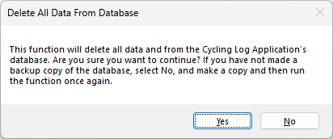

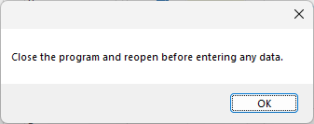

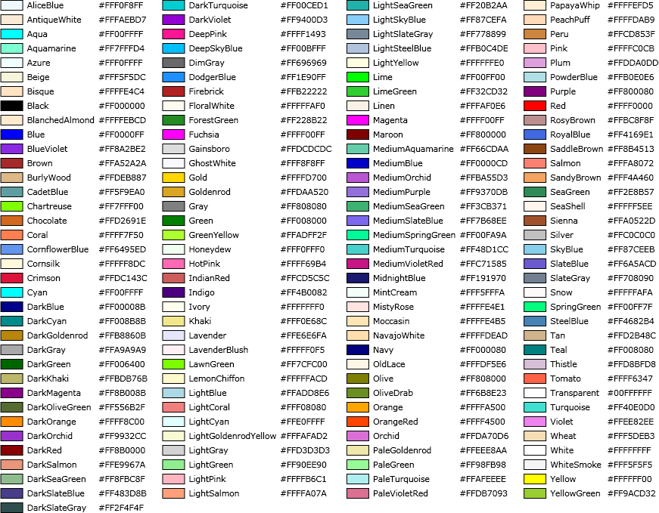

Color Options available for the Grid views:

|  |
| --- |
| AliceBlue |
| AntiqueWhite |
| Aqua |
| Aquamarine |
| Azure |
| Beige |
| Bisque |
| BlanchedAlmond |
| BlueViolet |
| Brown |
| BurlyWood |
| CadetBlue |
| Chartreuse |
| Chocolate |
| Coral |
| CornflowerBlue |
| Cornsilk |
| Crimson |
| Cyan |
| DimGray |
| DodgerBlue |
| Firebrick |
| FloralWhite |
| ForestGreen |
| Fuchsia |
| Gainsboro |
| Gold |
| Goldenrod |
| Gray |
| Green |
| GreenYellow |
| Honeydew |
| HotPink |
| IndianRed |
| Ivory |
| Khaki |
| Lavender |
| LavenderBlush |
| LawnGreen |
| LemonChiffon |
| LightBlue |
| LightCoral |
| LightCyan |
| LightGoldenrodYellow |
| LightGray |
| LightGreen |
| LightPink |
| LightSalmon |
| LightSeaGreen |
| LightSkyBlue |
| LightSlateGray |
| LightSteelBlue |
| LightYellow |
| Lime |
| LimeGreen |
| Linen |
| Magenta |
| MediumAquamarine |
| MediumOrchid |
| MediumPurple |
| MediumSeaGreen |
| MediumSlateBlue |
| MediumSpringGreen |
| MediumTurquoise |
| MintCream |
| MistyRose |
| Moccasin |
| NavajoWhite |
| OldLace |
| Olive |
| OliveDrab |
| Orange |
| OrangeRed |
| Orchid |
| PaleGoldenrod |
| PaleGreen |
| PaleTurquoise |
| PaleVioletRed |
| PapayaWhip |
| PeachPuff |
| Peru |
| Pink |
| Plum |
| PowderBlue |
| Purple |
| Red |
| RosyBrown |
| RoyalBlue |
| SaddleBrown |
| Salmon |
| SandyBrown |
| SeaGreen |
| SeaShell |
| Sienna |
| Silver |
| SkyBlue |
| SlateBlue |
| SlateGray |
| Snow |
| SpringGreen |
| SteelBlue |
| Tan |
| Thistle |
| Tomato |
| Transparent |
| Turquoise |
| Violet |
| Wheat |
| White |
| WhiteSmoke |
| Yellow |
| YellowGreen |

# About

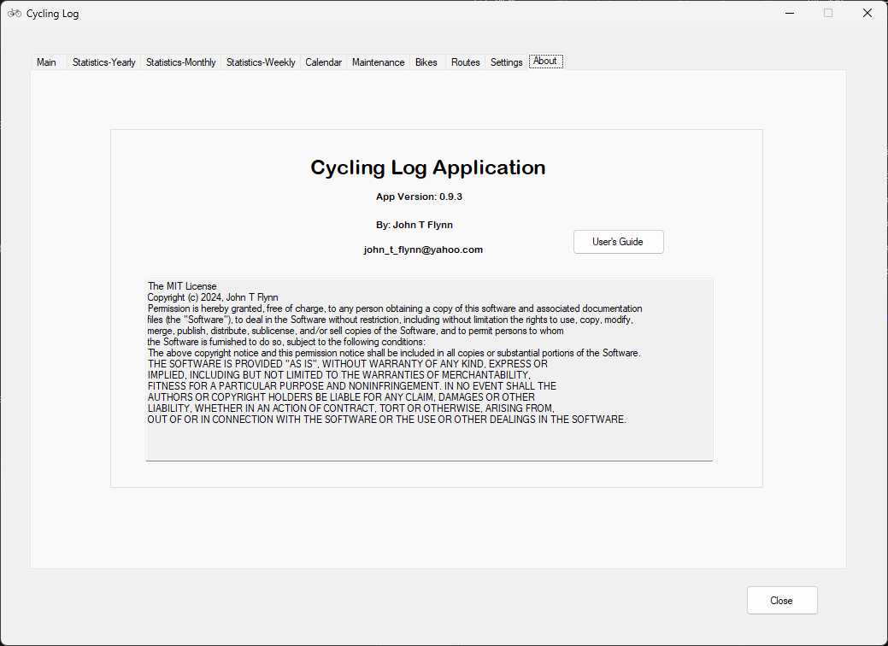

Figure 57 - Control Options Settings tab

# View Ride Data

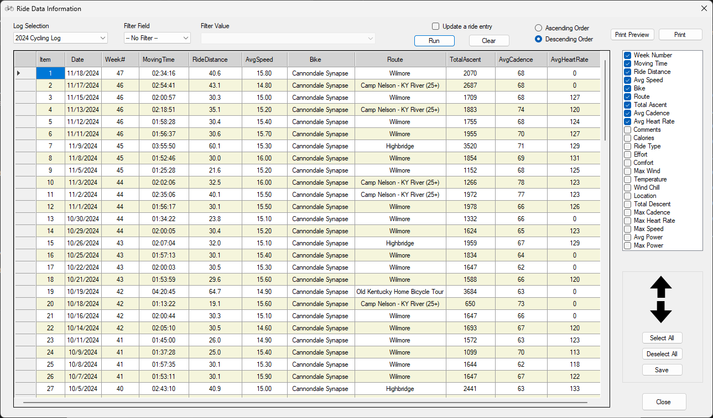

Figure 63 - Log Settings tab

# Planner

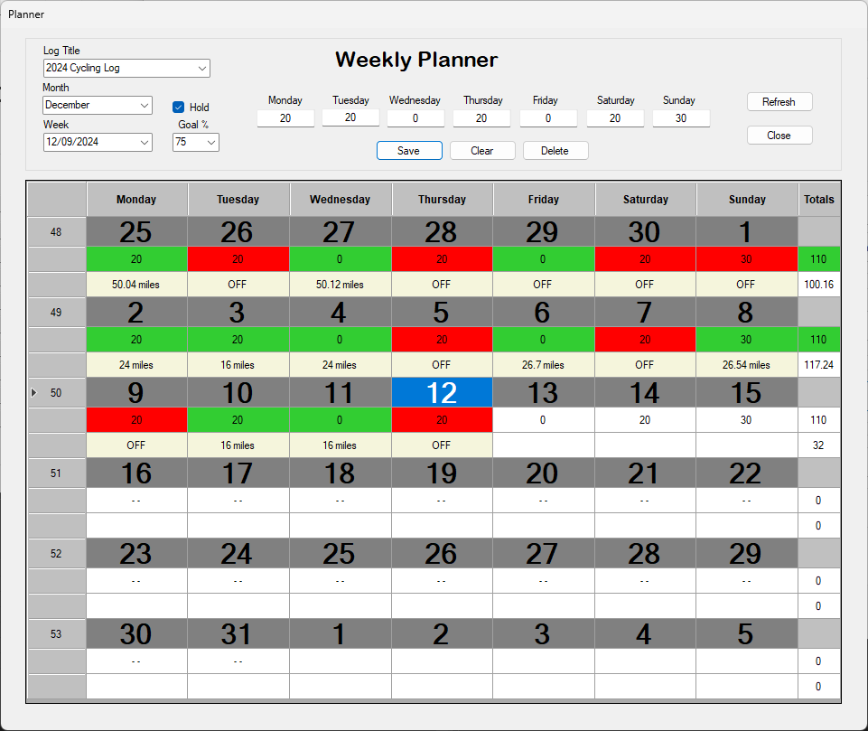

## Hold option

When the Hold option is not checked, and the Week selection is changed to a particular week value, the Weekly Planner values that may have been saved for the selected week will appear in the Week day text boxes. If you then check the Hold option, and change the Week dropdown value to a different week, the values will not get loaded for that week. This allows an easy way to update additional weeks with similar data.

# Charts

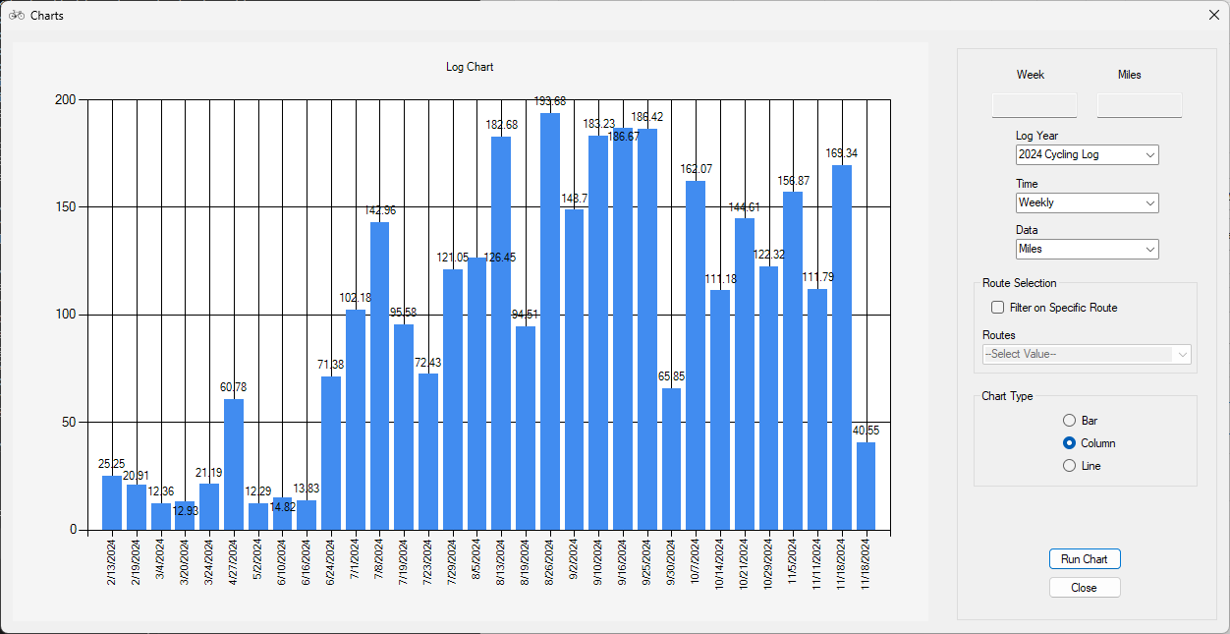

Figure 76 - Chart Options

# How do I …

## How do I setup my very first log?

* Open the Cycling Log Application
* Select the Settings tab
* Enter a label for Bike 1
* Enter any existing known miles that have occurred on the bike that are not included in this log or enter 0.
* Click the Save button
* Now refer to the section below “How do I add a new Log?”

## How do I enter data for a ride?

* Click the Data Entry button on the Main Tab
* Select the log that you need to enter the data into
* Select the correct date
* Complete the form
* Click the Save button

## How do I remove a Ride entry?

* Open the Data Entry Form
* Select the Log Entry Value
* Select the date for the Ride that needs to be removed
* Click the Retrieve button
* Click the Delete button

## How do I switch a Ride entry to a different date?

* Open the Data Entry Form from the Main tab
* Select the Log Title
* Select the date for the Ride to switch
* Click the Retrieve button which will populate the form with data from that ride entry
* Now select the new date that the ride entry needs to be switched.
* Click the Save button

Or

* Open the View Ride Data from the Main tab
* Select the Log Title
* Click Run
* Check the box for ‘Update a ride entry’
* Now click on the ride entry in the grid
* Now select the new date that the ride entry needs to be switched.
* Click the Update button

## How do I clone/copy a ride for another date

* Open the Data Entry Form from the Main tab
* Select the Log Title
* Select the date for the Ride to clone
* Click the Retrieve button which will populate the form with data from that ride entry
* Now select the new date that the ride entry needs to be set to.
* Update any needed changes
* Click the Save button

## How do I add a second entry to the same date?

* Open the Data Entry Form from the Main tab
* Select the date that requires the second or more entry
* Fill the Date Entry Form
* Click the Save button

## How do I remove a duplicate entry?

* Open the Data Entry Form from the Main tab
* Select the Log Title
* Select the date for the Ride
* Click the Delete button

## How do I modify a Ride entry once it has been submitted?

* Open the Data Entry Form from the Main tab
* Select the Log Title
* Select the date for the Ride
* Click the Retrieve button which will populate the form with data from that ride entry
* Now make any needed changes
* Click the Save button
* Or
* Open the View Ride Data from the Main tab
* Select the Log Title
* Click Run
* Check the box for ‘Update a ride entry’
* Now click on the ride entry in the grid
* Now make any needed changes
* Click the Update button