*Note: Check out the cyberbank.sql for data input*

**Tutorial for setting up the ‘cyberbank’ database**

**1. Open up the app XAMPP Control and click on the ‘admin’ for the MySQL.**

**Download link for XAMPP:** [**https://www.apachefriends.org/download.html**](https://www.apachefriends.org/download.html)

**2. On whatever browser you are using. Check the url and if this page that you are on.**

**3. Since cyberbank was already created. The following images are showing the creation process of the database. On your pc name it ‘cyberbank’ and not ‘an_cyberbank’**

**4. Create table ‘transaction’ with five columns and then click ‘go’ when completed.**

**5. Enter the following for the table ‘transaction’**

**6. Make ‘sno’ primary**

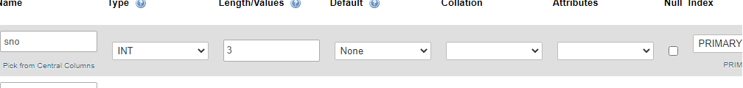

**7. Next step, create another table. And call it ‘users’ and enter these values. And make ‘id’ the primary.**

**You should have something that looks like the following pictures.**

**! This marks the end of the SQL database creation !.**

**Next, will be the tutorial of how an admin would create accounts, transfer money, and observe transaction history between accounts and their times.**

**Note: Before we begin. Check to make sure you have the source code on your MS Visual Studio Code Editor. OTHERWISE IT WILL NOT WORK PROPERLY!.**

**Also, again. Make sure the database you created is named cyberbank**

**Step 1: Make sure this is your source code.**

**Step 2: From the homepage (**[**http://localhost/final_cyberbank/home.php**](http://localhost/final_cyberbank/home.php)**) click on either “Admin Homepage” or “Create Account” to enter the steps following for account creation, money transfer, and transaction.**

**Step 3: In the account creation page enter the information for account page. (**[**http://localhost/final_cyberbank/createuser.php**](http://localhost/final_cyberbank/createuser.php)**)**

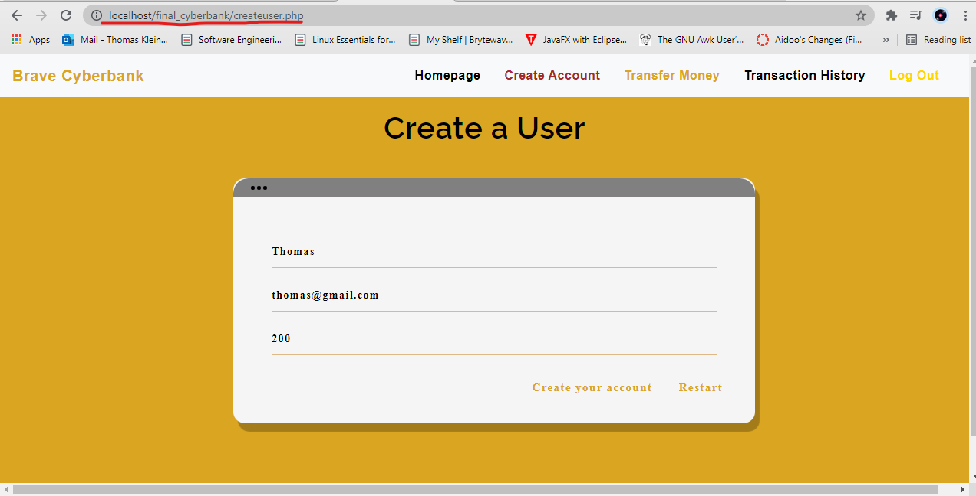

**Step 4: Go to the phpadmin page and change the ‘id’ from 0 to 1 so that new users can be created. (Note: You’ll have to repeat this process repetitively.)**

**Step 5: In the next step, will be a money transfer from account ‘Bradford to ‘Thomas. The whole number 50 will be used as an expression of $50.**

**Below will show the recorded time and amount transferred between accounts.**

**And finally, below will be two screenshots to show both the 50 dollars transferred to ‘Thomas’ account on the phpmyadmin and on (**[**http://localhost/final_cyberbank/transfermoney.php**](http://localhost/final_cyberbank/transfermoney.php)**) as well.**

**Final note: Make sure to run files on localhost as it will only show php code if you run it on C drive or on any local files that are not ‘htdoc’.**