**Grameenphone hackathon**

**Part-2**

**(Category: “Business Analyst”)**

**Name:** Md. Tarek Hasan **Mobile:** 01670974776

**Email:** [tarek.inspire@gmail.com](mailto:tarek.inspire@gmail.com)

1. **High level design of the service flow**

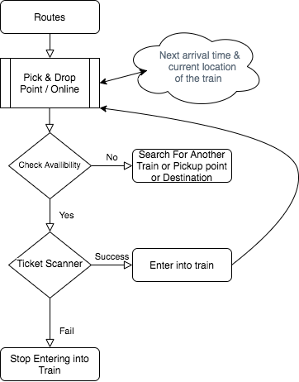

1. **High level architecture of this system**

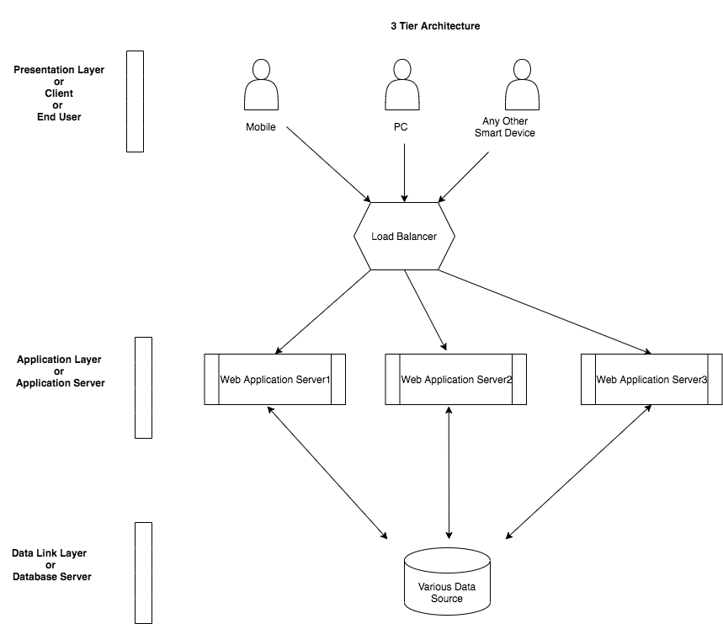

1. **UML diagram**

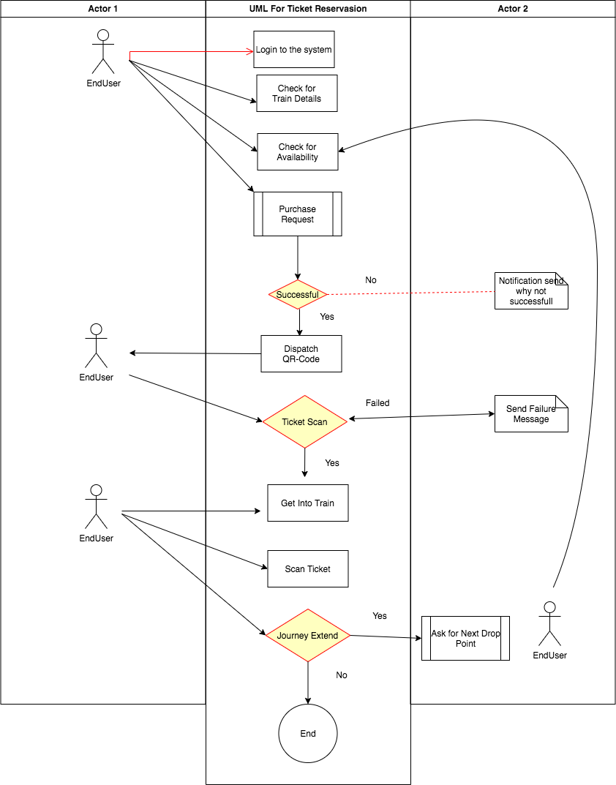

1. **ERD**

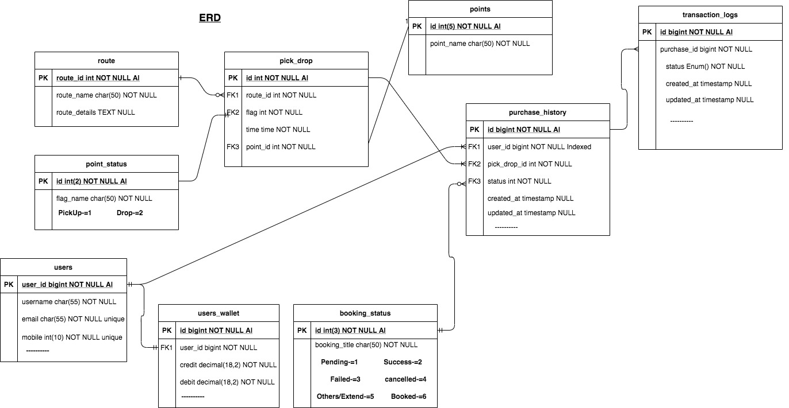

1. **High Level API Designs**

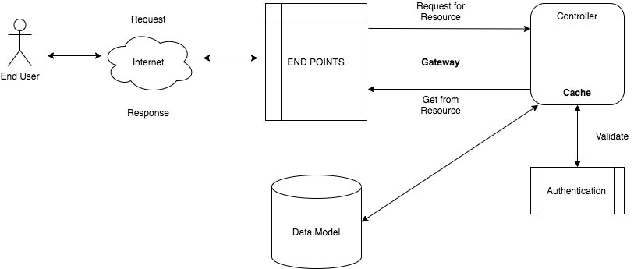

1. **TPS (transaction per second)**:

**Calculation** = user forecast / time range;

App Login = 100k per day 86400 seconds in a day

1.16 transactions per second

Booking = 80k per day

0.93 transactions per second

Purchase = 50k per day

0.58 transactions per second

Complete Journey = 25k per day

0.3 transactions per second

**Infrastructure:**

Get transaction per second by approx. user request in a given range (Above Example)

Get TMM Count

TPS (of full server system) = (TMM * TPS)

0 - - - - - - - 5 - - - - - - - 10ms

if transaction come in between after 5 and failed then we will take a log & regenerate the transaction (while limit exceed of TPS)

#### Need to Calculate Bandwidth

#### Estimate Peak Load

Using JMeter we can in in detail

Scale Database, use sharding technology & use License product to enhance TPS.

Highly Parallel Loosely Coupled

Ensure that multiple processing complexes remained synchronized in real-time.