Quick Guide to the M710 Control Program.

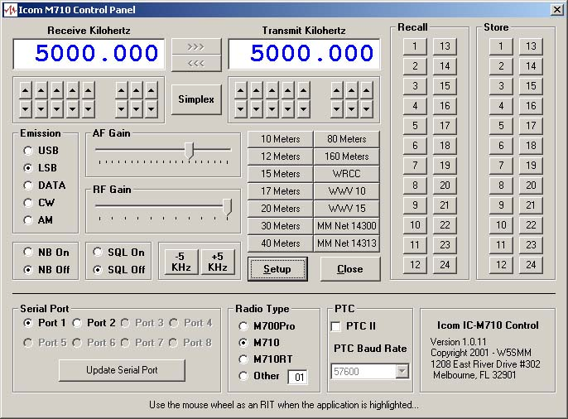

M710 control program is an easy to use program that makes using your ICOM HF-SSB Marine radio as convenient as using a Ham radio. Its supports the ICOM M700Pro, M710 and M710RT HF, SSB Marine radios.

The radio may be directly connected to the computer via an RS232 port or through the SCS PTC II or PTC II Pro modem control port used by your HF E-Mail program. “Same connection as used by AirMail 2000”. (The connection via the PTC II control port is not available on the PTC IIe modem).

Installation of Program:

Unzip the program it in a directory on your computer and run “setup.exe”. This will install all the files needed to run the program.

Program Notes:

This program was written by Vic Poor, W5SMM and Tom Lafleur, KA6IQA in Microsoft Visual Basic Version 6.0.

Radio setup:

Direct connection to the Radio:

The radio may be connected via a special NMEA, RS-232 cable direct to the radio. ‘Warning: the M700Pro and M710 require a special NMEA cable. (See drawing on last page of the document)’
The M710RT uses a standard 9-pin RS-232 connector on the front of the transceiver as well as the special NMEA connection on the rear.

Communication with the radio is via NMEA command at 4800 baud, 8 bits and no parity.

Radio Connection:

M700Pro DB9 for NMEA
M710 DB9 for NMEA
M710RT Jxx for RS-232 and Jxx for NMEA

Connection via an SCS PTC II or PTC IIPro HF-Modem:

The computer is connected with a standard RS-232, 9-pin cable to the RS-232 connection on the back of the PTC II modem. The radio is connected to the modem with a special cable from the modem’s 8-pin HF transceiver control port to the 1/8-inch “Clone Jack” on the radio. (See drawing on last page of the document)’

Setup Button:

Selecting the Setup button will expand the window to allow you to configure the serial port and other communication parameters for the radio. The program allows selection of serial ports 1 to 8. Only ports that are available on your computer will be highlighted.

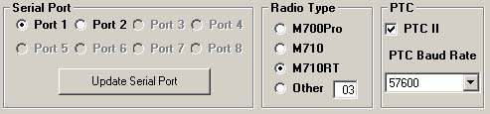
- Use the Serial Port box above to select the Serial Port that is connected to you radio or PTC II modem.
- Select Radio Type. The NMEA address is pre-selected for the listed models.
- PTC II, check this if radio is connected via a PTC II modem and set the Modem’s Baud-Rate.
- Then, select “Update Serial Port” to make the changes.
- Close the Setup Window, by clicking on the Setup button again.

Receive and Transmit Window:

This window will allow you to set the Receive and Transmit Frequency’s for the Radio.

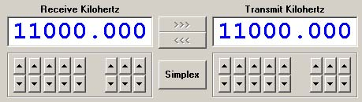

Simplex button allows selection of Simplex (Same TX and RX frequency) or Duplex mode. (Difference TX and RX frequency)
The >>> and <<< buttons allow moving the frequency selected from one window to the other.
The UP and DOWN arrows allow you to change individual digits in the frequency select window.

If you have a mouse with a wheel, you can use the wheel as an RIT frequency control when the application is highlighted. It will change the Receive frequency in 10Hz steps.

Band Select Window:

This window is a quick Ham band selector. Click on any button to change the radio to the correct band. It will also allow a selection of a few pre-programmed commonly used Ham maritime frequencies and time of day reference stations.

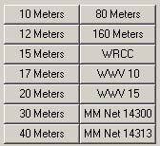

Mode Select Window:

Allow you to select the basic operating controls and emission of the radio.

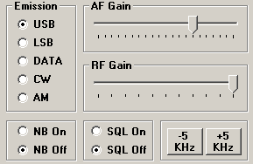

Emission, selects the mode for the radio.
NB, enables the noise blanker.
SQL, enables the squelch.
AF Gain, select the volume. (Use the mouse to slide it)
RF Gain, selects the RF AGC gain of the radio. (Use the mouse to slide it)
+-5 KHz, changes the received frequency by + or - 5 KHz.

Recall-Save Window:

This buttons allow you to save and recall 24 of your favorite, Transmit, Receive frequency along with their current Mode, Volume, AGC, NB and SQL setting. If you hold the mouse cursor over a Recall or Save button for a few seconds, the current value saved will be displayed.
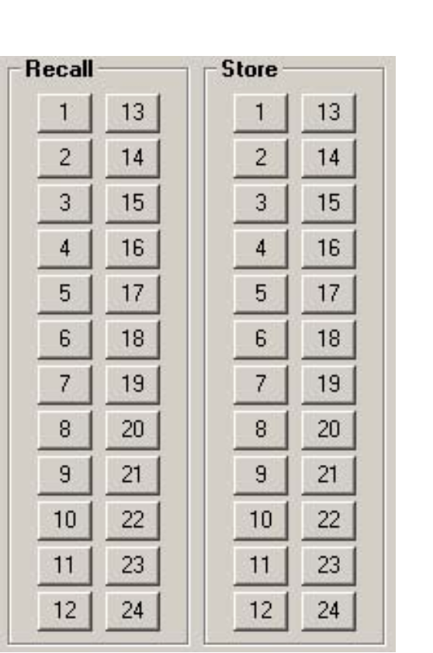

Special NMEA Serial Cable:

The cable is a DB-9F on computer end and a DB-9M on the radio end. On the computer side pins 8 and 7 and pins 1, 4 and 6 are connected together. Pin 5 (ground) on the Computer is connected to pins 6,8 and 9 on the radio. Pin 2 (RxD) on the computer is connected to pin 7 (NMEA-Out-+) on the radio. Pin 3 (TxD) on the computer is connected to pin 5 (NMEA-In +) on the radio.

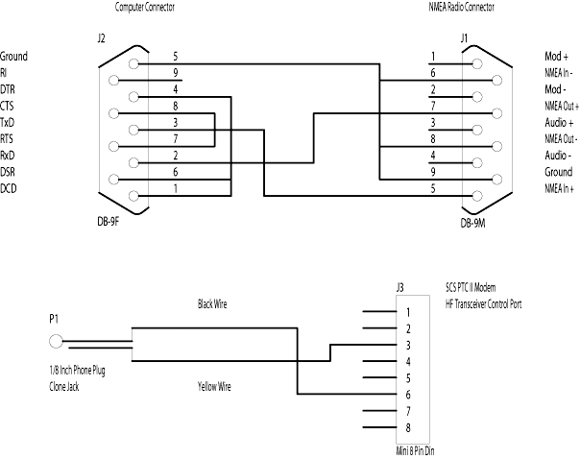

PTC II cable information:

The cable comes pre-wired from SCS with a miniature 8-Pin DIN plug on one end. On the open end, cut all but the black and yellow wires. Tape all of the extra wires back and insure that they do not touch!! The Black wire goes to the TIP (Center pin) of a standard 1/8-inch 2 wire plug and the Yellow wire goes to the RING, (The outside or ground pin).

Pin 3 is Ground. (Yellow Wire)
Pin 6 is CI-V control for ICOM. (Black Wire)

More information on wiring option for ICOM Marine radios and the SCS PTC II modems can be found at Farallon Electronics web site at: http://www.yachtwire.com/.

