GENERAL CONFEDERATION OF LABOR OF VIETNAM

**TON DUC THANG UNIVERSITY**

**FACULTY OF INFORMATION TECHNOLOGY**



**SOFTWARE ENGINEERING**

**BUILDING COMPANY SELLING FUNCTIONAL FACTS MANAGEMENT**

*Instructing Lecturer*: **Mr Phạm Thái Kỳ Trung**

*Student’s name*: **Phạm Minh An – 518H0591**

**Trần Hoàng Long – 518H0105**

Class **: 18H50301**

Course  **: 22**

**HO CHI MINH CITY, YEAR 2022**

GENERAL CONFEDERATION OF LABOR OF VIETNAM

**TON DUC THANG UNIVERSITY**

**FACULTY OF INFORMATION TECHNOLOGY**



**SOFTWARE ENGINEERING**

**BUILDING COMPANY SELLING FUNCTIONAL FACTS MANAGEMENT**

Instructor Lecturer: **Mr Pham Thai Ky Trung**

Student’s name: **Phạm Minh An - 518H0591**

**Trần Hoàng Long - 518H0105**

Class **: 18H50301**

Course  **: 22**

**HO CHI MINH CITY, YEAR 2022**

**ACKNOWLEDGEMENT**

In order to make this report complete and achieve good results, we would like to express our sincere gratitude to the leadership of Ton Duc Thang University for supporting, helping and facilitating us to complete the report well during the study period and especially thanks for the conscientious guidance and assistance of Mr. Pham Thai Ky Trung over the past time. Completely thank for having received the support and assistance of many teachers and classmates. With limited time and experience, this report cannot avoid mistakes. We are looking forward to receiving advice and comments from teachers so that we can improve our awareness, better serve the practical work later.

We sincerely thank you

**THIS PROJECT WAS ACCOMPLISHED AT TON DUC THANG UNIVERSITY**

I commit that this product belong to us with the guardian of Mr. Pham Thai Ky

Trung. The content of research, result of this project is honest and has not been published in any form before. The data in the tables for analysis, comment and evaluation were collected by the author from various sources in the reference section.

Besides, our project used many kinds of comments, assessments as well as data

from other authors, organizations. This project has original quotes and annotations.

**If any fraud is detected, I will take full responsibility for the contents of my**

**project.** Ton Duc Thang University is not involved in any violations of copyright and copyright caused by me during implementation (if any).

*Ho Chi Minh City, May 24th 2022*

*Author*

*(Sign and write full name)*

*Phạm Minh An*

*Tran Hoang Long*

**EVALUATION AND INSTRUCTION LECTURER**

**Confirmation of the teacher instructor**

_________________________________________________________

_________________________________________________________

_________________________________________________________

_________________________________________________________

_________________________________________________________

_________________________________________________________

_________________________________________________________

Ho Chi Minh City, May 24th 2022

(Sign and write full name)

**The assessment of the teacher marked**

_________________________________________________________

_________________________________________________________

_________________________________________________________

_________________________________________________________

_________________________________________________________

_________________________________________________________

_________________________________________________________

Ho Chi Minh City, May 24th 2022

(Sign and write full name)

**CONTENTS**

ACKNOWLEDGEMENT i

THIS PROJECT WAS ACCOMPLISHED AT TON DUC THANG UNIVERSITY ii

EVALUATION AND INSTRUCTION LECTURER iii

CONTENTS 1

LIST OF TABLES AND FIGURE 3

I – INTRODUCTION 5

1.1 Purpose and Scope 5

1.2 Product overview 5

1.3 Structures of the Document 6

1.4 Terms, Acronyms and Abbreviations 6

II – PROJECT MANAGEMENT PLAN 6

2.1 Project Organization 6

2.2 Lifecycle Model Used 7

2.4 Hardware and Software Resource Requirements 8

2.5 Impact of the project on individuals and organizations 8

2.6 PROFESSIONAL STANDARDS 8

III – REQUIREMENT SPECIFICATIONS 9

3.1 Stakeholders for the system 9

3.2 Use case model 10

3.3.1 Graphical use case model 10

3.3.2 Textual Description for each use case 10

3.3 Functional requirements & Non-functional requirements 15

IV-ARCHITECTURE 15

4.1 Architectural styles used 15

4.2 Architectural model 16

V - DESIGN 16

5.1 GUI 16

5.1.1 Winform 16

5.1.2 Webform 27

5.2 Static model – class diagrams 31

5.3 Dynamic model – Sequence diagrams 32

5.3.1 Goods Received Sequence diagram 32

5.3.2 Goods Delivery Note Sequence diagram 33

5.3.3 Order Sequence diagram 34

5.3.4 Statistics Sequence diagram 35

VI – TEST PLAN 35

6.1 Requirements/specifications-based system level test cases 35

6.2 Traceability of test cases to use cases 35

6.3 Techniques used for test generation 35

6.4 Assessment of the goodness of your testsuite 35

VII – DEMO 36

7.1 Database 36

7.2 Source code 42

7.3 Testing 43

VIII – REFERENCES 43

8.1 Slides: 43

8.2 Internet link : 43

**LIST OF TABLES AND FIGURE**

**TABLES:**

Table 3.1: Use Case Login Specification 12

Table 3.2: Use Case Statistics Specification 12

Table 3.3: Use Case Order Specification 12

Table 3.4: Use Case Good Received Specification 13

Table 3.5: Use Case Good Delivery Note Specification 13

Table 3.6: Use Case Revenue Report Specification 13

Table 3.7: Use Case Stock Report Specification 14

Table 3.8: Use Case Add Specification 14

Table 3.9: Use Case Update Delivery Status Specification 15

Table 3.10: Use Case Update Payment Status Specification 15

Table 3. 11: Use Case Add to Cart Specification 15

Table 3.12: Requirements table 16

**FIGURE:**

Figure 2.1: Organization chart 6

Figure 2.2: Lifecycle Model 7

Figure 3.1: Use Case Model 10

Figure 4.1: 3 Layer Architecture 16

Figure 5.1: Login form 17

Figure 5.2: MainPage Account 18

Figure 5.3: Import form 19

Figure 5.4: View before print import note 20

Figure 5.5: Export form 21

Figure 5.6: Export bill 22

Figure 5.7: View before delivery note 23

Figure 5.8: Import Bill 24

Figure 5.9: Delivery Bill 25

Figure 5.10: Incoming and Spending Statistics form 26

Figure 5.11: Statistics of products form 27

Figure 5.12: Login Page 28

Figure 5.13: Account’s Info Page 28

Figure 5.14: Create Order Page 29

Figure 5.15: Order Status Page (Unprocess Order) 30

Figure 5.16: Order Status Page (On Shipped Order) 30

Figure 5.17: Order Status Page (History Order) 31

Figure 5.18: Class Diagram 32

Figure 5.19: Good Received Sequence Diagram 33

Figure 5.20: Goods Delivery Sequence Diagram 34

Figure 5.21: Order Sequence Diagram 35

Figure 5.22: Statistics Sequence Diagram 36

Figure 7.1: TaiKhoan Data 37

Figure 7.2: PhieuXuatKho Data 38

Figure 7.3: PhieuNhapKho Data 39

Figure 7.4: PhieuDatHang Data 40

Figure 7.5: HangHoa Data 41

Figure 7.6: DanhSachDatHang Data 42

Figure 7.7: Source Code 43

**I – INTRODUCTION**

* 1. **Purpose and Scope**

The system is built on a user-friendly environment, helping users get used to the first time they interact with the system. At the same time, the system provides absolute trust with exact information consumers need.

The management system needs to strictly comply with the requirements set out to ensure business purposes and moreover is the interests of customers.

For the purpose of ensuring optimization requirements in sales and meet the following requirements functional :

- Comprehensive management for agents and companies.

- Business exchange management.

- Payment management.

- System management.

* 1. **Product overview**

A company selling functional facts to agents needs software with the following main functions:

* Accountants shall be able to create Goods Received when the company imports goods (a warehouse receipt will include many items)
* Agents shall be able to place an order of items and choose a payment method (Cash, bank transfer, Momo...) (Webform)
* Accountants shall be able to create Goods Delivery Note to deliver goods to agents (print delivery slips), update the status of orders as being transferred and update the payment status of agents.
* Accountants shall be able to view incoming/outgoing stock reports and revenue reports monthly.

Scenarios for using the product : The main objects of use are companies that export goods in large quantities to distribute to retailers. This software helps companies manage incoming and outgoing goods and monthly revenue, and agents can easily place orders through the software in a convenient way.

* 1. **Structures of the Document**

This report has 7 main part :

* Introduction
* Project management plan
* Requirement specifications
* Architecture
* Design
* Test plan
* Demo

**1.4 Terms, Acronyms and Abbreviations**

**II – PROJECT MANAGEMENT PLAN**

**2.1 Project Organization**

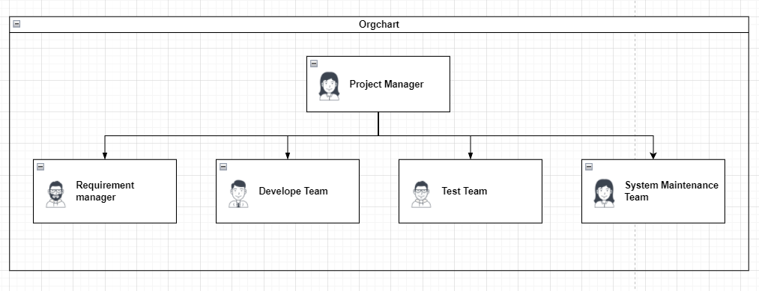

Figure 2.1: Organization chart

The team involved in project :

* Requirement manager: collect requirements from customers, analyze and plan to implement the project.
* Development team: build the system (coding) according to the implemented plan.
* Test team: check the defects of the product created by the development team.
* System maintenance team: periodical product warranty, in order to help the product use long-term.

**2.2 Lifecycle Model Used**

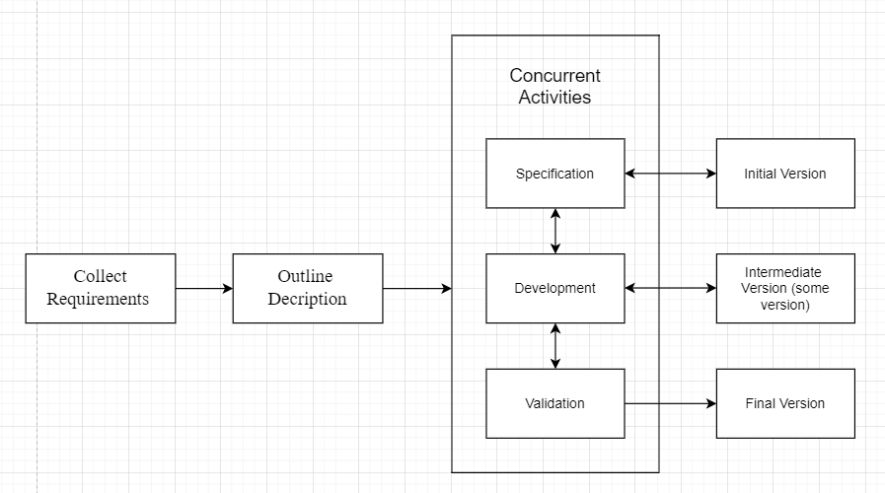

Figure 2.2: Lifecycle Model

This project is implemented following the incremental model.

First, we need to collect the customer's requirements, then create an outline for the project. Next we will do the loop: specification 🡪 development 🡪 validation . This work will result in many different incomplete versions. Continue until the validation is successful and the final version is released (the most complete version).

**2.4 Hardware and Software Resource Requirements**

In order for the development team can build this software, the equipments which they needs to have includes :

Hardware : Computer ( PC or laptop).

Software :

* Windows OS, Microsoft SQL Server Management Studio 18 (to edit database), Visual Studio 2019 to code.
* Diagramming tools : Online : draw.io : <https://app.diagrams.net/>

Visual Paradigm online: https://online.visual-paradigm.com/app/diagrams/

Software : Visio

**2.5 Impact of the project on individuals and organizations**

Management software helps a lot for accountants, agents and product distribution companies.

Accountant :

* Easier to control invoices (Goods received, Goods delivery Note)
* Updating goods figures (shipping status, payment status)

Agency:

* Easy to order
* Choose a form of payment

Company :

* Control the source of goods in/out
* Control monthly revenue, thereby making reasonable business policies.

**2.6 PROFESSIONAL STANDARDS**

During the working process, the team members exchanged cheerfully, followed the plan on schedule (not late for the deadline). The sense of responsibility of the members is pretty good.

**III – REQUIREMENT SPECIFICATIONS**

**3.1 Stakeholders for the system**

**Agency:** they are one of the system's primary interactors, who are involved in product purchases, review, and interactions with the company through the system.

**Accountant:** they are one of the system's primary interactors, they are responsible for the import/export of the company. Also the person who monitors the delivery and payment status for the order to the agent. In addition, they also have to make a report on revenue and quantity of goods incoming/outgoing every month to the company’s manager.

**System :** is the interaction environment between the agent and company. Here, the system acts as a bridge for payments, order management, sales data management,… In order to ensure benefits for consumers as well as company owners.

**3.2 Use case model**

***3.3.1 Graphical use case model***

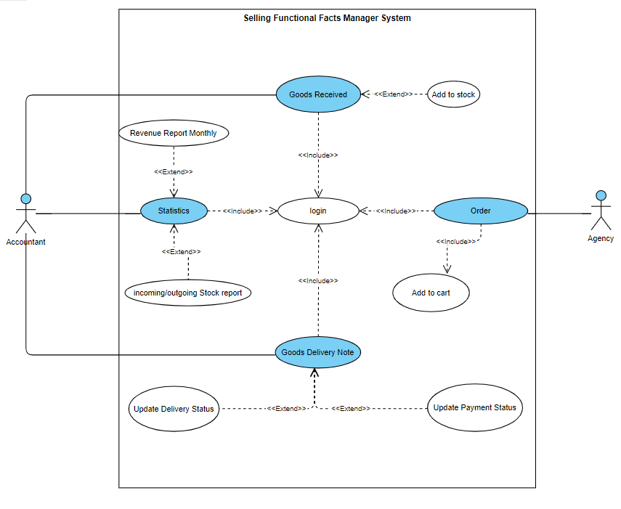

Figure 3.1: Use Case Model

***3.3.2 Textual Description for each use case***

| Use Case Name | Login | |
| --- | --- | --- |
| Participating Actors | Agency, Accountant. | |
| Entry Condition(s) | Users must have an account and password. | |
| Normal Flow of Events | Actor | System |
| 1, User enters account and password. | 1, System checks account information and password information. |
| Exit Condition(s) | Click “Exit” button. | |
| Exceptions (Alternate Flow of Events) | If you enter the wrong account or password, request to retype. | |

Table 3.1: Use Case Login Specification

| Use Case Name | Statistics | |
| --- | --- | --- |
| Participating Actors | Accountant. | |
| Entry Condition(s) | Accountant must login successful. | |
| Normal Flow of Events | Actor | System |
| 1, Accountant clicks “Statistics” | 1, The system displays “Stock Statistics” and “Revenue Statistics” |
| Exit Condition(s) | Click “Logout” button | |
| Exceptions (Alternate Flow of Events) |  | |

Table 3.2: Use Case Statistics Specification

| Use Case Name | Order | |
| --- | --- | --- |
| Participating Actors | Agency. | |
| Entry Condition(s) | Agency must login successful. | |
| Normal Flow of Events | Actor | System |
|  | The system will display the agent's order information. |
| Exit Condition(s) | Click “Logout” button | |
| Exceptions (Alternate Flow of Events) |  | |

Table 3.3: Use Case Order Specification

| Use Case Name | Good Received | |
| --- | --- | --- |
| Participating Actors | Accountant | |
| Entry Condition(s) | Accountant must login successful and click “Import”. | |
| Normal Flow of Events | Actor | System |
|  | The system displays item information. |
| Exit Condition(s) | Click “Logout” button | |
| Exceptions (Alternate Flow of Events) | If the Accountant does not enter the quantity, the system will not show the information of the item added to the inventory. | |

Table 3.4: Use Case Good Received Specification

| Use Case Name | Good Delivery Note | |
| --- | --- | --- |
| Participating Actors | Accountant | |
| Entry Condition(s) | User must login successful. | |
| Normal Flow of Events | Actor | System |
| Accountant clicks “Export” | The system displays the information of the orders in the statuses (not shipped, shipped, paid) |
| Exit Condition(s) | Click “Logout” button | |
| Exceptions (Alternate Flow of Events) |  | |

Table 3.5: Use Case Good Delivery Note Specification

| Use Case Name | Revenue Report | |
| --- | --- | --- |
| Participating Actors | Accountant | |
| Entry Condition(s) | Accountant Click on “Revenue Statistics” | |
| Normal Flow of Events | Actor | System |
| 1,Accountant clicks to select month and year.  2, Accountant click “totals statistics” | 1, The system shows the revenue of each order.  2, The system displays the total revenue of the selected month. |
| Exit Condition(s) | Click “Back” button | |
| Exceptions (Alternate Flow of Events) | If the user does not select the month or year, the system will show the revenue of all months/years. | |

Table 3.6: Use Case Revenue Report Specification

| Use Case Name | Stock Report | |
| --- | --- | --- |
| Participating Actors | Accountant | |
| Entry Condition(s) | Người dùng bấm vào thống kê hàng hóa | |
| Normal Flow of Events | Actor | System |
| 1,Accountant clicks to select month and year. | 1, The system shows the incoming/outgoing of products in stock in this month and year . |
| Exit Condition(s) | Click “Back” button | |
| Exceptions (Alternate Flow of Events) | If the user does not select the month or year, the system will show the stock of all months/years. | |

Table 3.7: Use Case Stock Report Specification

| Use Case Name | Add to stock | |
| --- | --- | --- |
| Participating Actors | Accountant | |
| Entry Condition(s) | Accountant chooses the product. | |
| Normal Flow of Events | Actor | System |
| 1, Accountant selects the item to add and edit the quantity.  2, Press the “Update” button. | 1, The system will add to the database.  2, The system displays item information. |
| Exit Condition(s) | Click “Back” button | |
| Exceptions (Alternate Flow of Events) | If the user does not enter the quantity (the quantity is 0), the system will not show the “update” button | |

Table 3.8: Use Case Add Specification

| Use Case Name | Update Delivery Status | |
| --- | --- | --- |
| Participating Actors | Accountant | |
| Entry Condition(s) | The accountant selects the order that is waiting for approval. | |
| Normal Flow of Events | Actor | System |
| 1, The user selects an unapproved order.  2,Press “Export”. | 1, The system displays the information of the order.  2,Transfer the order to the shipped zone. |
| Exit Condition(s) | Click “Back” button | |
| Exceptions (Alternate Flow of Events) | If the user does not select the order, the system will not show the “Export” button. | |

Table 3.9: Use Case Update Delivery Status Specification

| Use Case Name | Update Payment Status | |
| --- | --- | --- |
| Participating Actors | Accountant | |
| Entry Condition(s) | The accountant selects the order that shipped. | |
| Normal Flow of Events | Actor | System |
| 1, Accountant selects an shipped order.  2,Press “Export”. | 1, The system displays the information of the order.  2,Transfer the order to the paid zone. |
| Exit Condition(s) | Click “Back” button | |
| Exceptions (Alternate Flow of Events) | If the user does not select the order, the system will not show the “Export” button. | |

Table 3.10: Use Case Update Payment Status Specification

| Use Case Name | Add to cart | |
| --- | --- | --- |
| Participating Actors | Agency | |
| Entry Condition(s) | Angeny clicks “New Order”. | |
| Normal Flow of Events | Actor | System |
| 1, Agents choose products, enter quantity, choose payment method (momo, banking).  2, Press “Order” | 1, System added to database.  2, The system displays order information. |
| Exit Condition(s) | Click “Back” button | |
| Exceptions (Alternate Flow of Events) | If the agent does not enter the salary amount, or choose a payment method, the system will not display the "order" button. | |

Table 3.11: Use Case Add to Cart Specification

**3.3 Functional requirements & Non-functional requirements**

| Requirement | Functional | Non-functional |
| --- | --- | --- |
| Friendly system, easy to use. |  | x |
| Location of button, input text are placed logically. |  | x |
| The system must allow agents to choose products. | x |  |
| The system must allow agents to choose payment methods. | x |  |
| The system can assign rights to users when using. | x |  |
| The system must allow managers to manage products (add, edit, delete). | x |  |
| The system must allow accountants to make statistics and printit. | x |  |
| The system must allow accountant to update delivery status and payment status | x |  |

Table 3.12: Requirements table

**IV-ARCHITECTURE**

**4.1 Architectural styles used**

The architectural model of the system used is the 3 Layers model.

This approach helps define a structured solution that meets all technical and operational requirements, while optimizing common quality attributes such as performance, security, and manageability.

**4.2 Architectural model**

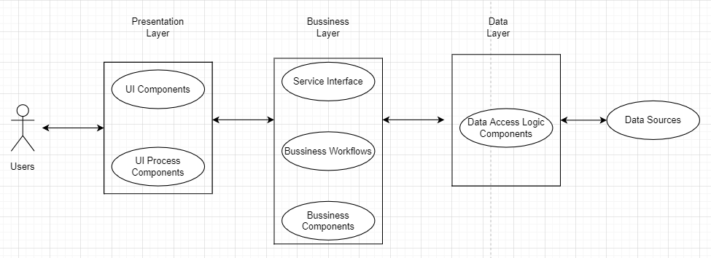

Figure 4.1: 3 Layers Architecture

**Presentation Layer (GUI):**

* UI Components: includes the components that make up the application's interface (GUI). They are responsible for acquiring and displaying data to the user… For example: textbox, button, combobox, etc.
* UI Process Components: is the component responsible for managing the transitions between UIs… Example: Arrange the process of checking customer information:

**Business Layer (BLL):**

* Service Interface : is a component of the programming interface that this class provides for the Presentation class to use.
* Business Workflows: responsible for defining and coordinating multi-step and lengthy business processes. These processes must be arranged and carried out in the correct order.
* Business Components: responsible for checking business rules, logical constraints, and performing jobs. These components also implement the services that the Service Interface provides, and the Business Workflows will use it.

**Data Layer (DAL):**

* Data Access Logic Components: is mainly responsible for storing and retrieving data from data sources (Data Sources).

**V - DESIGN**

* 1. **GUI**

***5.1.1 Winform***

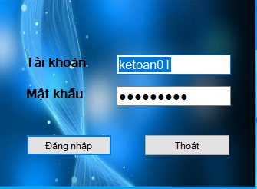

Figure 5.1: Login form

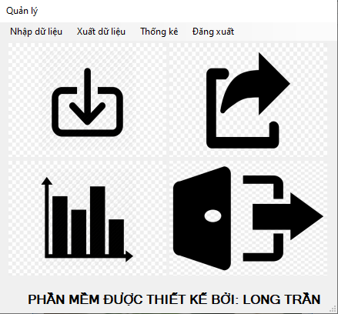

Figure 5.2: MainPage Account

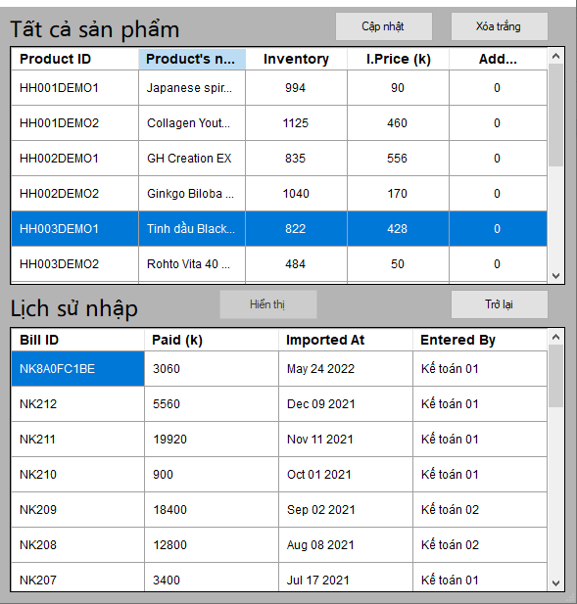

Figure 5.3: Import form

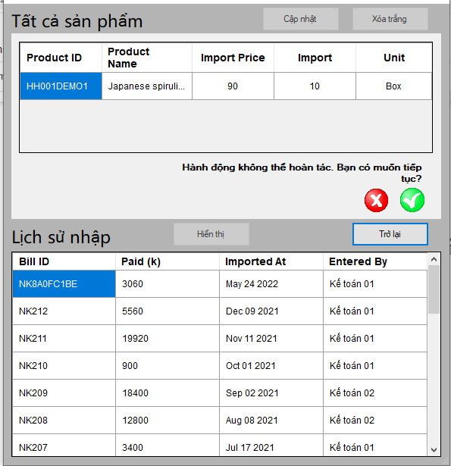

Figure 5.4: View before print import note

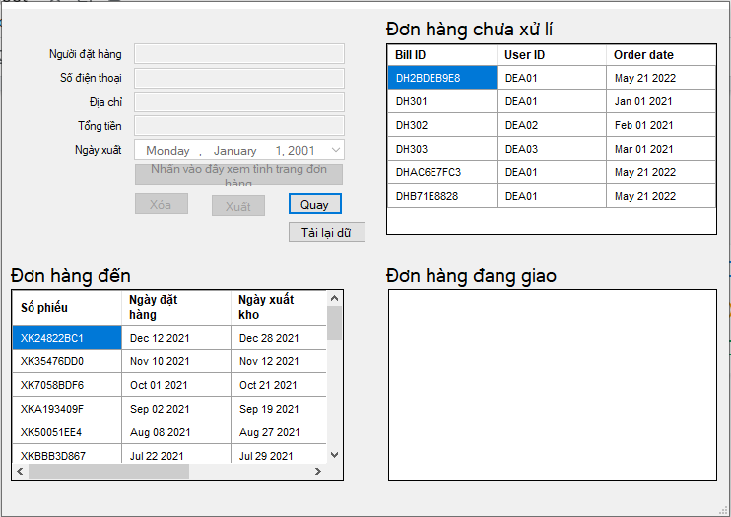

Figure 5.5: Export form

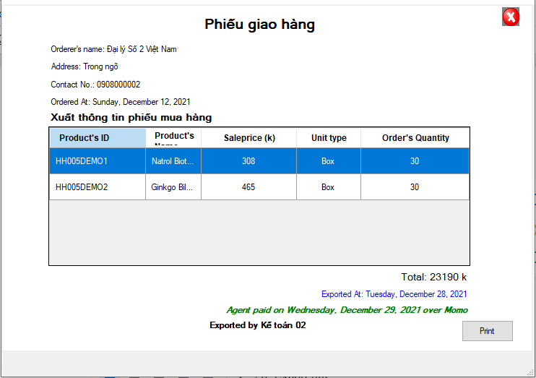

Figure 5.6: Export bill

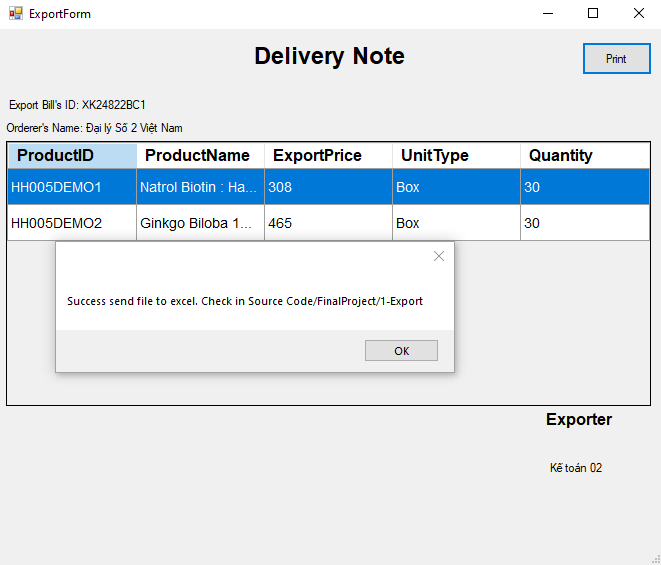

Figure 5.7: View before Delivery note

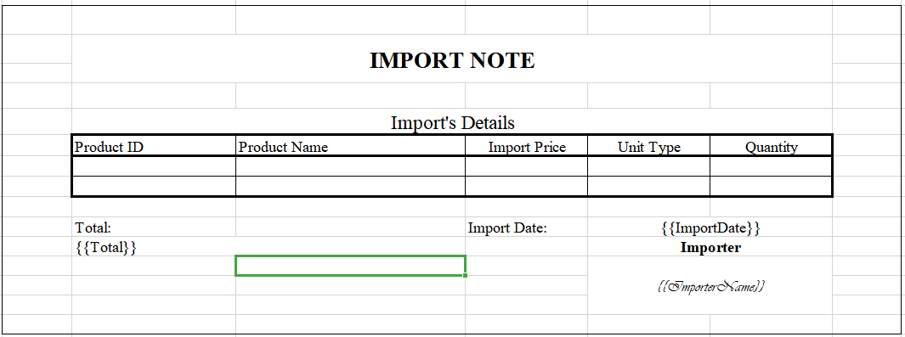

Figure 5.8: Import Bill

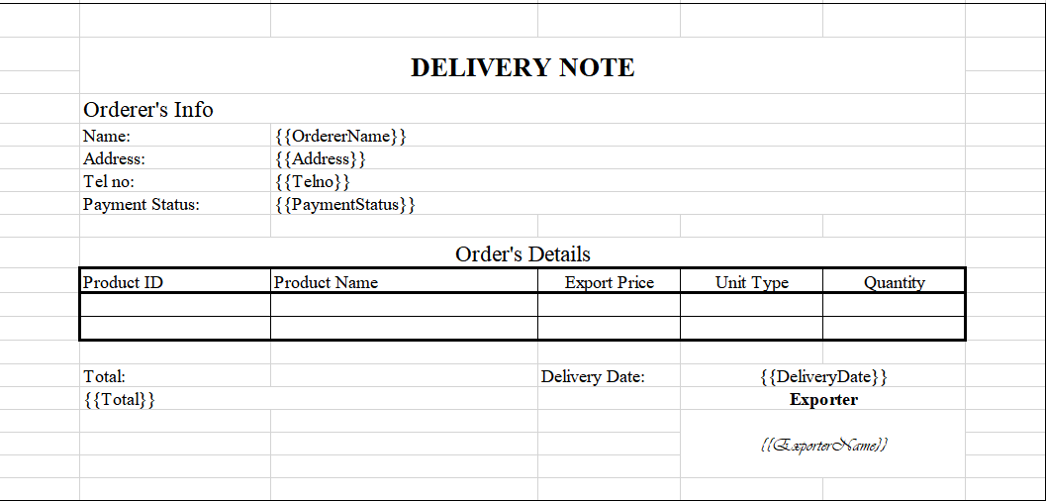

Figure 5.9: Delivery Bill

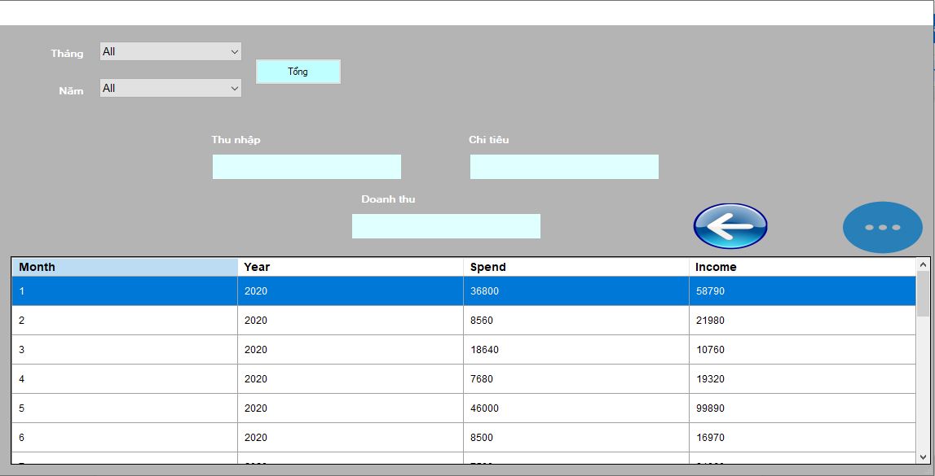

Figure 5.10: Incoming and Spending Statistics form

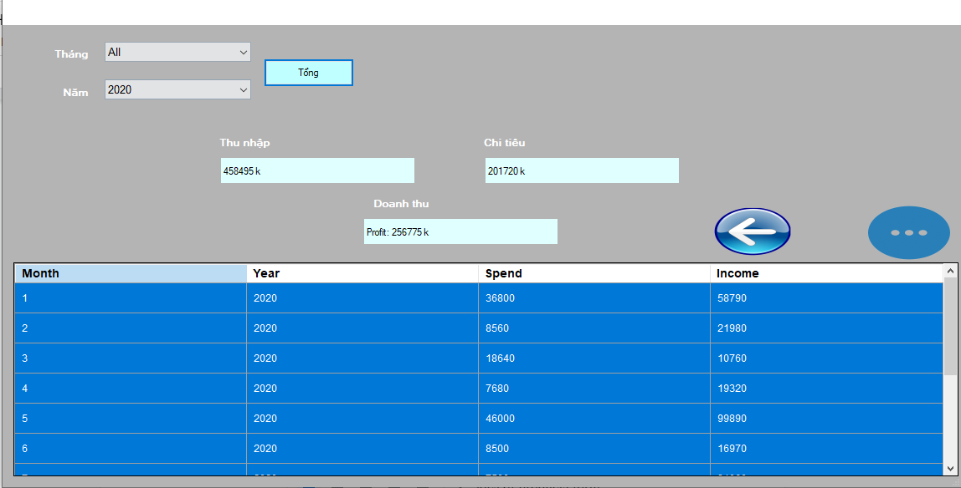

Figure 5.11: Statistics of products form

***5.1.2 Webform***

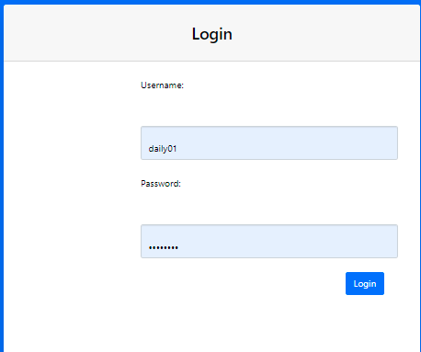

Figure 5.12: Login Page

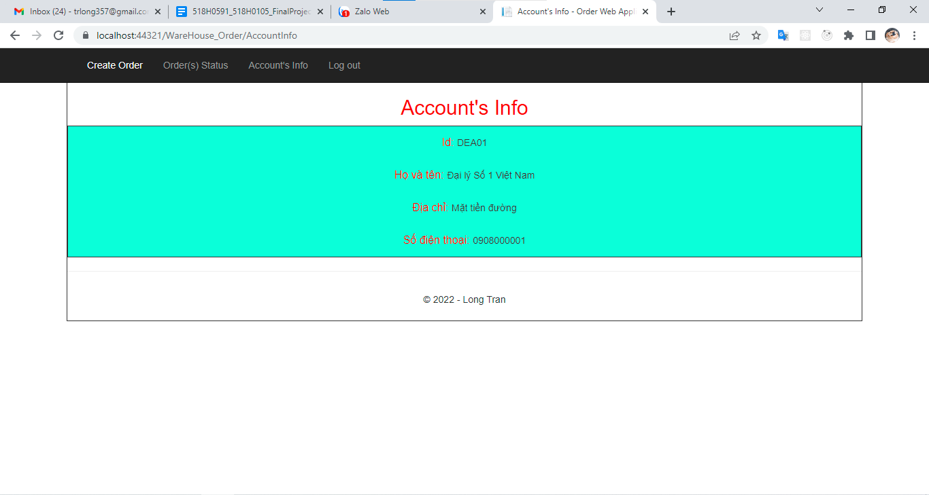

Figure 5.13: Account’s Info Page

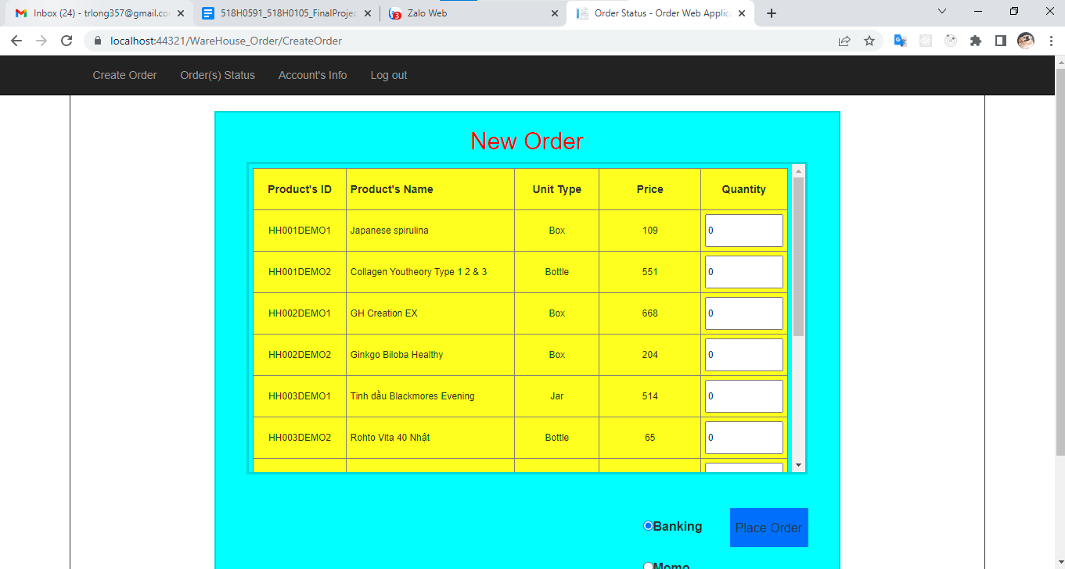

Figure 5.14:Create Order Page

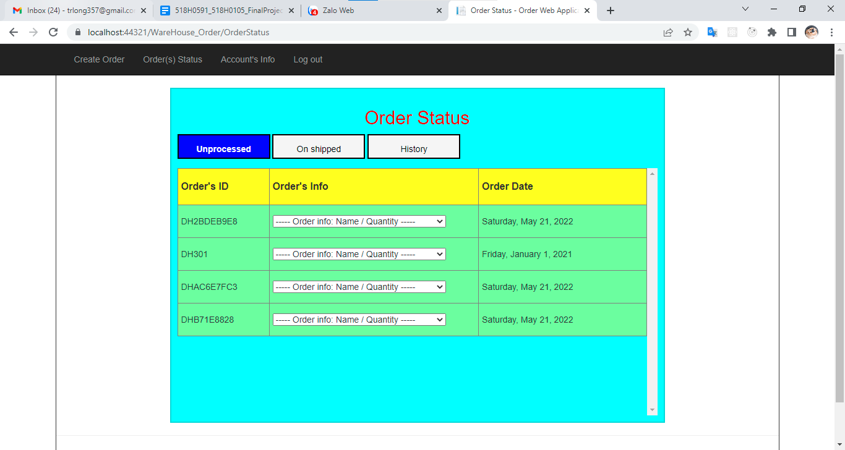

Figure 5.15: Order Status Page (Unprocess Order)

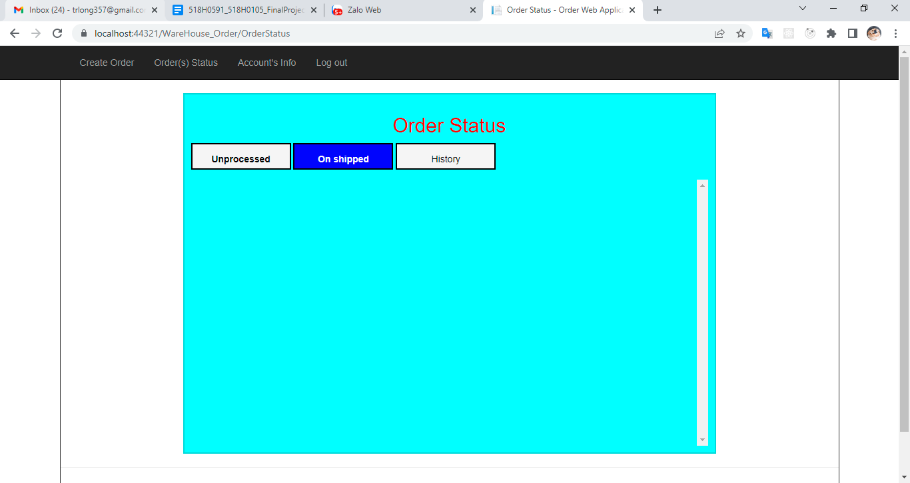

Figure 5.16: Order Status Page (On Shipped Order)

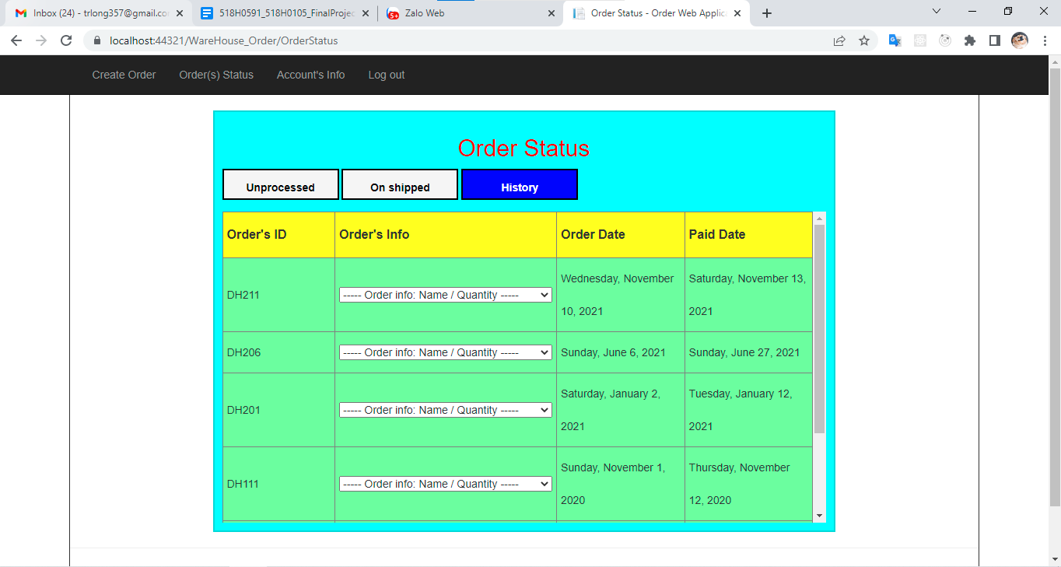

Figure 5.17: Order Status Page (History Order)

* 1. **Static model – class diagrams**

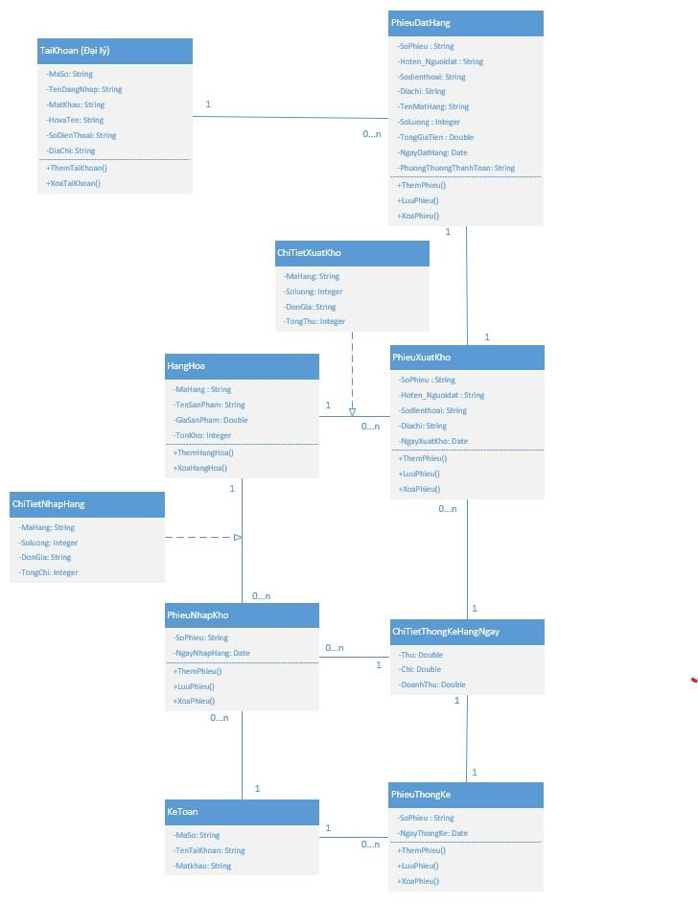

Figure 5.18: Class Diagram

* 1. **Dynamic model – Sequence diagrams**
     1. ***Goods Received Sequence diagram***

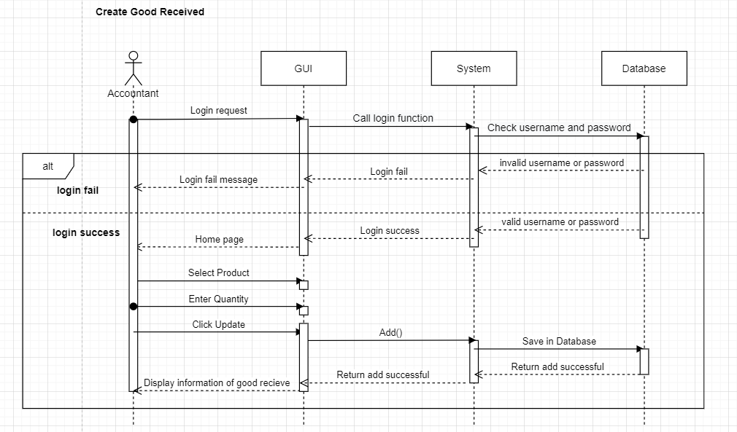

Figure 5.19: Goods Received Sequence Diagram

* + 1. ***Goods Delivery Note Sequence diagram***

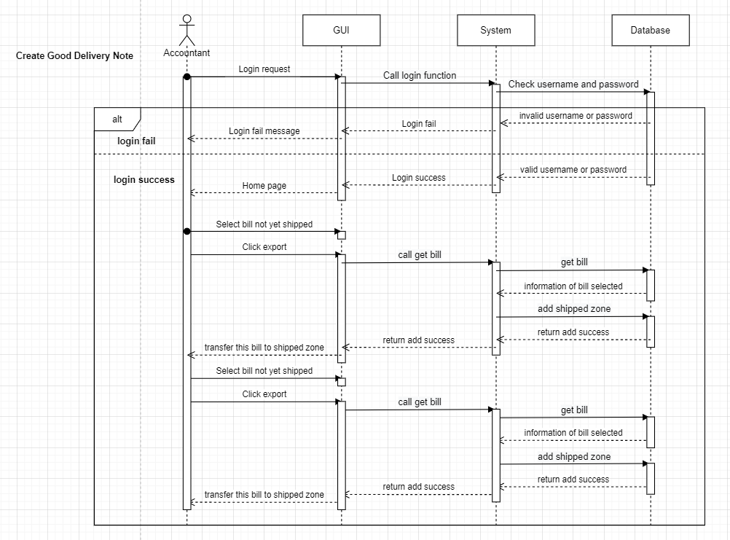

Figure 5.20: Goods Delivery Sequence Diagram

* + 1. ***Order Sequence diagram***

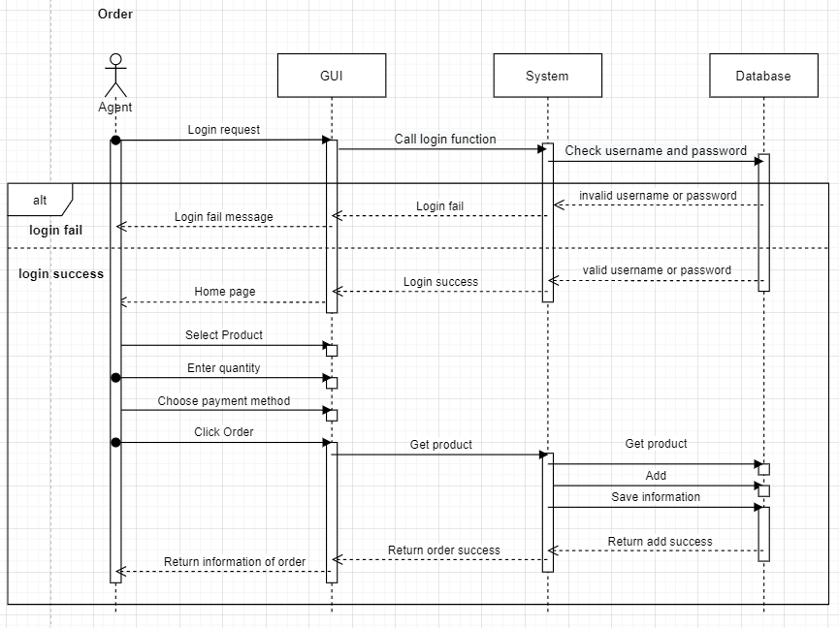

Figure 5.21: Order Sequence Diagram

* + 1. ***Statistics Sequence diagram***

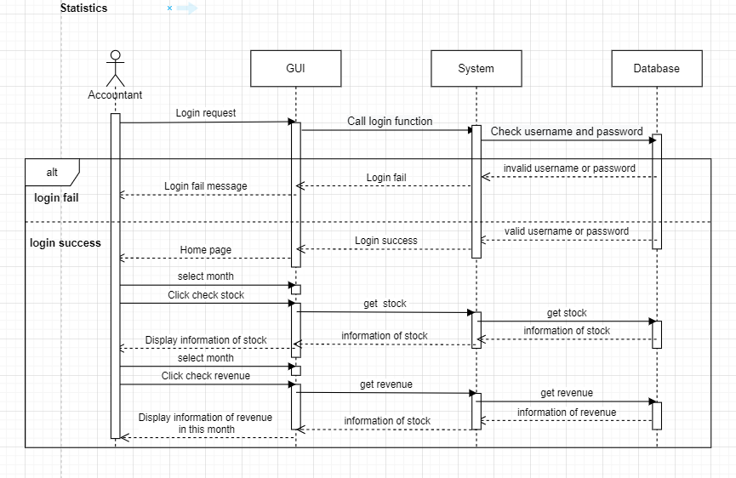

Figure 5.22: Statistics Sequence Diagram

**VI – TEST PLAN**

**6.1 Requirements/specifications-based system level test cases**

**6.2 Traceability of test cases to use cases**

**6.3 Techniques used for test generation**

**6.4 Assessment of the goodness of your testsuite**

**VII – DEMO**

Github : <https://github.com/vth24072000/Final-Project.git/>

Youtube : <https://www.youtube.com/watch?v=PPdsviB7-oA/>

New: <https://www.youtube.com/watch?v=fjyFbUOT-lk>

**7.1 Database**

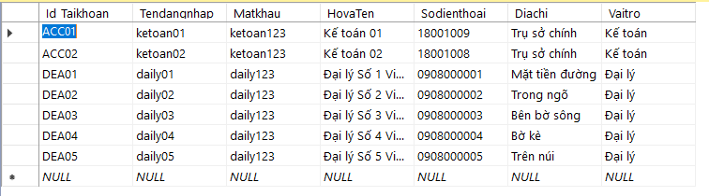

Figure 7.1: Taikhoan Data

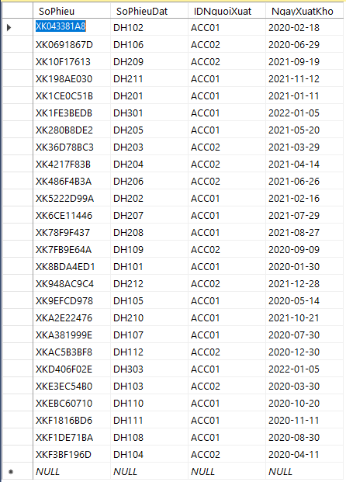

Figure 7.2: PhieuXuatKho Data

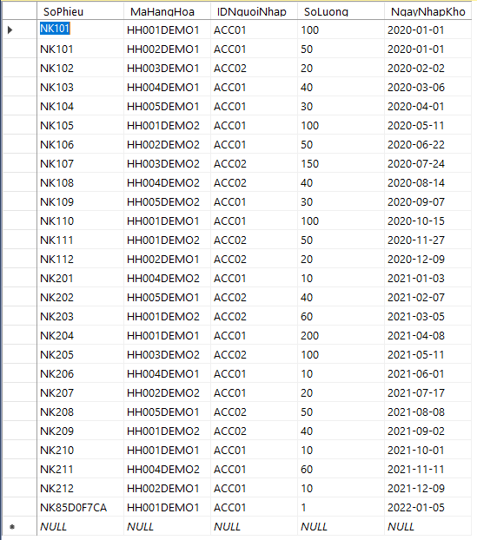

Figure 7.3: PhieuNhapKho Data

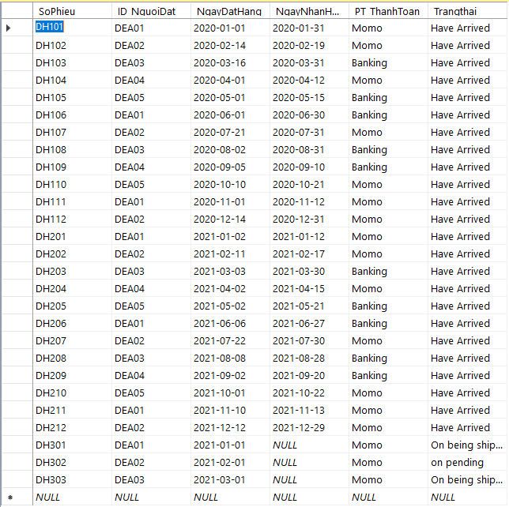

Figure 7.4: PhieuDatHang Data

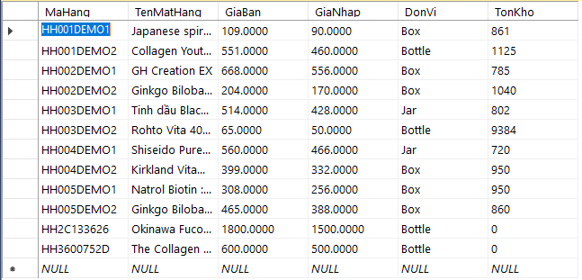

Figure 7.5: HangHoa Data

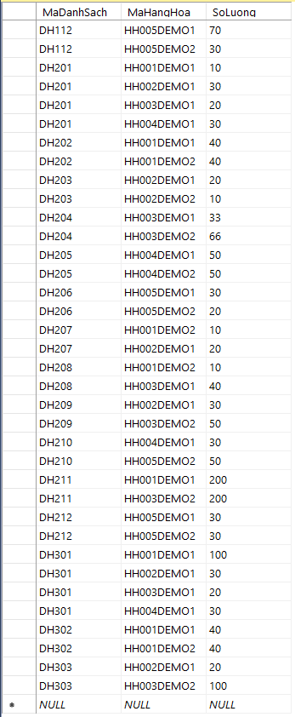

Figure 7.6: DanhSachDatHang Data

**7.2 Source code**

This section will capture some symbolic code.

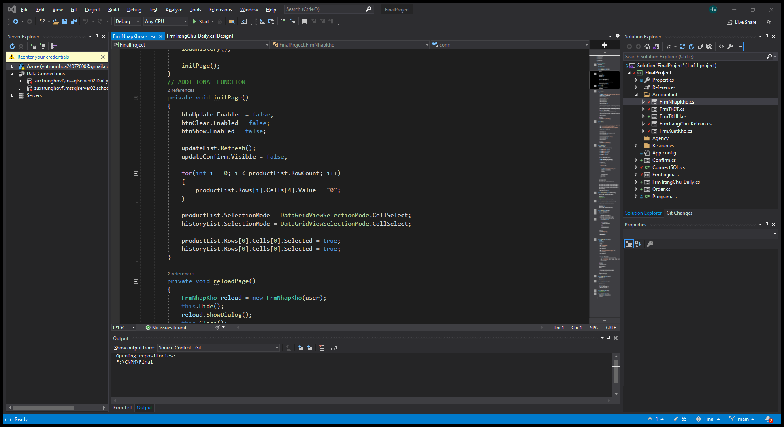

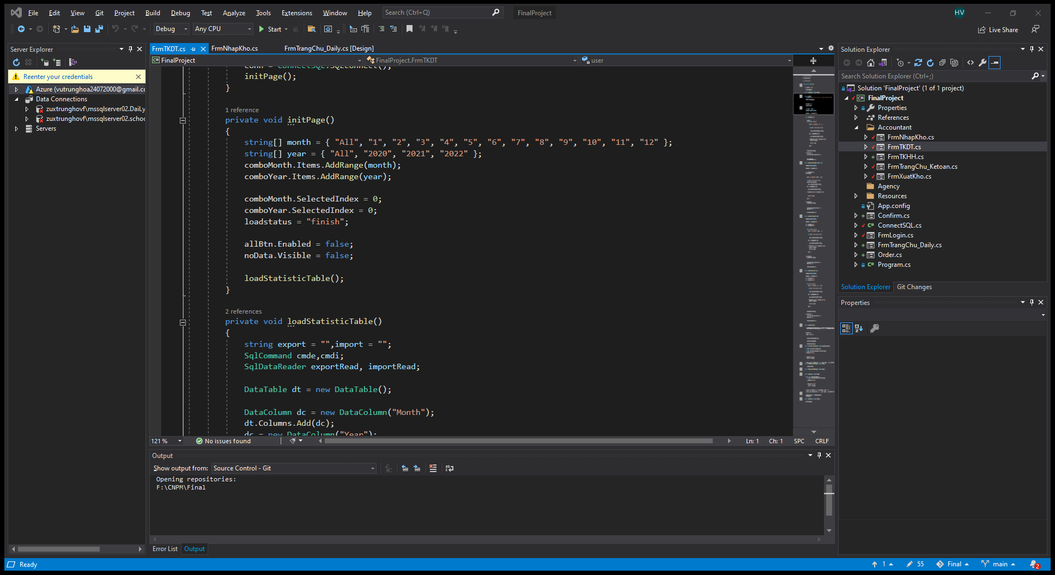

Figure 7.7: Source Code

**7.3 Testing**

**VIII – REFERENCES**

**8.1 Slides:**

- TDTU Slides:

**https://classroom.google.com/u/2/c/NDY0NTU1NjQwODU1/m/NDY5MTg1NTIwMzgw/details**

**8.2 Internet link :**

<https://codelearn.io/sharing/sequence-diagram-trong-uml/>

<https://viblo.asia/p/tim-hieu-ve-cach-thiet-ke-class-diagram-L4x5xLyY5BM/>

<https://itviec.com/blog/software-architect-la-gi/>

<https://viblo.asia/p/tim-hieu-ve-mo-hinh-3-lop-3-layer-Qbq5Qmyz5D8/>