Welcome to OpenSkyImager.

OSI (OpenSkyImager) was written in the hopes of forwarding astronomical image capture for Linux and the CCD (Charged Couple Device) cameras a team of us possessed at the time. The CCD cameras we bought were QHY (Qu Hung Yu) which serves us very well for our hobby of capturing deep sky objects in the night sky.

Below you will find a description of the programme for each of the buttons and tabs which are the heart of the programme and how to use it to get the best possible use out of your camera.
The cameras that this programme supports as of writing this document are the QHY2, 5, 5V, 5T, 5II, 5L-II, ,6, 6Pro, 7, 8, 9 and 9C, 10, 11 and 12. More cameras will be added once we have our hands on them and the firmware released by QHY.

So far OSI has been tested on Linux Ubuntu 12.04, 12.10, 13.04, 13.10, Min 9, 10, 11, 12, 13, 14, 15 and 16. Other people have reported OSI to work and run stable on ARM devices too. This version is classed as stable as it has been tested under ideal conditions out in the field at a star party namely Kelling Heath, Spring Equinox star party, Norfolk, England. UK and also from a balcony nearby Rome, Italy. But, it must also be said that this is still a work in progress as you will see once we start looking at the different tabs within OSI.

Warning before using this programme you will need to install the firmware which consist of the firmware that uploads into your camera and the udev rules which actually load the firmware into the camera.

Lets begin our tour with a look around OSI. Firstly the open programme shows a screen like this.

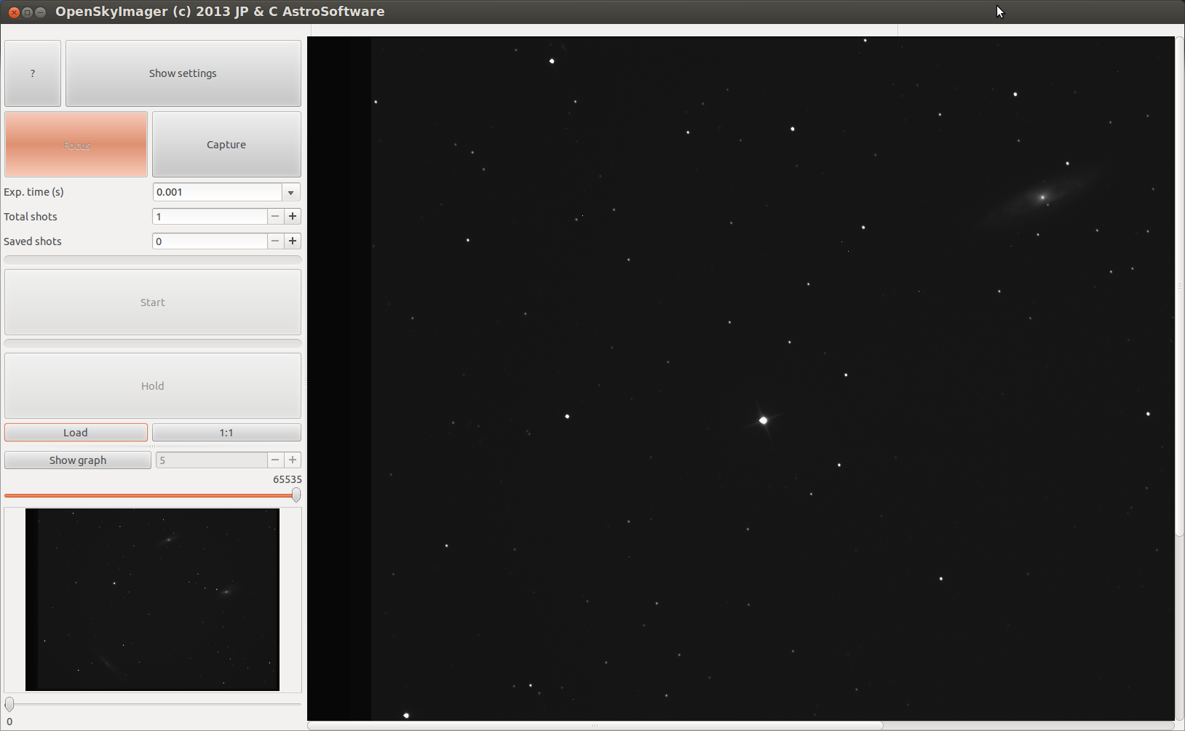
I have added an image to show what the programme will look like once in action under the stars. If we start our trip around the programme at the top left you can see the button with a question mark. This is just an about page that tells you about the program being open source and the authors. The About page should look like this.

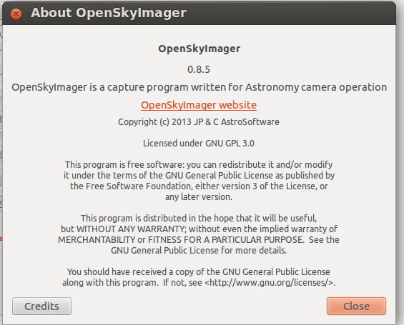
The next button is the Show Settings which opens up the heart of the programme that helps the user get the best out of your camera. Below these buttons we have the Focus button which allow you to focus the camera without saving images to your computer. The button to its right is the Capture button, pressing this button after setting all other settings will allow you to capture images and store them in the desired folder on your hard drive.

Below the Focus and Capture buttons we have the Exp.time(s) which is the exposure time calculated in seconds or parts of seconds. The mostly used times are already input into the drop down menu for your convenience. You can of course add your own timings here by simply clicking in the box and typing the amount of time you want in seconds.

Just under the Exp.time you will find the Total shots box. This is the number of frames you want to capture of the deep sky object. Just below this you have the Saved shots box. This is the number of images you have managed to save during this session. You can click into this box and put your own number in here. Especially useful should you wish to add images from the night before or wish to start a fresh count elsewhere on your hard drive.

Next we have the line which moves from left to right showing you how many images in graphic format you have captured to your hard drive. Useful to show how far through a captured set of images the programme has run through.

Just below this you have the Start button which does what it says. Once all settings have been set this button will actually start the sequence of capturing the images and storing them on the PC. Once the Start button is pressed it will change to Stop. Should you wish to stop the capture then press this button again. The computer will wait until the amount of exposure time has elapsed as it is waiting for a response from the camera. Pressing the Start button a second time the button will change colour and have KILL in the middle of the button.
Some times you may want to abandon the capture altogether for one reason or another. Pressing the KILL button will interrupt the cameras capture and return the camera to a waiting state and the Start button will return to normal once the camera is ready for normal use.

Between the Start button and the Hold button you will see the count down graphical counter. This moves from right to left and lets you see how far through the currant exposure you are. This count down is done in seconds so you can see the line move for each second passed.

The Hold button is a nice feature that allow you to pause your imaging session should clouds or an aircraft fly through the area you are imaging. Once the clouds or aircraft have flown through you press Hold again and the programme will resume capture till the required amount of images in total shots has been aquired.

Below and left of the Hold button we have the Load button. This will load a saved image in into the programme and allow you to inspect the image. To the right of the Load button we have the 1:1 button. Click this button and it will change to say Fit meaning your image on the right in the large area will fill the available space. Click it again and Fit will become 1:1. Now you can browse around the image by using the grab/scroll bars on the right and bottom of the image. Especially useful if the image is from a large format camera and the image is larger than the available space.

Just beneath the Load button we have the Show graph button. If you load or capture an image this will be shown in the small window below and is the same as the large image to the right. Click the Show graph button and it will change into a Histogram of the image on screen. Use the + and – buttons to the right of the Hide Graph to magnify the histograms output.

Top and bottom of the window where the small image or histogram is you have two sliders.
The top slider lowers the white point within the displayed image and the bottom slider raises the black count or raises the black point, This little window has another very important job.
You can use this window to help focus your camera. Here's how to use it. First choose a star on the large image in the right hand large window.
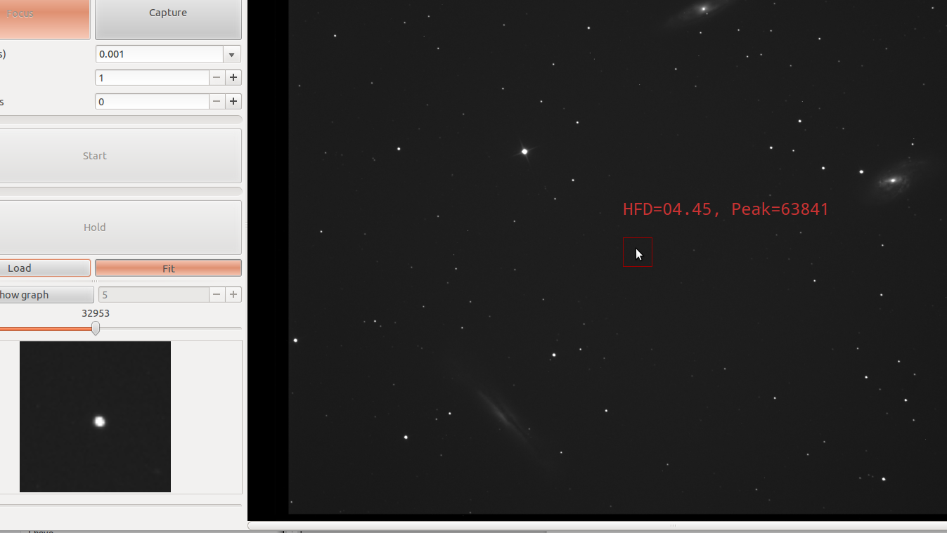
You will notice that it has some red writing and a red box around the star you clicked on.
The red writing is the HFD which is Half Flux Diameter which lets you know how far out of focus you are. The lower the number the better the focus. Now turn your attention to the little red box on the right of the screen. Move your mouse pointer into the red box and gently scroll the mouse wheel. Notice the red box on the large screen got smaller and the star in the little window on the left got larger ? The star has been magnified.

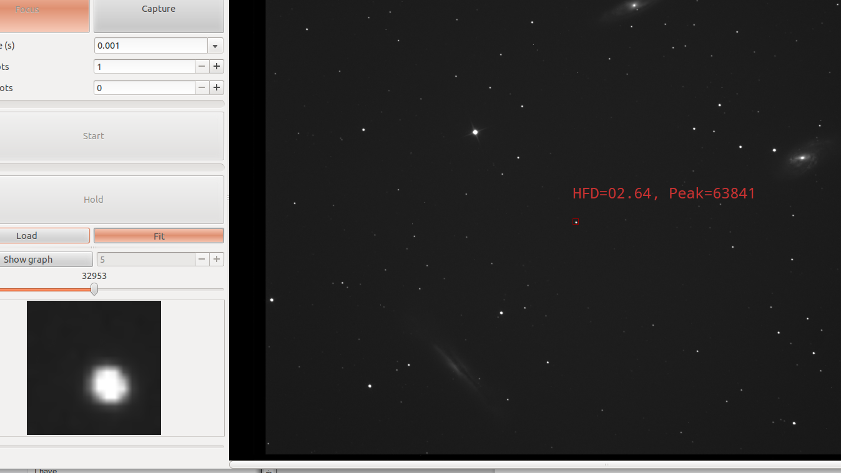
Now scroll the mouse wheel again in the opposite direction and the star in the left window will shrink back to normal size but the red box on the large image to the right will grow larger. Use this
to help focus your star.

Now lets turn our attention to the heart of the programme and the tabs that perform the
magic behind the scenes. Click Show settings at the top left. Now notice the tabs on the right.

The first tab should be Camera and should be your first call to set up which camera you have. Click the button with None to the right of Model. The programme should auto detect which cameras you have plugged in and should appear in this list. If for some reason your camera does not appear in this list you can try and click the Full list and click on your camera and see if it will Connect. If your camera is not in the list or is in the Full list and still it won't connect then there is another problem somewhere. Join the QHY Forum at http://qhyccd.com/ccdbbs/ for answers to this and other problems you may have.

After choosing your camera press Connect and your camera should now be connected and the drop down menus below should light up with the choices you can make.

Offset and Gain should be set according to the manufacturers advice.
For most cameras Offset is around the 120 mark and the Gain is best when set to between 0 -10
Remember the higher the gain the more noise you input into the image.
Binning Mode is a feature which will allow you to make a super pixel by adding together the amount of pixels chosen by the binning number. Most images are captured with Bin X1 or Bin X2.
Bin X4 is best for focusing.
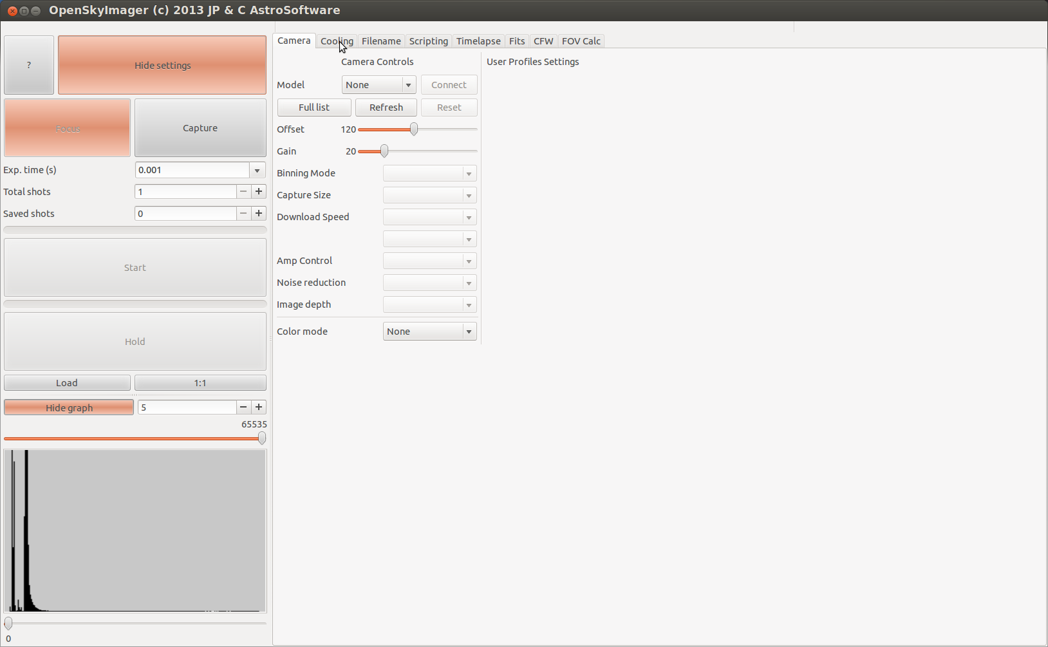
Capture size if your camera supports it will allow you to capture different size frames.
Sometimes used for the capture of planets where 2,000 x 2,000 would be a complete waste of space and time so use the Capture size to help. Also useful for focusing as it speeds up the download of the image from the camera.

Download Speed is available to all QHY CCD cameras. Use the 0 or slow download speed for capture of your good images and 1 or fast download for focusing. You will notice that the faster you download your images the brighter your images will be. So for instance if you set X4 binning and fast download speed for focusing your images will be very bright and easy to the deepsky object on screen. Then set the Binning back to 1 and set the download speed back to 0 or slow and notice now the image is very dim even after many minutes capture. This is normal behaviour as other programmes are used for the post processing your images and will not be discussed here.

Light/Dark are for the different kind of images meaning either a light frame or the images you are going to capture or the dark frame which is captured with the telescope covered helps rid the light frame of unwanted hot and cold pixels. Again this is in post processing stage.

Amp control is for controlling the amplifier inside the camera. Some cameras have to take two images, first field followed by the second field to get an even image of both fields. QHY6 is one such camera. Take only one field and you would get a light line of pixels followed by a dark line of none exposed pixels forming a black line through your image. Again follow the manufactures advice here.

Image depth is either 8 or 16 bit depending on the camera plugged in. Most of the QHY5 series of cameras are only 8 bit so trying to save a 16 bit depth image would be a waste of hard drive space. So only choose the bit depth according to your camea.

Colour mode is only for the one shot colour (OSC) cameras like the QHY8 etc. Set this according to your cameras needs.

Moving onto the Cooling tab we should see something like the image below.
This is for the cameras that have the DC201 power supply which can be controlled by the computer.
Pressing Manual mode turns on Auto mode and setting the temperature on the right it is now “set and forget”. The temperature will be lowered gently to what the user has set it too.
Enable tec read is just allowing the programme to read the temperature of the temperature controlling device. Temperature read out can be superimposed on the front screen should you wish to see the temperature read out.

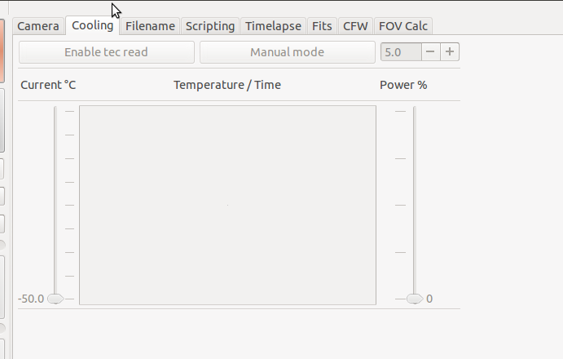
Beware that when the camera is set in “fast download “ mode, the automatic temperature control and the CCD temperature read are disabled in order to get the highest speed in preview mode and ease the focus process at most.
Camera will retain the last value set for cooling power, and the previous choice for cooling mode will be restored once exiting from “fast download” mode.

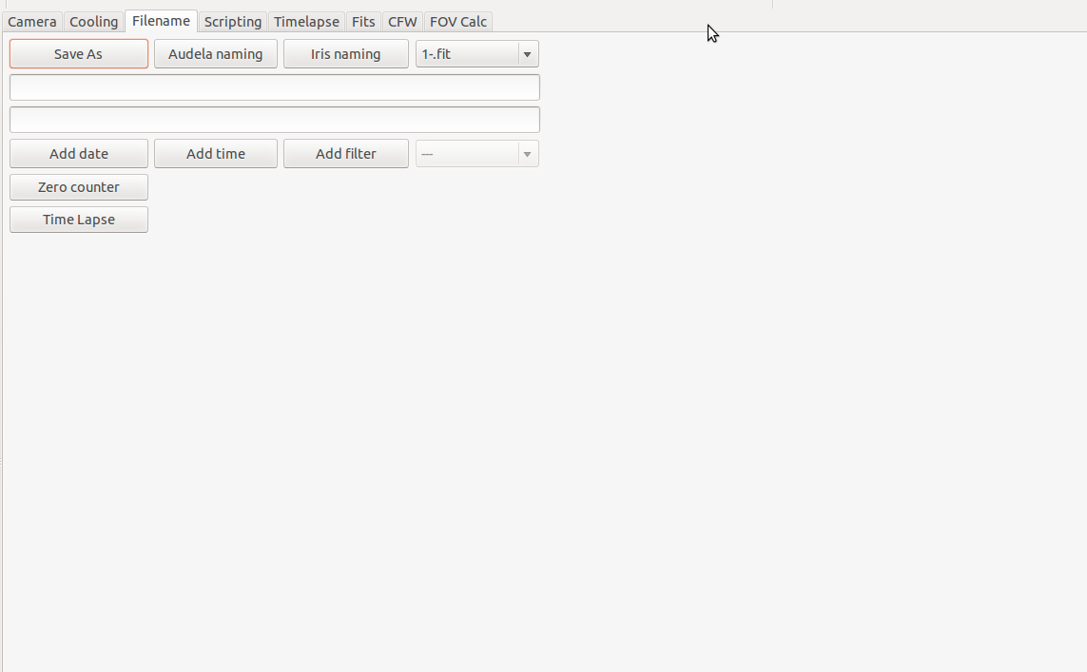
Moving onto the Filename tab you should see something like the image below.
If your using either Audela or Iris (Siril under Linux) you can just choose one of the standard naming conventions to the right of Save As. Both Iris (Siril) and Audela have their own naming convention. Save As allows you to choose where and the name of the file you wish to save. On the far right of the 3 naming conventions you have the format in which you wish to save.
The standard is the .fit format for astronomical images. The .avi is mostly used for the capture of
planetary images. A third option is to save in both formats at the same time.

When saving to an avi from a 16Bit source, data will be scaled down to 8Bit in linear mode.

Add date and Add time will append the date and time to the filename and is useful if you want to keep records of the date and time of captured files.
Add filter is a way of adding the filter name to the name of the captured set of the files. Mostly used by mono imagers so that they know what filter was used when taking the image and is useful in the post processing stage. Just select the filter type from the drop down menu.

Zero counter resets the counter on the main page of OSI. Below Zero counter we have Time Lapse. Pressing this button activates the Time Lapse tab.

The next tab is the Scripting page and is a work in progress. When operational it will allow the user to set up a series of exposure times, number of images to capture, binning and filters.

The Timelapse tab should look something like below.

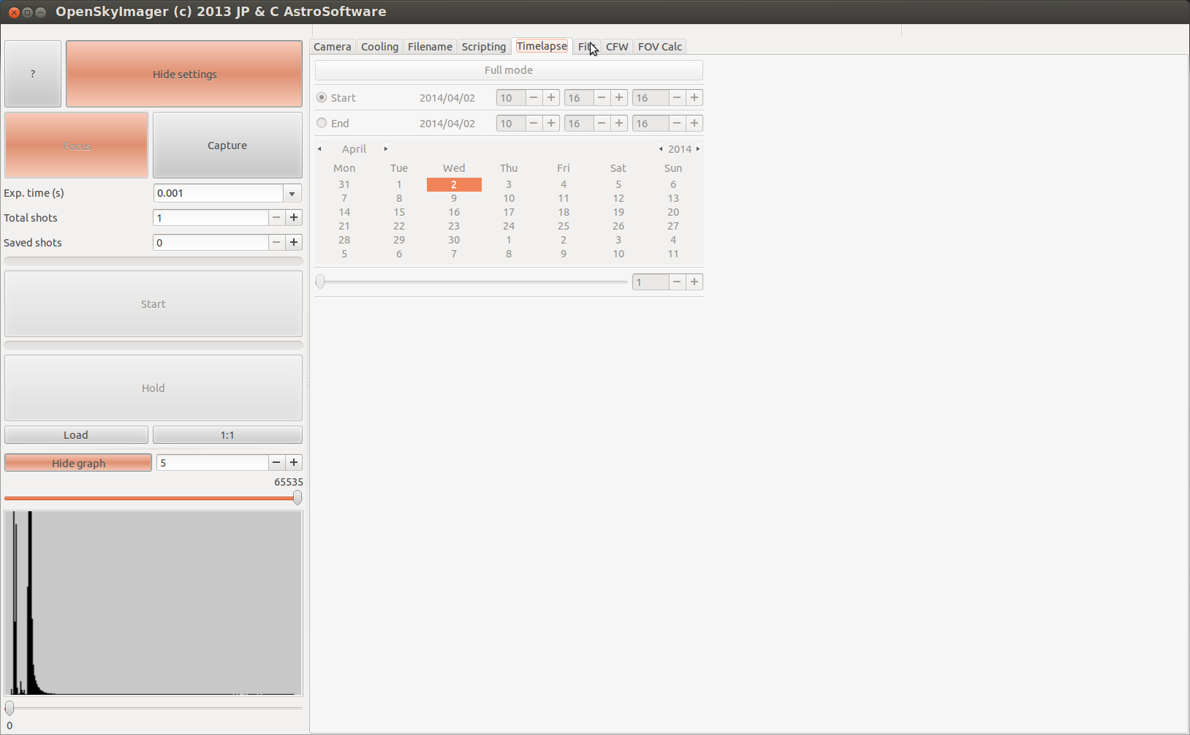
Notice if you did not press the TimeLapse button on the Filename tab this page will be greyed out and so can not be used. For the use of a quick time lapse sequence just move the slider to adjust the counter in seconds at the bottom of the page. This will make the programme pause/sleep between each image captured. Useful if you want to take a sequence of images of an occultation of a planet disappearing behind another or the Moon or even a star going behind a planet. To use this page to its fullest extent you first have to press the Full mode.

Turning on Full mode now allows you to set all the parameters needed to set up a complete sequence of a time lapse set of images from the year, month, day, date and time to start capture and end the imaging sequence.

To change the month press the little arrow buttons on either side of the displayed Month, use the same kind of arrows either side of the displayed Year to adjust the year. Use the up and down buttons to change the hours, minutes and seconds. The last thing to set should be the amount of time in seconds to actually pause or sleep between each image. The maximum amount of time allowed to sleep is 86400 seconds which is 24 hours.
The next tab is the Fits tab and is a work in progress and will show and allow adjusting the fits header of the captured images.

The CFW (colour filter wheel) should resemble the image below.

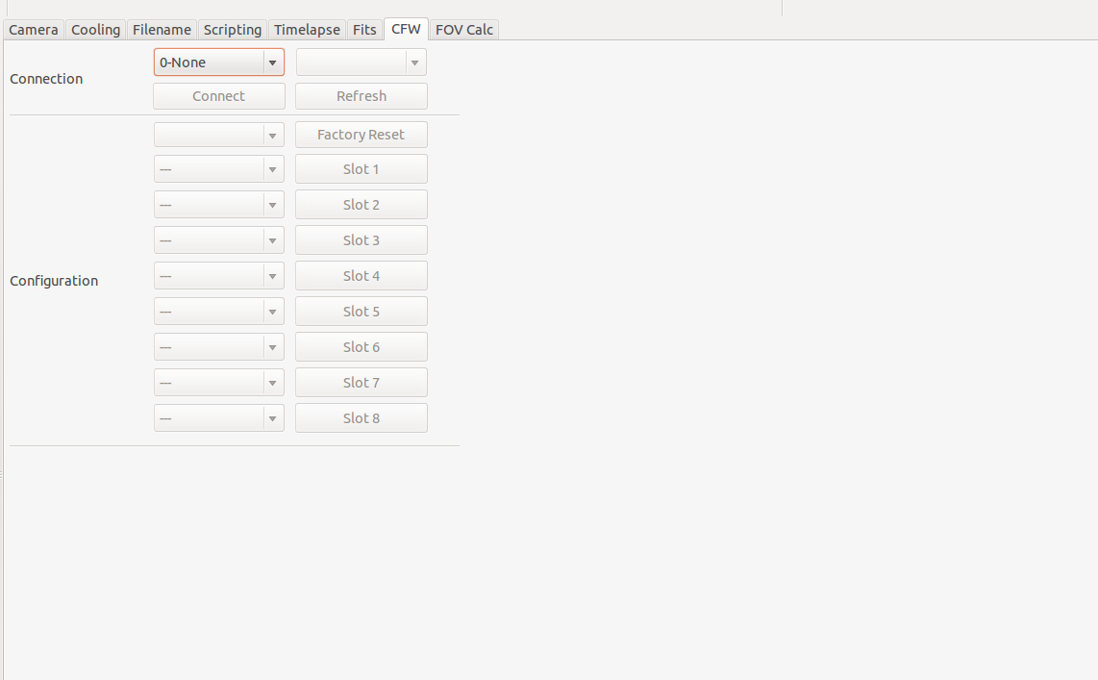
Here you can choose which method you wish to use to talk to the QHY filterwheel.
There are two methods at present, either through the QHY9 via the cameras own serial port or through the serial port of the of the computer. You can also use a USB 2 Serial converter should your computer not have a serail port. Both methods have been tested. First choose your method, then press Connect. Depending on which version of filterwheel you have you will see either a 5 slot or 8 slot option. Now fill in the details of where your filters sit within the filter wheel. To move to the relevant slot press the Slot 1 – 8. At present you have to manually press the “slot” buttons to move the filter wheel but will in future be done from the Scripting tab. Just in case your filter wheel becomes mixed up and does not know which filter is in which slot press the Factory Reset which should zero the filter wheel and the red LED will shine as the filter wheel rotates back to zero position.

The last tab is the FOV Calc. Again this is a work in progress.
When completed it is hopped that entering your CCD pixel size and diagonal size along with the focal length of the instrument being used it will give you the very close approximation of the field of view your captured images will show.

Lastly if you can programme in C and GTK and would like to join the team then please do send an email to :- him/her/them/me/some-one-else. Errrr, did I miss anyone out ?

