**Readme for the colab version of the WAPOR4Awp**

The colab version of the WaPOR4Awp is scripted in python to be executed in google cloud computer through Google Colaboratory (Colab) in your google drive.

Note: to use the colab notebook, you need Google account, which will give you access to google Drive () with 15 GB of space.

Why colab version: it helps users to use free resources (Google's cloud computer) and avoid the hassle of installing Python dependencies (packages) on their local machine (PC or laptop). Colab allows anybody to write and execute arbitrary python code through the browser and is especially well suited to machine learning, data analysis, and education. Users can run the colab version of WAPOR4Awp in two steps:  
  
**Step 1:** Load the colab version of the WAPOR4Awp folder in your google drive (My Drive): (see below the screenshot of the folder and internal files)

**Step 2:** Connect Google Colab with Google Drive and run the python scripts in the cloud. (How to Connect Google Colab with Google Drive, read the description in the next page).

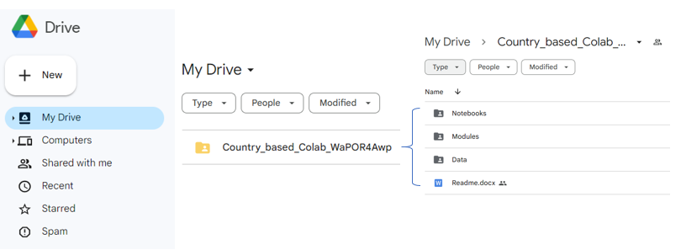

How to Connect Google Colab with Google Drive

*Source: (© Copyright Reserved @2021 Marktechpost, LLC.)*

[*https://www.marktechpost.com/2019/06/07/how-to-connect-google-colab-with-google-drive/*](https://www.marktechpost.com/2019/06/07/how-to-connect-google-colab-with-google-drive/) *.*

In this tutorial, you’ll learn how to connect your Google Colab with Google Drive to build some Deep Learning model on Google Colab. In Google Colab, you can build deep learning models on 12GB of GPU besides this now, Google Colab is providing TPU also.

This is a completely free to use research project from Google.

### What is Google Colaboratory ?

In Short, Google Colaboratory is known as Colab. This is a cloud service, and now Google Colab supports GPU and TPU!

Using Colab, you can:

* Enhance your Python programming language coding skills
* Develop excellent deep learning models using most popular libraries like TensorFlow, Keras,     PyTorch, and OpenCV.
* Do anything without much worrying about packages, libraries, and their installation.
* Here is Colab most of the libraries are pre-installed that makes it easy to use, libraries which are not pre-installed here can be installed with a simple command

     “ !pip install package_name

[Introduction to TensorFlow for Artificial Intelligence, Machine Learning, and Deep Learning](https://click.linksynergy.com/link?id=vByl4oOx0*E&offerid=467035.14021095846&type=2&murl=https%3A%2F%2Fwww.coursera.org%2Flearn%2Fintroduction-tensorflow) [Advertisement]

### Loading Your Data into Google Colaboratory

One thing that makes Colab the best of all is that it comes with various libraries that help in accessing lots of Services provided by Google itself. Colab saves all your Jupyter Notebook to Google Drive, and you can share your Jupyter Notebooks very efficiently anywhere.

But the problem arises when we have to work with a huge Dataset, As google colab also provides many ways to upload your data to its Virtual Machine on which your code is running. But as soon as you got disconnected all of your Data is lost when you reconnect to the new Virtual Machine that is offered to you.

I’m here to help you with this problem of uploading your data to colab again and again.

To avoid this problem, follow these Steps:

#### 1. First of all, Upload your Data to your Google Drive.

#### 2. Run the following script in the colab shell.

#Start by connecting gdrive into the google colab

from google.colab import drive

drive.mount(‘/content/gdrive’)

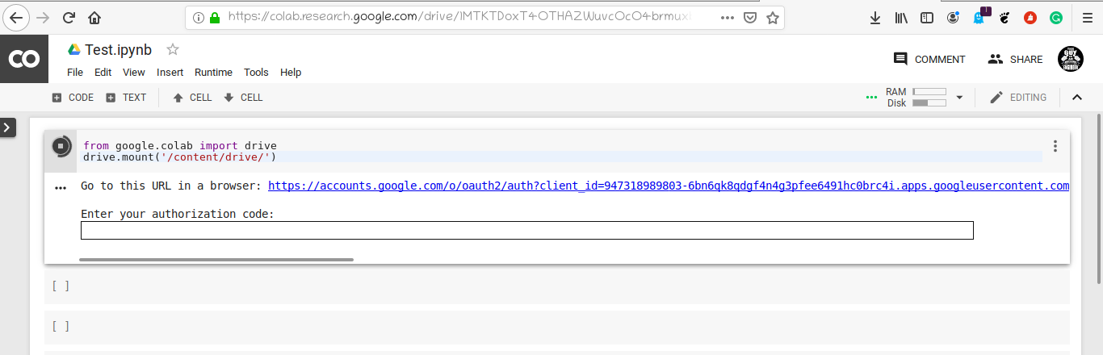

Go to the mentioned link..

#### 3. Copy the authorization code of your account.

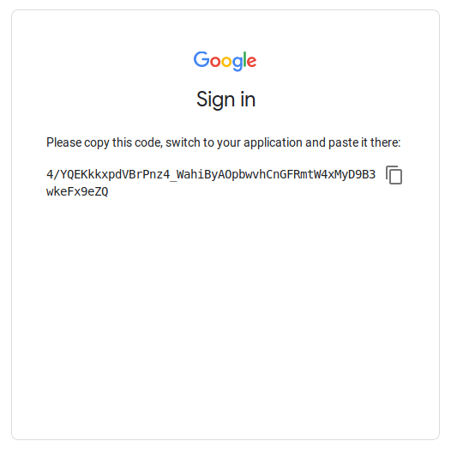

#### 4. Paste the authorization code into the output shell.

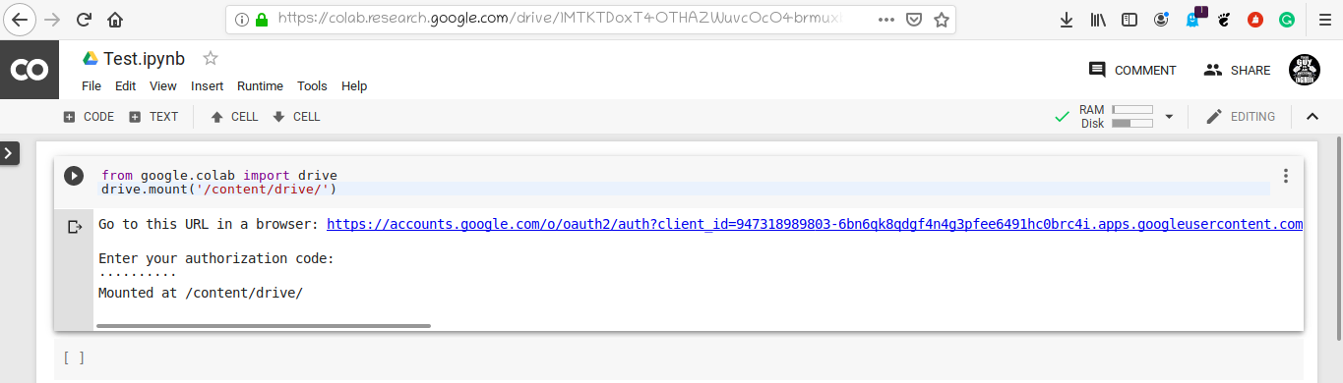

#### 5. Congrats! Now your Google Drive is mounted to this location /content/gdrive/My Drive/

