Introduction to Software Engineering

Project Proposal

The student team is required to complete the Project Proposal documentation for the assigned course project, following the attached template.


Software Engineering Department
Faculty of Information and Technology
University of Science
Table of Contents
Objectives 1
1 Member Contribution Assessment 2
2 Preliminary Problem Statement 3
3 Proposed Solution 4
4 Development Plan 5
5 Human Resources & Costing Plan 6
6 Tools setup 7

Project Proposal

Objectives
This document focus on the following topics:
- Completing the Project Proposal document with the following sections:
Hiển thị dữ liệu phức tạp
DataGridView

  - Preliminary Problem Statement
  - Proposed Solution
  - Development Plan
  - Human Resources & Costing Plan
- Understanding the Project Proposal document.

Member Contribution Assessment
ID | Name | Contribution (%) | Signature
23127004 | Lê Nhật Khôi | 100% | 
23127158 | Nguyễn Thanh Gia Bảo | 100% | 
2312765 | Nguyễn Hải Đăng | 100% | 
23127181 | Nguyễn Trần Quốc Duy | 100% | 

Preliminary Problem Statement
In recent years, the demand for pet ownership has grown rapidly as pets have become an essential part of modern human life. Pets not only provide companionship and emotional support but also contribute to improving mental health, reducing stress, and enhancing quality of life. Many people now consider pets as members of their families, investing time, care, and financial resources to ensure their well-being. The growing social trend of pet keeping has led to an increasing demand for various animal species, such as dogs, cats, birds, rabbits, hamsters, and ornamental fish, as well as for related products like food, accessories, and healthcare services.
Along with this surge in demand, the pet trading market has expanded significantly both online and offline. However, the current processes of buying and selling pets still face multiple challenges. Information about available pets is often scattered across social media platforms, unverified websites, or small local pet stores, making it difficult for buyers to compare prices, verify authenticity, or assess the health and origin of pets. Additionally, many transactions lack transparency and security, leading to issues such as misinformation, poor after-sale support, and even fraudulent activity. Furthermore, the absence of an integrated online platform causes inconvenience in communication between buyers and sellers, as well as inefficiencies in managing pet listings and user data.
To address these issues, our development team proposes 5Pets, a web-based application designed to create a safe, convenient, and reliable environment for buying, selling, and managing pet-related activities. The system will consist of two main subsystems:
- Customer Subsystem (Client Side): The user-facing web interface that allows customers to browse, search, and purchase pets or related products.
- Admin Dashboard (Admin Side): The management portal, also known as the Admin Dashboard, is exclusively used by the website owner or system administrator to manage listings, users, and categories within the platform.
When a customer accesses the PetShop Online website, the system will automatically display the main homepage containing categories such as pets, accessories, food, and care services. Users can view detailed information about each pet, including its name, species, breed, gender, age, health status, vaccination record, and price. Each pet post will include a description, photos, and seller contact details.
Users can register for an account as a buyer, sellers can register for an account as an admin
- A buyer can search for pets by species, price range, or location, and add desired pets to a shopping cart or favorites list.
- A seller can create new listings, upload pet photos, information about availability or pricing, and delete products.
All data related to pets, users, and transactions will be stored in a centralized database managed by the web server. The Admin Dashboard provides essential CRUD (Create, Read, Update, Delete) functionalities, allowing administrators to manage core system data efficiently. Through this dashboard, the admin, who is also the host, can create, modify, or remove records related to pets, users, product categories, and orders. This subsystem ensures that data remains organized, up-to-date, and consistent across the platform. Future enhancements may include advanced features such as seller verification, review moderation, and sales reporting. On the other hand, the admin can also modify the logo, information about the shop (phone, address, …) and the favicon of the website through this Admin Dashboard.
The operating environment of the 5Pets system will be based on modern web technologies. The application will run on web browsers supporting HTML5, such as Google Chrome, Microsoft Edge, or Mozilla Firefox. The frontend will be developed using HTML5, CSS3, and JavaScript (with React frameworks and TailwindCSS Style frameworks) to ensure responsiveness and user interactivity. The backend will be implemented using Python (with Flask framework), hosted on the free platform Render/Vercel server. All persistent data will be stored in MongoDB.
The system must comply with standard documentation and security practices, including HTTPS encryption, input validation, and secure password hashing. It will also adhere to IEEE documentation standards and be developed following an Agile process, allowing incremental releases and feedback integration.
In conclusion, the 5Pets aims to create a centralized and secure platform for buying and selling pets and pet-related products. By providing an intuitive user interface, transparent listing verification, and robust management tools, the system will not only enhance the convenience of online pet trading but also promote responsible pet ownership and community engagement. This preliminary problem statement serves as the foundation for further analysis and detailed specification in subsequent development phases.

Proposed Solution

Software

Features
The student team should utilize user story mapping to justify the necessity of the features to be implemented, and will also list the software functionalities along with any relevant constraints (if applicable).
Example:

User Role | Demand | Requirement
Pet Lover

Demand | Requirement
As loved Animal, I want to find pets suitable with my cost and pets which I love. | - Having compare and find with suitable cost.
As Seller, I manage view and people care about product my shop to know trend of social. | - Having dashboard to analysis, evaluation.
As register, I want to registered having verify and send request when reset password.

Software Architecture
The student team should present the overall architecture of the software system that the team will build to fulfill the list of functionalities outlined in section 3.1.1.

Hardware
The student team should describe the hardware and equipment requirements necessary for the software to operate.

Development Plan

- The student team should present a detailed software development plan, along with the specific deliverables for each phase.

Requirements Analysis

Software Design

Implementation

Testing

Deployment and Maintenance

Human Resources & Costing Plan

- The student team should present the personnel structure for the entire project or each development phase and list the anticipated costs.

Tools setup
To ensure effective teamwork and organized project management throughout the 5Pets development process, our team established a consistent set of collaboration and development tools. These tools support communication, task tracking, source control, and assignment submission in alignment with the Agile methodology.

1. Communication & Collaboration
- Discord Server:
Server name: 5Pets
  - Channels:
    - #general – for group-wide announcements and discussions
    - #development – for daily technical discussions and progress updates
    - #design_uiux – for sharing UI mockups and design feedback
    - #trello_notifications – automatically synced with Trello to notify task status changes
  - All members use both desktop and mobile apps to ensure consistent communication and quick responses.
  - Discord serves as the main hub for collaboration, replacing Slack.
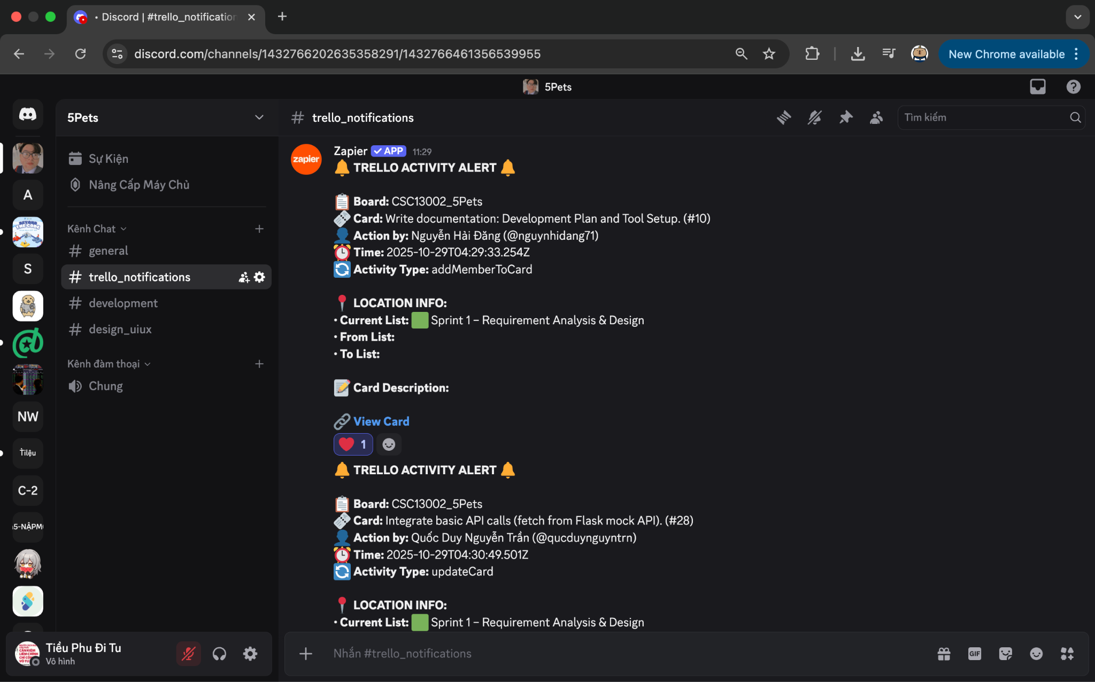

2. Project Management
- Trello Board:
The project board, named CSC13002_5Pets, follows the Agile Scrum framework. Tasks are divided into four sprints, corresponding to project phases:
- Sprint 1 – Requirement Analysis & Design
(Use case diagrams, class diagrams, architecture, tool setup)
- Sprint 2 – Frontend Development (Client Side)
(React + TailwindCSS implementation, navigation, and UI features)
- Sprint 3 – Backend & Admin Dashboard
(Flask + MongoDB integration, CRUD APIs, admin authentication, dashboard UI)
- Sprint 4 – Testing, Deployment & Documentation
(Testing, deployment to Render/Vercel, final report, and presentation)
Each Trello card represents a task with assigned members, due dates, and detailed checklists. Trello is integrated with Discord to automatically notify the team whenever a card is updated or completed.
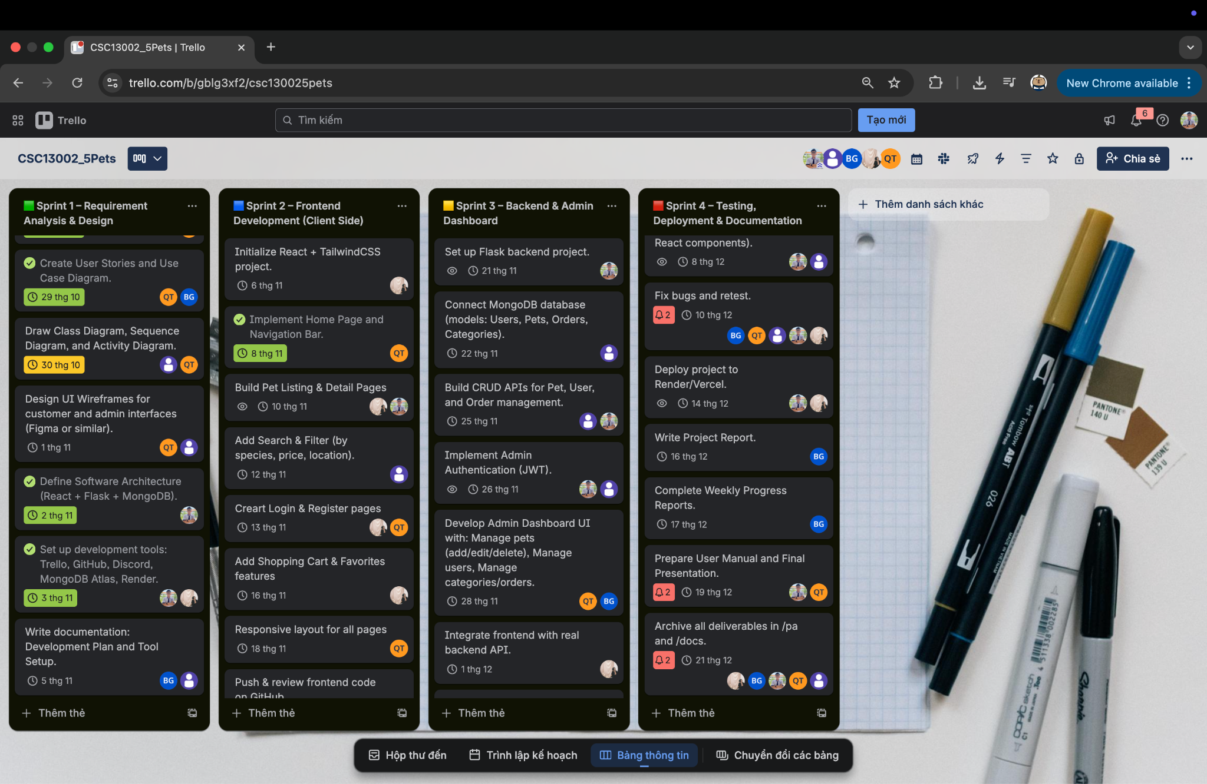

3. Source Control
- GitHub Repository:
Repository name: 5Pets
Repository structure:
/src → Source code (frontend & backend)
/docs
/management → Planning documents and reports
/requirements → Vision document, use cases, requirements
/analysis_design → Architecture, UML diagrams, UI mockups
/test → Test plans, test cases, and test reports
/pa → Project assignment folders (PA0, PA1, ...)
- Branching Strategy:
  - main → stable release
  - name_dev → active development for each member
  - feature/* → new feature branches
All commits include descriptive messages referencing corresponding Trello tasks. GitHub ensures version control, code integrity, and transparent contribution tracking among all members.

4. Assignment Management
- Moodle:
Used for submitting project assignments (PA0, PA1, etc.) and receiving feedback from instructors. Each submission is also stored in the /pa folder of the GitHub repository.
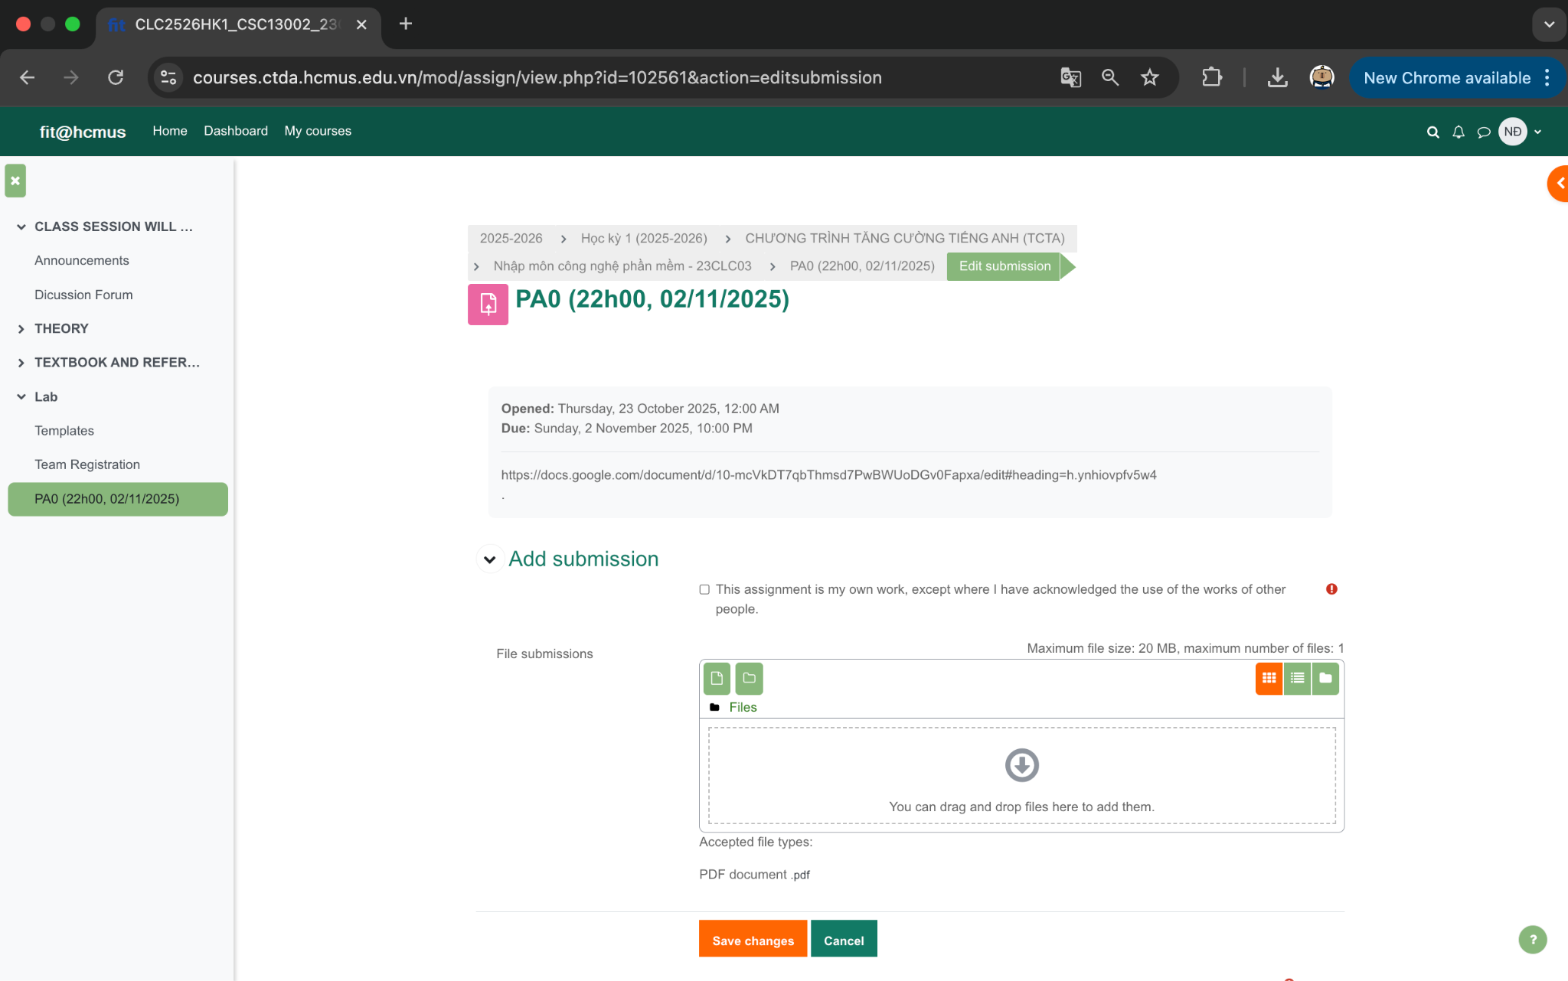

5. Development Tools
- Frontend: React + TailwindCSS
- Backend: Flask (Python)
- Database: MongoDB Atlas (Cloud)
- Hosting: Render (for backend) and Vercel (for frontend)
- Version Control: Git (via GitHub)

6. Monitoring and Evaluation
- Team members are required to:
  - Update their Trello cards regularly.
  - Communicate daily via Discord.
  - Commit code weekly to GitHub.
- Instructors and TAs can monitor progress via Trello–Discord integration and GitHub activity logs.

One of the main goals of this project assignment is to help you practice teamwork for professional software development. We'll assess and evaluate your effectiveness in team collaboration. Everyone is required to work closely with others in the group to deliver results, and we'll use tools to monitor and assess each group’s teamwork performance.
You are required to use the following tools:
- Moodle: Used for posting and submitting assignments.
- Slack (or a similar tool like MS Teams or Discord or Telegram): Used for discussions and interactions among group members for each project.
  - TAs will create a Slack project and add all students to it.
  - There will be a general channel for everyone, used for general project discussions.
  - Each group will have a channel linked to Trello. Any updates from Trello will be posted in this channel. Group members must use this channel to discuss their project.
  - Slack has desktop and mobile applications; please open the app and check it frequently.
- JIRA (or a similar tool like Azure Boards): Each group will have one board. Tasks are organized into sprints.
- Bitbucket, GitHub, or another source control tool: Used to store source code and documentation. Each group will belong to a team on the repository and have the following folders:
  - /src: Used to store source code.
  - /docs: Used to store documentation, which has these subfolders:
    - management: Storing planning documents, reports (weekly report, project status report, etc.).
    - requirements: Storing all requirements, including vision documents and use cases.
    - analysis and design: Storing all analysis and design related documents, including software architecture documents, UML models, and UI designs.
    - test: Storing all test documents such as test plans, test cases, and test reports.
  - /pa: Including subfolders to store submissions. Each subfolder contains one PA submission.
- TAs will help set up these tools during the first few lab sessions.
Important note: the effective use of tools to support teamwork is crucial for project success. Thus, using tools effectively is an important criterion for grading. Everyone is required to use the tools chosen by the team regularly.

