

JOINT INSTITUTE FOR NUCLEAR RESEARCH

Veksler and Baldin laboratory of High Energy Physics

**FINAL REPORT ON THE**

**SUMMER STUDENT PROGRAM**

*Development of a software package for JINR's administrative and organizational activities*

**Supervisor:**

Igor Stanislavovich Pelevanyuk

**Student:**

Anna Ilina, Dubna State University

**Participation period:**

July 01 – August 25

Dubna, 2019

# Contents

Introduction 3

IndicoAbstract 3

JINRex 6

Methods 7

IndicoAbstract 7

JINRex 7

Results 8

IndicoAbstract 8

JINRex 8

Summary 9

Acknowledgments 10

# Introduction

The administrative and organizational activities of JINR include a lot of various tasks, among which there is the creation of a book of abstracts for conferences which are constantly organized at the institute as well as the organization and accounting of excursions for different types of auditory. During SSP I developed a software package to automate these tasks. It includes two products: IndicoAbstract: generator of Indico's Books of Abstracts and JINRex”: JINR System of organization and accounting of the excursions. Let us dwell on each of the products in more detail.

# IndicoAbstract

Book of abstracts contains a large number of pages stylized in a special way and containing information about the conference, speakers and their abstracts (fig. 1, fig. 2). 6-7 people manually wrote the book, continuous work took about 20 man-hours.

Creating such a book has a number of nuances:

1. The input file is generated by the Indico web service in .xml format (fig. 3).
2. All authors write Affiliations in their own way, which must be brought to one standard (fig. 4).
3. If the two authors have the same affiliation, it must be indicated once in the document.
4. Each author must have an affiliation index (fig. 5).
5. Each Speaker must have an email index (fig. 5).
6. Abstracts must be divided into sections.
7. In each section, Abstracts must be sorted by the names of the authors.
8. Each article does not allow the use of two or more languages. All paragraphs should be written in one language (fig. 3).
9. The style and formatting of the document should be identical to the document written by hand.
10. The generated document must have an editable format.

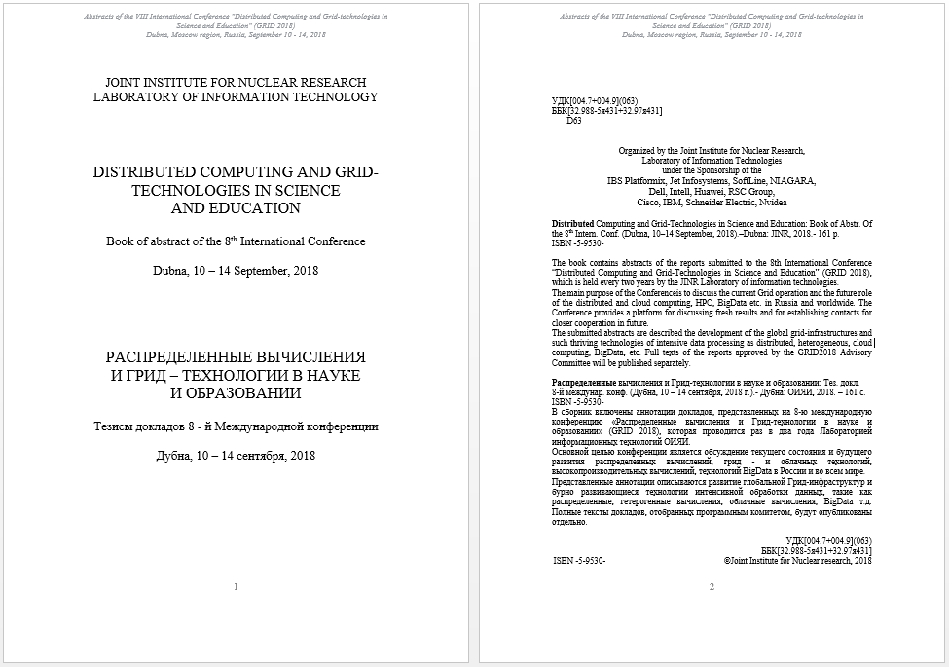

Figure . Book of abstracts frontpages

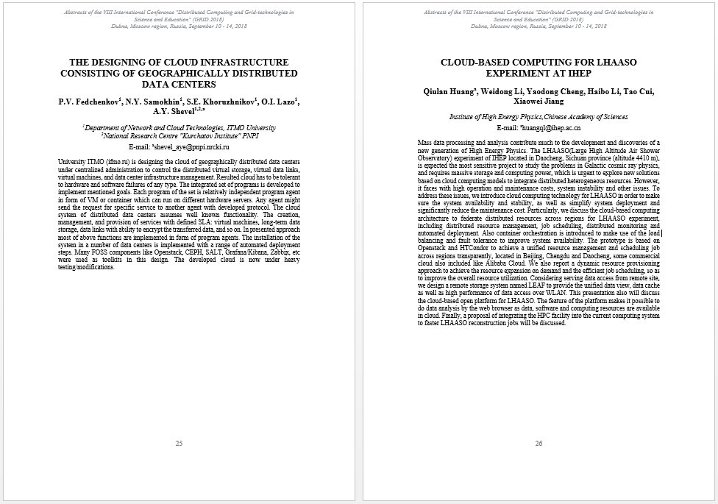

Figure . Book of abstracts content

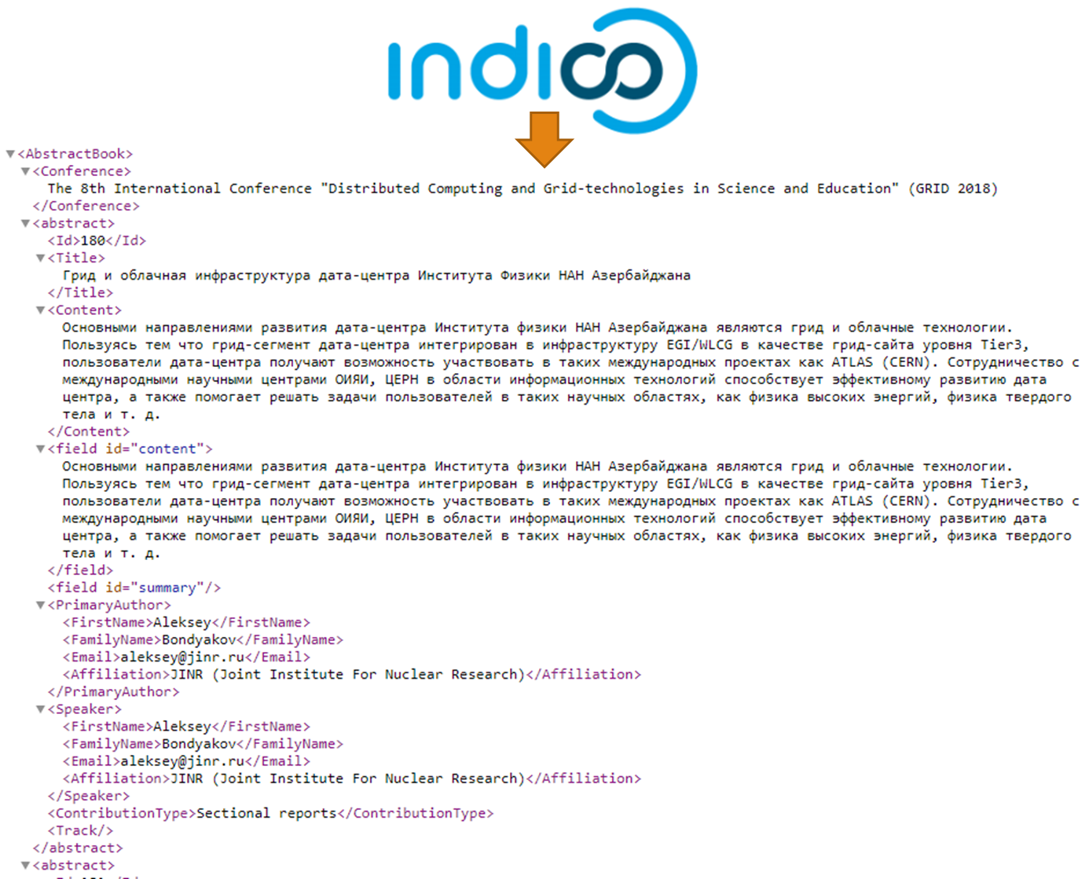

Figure . Example of the input file generated by the Indico web service in .xml format

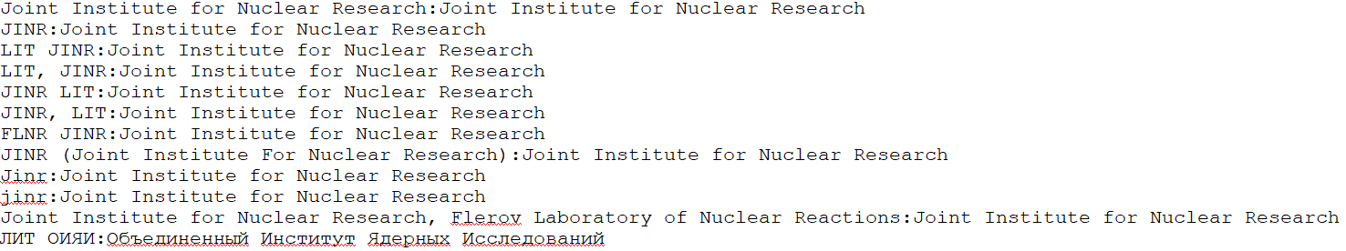

Figure . Variation in writing Joint Institute of Nuclear Research and bringing it to one standard

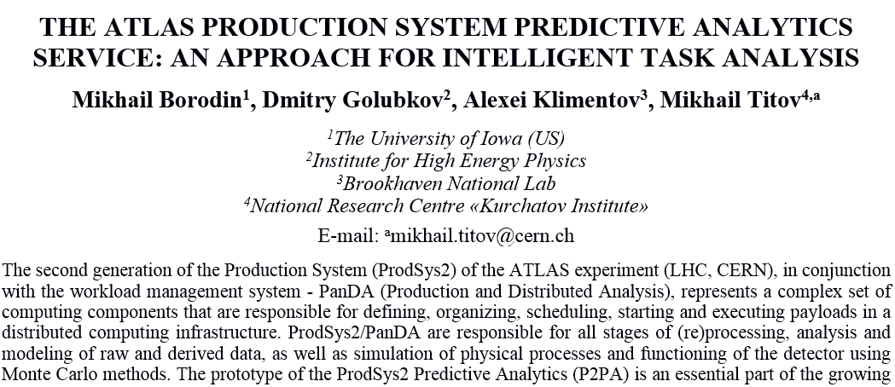

Figure . Affiliation and email indexes

# JINRex

System of organization and accounting of the excursions should be a web service that satisfies the following conditions:

1. The system should have a human-friendly interface.
2. It should have a user authorization and authentication system.
3. Each authenticated user should be assigned to one of the roles:
   1. Organizator – the person can create an application for an excursion.
   2. Incharge – the person who is responsible for conducting the excursion at the specific facility.
   3. Guide – the person who conducts excursions.
4. Each facility should have its own set of areas where excursions can be held.
5. The form for sending an application for an excursion have to include the following fields:
   1. Desired facility.
   2. Desired set of areas from those that are attached to the facility.
   3. Full user’s name from the list of Organizators.
   4. Full user’s name from the list of Guides.
   5. Full user’s name from the list of Incharges.
   6. Occasion excursion.
   7. Date excursion.
   8. Time period excursion.
   9. Language excursion.
   10. Type of auditory excursion.
   11. Number of participants.
   12. Age of the participants.
6. The system should have a mechanism for viewing all requests for excursions.
7. The system should have a mechanism for changing data in the application for the excursion.
8. Each of excursions should have Status field which can take one of two values: Confirmed and Unconfirmed. When creating or changing an application for an excursion the status should change to Unconfirmed until all participating persons (Organizator, Guide and Incharge) confirm these changes. Each person must receive a notification. After confirmation, the status of the application for the excursion should change to Confirmed.

# Methods

# IndicoAbstract

The method of generating documents based on templates in the .docx format. It is based on the fast process of creating a text template with variables that will be automatically replaced with the necessary data using special libraries (fig. 6).

To implement document generation using this method, it is necessary to create a software product with the appropriate library. Such a product should be able to read information from the input file and use the library to replace it with the corresponding variables. The disadvantages include the fact that if the corresponding library does not work correctly, the final document will also be incorrectly generated (there is a dependence on third-party software developers). [1] This approach is most practical for the generation of documents with large volumes of information, which must be issued in a special way, since:

1. Allows you to achieve your goal.
2. Supports the WYSIWYG property (What you see is what you get). [2]
3. Does not require writing tex- or html-views, unlike the LaTeX system. [3].
4. The final document has the same set of styles for formatting the text that was used in the template, which guarantees full compliance of the generated document with the standard.
5. The final document saves all notes made in the template (fig. 6).
6. The final document has an editable .docx format, which guarantees the possibility of editing information in case of its change.
7. A .docx format document can be easily exported to a .pdf document and immediately sent to print.

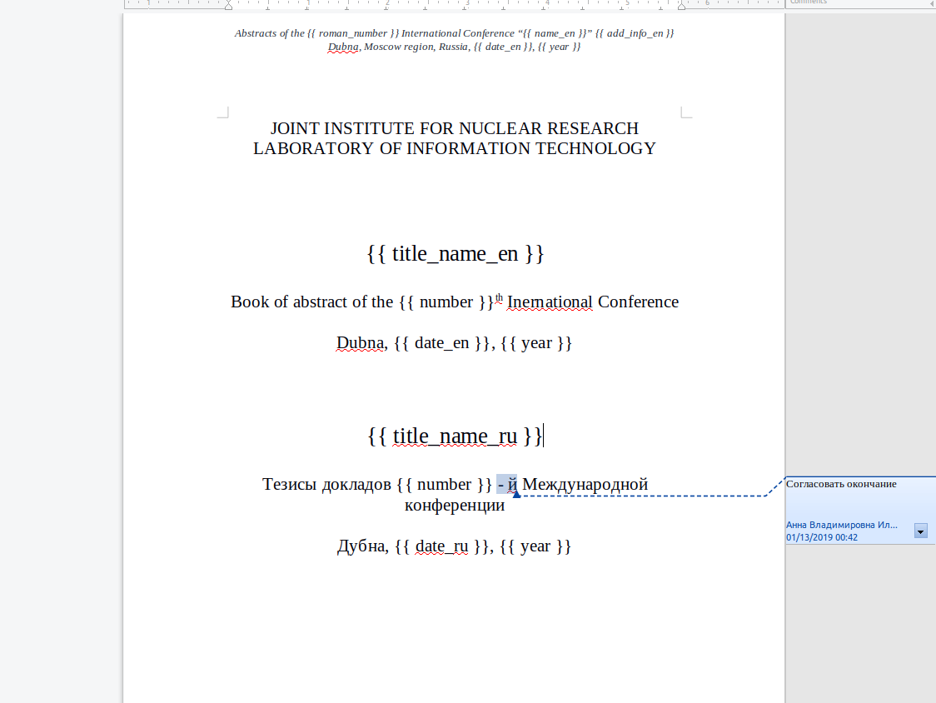

Figure . Example template with variables for generating book of abstracts

The implementation includes the following components:

1. Programming language Python v3.6. [4]
2. Library xml.etree.cElementTree for working with XML files in pure Python which is used when processing large files. [5]
3. Library python-docx for creating Microsoft Word (.docx) files. [6]
4. Library python-docx-template (docxtpl) for modifying Microsoft Word (.docx) files. [7]

# JINRex

The implementation includes the following components:

1. Programming language Python v3.6. [4]
2. Django. It is a high-level Python Web framework that encourages rapid development and clean, pragmatic design. Built by experienced developers, it takes care of much of the hassle of Web development, so you can focus on writing your app without needing to reinvent the wheel. Moreover, it’s free and open source. [8]
3. Bootstrap v3.1.1.
4. JavaScript
5. JQuery v1.11.0.
6. Crispy Forms v1.0.0.
7. DataTables v1.10.18.

# Results

# IndicoAbstract

# JINRex

# Summary

# Acknowledgments

# References

1. Автоматизируем генерацию *docx* документов по шаблону с помощью *python* и *docxtpl*. – Электрон. текст. дан. – Режим доступа: <http://tut-admin.ru/2017/05/31/автоматизируем-генерацию-docx-документо/>.
2. *WYSIWYG.* – Электрон. текст. дан. – Режим доступа: <https://ru.wikipedia.org/wiki/WYSIWYG>.
3. *ТеХ* - система для вёрстки текстов с формулами. – Электрон. текст. дан. – Режим доступа: <http://www.wikiznanie.ru/ru-wz/index.php/ТеХ_-_система_для_вёрстки_текстов_с_формулами>.