TRÍ TUỆ NHÂN TẠO – CT332
THỰC HÀNH BUỔI 2
TRẦN QUỐC TOÀN B2410699

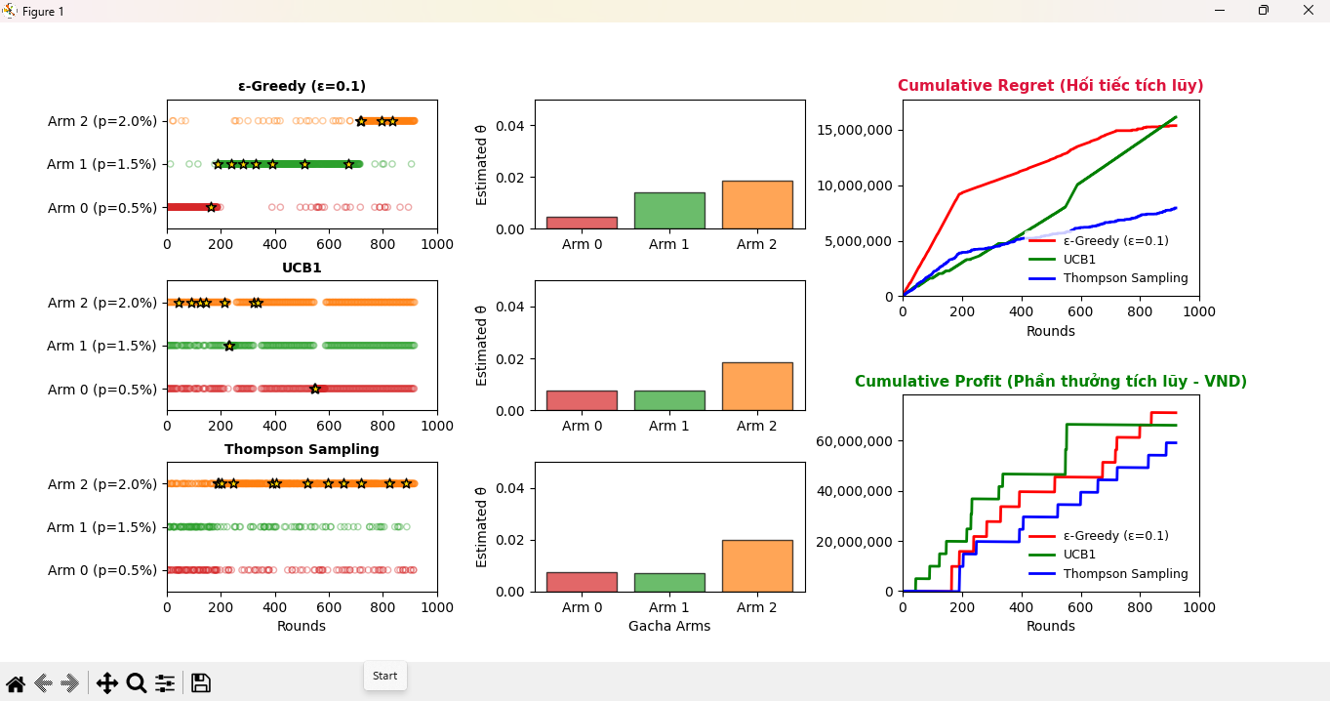
Code: Multi-Arm Bandit
import matplotlib
matplotlib.use('TkAgg')
import numpy as np
import matplotlib.pyplot as plt
from matplotlib.animation import FuncAnimation
np.random.seed(42)
true_probs = [0.005, 0.015, 0.02]
rewards = [10000000, 6000000, 5000000]
cost = 1000
n_arms = len(true_probs)
n_rounds = 1000
epsilon = 0.1
policies = ['eps_greedy', 'ucb', 'thompson']
titles = ["ε-Greedy (ε=0.1)", "UCB1", "Thompson Sampling"]
arm_colors = ['tab:red', 'tab:green', 'tab:orange']
Q_eps = np.zeros(n_arms)
N_eps = np.zeros(n_arms)
Q_ucb = np.zeros(n_arms)
N_ucb = np.zeros(n_arms)
alpha_ts = np.ones(n_arms)
beta_ts = np.ones(n_arms)
histories = {p: [] for p in policies}
regret_history = {p: [0] for p in policies}
profit_history = {p: [0] for p in policies}
true_evs = [p * r for p, r in zip(true_probs, rewards)]
best_ev = max(true_evs)
def select_epsilon_greedy():
if np.random.rand() < epsilon:
return np.random.randint(n_arms)
return np.argmax(Q_eps)
def select_ucb(t):
if 0 in N_ucb:
return np.argmin(N_ucb)
ucb_values = Q_ucb + 0.3 * np.sqrt(2 * np.log(t + 1) / N_ucb)
return np.argmax(ucb_values)
def select_thompson():
samples = np.random.beta(alpha_ts, beta_ts)
return np.argmax(samples)
def update_estimates(policy, a, r):
if policy == 'eps_greedy':
N_eps[a] += 1
Q_eps[a] += (r - Q_eps[a]) / N_eps[a]
elif policy == 'ucb':
N_ucb[a] += 1
Q_ucb[a] += (r - Q_ucb[a]) / N_ucb[a]
elif policy == 'thompson':
alpha_ts[a] += r
beta_ts[a] += (1 - r)
def run_one_step(policy, t):
if policy == 'eps_greedy':
a = select_epsilon_greedy()
elif policy == 'ucb':
a = select_ucb(t)
else:
a = select_thompson()
r = np.random.rand() < true_probs[a]
update_estimates(policy, a, r)
histories[policy].append((t, a, r))
regret = best_ev - true_evs[a]
regret_history[policy].append(regret_history[policy][-1] + regret)
net_reward = rewards[a] - cost if r else -cost
profit_history[policy].append(profit_history[policy][-1] + net_reward)
fig = plt.figure(figsize=(16, 9))
main_grid = plt.GridSpec(1, 3, width_ratios=[1, 1, 1.1], wspace=0.35)
left_grid = main_grid[0].subgridspec(3, 1, hspace=0.4)
middle_grid = main_grid[1].subgridspec(3, 1, hspace=0.4)
right_grid = main_grid[2].subgridspec(2, 1, hspace=0.5)
axes_scatter = []
axes_bars = []
for i, policy in enumerate(policies):
ax_scat = fig.add_subplot(left_grid[i])
ax_scat.set_xlim(0, n_rounds)
ax_scat.set_ylim(-0.5, n_arms - 0.5)
ax_scat.set_yticks(range(n_arms))
ax_scat.set_yticklabels([f"Arm {j} (p={true_probs[j] * 100:.1f}%)" for j in range(n_arms)])
ax_scat.set_title(titles[i], fontweight='bold', fontsize=10)
if i == 2: ax_scat.set_xlabel("Rounds")
axes_scatter.append(ax_scat)
ax_bar = fig.add_subplot(middle_grid[i])
ax_bar.set_ylim(0, max(true_probs) * 2.5)
ax_bar.set_xticks(range(n_arms))
ax_bar.set_xticklabels(["Arm 0", "Arm 1", "Arm 2"])
ax_bar.set_ylabel("Estimated θ̂")
if i == 2: ax_bar.set_xlabel("Gacha Arms")
axes_bars.append(ax_bar)
bars = [ax.bar(range(n_arms), [0] * n_arms, color=arm_colors, alpha=0.7, edgecolor='black') for ax in axes_bars]
ax_regret = fig.add_subplot(right_grid[0])
ax_regret.set_title("Cumulative Regret (Hối tiếc tích lũy)", fontweight='bold', color='crimson', fontsize=11)
ax_regret.set_xlim(0, n_rounds)
ax_regret.set_xlabel("Rounds")
ax_regret.ticklabel_format(style='plain', axis='y')
ax_regret.get_yaxis().set_major_formatter(plt.FuncFormatter(lambda x, loc: "{:,}".format(int(x))))
ax_profit = fig.add_subplot(right_grid[1])
ax_profit.set_title("Cumulative Profit (Phần thưởng tích lũy - VND)", fontweight='bold', color='green', fontsize=11)
ax_profit.set_xlim(0, n_rounds)
ax_profit.set_xlabel("Rounds")
ax_profit.ticklabel_format(style='plain', axis='y')
ax_profit.get_yaxis().set_major_formatter(plt.FuncFormatter(lambda x, loc: "{:,}".format(int(x))))
policy_lines = {'eps_greedy': 'red', 'ucb': 'green', 'thompson': 'blue'}
lines_regret = {p: ax_regret.plot([], [], color=policy_lines[p], label=titles[k], linewidth=2)[0] for k, p in
enumerate(policies)}
lines_profit = {p: ax_profit.plot([], [], color=policy_lines[p], label=titles[k], linewidth=2)[0] for k, p in
enumerate(policies)}
ax_regret.legend(loc="lower right", fontsize=9, frameon=True, facecolor='white', edgecolor='none')
ax_profit.legend(loc="lower right", fontsize=9, frameon=True, facecolor='white', edgecolor='none')
def update(frame):
for i, policy in enumerate(policies):
run_one_step(policy, frame)
t_list = [h[0] for h in histories[policy]]
arm_list = [h[1] for h in histories[policy]]
reward_list = [h[2] for h in histories[policy]]
for coll in list(axes_scatter[i].collections):
coll.remove()
for arm in range(n_arms):
arm_times = [t for t, a in zip(t_list, arm_list) if a == arm]
arm_rewards = [r for a, r in zip(arm_list, reward_list) if a == arm]
x_empty = [t for t, r in zip(arm_times, arm_rewards) if r == 0]
y_empty = [arm] * len(x_empty)
x_filled = [t for t, r in zip(arm_times, arm_rewards) if r == 1]
y_filled = [arm] * len(x_filled)
axes_scatter[i].scatter(x_empty, y_empty, facecolors='none', edgecolors=arm_colors[arm], s=20, alpha=0.4)
if x_filled:
axes_scatter[i].scatter(x_filled, y_filled, color='gold', marker='*', s=60, edgecolors='black',
zorder=3)
if policy == 'eps_greedy':
est = Q_eps.copy()
elif policy == 'ucb':
est = Q_ucb.copy()
else:
est = alpha_ts / (alpha_ts + beta_ts)
for j, b in enumerate(bars[i]):
b.set_height(est[j])
lines_regret[policy].set_data(range(len(regret_history[policy])), regret_history[policy])
lines_profit[policy].set_data(range(len(profit_history[policy])), profit_history[policy])
all_regrets = [val for p in policies for val in regret_history[p]]
all_profits = [val for p in policies for val in profit_history[p]]
ax_regret.set_ylim(min(all_regrets) - 5, max(all_regrets) * 1.1 + 10)
ax_profit.set_ylim(min(all_profits) * 1.1 - 2000, max(all_profits) * 1.1 + 10000)
return list(lines_regret.values()) + list(lines_profit.values()) + [b for bar in bars for b in bar]
anim = FuncAnimation(fig, update, frames=n_rounds, interval=15, blit=False, repeat=False)
plt.show()

--HẾT--

