* 1. **ERD**

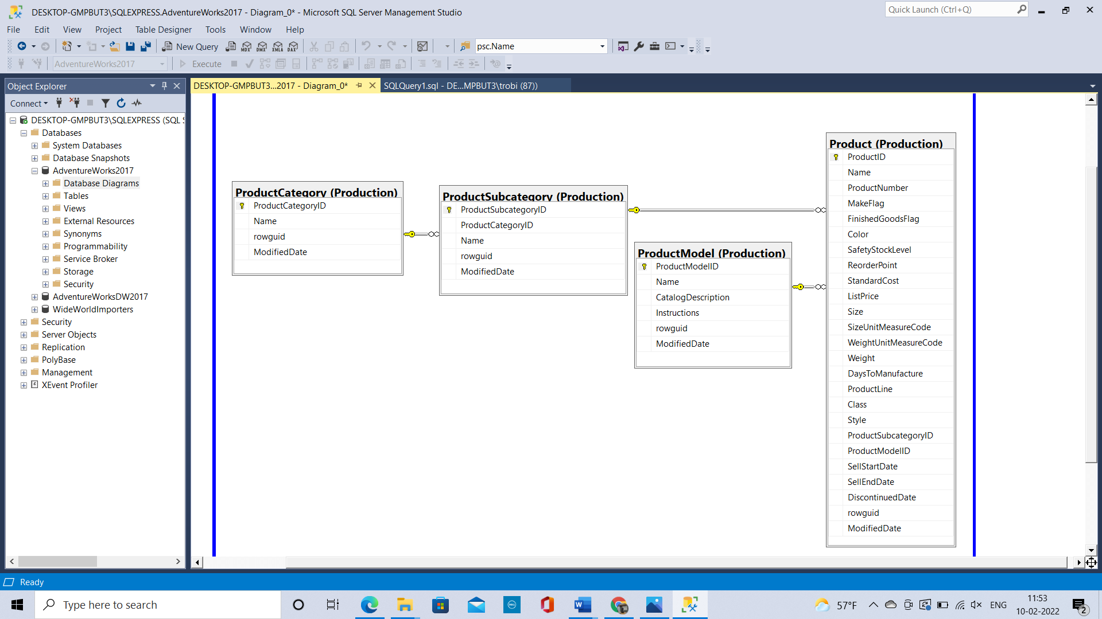

* 1. **Get Fields Query**
     1. How many rows are in the Product table?  
        **504**
     2. How many rows are in the SubCategory table?  
        **37**
     3. How many rows are in the Category table?  
        **4**
     4. Based on prior assignments and using the field list below, how many rows should appear in your query?  
        **295**

e) i) How many rows did you get in the query?  
**304 rows**

1. Did the row count match your expectations based on prior assignments? If not, explain the difference and offer a business explanation as to what is happening.

**No, it didn’t match because here I am asked to list all the rows in the product table which have listPrice and StandardCost greater than 0. Whereas in previous assignment I was asked to display the fields only which have the subcategory.**

f) Screenshot  
  
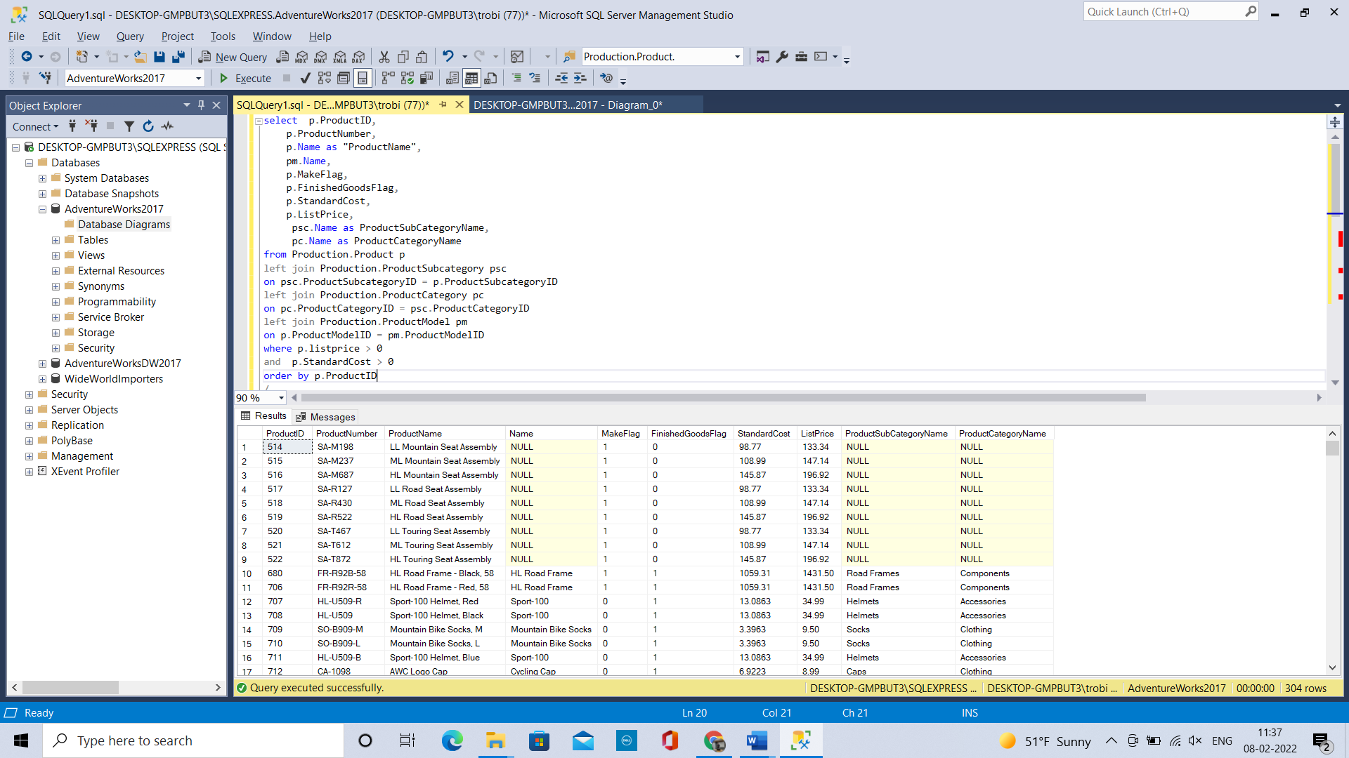

g) Paste a copy of the final SQL Code in the Get Fields Query section of A03.docx  
  
select p.ProductID,

p.ProductNumber,

p.Name as "ProductName",

pm.Name,

p.MakeFlag,

p.FinishedGoodsFlag,

p.StandardCost,

p.ListPrice,

psc.Name as ProductSubCategoryName,

pc.Name as ProductCategoryName

from Production.Product p

left join Production.ProductSubcategory psc

on psc.ProductSubcategoryID = p.ProductSubcategoryID

left join Production.ProductCategory pc

on pc.ProductCategoryID = psc.ProductCategoryID

left join Production.ProductModel pm

on p.ProductModelID = pm.ProductModelID

where p.listprice > 0

and p.StandardCost > 0

order by p.ProductID

* 1. **Math Query**Screenshot

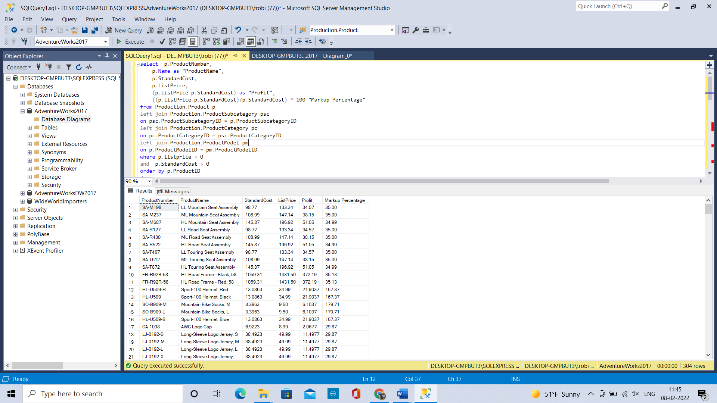Final SQL code:  
  
select p.ProductNumber,

p.Name as "ProductName",

p.StandardCost,

p.ListPrice,

(p.ListPrice-p.StandardCost) as "Profit",

((p.ListPrice-p.StandardCost)/p.StandardCost) * 100 "Markup Percentage"

from Production.Product p

left join Production.ProductSubcategory psc

on psc.ProductSubcategoryID = p.ProductSubcategoryID

left join Production.ProductCategory pc

on pc.ProductCategoryID = psc.ProductCategoryID

left join Production.ProductModel pm

on p.ProductModelID = pm.ProductModelID

where p.listprice > 0

and p.StandardCost > 0

order by p.ProductID

g) Answer in Get Fields Query section of A03.docx. Add an order by and manipulate it so that you can answer the following questions. Remember that you cannot sort a FORMATTED field so be sure that you did not FORMAT any of your fields yet.

* + 1. What is the most profitable product?  
       **Mountain-100 Silver, 38**

**Mountain-100 Silver, 42**

**Mountain-100 Silver, 44**

**Mountain-100 Silver, 48**

**Profit – 1487.8356**order by profit desc

* + 1. What is the least profitable product?  
       **Patch Kit/8 Patches  
       Profit – 1.4335**order by profit
    2. What product has the highest markup percentage?  
       **Mountain Bike Socks, M  
       Mountain Bike Socks, L 179.71%**order by Markup_Percentage desc
    3. What product has the smallest markup percentage?  
       AWC Logo Cap

**Long-Sleeve Logo Jersey, S**

**Long-Sleeve Logo Jersey, M**

**Long-Sleeve Logo Jersey, L**

**Long-Sleeve Logo Jersey, XL**

**Short-Sleeve Classic Jersey, S**

**Short-Sleeve Classic Jersey, M**

**Short-Sleeve Classic Jersey, L**

**Short-Sleeve Classic Jersey, XL**

**All above products have 29.87 %**order by Markup_Percentage

* 1. **Sub-Category Aggregate Query**

Screenshot  
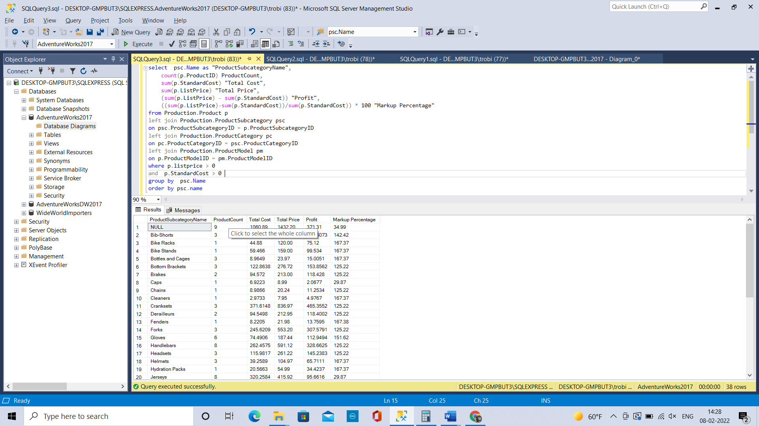  
  
Final SQL Code  
  
select psc.Name as "ProductSubcategoryName",

count(p.ProductID) ProductCount,

sum(p.StandardCost) "Total Cost",

sum(p.ListPrice) "Total Price",

(sum(p.ListPrice) - sum(p.StandardCost)) "Profit",

((sum(p.ListPrice)-sum(p.StandardCost))/sum(p.StandardCost)) * 100 "Markup Percentage"

from Production.Product p

left join Production.ProductSubcategory psc

on psc.ProductSubcategoryID = p.ProductSubcategoryID

left join Production.ProductCategory pc

on pc.ProductCategoryID = psc.ProductCategoryID

left join Production.ProductModel pm

on p.ProductModelID = pm.ProductModelID

where p.listprice > 0

and p.StandardCost > 0

group by psc.Name

order by psc.name

1. Answer in Sub-Category Aggregate Query section of A03.docx. Add an order by and manipulate it so that you can answer the following questions. Remember that you cannot sort a FORMATTED field so be sure that you did not FORMAT any of your fields yet.
   * 1. What is the most profitable subcategory?  
        **Road Bikes -- 25968.7222** -- order by Profit desc
     2. What is the least profitable subcategory?  
        **Caps -- 2.0677** -- order by Profit
     3. What subcategory has the highest markup percentage?  
        **Socks -- 173.57**% -- order by MarkupPercentage desc
     4. What subcategory has the smallest markup percentage?  
        **Caps, Jerseys -- 29.87%** -- order by MarkupPercentage
   1. **Category Aggregate Query**

Screenshot  
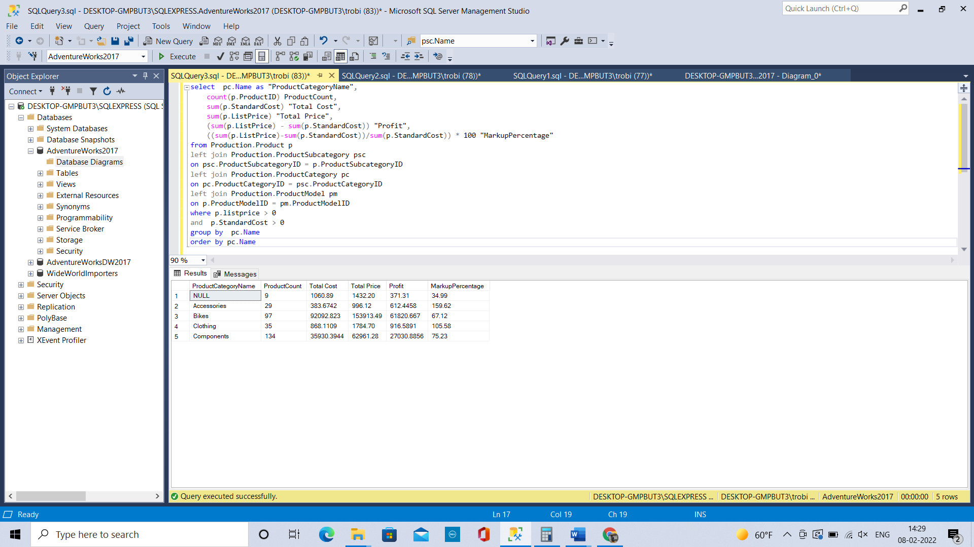  
  
Final SQL Code  
select pc.Name as "ProductCategoryName",

count(p.ProductID) ProductCount,

sum(p.StandardCost) "Total Cost",

sum(p.ListPrice) "Total Price",

(sum(p.ListPrice) - sum(p.StandardCost)) "Profit",

((sum(p.ListPrice)-sum(p.StandardCost))/sum(p.StandardCost)) * 100 "MarkupPercentage"

from Production.Product p

left join Production.ProductSubcategory psc

on psc.ProductSubcategoryID = p.ProductSubcategoryID

left join Production.ProductCategory pc

on pc.ProductCategoryID = psc.ProductCategoryID

left join Production.ProductModel pm

on p.ProductModelID = pm.ProductModelID

where p.listprice > 0

and p.StandardCost > 0   
group by pc.Name  
order by pc.Name   
  
d) Answer in Category Aggregate Query section of A03.docx. Add an order by and manipulate it so that you can answer the following questions. Remember that you cannot sort a FORMATTED field so be sure that you did not FORMAT any of your fields yet.

* + 1. What is the most profitable category?  
       **Bikes-- 61820.667**-- order by profit desc
    2. What is the least profitable category?  
       **Accessories -- 612.4458** -- order by profit
    3. What category has the highest markup percentage?

**Accessories -- 159.62**% -- order by MarkupPercentage desc

* + 1. What category has the smallest markup percentage?

**Bikes -- 67.**12 -- order by MarkupPercentage

* 1. **Formatted Fields**

Screenshot  
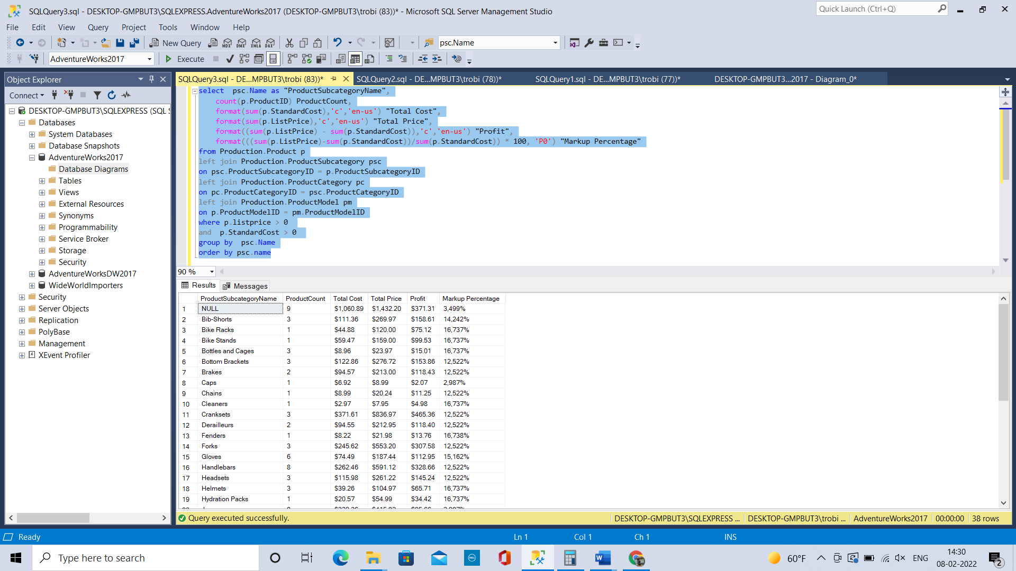  
  
Final SQL Code  
  
select psc.Name as "ProductSubcategoryName",

count(p.ProductID) ProductCount,

format(sum(p.StandardCost),'c','en-us') "Total Cost",

format(sum(p.ListPrice),'c','en-us') "Total Price",

format((sum(p.ListPrice) - sum(p.StandardCost)),'c','en-us') "Profit",

format(((sum(p.ListPrice)-sum(p.StandardCost))/sum(p.StandardCost)) * 100, 'P0') "Markup Percentage"

from Production.Product p

left join Production.ProductSubcategory psc

on psc.ProductSubcategoryID = p.ProductSubcategoryID

left join Production.ProductCategory pc

on pc.ProductCategoryID = psc.ProductCategoryID

left join Production.ProductModel pm

on p.ProductModelID = pm.ProductModelID

where p.listprice > 0

and p.StandardCost > 0

group by psc.Name

order by psc.name  
  
h) Answer in Formatted Fields Query section of A03.docx. **Add an order by the FORMATTED Markup Percentage field** and manipulate it so that you can answer the following questions:

* + 1. What is the most profitable sub-category?

**Bike Stands -- $99.53**

* + 1. What is the least profitable sub-category?

**Wheels -- $1,719.71**

* + 1. What sub-category has the highest markup percentage?

**Mountain Frames -- 8,585%**

* + 1. What sub-category has the smallest markup percentage?

**Bottom Brackets to Wheels (11 rows) -- 12,522%**

* + 1. Are these answers different from those you got above in the Sub-Category Query when you sorted before formatting? What is different?

**The values are different because when we sort after formatting it is ordering in a character format.**

* 1. **Discussion**
  2. Discuss why some kinds and types of Products do not show up in these queries.

**Because their standard cost and list price is zero**

* 1. Why did you have to eliminate some rows to make this work and the answer is NOT that some rows had zero cost? From a business point of view what rows did not have costs?

**The products which are not finished goods have zero cost.**

* 1. **Business Meaning - Graduate Students Only**
  2. Discuss if we should sell products with a high profit or focus on selling those with a high markup percentage.

**We should focus on selling the products with a high markup percentage than with high profit because we are investing less and getting more. If we can invest more on the products with high markup percentage we will get more profit.  
So rather than selling the products with high profit we should focus on selling the products with high markup percentage.**