1. **Understand Data Structure and Data**



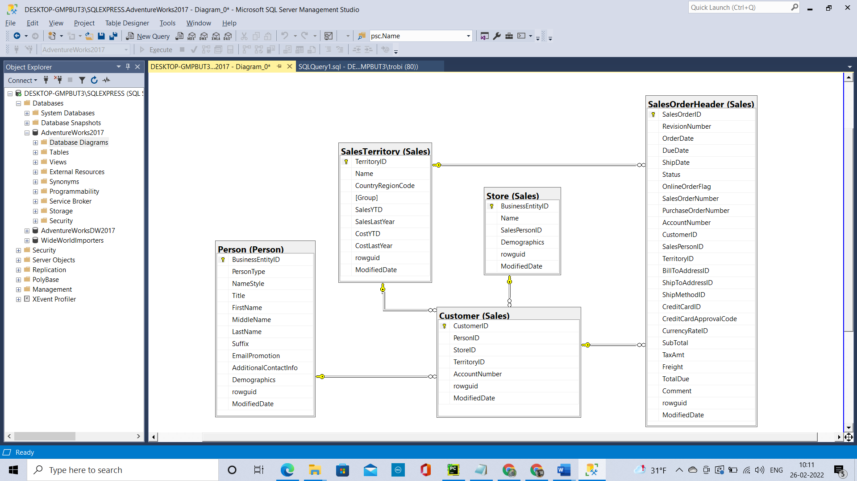

* + 1. For each table answer the following in A06.docx
       1. How many rows?

Person.Person - 19972  
Sales.SalesTerritory - 10  
Sales.Store - 701  
Sales.Customer - 19820  
Sales.SalesOrderHeader - 31465

* + - 1. Describe the table

Person.Person – Store the details of the Customer details and the customer can be Person (Individual- Retail), Store Contact person, Vendor Contact person etc.  
Sales.SalesTerritory – Store the details of Territory and Territory Wise sale.   
Sales.Store – Store the details of the Store name which is a Customer  
Sales.Customer – Store the account number and many key fields which points to the other tables like person, store, salesterritory.  
Sales.SalesOrderHeader – Store the details of sales like salesorderID, OrderDate, CustID, Billing details, Shipping details, Amt Due etc.

* + 1. For each relationship answer the following in A06.docx
       1. Describe the relationship

Customer and Store  
The BusinessEntityID of Store table (One) is related to StoreID of Customer table(Many)

Customer and Person   
The BusinessEntityID of Person table (One) is related to PersonID of Customer table(Many)

Customer and SalesTerritory  
The TerritoryID of SalesTerritory table (One) is related to TerritoryID of Customer table(Many)

Customer and SalesOrderHeader  
The CustomerID of SalesOrderHeader table (Many) is related to CustomerID of Customer table(One)

SalesTerritory and SalesOrderHeader  
The TerritoryID of SalesTerritory table (One) is related to TerritoryID of SalesOrderHeader table(Many)

* + - 1. Does the relationship always exist? If not, when not?  
           
         Customer and Store  
         No, the relationship doesn’t exist when the StoreID of Customer table is null.

Customer and Person   
No, the relationship doesn’t exist when the PersonID of Customer table is null.

Customer and SalesTerritory  
No, the relationship doesn’t exist when the TerritoryID of Customer table is null.

Customer and SalesOrderHeader  
No, the relationship doesn’t exist when the CustomerID of SalesOrderHeader table is null.

SalesTerritory and SalesOrderHeader  
No, the relationship doesn’t exist when the TerritoryID of SalesOrderHeader table is null.

1. **Customer Name and Kinds of Customers**
   1. Explain why there is no customer name in the Customer table and where is the customer name?

There is no customer name because there are different type of customers (Store, Person (“IN”), Store Contact person (In person table “SC”)) and the customer name can be found in Person Table.

* 1. The structure and the data tells you that there is more than one type of customer, which are:
     1. Person
     2. Store
     3. Store with Contact
  2. How did I arrive at that conclusion? What fields have what values for each of the three customer types?
     1. Person – The Person table and the PersonType should be “IN”
     2. Store – The Store table and the Name field of Store table.
     3. Store with Contact – The Person table and the PersonType should be “SC”

1. **Customer Name List**

select c.AccountNumber,

case when p.PersonType is null then 'Store'

else

case when p.PersonType = 'SC' then 'Store with Contact'

when p.PersonType = 'IN' then 'Person'

else 'error' end

end as CustomerType,

case when p.PersonType is null then

s.name

else

case when p.PersonType = 'SC' then

concat(s.name,' - ',concat(p.LastName,',',p.FirstName,' ',

case when p.MiddleName is null then ''

when len(p.MiddleName) = 1 then concat(p.MiddleName,'.')

when len(p.MiddleName) > 1 then p.MiddleName

else 'error' end))

when p.PersonType = 'IN' then

concat(p.LastName,',',p.FirstName,' ',

case when p.MiddleName is null then ''

when len(p.MiddleName) = 1 then concat(p.MiddleName,'.')

when len(p.MiddleName) > 1 then p.MiddleName

else 'error' end)

else 'error' end

end name

from Sales.customer c

left join Person.Person p

on c.PersonID = p.BusinessEntityID

left join sales.Store s

on c.StoreID = s.BusinessEntityID

order by c.AccountNumber asc

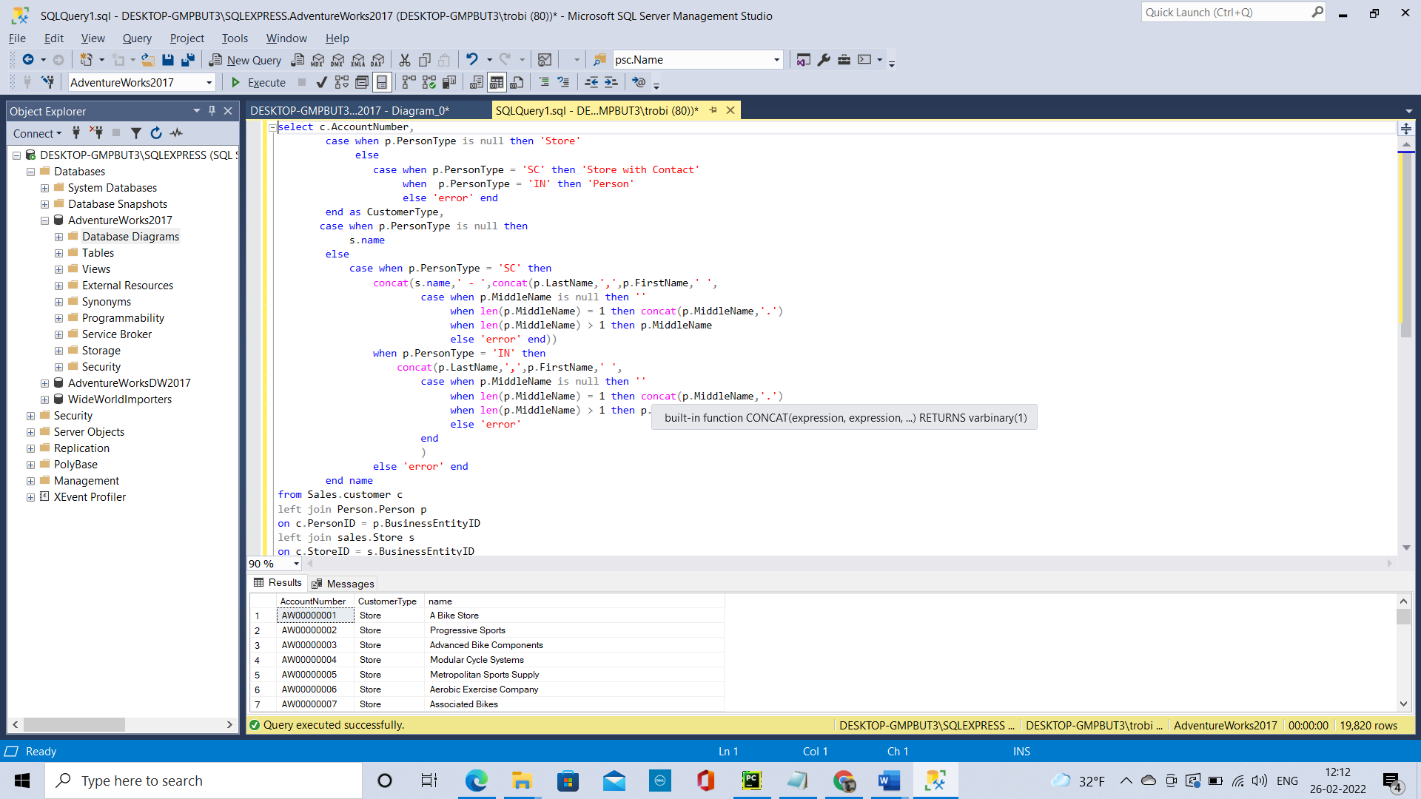

* 1. Create Store with Contact Customer Report
     1. Limit your query to only include Store with Contact customer type
        1. Submit a **copy of the code** in A06.docx.

select c.AccountNumber,

case when p.PersonType is null then 'Store'

else

case when p.PersonType = 'SC' then 'Store with Contact'

when p.PersonType = 'IN' then 'Person'

else 'error' end

end as CustomerType,

case when p.PersonType is null then

s.name

else

case when p.PersonType = 'SC' then

concat(s.name,' - ',concat(p.LastName,',',p.FirstName,' ',

case when p.MiddleName is null then ''

when len(p.MiddleName) = 1 then concat(p.MiddleName,'.')

when len(p.MiddleName) > 1 then p.MiddleName

else 'error' end))

when p.PersonType = 'IN' then

concat(p.LastName,',',p.FirstName,' ',

case when p.MiddleName is null then ''

when len(p.MiddleName) = 1 then concat(p.MiddleName,'.')

when len(p.MiddleName) > 1 then p.MiddleName

else 'error'

end

)

else 'error' end

end name

from Sales.customer c

left join Person.Person p

on c.PersonID = p.BusinessEntityID

left join sales.Store s

on c.StoreID = s.BusinessEntityID

where p.PersonType = 'SC'

order by c.AccountNumber asc

1. **Count Customer Types**

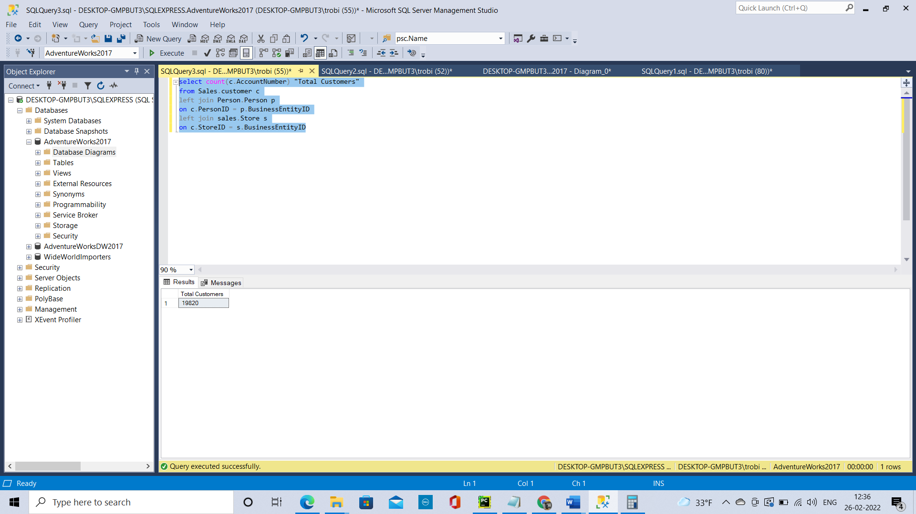

select count(c.AccountNumber) "Total Customers"

from Sales.customer c

left join Person.Person p

on c.PersonID = p.BusinessEntityID

left join sales.Store s

on c.StoreID = s.BusinessEntityID

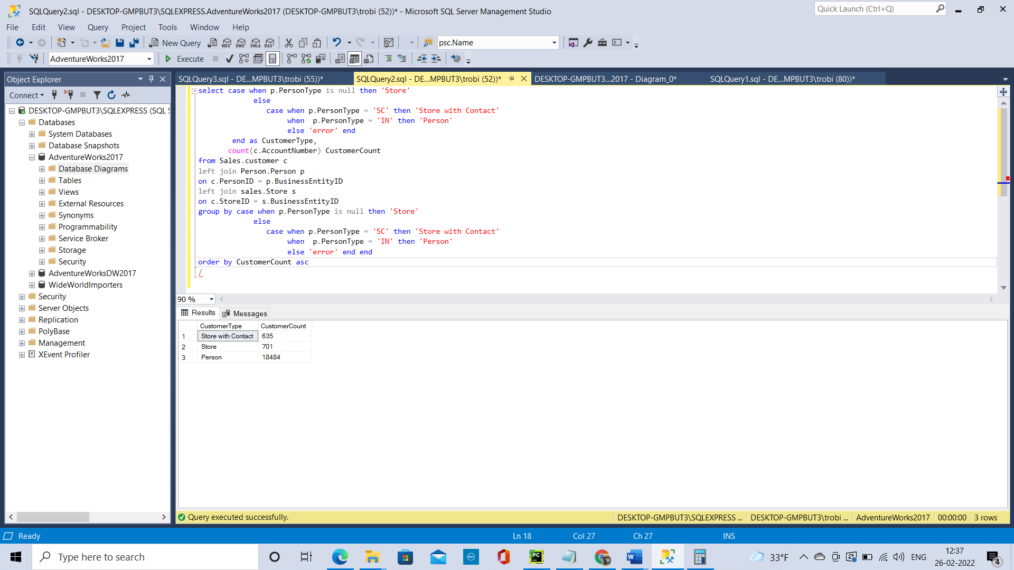

select case when p.PersonType is null then 'Store'

else

case when p.PersonType = 'SC' then 'Store with Contact'

when p.PersonType = 'IN' then 'Person'

else 'error' end

end as CustomerType,

count(c.AccountNumber) CustomerCount

from Sales.customer c

left join Person.Person p

on c.PersonID = p.BusinessEntityID

left join sales.Store s

on c.StoreID = s.BusinessEntityID

group by case when p.PersonType is null then 'Store'

else

case when p.PersonType = 'SC' then 'Store with Contact'

when p.PersonType = 'IN' then 'Person'

else 'error' end end

order by CustomerCount asc

1. **Discussion**
   1. What do you now know about AdventureWorks customers?

The AdventureWorks customers are Individual persons, Stores, Store contact person

* 1. Look at the counts. What are the data points that is most important to communicate to management?

For 66 (701-635) store there is no contact person. This detail should be got in order to get orders.

* 1. Given the datapoints what customers should AdventureWorks focus on?

AdventureWorks should focus on Stores and Store Contact person since their numbers are low. And Individual customers(Retail) is their strength.