## **Understand Data Structure and Data.**

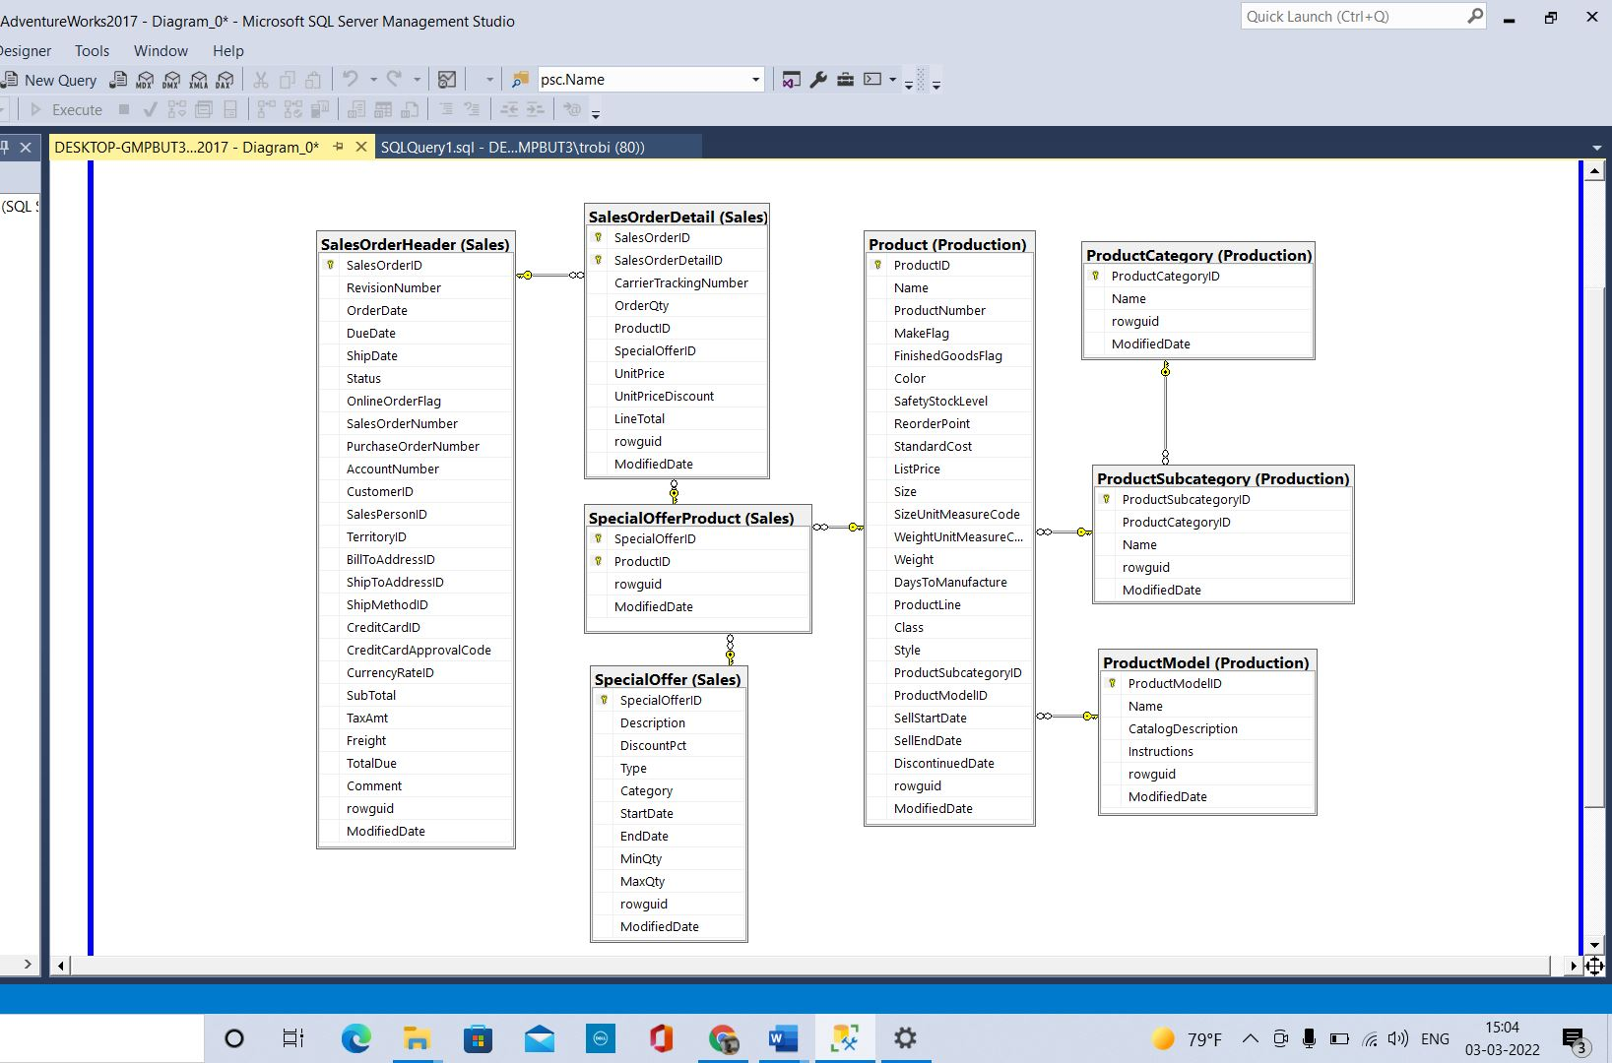



* 1. Understand the Tables
     1. Write and run a query to select all rows and fields from each of the tables in your ERD. Familiarize yourself with the data.
     2. For each table answer the following in A07.docx
        1. How many rows?

sales.SalesOrderHeader--31465

sales.SalesOrderDetail--121317

sales.SpecialOffer--16

sales.SpecialOfferProduct--538

Production.Product--504

Production.ProductModel--128

Production.ProductCategory—4

Production.ProductSubcategory--37

* + - 1. Describe the table

sales.SalesOrderHeader—Stores the Order details and it is the header table for SalesOrderDetail for each record in SalesOrderHeader table there will be multiple values in the SalesOrderDetail table.

sales.SalesOrderDetail—Stores the details for the salesorder and it contains all the information with respect to sales

sales.SpecialOffer—It Stores the Account Number, CustomerID details of the Customer

sales.SpecialOfferProduct—It is the intermediate table that connects product, specialoffer, salesorderdetail table

Production.Product—It stores the details of the product

Production.ProductModel—It stores the details of the Models

Production.ProductCategory— It store the Categories of the product

Production.ProductSubcategory—It stores the SubCategories of the product

* + 1. For each relationship answer the following in A07.docx
       1. Describe the relationship

SalesOrderHeader, SalesOrderDetail  
The SalesOrderID is the key to connect Header(One) , Detail(Many)

SalesOrderDetail, SpecialOfferProduct  
SpecialOfferID and ProductID is the key to connect SalesOrderDetail(Many), SpecialOfferProduct(One)

SalesOrderHeader, Customer  
CustomerID is the key to connect SalesOrderHeader (Many), Customer (One)  
  
SpecialOfferProduct,Product  
ProductID is the key to connect SpecialOfferProduct (Many), Product(One)

Product, ProductSubCategory  
ProductSubCategoryID is the key to connect Product (Many), ProductSubCategory(One)

ProductSubCategory, ProductCategory  
ProductCategoryID is the key to connect ProductCategory (One), ProductSubCategory(Many)

Product, ProductModel  
ProductModelID is the key to connect ProductModel (One), Product (Many)

* + - 1. Does the relationship always exist? If not, when not?

The relationship does not exist when there are null records in the Many side or unmatching records between the two tables.  
  
The relationship exists only when there are matching records (Key columns (Relationship)) in the two tables.

* + 1. Assuming the goal is to investigate profitability of product sales for AdventureWorks, what table should drive your queries (i.e., be the FROM table)?

sales.SalesOrderDetail

* + 1. Which table has the most rows that gives you pertinent sales information about products?

sales.SalesOrderDetail

## **All Sales.**

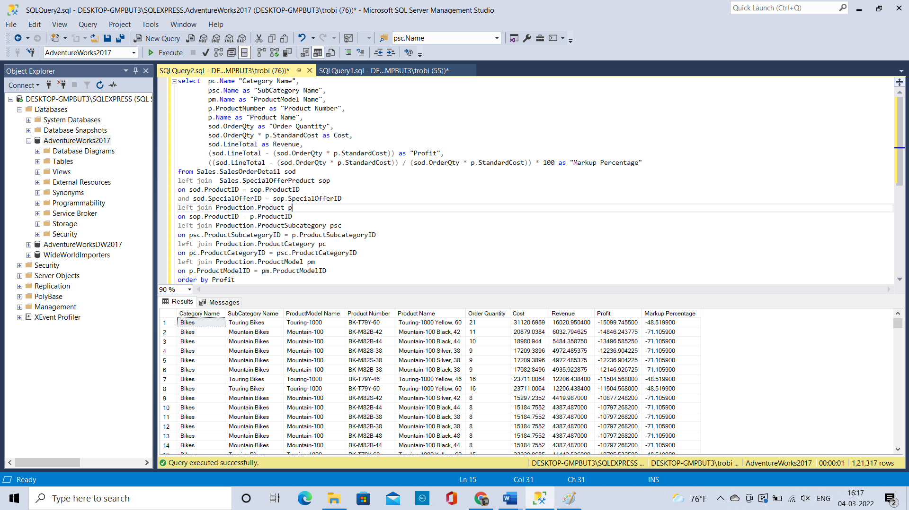

* 1. Submit a **copy of the code** in A07.docx.

select pc.Name "Category Name",

psc.Name as "SubCategory Name",

pm.Name as "ProductModel Name",

p.ProductNumber as "Product Number",

p.Name as "Product Name",

sod.OrderQty as "Order Quantity",

sod.OrderQty * p.StandardCost as Cost,

sod.LineTotal as Revenue,

(sod.LineTotal - (sod.OrderQty * p.StandardCost)) as "Profit",

((sod.LineTotal - (sod.OrderQty * p.StandardCost)) / (sod.OrderQty * p.StandardCost)) * 100 as "Markup Percentage"

from Sales.SalesOrderDetail sod

left join Sales.SpecialOfferProduct sop

on sod.ProductID = sop.ProductID

and sod.SpecialOfferID = sop.SpecialOfferID

left join Production.Product p

on sop.ProductID = p.ProductID

left join Production.ProductSubcategory psc

on psc.ProductSubcategoryID = p.ProductSubcategoryID

left join Production.ProductCategory pc

on pc.ProductCategoryID = psc.ProductCategoryID

left join Production.ProductModel pm

on p.ProductModelID = pm.ProductModelID

order by Profit

* 1. Change your query and return it to answer the following questions in A07.docx:
     1. What was the most profitable sale?

674216.578641 Bikes Mountain Bikes Mountain-200 BK-M68B-42 Mountain-200 Black, 42

* + 1. What sale produced the most revenue?

4400592.800400 Bikes Mountain Bikes Mountain-200 BK-M68B-38 Mountain-200 Black, 38

* + 1. What sale had the highest markup percentage?

167.380300 Accessories Fenders Fender Set - Mountain FE-6654 Fender Set - Mountain

* + 1. What was the least profitable sale?

-153696.116612 Bikes Road Bikes Road-650 BK-R50R-44 Road-650 Red, 44

* + 1. What sale produced the least revenue?

162.720000 Components Saddles LL Road Seat/Saddle 1 SE-R581 LL Road Seat/Saddle

* + 1. What sale had the lowest markup percentage?

-21.670200 Clothing Jerseys Long-Sleeve Logo Jersey LJ-0192-L Long-Sleeve Logo Jersey, L

* 1. Describe what you think the most important findings are from these queries in A07.docx.

The Profit is in Negative for many products and with the order by clause we will be able to achieve our results. Not all the categories with the highest profit have highest markup percentage or highest revenue.

## **Product Profitability**

select p.ProductNumber as "Product Number",

p.Name as "Product Name",

sum(sod.OrderQty) as "Total Quantity",

sum(sod.OrderQty * p.StandardCost) as "Total Cost",

sum(sod.LineTotal) as "Total Revenue",

sum(sod.LineTotal - (sod.OrderQty * p.StandardCost)) as "Total Profit",

(sum(sod.LineTotal - (sod.OrderQty * p.StandardCost))/sum(sod.OrderQty * p.StandardCost)) * 100 as "Markup Percentage"

from Sales.SalesOrderDetail sod

left join Sales.SpecialOfferProduct sop

on sod.ProductID = sop.ProductID

and sod.SpecialOfferID = sop.SpecialOfferID

left join Production.Product p

on sop.ProductID = p.ProductID

group by p.ProductNumber,p.Name

order by "Total Profit" desc

Change your query and return it to answer the following questions in A07.docx:

* + 1. What is the most profitable product?

674216.578641 Mountain-200 Black, 42 BK-M68B-42

* + 1. What product produces the most revenue?

4400592.800400 Mountain-200 Black, 38 BK-M68B-38

* + 1. What product has the highest markup percentage?

167.380300 Fender Set - Mountain FE-6654

* + 1. What is the least profitable product?

-153696.116612 Road-650 Red, 44 BK-R50R-44

* + 1. What product produces the least revenue?

162.720000 LL Road Seat/Saddle SE-R581

* + 1. What product has the least markup percentage?

-21.670200 Long-Sleeve Logo Jersey, L LJ-0192-L

## Describe what you think the most important findings are from these queries

The Profit is in Negative for many products and with the order by clause we will be able to achieve our results.

## **Product Model Profitability**

select pm.Name as "Product Model",

sum(sod.OrderQty) as "Total Quantity",

sum(sod.OrderQty * p.StandardCost) as "Total Cost",

sum(sod.LineTotal) as "Total Revenue",

sum(sod.LineTotal - (sod.OrderQty * p.StandardCost)) as "Total Profit",

(sum(sod.LineTotal - (sod.OrderQty * p.StandardCost)) / sum(sod.OrderQty * p.StandardCost)) * 100 as "Markup Percentage"

from Sales.SalesOrderDetail sod

left join Sales.SpecialOfferProduct sop

on sod.ProductID = sop.ProductID

and sod.SpecialOfferID = sop.SpecialOfferID

left join Production.Product p

on sop.ProductID = p.ProductID

left join Production.ProductModel pm

on p.ProductModelID = pm.ProductModelID

group by pm.Name

order by "Total Profit"

* + 1. What is the most profitable product model?

Mountain-200 3918915.711172

* + 1. What product model produces the most revenue?

Mountain-200 22286174.606772

* + 1. What product model has the highest markup percentage?

Fender Set - Mountain 167.380300

* + 1. What is the least profitable product model?

Road-650 -457526.331446

* + 1. What product model produces the least revenue?

LL Road Seat/Saddle 1 162.720000

* + 1. What product model has the least markup percentage?

Long-Sleeve Logo Jersey -17.880500

* 1. Describe what you think the most important findings are from these queries in A07.docx.

The Profit is in Negative for many ProductModels and with the order by clause we will be able to achieve our results.

## **SubCategory Profitability**

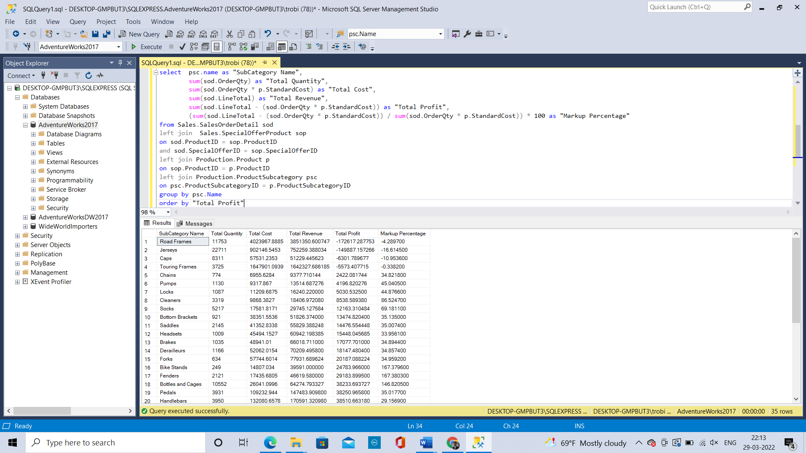

select psc.name as "SubCategory Name",

sum(sod.OrderQty) as "Total Quantity",

sum(sod.OrderQty * p.StandardCost) as "Total Cost",

sum(sod.LineTotal) as "Total Revenue",

sum(sod.LineTotal - (sod.OrderQty * p.StandardCost)) as "Total Profit",

(sum(sod.LineTotal - (sod.OrderQty * p.StandardCost)) / sum(sod.OrderQty * p.StandardCost)) * 100 as "Markup Percentage"

from Sales.SalesOrderDetail sod

left join Sales.SpecialOfferProduct sop

on sod.ProductID = sop.ProductID

and sod.SpecialOfferID = sop.SpecialOfferID

left join Production.Product p

on sop.ProductID = p.ProductID

left join Production.ProductSubcategory psc

on psc.ProductSubcategoryID = p.ProductSubcategoryID

group by psc.Name

order by "Total Profit"

* + 1. What is the most profitable subcategory?

Mountain Bikes 4908041.892480

* + 1. What subcategory produces the most revenue?

Road Bikes 43909437.508212

* + 1. What subcategory has the highest markup percentage?

Fenders 167.380300

* + 1. What is the least profitable subcategory?

Road Frames -172617.287753

* + 1. What subcategory produces the least revenue?

Chains 9377.710144

* + 1. What subcategory has the least markup percentage?

Jerseys -16.614500

* 1. Describe what you think the most important findings are from these queries in A07.docx.

The Profit is in Negative for many ProductSubCategory similarly the markup percentage and with the order by clause we will be able to achieve our results.

Bikes make the most profit.  All subcategories of the category bike are in the top five list. Specific bikes make the most and also lose the most.

## **Category Profitability**

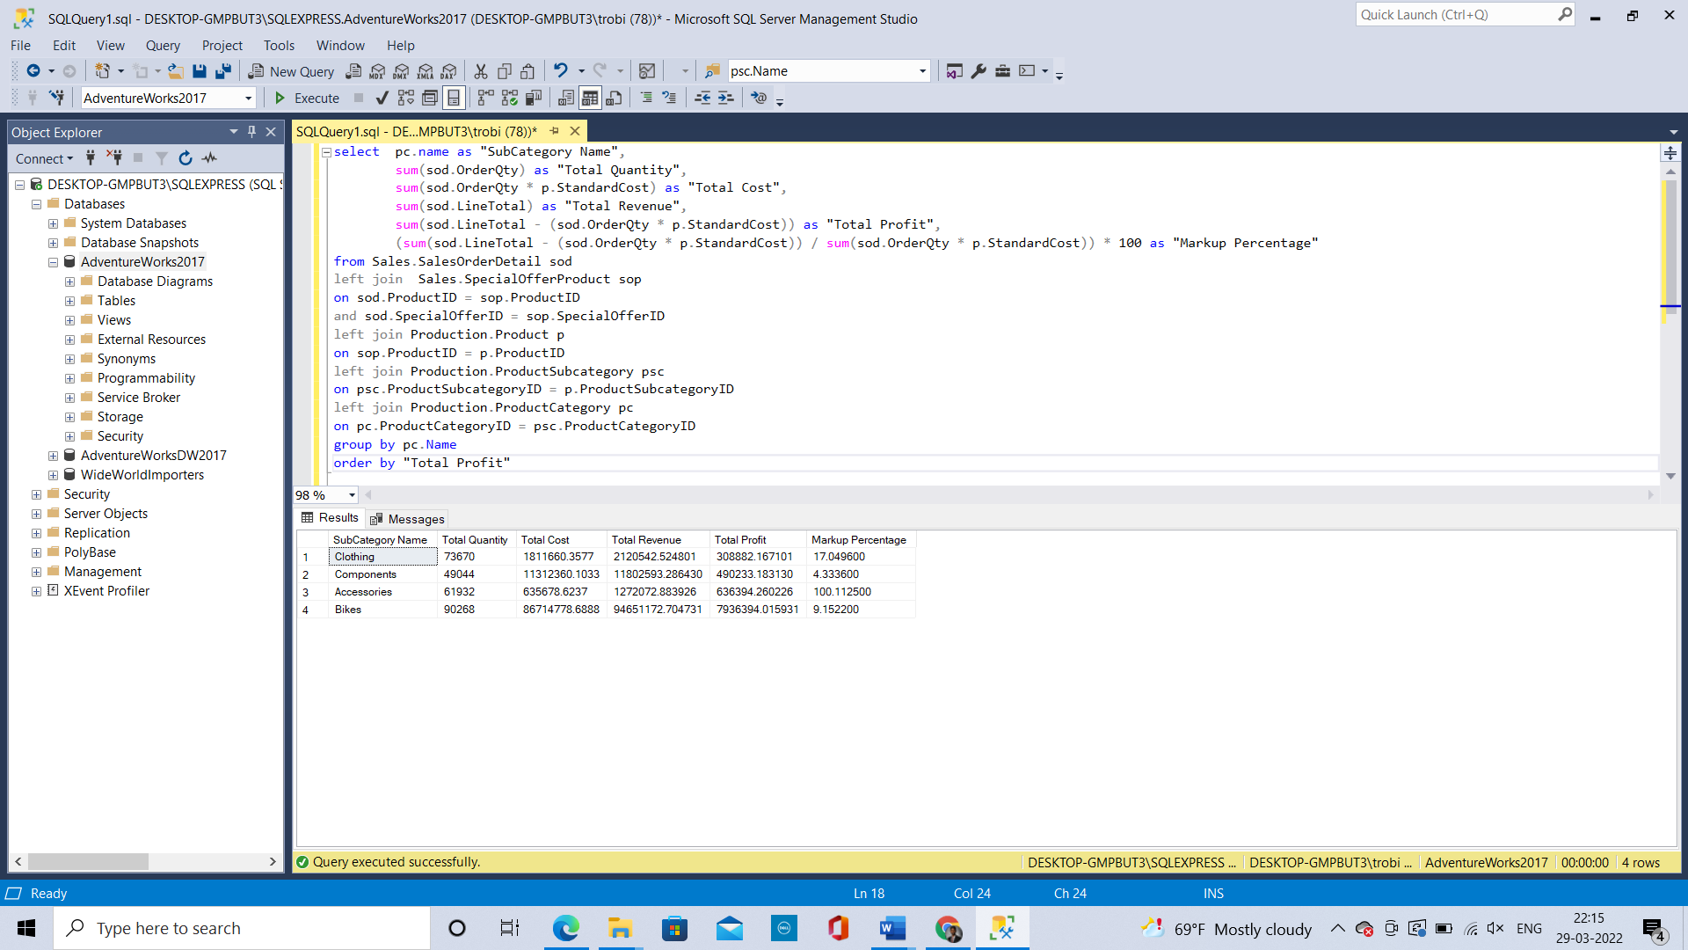

select pc.name as "SubCategory Name",

sum(sod.OrderQty) as "Total Quantity",

sum(sod.OrderQty * p.StandardCost) as "Total Cost",

sum(sod.LineTotal) as "Total Revenue",

sum(sod.LineTotal - (sod.OrderQty * p.StandardCost)) as "Total Profit",

(sum(sod.LineTotal - (sod.OrderQty * p.StandardCost)) / sum(sod.OrderQty * p.StandardCost)) * 100 as "Markup Percentage"

from Sales.SalesOrderDetail sod

left join Sales.SpecialOfferProduct sop

on sod.ProductID = sop.ProductID

and sod.SpecialOfferID = sop.SpecialOfferID

left join Production.Product p

on sop.ProductID = p.ProductID

left join Production.ProductSubcategory psc

on psc.ProductSubcategoryID = p.ProductSubcategoryID

left join Production.ProductCategory pc

on pc.ProductCategoryID = psc.ProductCategoryID

group by pc.Name

order by "Total Profit"

* + 1. What is the most profitable category?

Bikes 7936394.015931

* + 1. What category produces the most revenue?

Bikes 94651172.704731

* + 1. What category has the highest markup percentage?

Accessories 100.112500

* + 1. What is the least profitable subcategory?

Clothing 308882.167101

* + 1. What category produces the least revenue?

Accessories 1272072.883926

* + 1. What category has the least markup percentage?

Components 4.333600

* 1. Describe what you think the most important findings are from these queries in A07.docx.

Even though, Accessories gave least revenue it produces high markup percentage which means this is more profitable since the investment is less.

## **Discussion**

* 1. Summarize your findings and describe the most important and least important information found in your investigations. Differing levels of detail (e.g., product level, subcategory level, and category level information) can show or hide important information. What were you able to see at the differing levels of detail?

The Profit is negative for many Products, ProductModels, SubCategories that will be the most important point and Profit in Categorywise is the least important since it only gives the generalized picture and doesn’t go in detail. Bikes make the most profit.  All subcategories of the category bike are in the top five list. Specific bikes make the most and also lose the most

* 1. Graduate students: Based on your findings, add a Next Steps section describing what the next investigation should be in this ongoing problem.

AdventureWorks should focus on selling more products that has high markup percentage since that gives profit with less investment and also look into what goes wrong in the sales where there are losses and try to mitigate those things.