# **Understand Data Structure and Data**



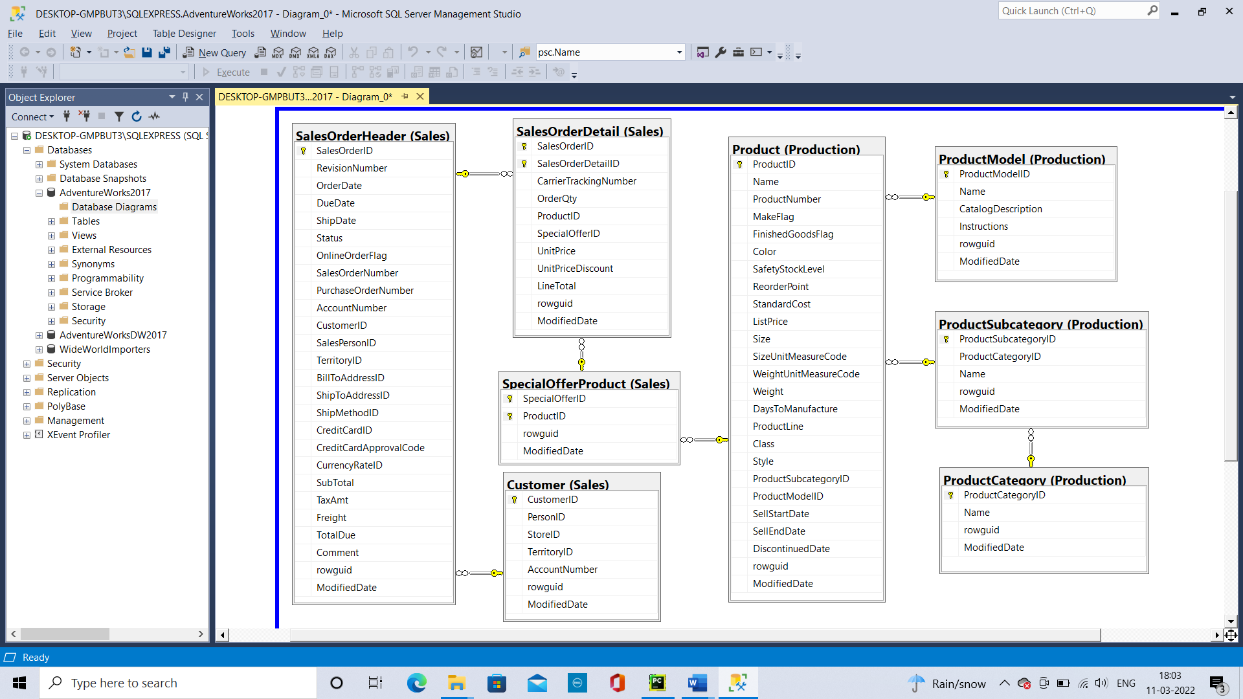

* + 1. For each table answer the following in A07.docx
       1. How many rows?

sales.SalesOrderHeader;--31465

sales.SalesOrderDetail;--121317

sales.Customer;--19820

sales.SpecialOfferProduct;--538

Production.Product;--504

Production.ProductModel;--128

Production.ProductSubcategory;--37

Production.ProductCategory;--4

* + - 1. Describe the table

sales.SalesOrderHeader—Stores the Order details and it is the header table for SalesOrderDetail for each record in SalesOrderHeader table there will be multiple values in the SalesOrderDetail table.

sales.SalesOrderDetail—Stores the details for the salesorder and it contains all the information with respect to sales

sales.Customer—It Stores the offer that are available against products

sales.SpecialOfferProduct—It is the intermediate table that connects product, specialoffer, salesorderdetail table

Production.Product—It stores the details of the product

Production.ProductModel—It stores the details of the Models

Production.ProductCategory— It store the Categories of the product

Production.ProductSubcategory—It stores the SubCategories of the product

* + 1. For each relationship answer the following in A07.docx
       1. Describe the relationship

SalesOrderHeader, SalesOrderDetail  
The SalesOrderID is the key to connect Header(One) , Detail(Many)

SalesOrderDetail, SpecialOfferProduct  
SpecialOfferID and ProductID is the key to connect SalesOrderDetail(Many), SpecialOfferProduct(One)

SalesOrderHeader, Customer  
CustomerID is the key to connect SalesOrderHeader (Many), Customer (One)  
  
SpecialOfferProduct,Product  
ProductID is the key to connect SpecialOfferProduct (Many), Product(One)

Product, ProductSubCategory  
ProductSubCategoryID is the key to connect Product (Many), ProductSubCategory(One)

ProductSubCategory, ProductCategory  
ProductCategoryID is the key to connect ProductCategory (One), ProductSubCategory(Many)

Product, ProductModel  
ProductModelID is the key to connect ProductModel (One), Product (Many)

* + - 1. Does the relationship always exist? If not, when not?

The relationship does not exist when there are null records in the Many side or unmatching records between the two tables.  
  
The relationship exists only when there are matching records (Key columns (Relationship)) in the two tables.

* 1. Understand Types of Sales
     1. With the exception of the Customer table, the above is the same as last assignment, but this assignment focuses on types of sales, as opposed to types of products sold, so:
        1. Write a query and review the data for SalesOrderHeader.
        2. Notice that some sales orders have salespersons and some do not have salespersons.
           1. To figure out why some sales orders have salespersons and some do not, identify the fields (there is more than one) on the SalesOrderHeader table that correlate with having and not having salespersons on the order.

select distinct SalesPersonID,PurchaseOrderNumber

from sales.SalesOrderHeader

--where SalesPersonID is null

order by SalesPersonID,PurchaseOrderNumber

* + - * 1. For each field that correlates and that you have verified with the DISTINCT clause

What is the field name?

PurchaseOrderNumber

What is the correlation?

When SalesPersonID is null PurchaseOrderNumber is also null

* + - * 1. Given the above:

What can you say about sales orders that have sales persons?

Those orders are made by Salesperson and there is also a PurchaseOrderNumber associated with it.

What can you say about sales orders that don’t have sales persons?

Those orders maybe directly made by the customers ie) the retail customers. By

* + 1. Does the presence or absence of sales persons on sales orders have any relationship to the types of customers that we analyzed in a prior assignment?
       1. Modify your SalesOrderHeader query to add a Customer table join.
       2. Include only the following fields in your query
          1. OnlineOrderFlag
          2. PurchaseOrderNumber
          3. SalesPersonID
          4. Customer Type - Go to your prior assignment and copy your customer type case statement and paste it into your query.
       3. Include the DISTINCT clause in your query
       4. Sort by descending OnlineOrderFlag and SalesPersonID

select distinct soh.onlineorderflag,

soh.SalesPersonID,

soh.PurchaseOrderNumber,

case when c.StoreID is not null and c.PersonID is null then 'Store'

when c.StoreID is null and c.PersonID is not null then 'Individual'

when c.StoreID is not null and c.PersonID is not null then 'Store with Contact'

else 'error' end as CustomerType

from sales.SalesOrderHeader soh

left join Sales.Customer c

on soh.CustomerID = c.CustomerID

order by soh.onlineorderflag desc,soh.SalesPersonID desc

* + - 1. Given the above:
         1. What can you say about online sales orders?

We can say that online sales orders are made by Individuals and no salesperson is making the online sales order.

* + - * 1. What can you say about sales orders that are not online?

All the sales orders that are not online have salespersonID and PurchaseOrderNumber and also made by StorewithContact customer type

* + 1. What can you say about AdventureWorks based on what you have found?
       1. Modify your query to add a SalesOrderDetail table join
       2. Include only the following fields in your query
          1. OnlineOrderFlag
          2. SalesPersonID
          3. PurchaseOrderNumber
          4. Customer Type - Go to your prior assignment and copy your customer type case statement and paste it into your query.
          5. OrderQty
       3. Include the DISTINCT clause in your query
       4. Sort by descending OnlineOrderFlag and SalesPersonID

select distinct soh.onlineorderflag,

soh.SalesPersonID,

soh.PurchaseOrderNumber,

case when c.StoreID is not null and c.PersonID is null then 'Store'

when c.StoreID is null and c.PersonID is not null then 'Individual'

when c.StoreID is not null and c.PersonID is not null then 'Store with Contact'

else 'error' end as CustomerType,

sod.OrderQty

from sales.SalesOrderHeader soh

left join Sales.Customer c

on soh.CustomerID = c.CustomerID

left join Sales.SalesOrderDetail sod

on soh.SalesOrderID = sod.SalesOrderID

order by soh.onlineorderflag desc,soh.SalesPersonID desc

* + - 1. Given the results of your query and the information in the reading, what can you say about AdventureWorks’ sales?

Online orders are made by Individual ie. Retailing   
While Offline orders are made by Store with contact and there is a Salesperson and purchaseordernumber are associated with it. ie. Wholesale

# **Get Sales Data**

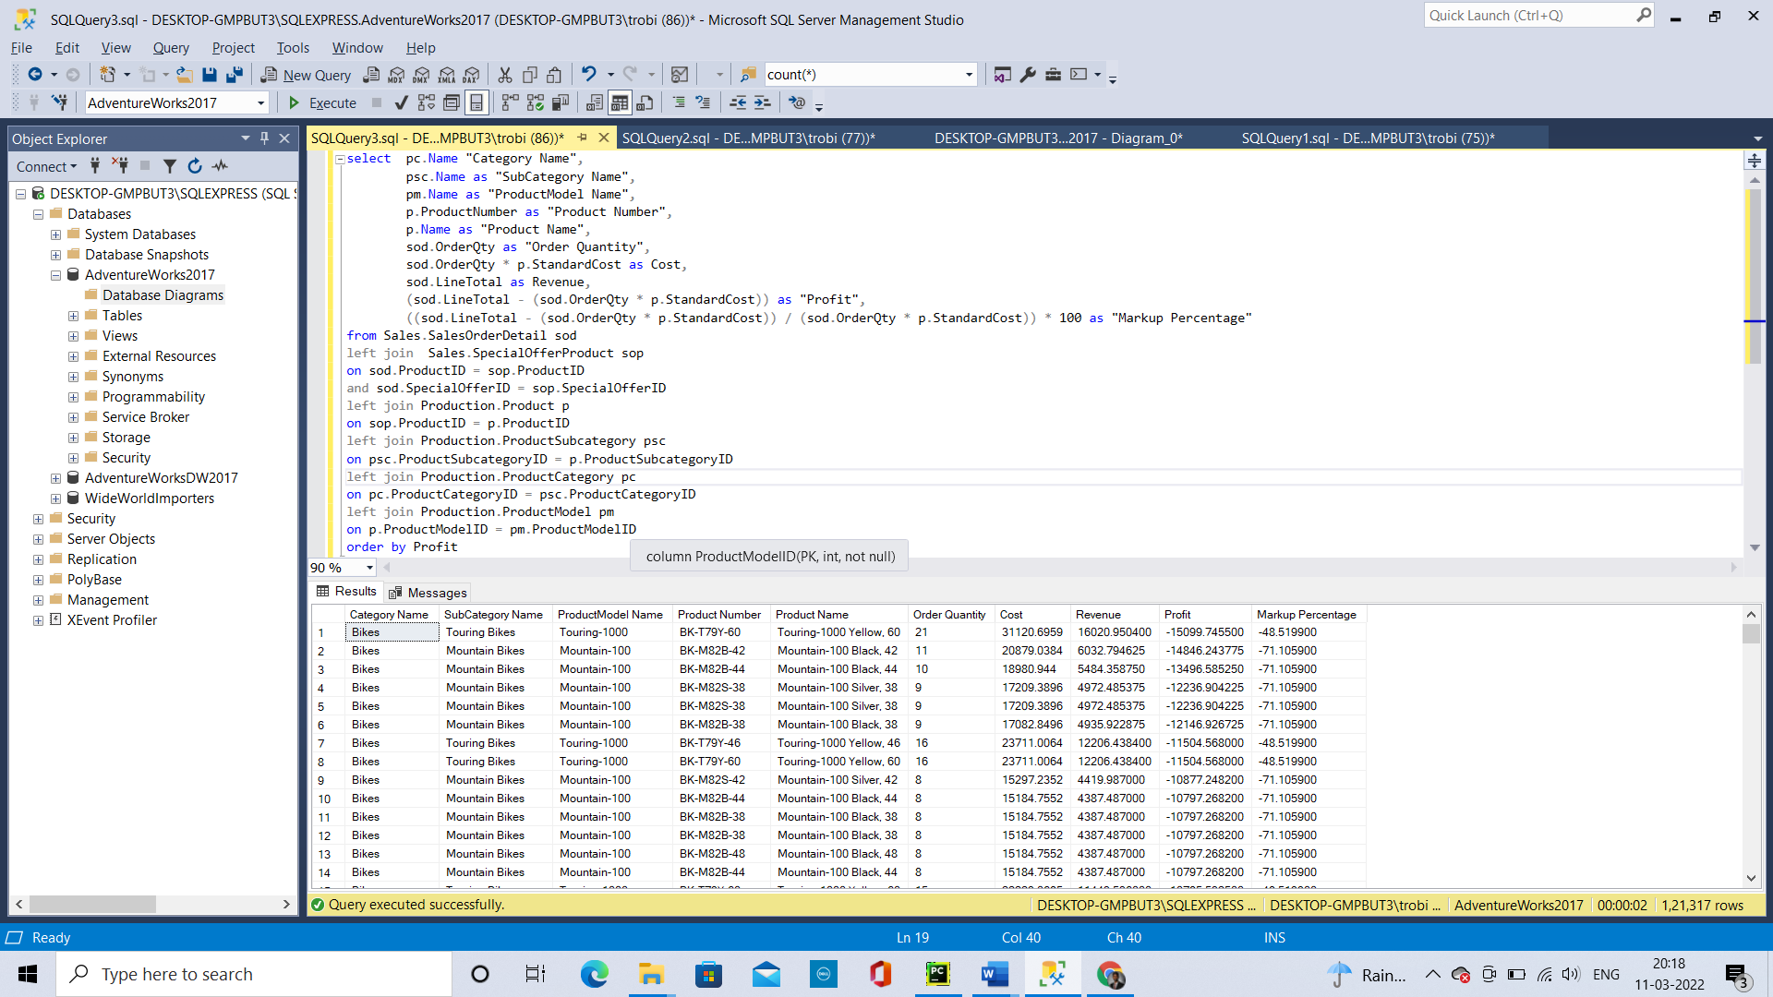

select pc.Name "Category Name",

psc.Name as "SubCategory Name",

pm.Name as "ProductModel Name",

p.ProductNumber as "Product Number",

p.Name as "Product Name",

sod.OrderQty as "Order Quantity",

sod.OrderQty * p.StandardCost as Cost,

sod.LineTotal as Revenue,

(sod.LineTotal - (sod.OrderQty * p.StandardCost)) as "Profit",

((sod.LineTotal - (sod.OrderQty * p.StandardCost)) / (sod.OrderQty * p.StandardCost)) * 100 as "Markup Percentage"

from Sales.SalesOrderDetail sod

left join Sales.SpecialOfferProduct sop

on sod.ProductID = sop.ProductID

and sod.SpecialOfferID = sop.SpecialOfferID

left join Production.Product p

on sop.ProductID = p.ProductID

left join Production.ProductSubcategory psc

on psc.ProductSubcategoryID = p.ProductSubcategoryID

left join Production.ProductCategory pc

on pc.ProductCategoryID = psc.ProductCategoryID

left join Production.ProductModel pm

on p.ProductModelID = pm.ProductModelID

order by Profit

# **Graph Profits**

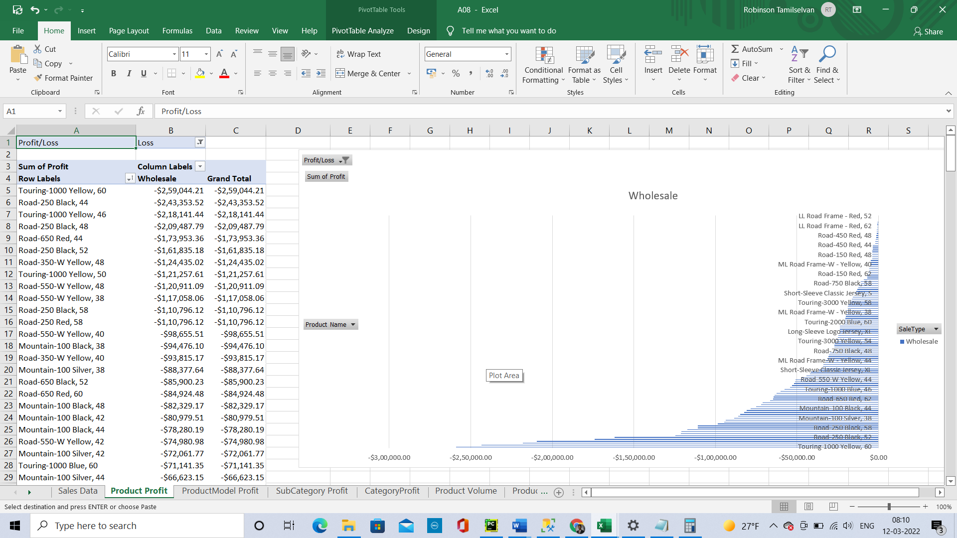

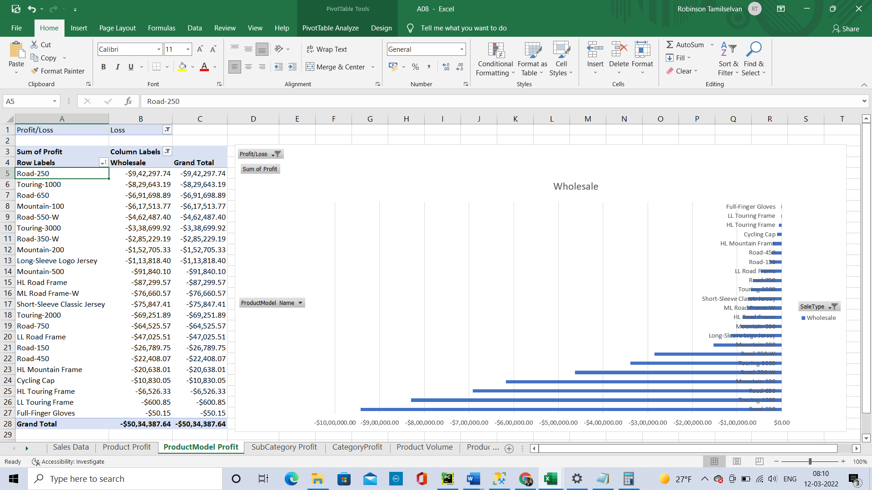

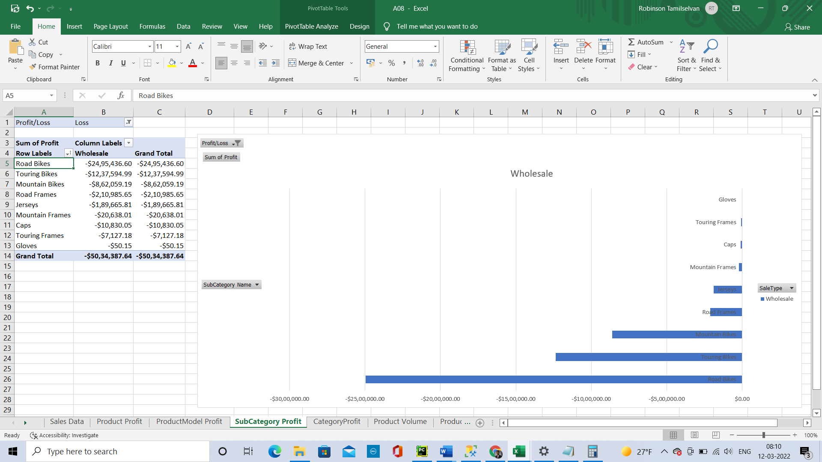

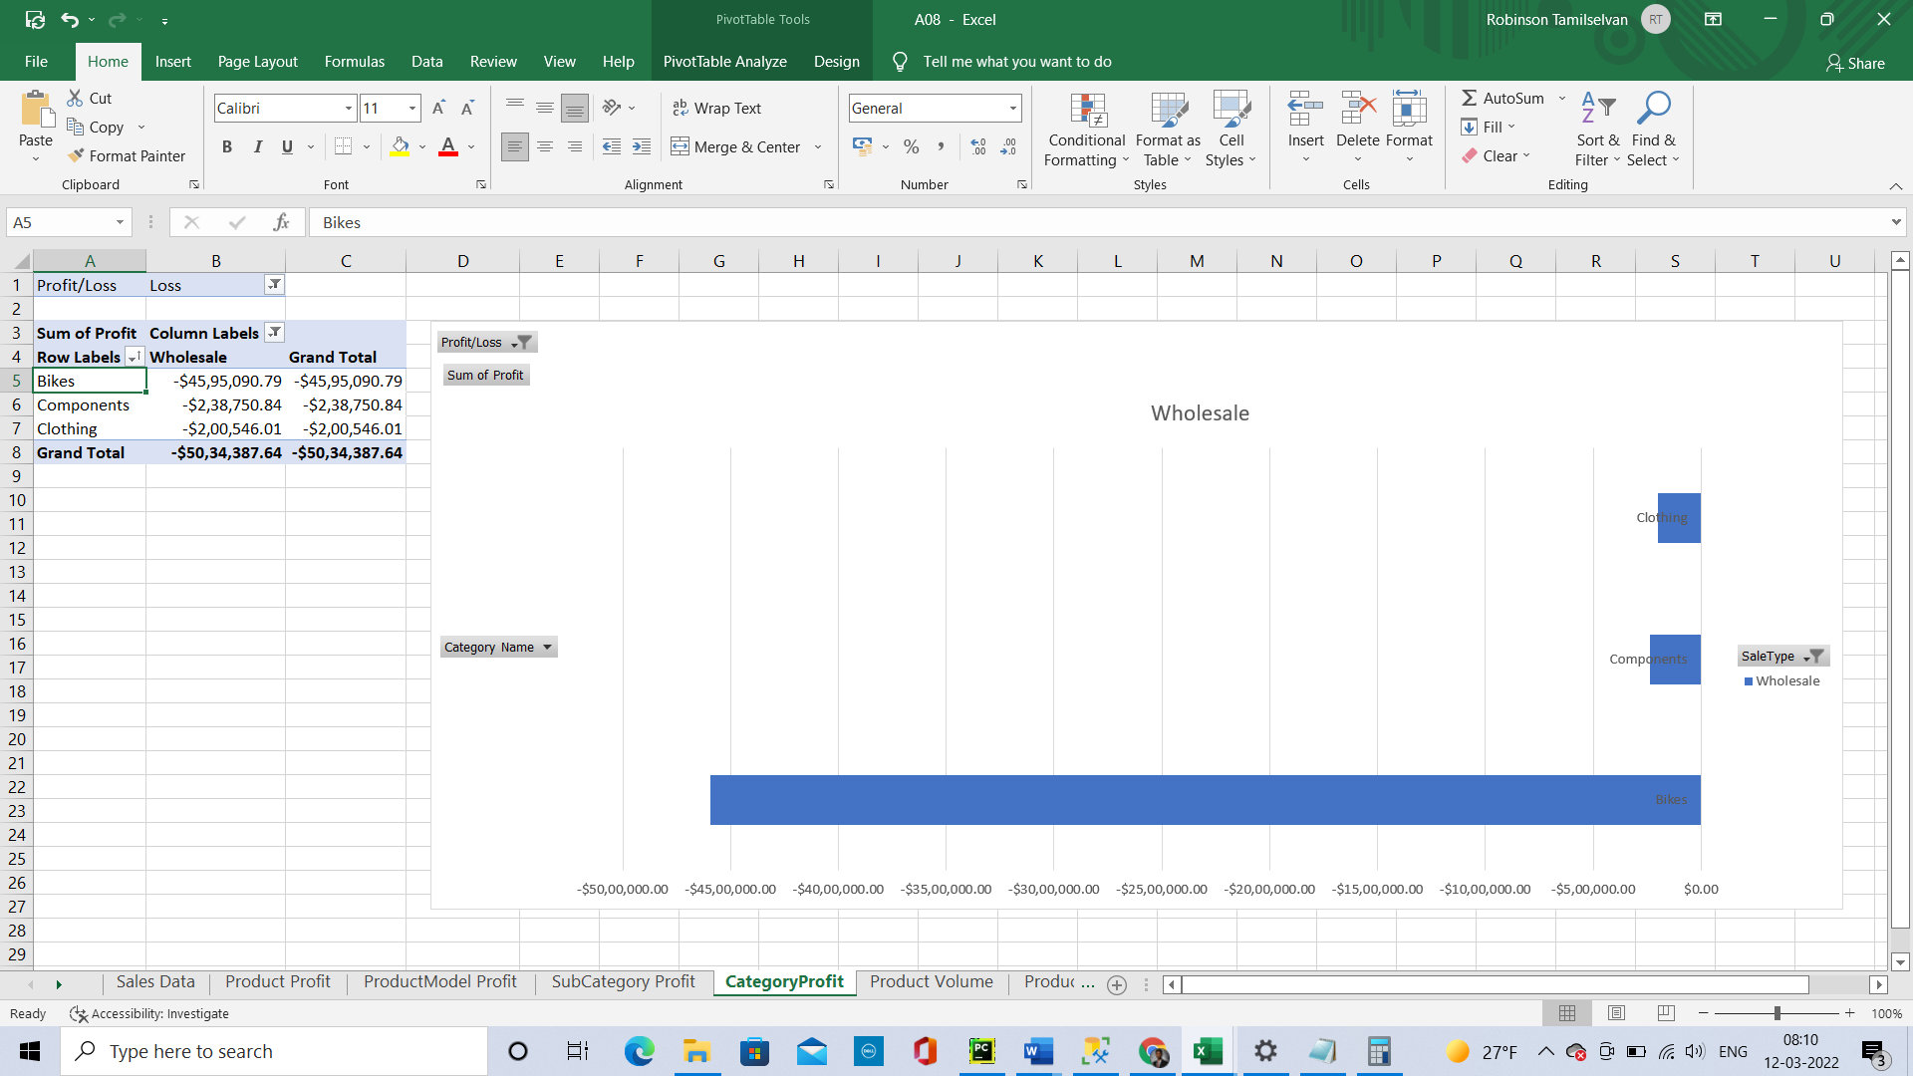

* + 1. What product generated the most loss?

Touring-1000 Yellow, 60

* + 1. What product model generated the most loss?

Road-250

* + 1. What subcategory generated the most loss?

Road Bikes

* + 1. What category generated the most loss?

Bikes

* + 1. What percentage of loss was generated by Retail sales?

0%

* + 1. What percentage of loss was generated by Wholesale sales?

100%

* + 1. Given these findings what should AdventurWorks do?

Should focus on Retail sales more which is their strength. And also make the Wholesales where there are losses and turn into a Profitable one.

# **Graph Sales Volume**

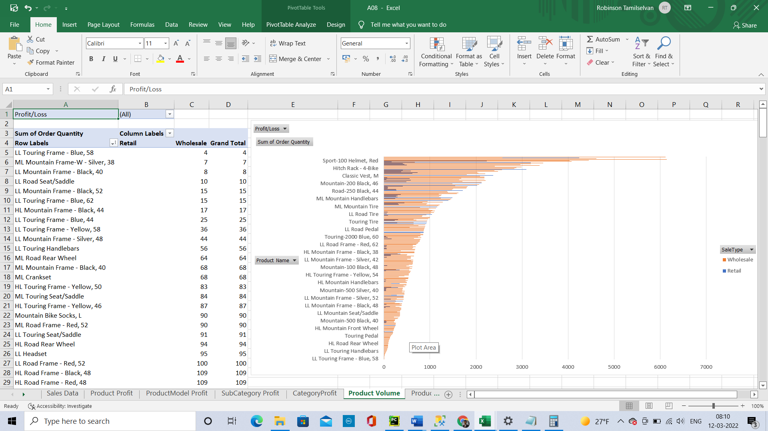

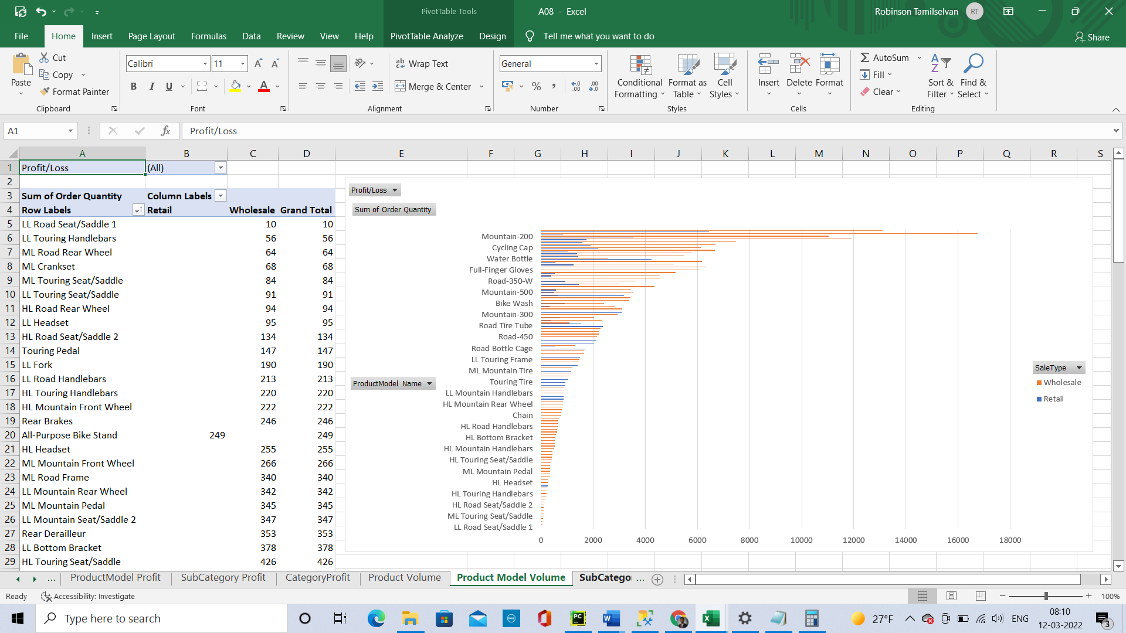

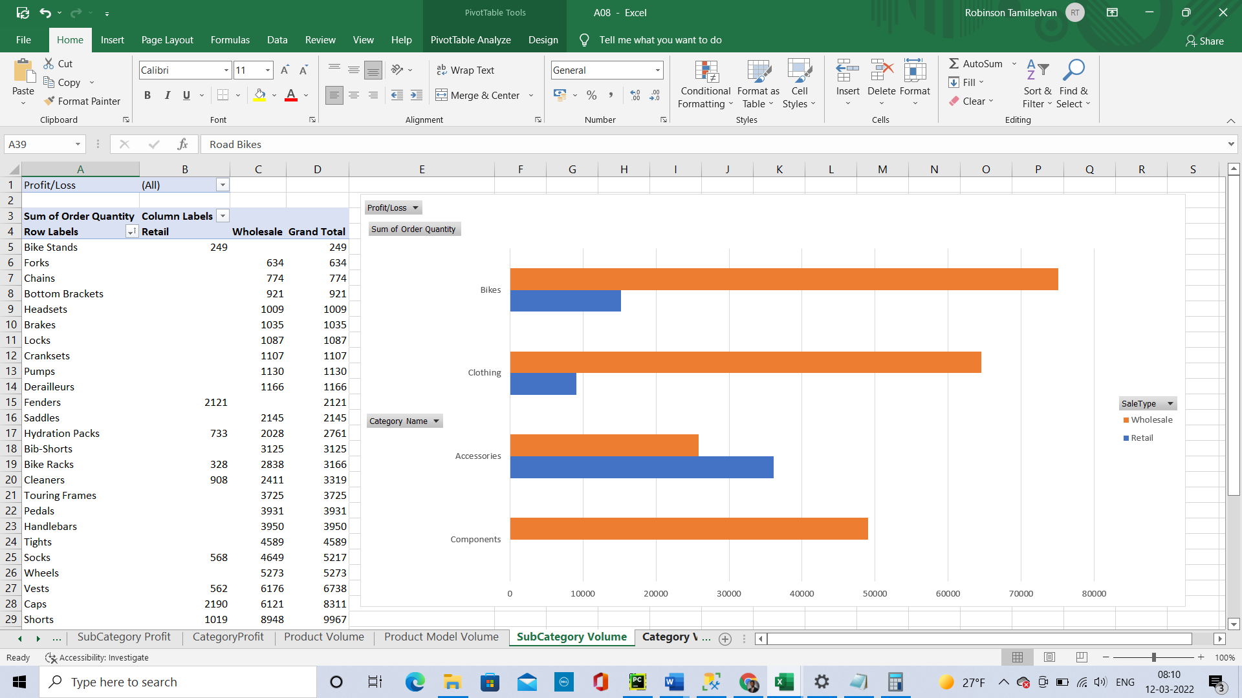

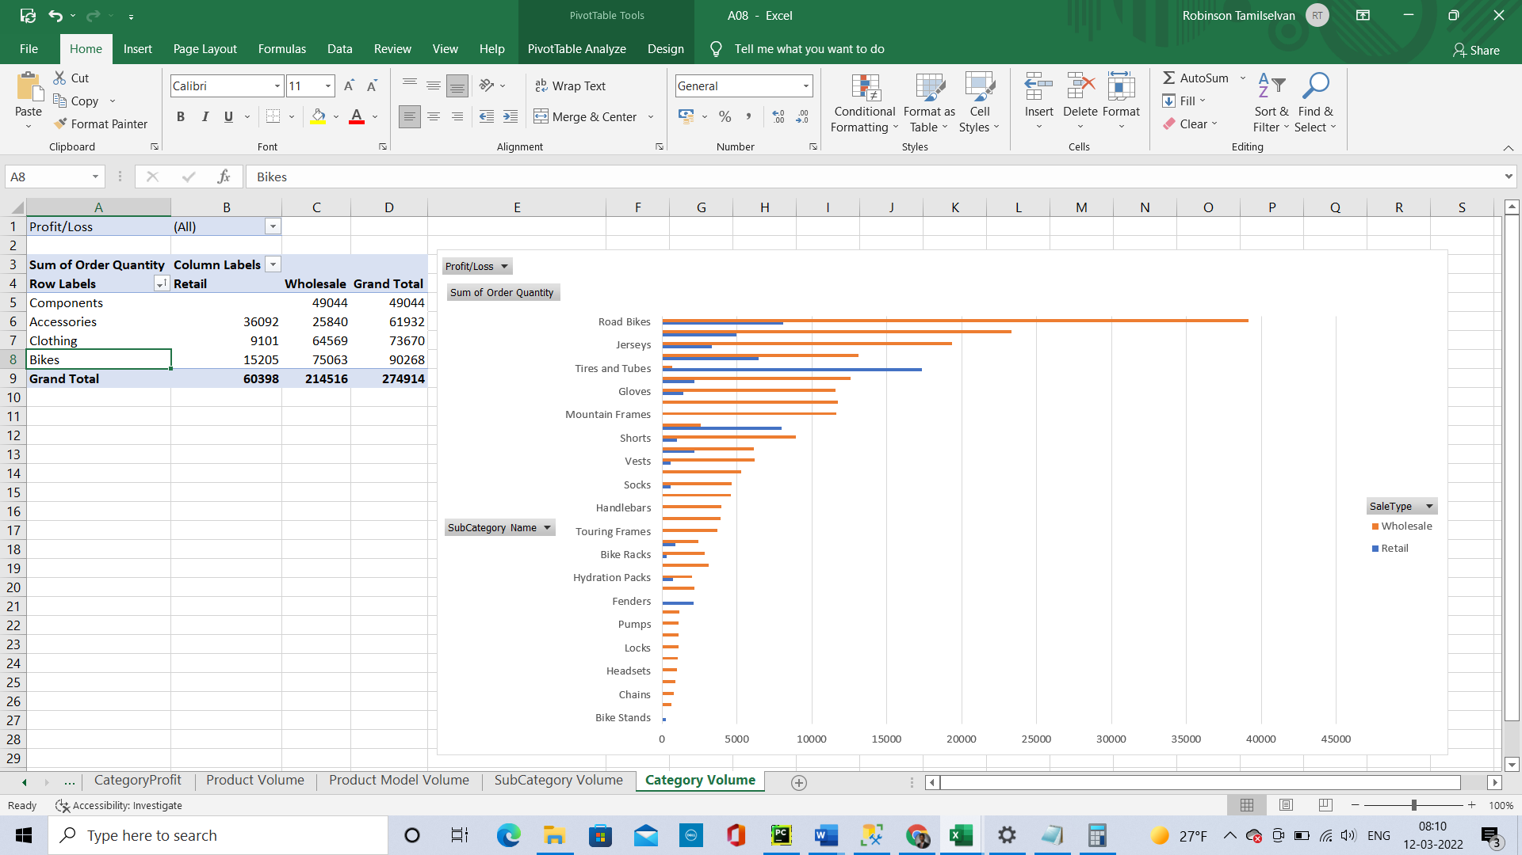

* 1. Answer the following questions in A07.docx:
     1. What product generated the most volume?

AWC Logo Cap

* + 1. What product model generated the most volume?

Sport-100

* + 1. What subcategory generated the most volume?

Road Bikes

* + 1. What category generated the most volume?

Bikes

* + 1. What percentage of volume was generated by Retail sales?

21.97%

* + 1. What percentage of volume was generated by Wholesale sales?

78.03%

* + 1. Given these findings would happen if AdventureWorks focused solely on Retail sales and abandoned Wholesale sales?

They will have less number of sales

* + 1. Given these findings what should AdventurWorks do?

They should try to sell more on Retailing

# **Discussion**

* 1. Summarize your findings and describe the most important and least important information found in your investigations.

Overall, the Retail gives profit and the Wholesales gives Loss. But the 78% of sales is done to the Wholesales while only 20% of the sales has been done by Retail sector. All the Retail sales are done through online to the Individuals.

* 1. Provide recommendations for AdventureWorks based on your findings

Concentrate to sell more on Retail through online where they have more Profit and try to focus on the Wholesale where the Loss occurs and rectify it.

* 1. Graduate students: Based on your findings, add a Next Steps section describing what the next investigation should be in this ongoing problem.

In wholesale the Profit is 2718348.39 whereas the Loss is 5034387.64.  
In Retail the Profit is 11687942.88 and the Loss is 0.

|  |  |
| --- | --- |
| SalesPersonID | Profit |
| 280 | 35603.65 |
| 285 | -20766.4 |
| 287 | -24279.3 |
| 283 | -40680.7 |
| 286 | -87954.4 |
| 288 | -89576.2 |
| 274 | -91764 |
| 284 | -121359 |
| 289 | -142034 |
| 278 | -144573 |
| 290 | -145757 |
| 279 | -147095 |
| 282 | -158767 |
| 276 | -197157 |
| 277 | -261894 |
| 275 | -281662 |
| 281 | -396323 |

Expect for one Salesperson all other sales persons are bringing losses so focus on what the Sales person 280 is doing right and make the other Salesperson follow the same.  
And also try to Increase the Retail Sales through online.