# **Understand Data Structure and Data**

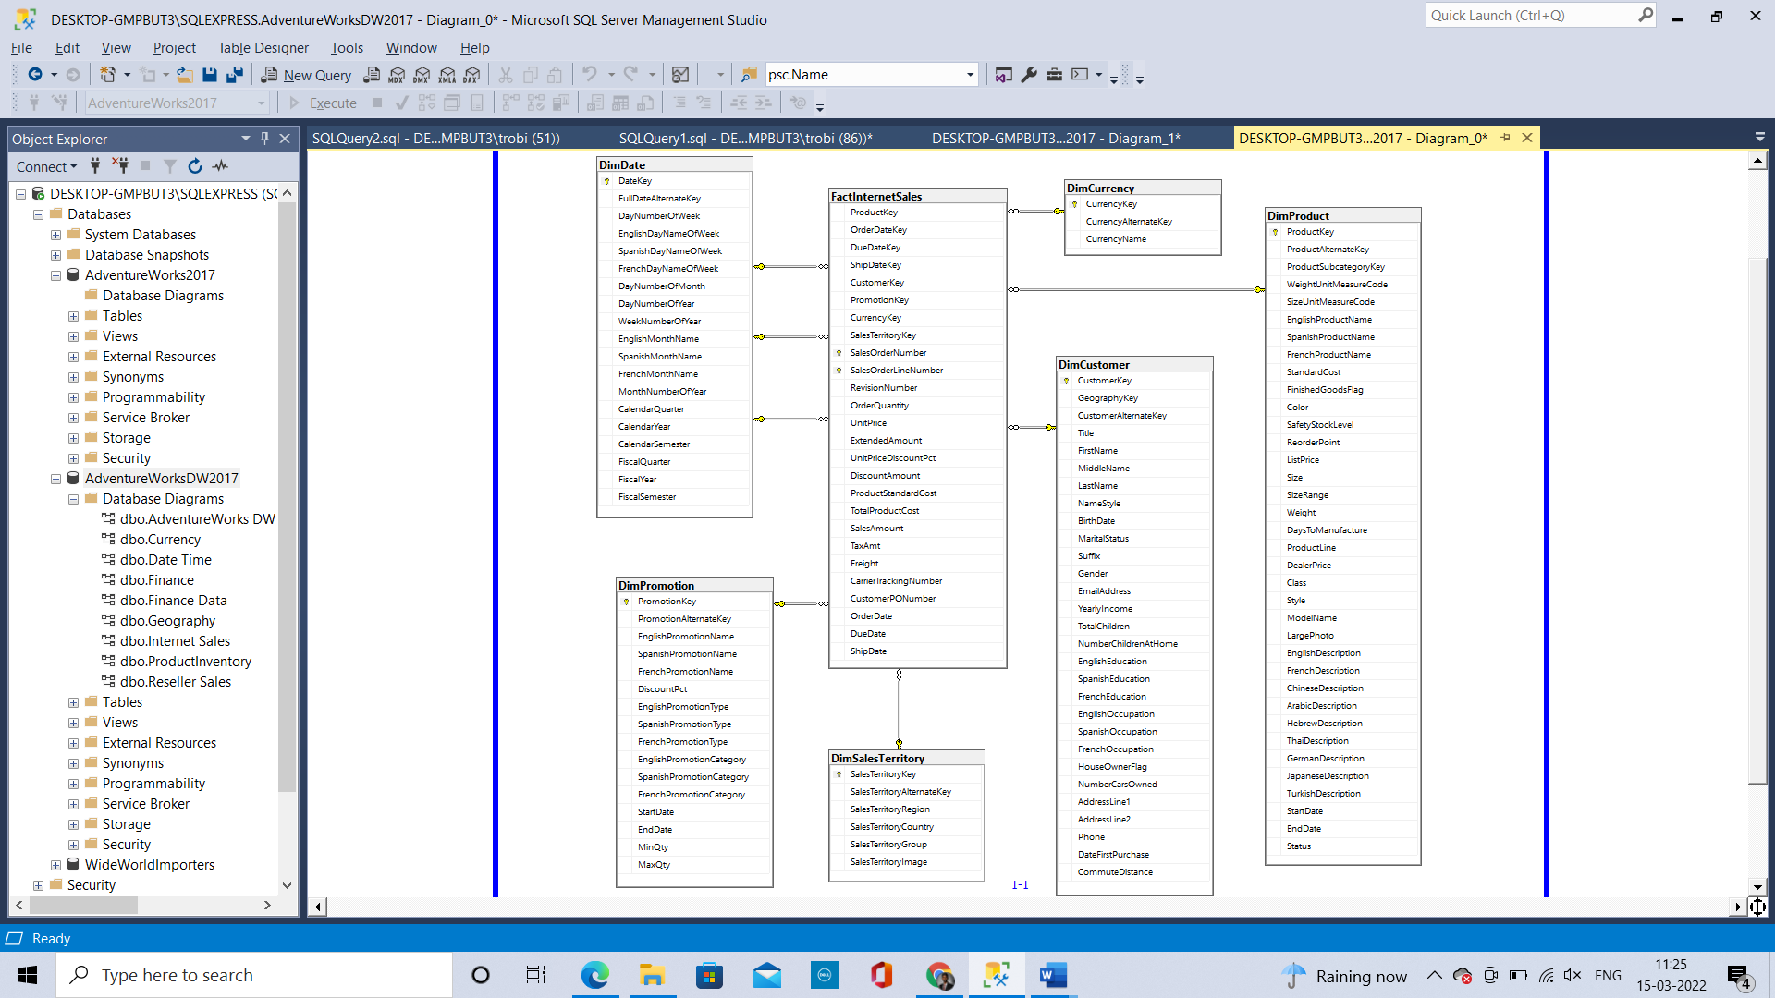

# **Map the Data**

# **Discussion**

* 1. Imagine the process and explain in an MS Word document (A09.docx) how the data warehouse data got into the data warehouse and **explain why** the OLTP was converted to the data warehouse for sales.

The database data got into Datawarehouse through ETL (Extract, Transform, Load) process. This has been done for OLAP (Online Analytic Process) where the queries (select) run faster where the data are denormalized. And it provides output for queries quickly.  
Whereas Database (OLTP) is designed in such a way that transactions are inserted, updated, deleted quickly. It is designed in a way that DML operations are done quickly. And the Normalization is strictly followed in Database.

Here it’s been done because they have to do Analysis for Sales. It can be done in OLTP (But it will be time-Consuming, Cost of the queries will be higher, complex queries needs to written). Since it’s been Extracted, Transformed and Loaded into Datawarehouse the reports can be taken out quickly, and also with simple queries.