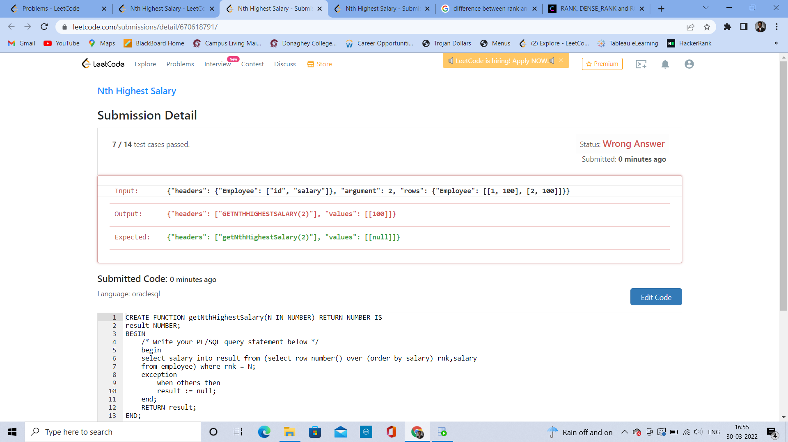

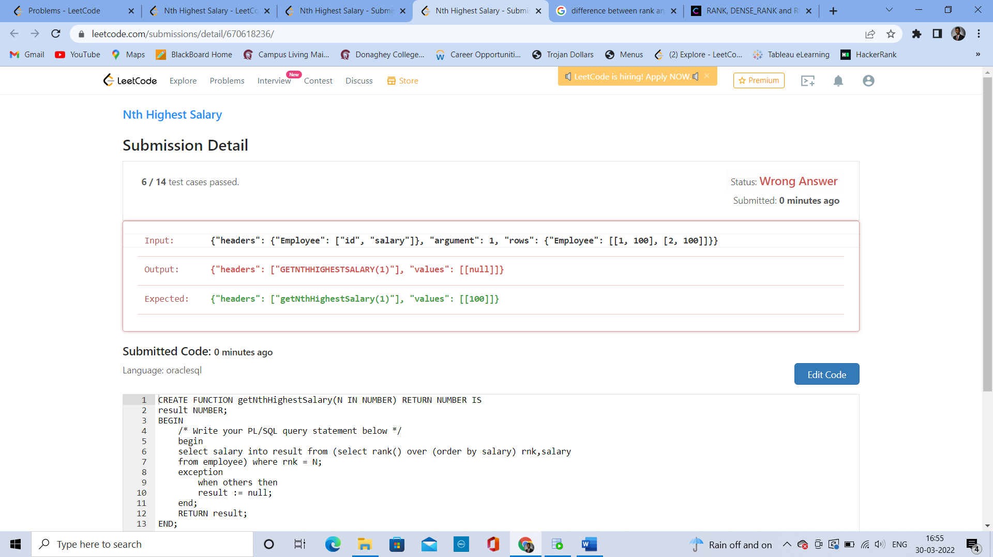

CREATE FUNCTION getNthHighestSalary(N IN NUMBER) RETURN NUMBER IS

result NUMBER;

BEGIN

/* Write your PL/SQL query statement below */

begin

select salary into result from (select row_number() over (order by salary) rnk,salary

from employee) where rnk = N;

exception

when others then

result := null;

end;

RETURN result;

END;

CREATE FUNCTION getNthHighestSalary(N IN NUMBER) RETURN NUMBER IS

result NUMBER;

BEGIN

/* Write your PL/SQL query statement below */

begin

select salary into result from (select rank() over (order by salary) rnk,salary

from employee) where rnk = N;

exception

when others then

result := null;

end;

RETURN result;

END;