Overview

Introduction
The Ski simulator is a software package designed to functionally simulate the IA-64 processor architecture at the instruction level. Ski offers an informative, screen-oriented machine state display and a friendly, powerful command interface. Programs may be loaded from disk in executable format; they may be run from start to finish, single-stepped, and breakpointed. Translation lookaside buffers may be simulated. Certain Linux and MS-DOS operating system functions (system calls) are provided for simulation of application programs. These capabilities are complemented by screen-oriented symbolic debugging to provide a view into the simulated IA-64 processor.

Ski's Strengths
Ski is particularly well-suited for:
- IA-64 application development:
Ski can simulate IA-64 programs in a Linux environment and IA-32 programs in an MS-DOS environment. Ski provides a user interface that looks very much like a typical debugger– but the processor you are debugging on is virtual, simulated by Ski. Ski has successfully executed the SPEC-92 and SPEC-95 benchmark suites.
- IA-64 compiler tuning:
Ski provides performance statistics that can help you tune IA-64 compiler code generators. Ski can help you improve your compiler's use of IA-64 architectural enhancements for parallelism.
- IA-64 operating system and firmware development:
Ski can simulate a "raw" IA-64 processor, with no operating system provided. Because of this, you can use Ski to simulate an IA-64 operating system running IA-64 and IA-32 programs. For example, Ski has been used successfully to develop the IA-64 version of the Linux kernel.
- IA-64 processor functional hardware verification:
Ski is a true implementation of the IA-64 architecture. You can compare the behavior of code simulated with Ski to the same code running on other IA-64 implementations. This helps you verify the correctness of those implementations.

Ski's Scope
Many different kinds of simulators can be created: device simulators that function at the semiconductor quantum physics level, circuit simulators that model the behavior of small numbers of transistors and other circuit elements, gate simulators that model digital circuits at the boolean logic level, and so on. Ski is an instruction simulator, which makes it very fast. Ski doesn't model any particular physical IA-64 implementation. Instead, it models an architecturally-compliant IA-64 processor with extensive compute resources.

What You Need to Know to Use This Manual
This manual describes the user interface of Ski in detail. In reading this manual, you will learn how to use Ski to simulate your IA-64 and IA-32 programs. To understand this manual, you should already be familiar with the IA-64 architecture. IA-64 abbreviations such as ip, psr, and eax are used without explanation.

Defects and Defect Reporting
Ski is provided "as is", without any guarantees or warranties. However, a mailing list has been created for reporting Ski defects and for general Ski discussions. See the release notes for details on the mailing list address and how to subscribe.

Ski Variations
The simulator is available in three varieties, distinguished by their user interfaces: ski, xski, and bski. The underlying simulation engine is identical across all three varieties. The figures below show how each variety looks when first started. Illustration 1: The Curses-based ski Interface shows ski, which uses a terminal-oriented, curses-based, character user interface. Illustration 2: The X Window System, Motif-based xski Interface shows xski, using an X Window System, Motif-based, graphical user interface. Illustration 3: The Command-Line bski Interface shows bski, which provides a batch-oriented, command-line-driven environment and no user interface. Ski command line flags, some of which are shown in Illustration 3: The Command-Line bski Interface are described in "Command Line Flags".
The three varieties understand the same command language. There are a few, unavoidable differences and they are pointed out where appropriate in this manual. Most examples and sample screen displays are taken from xski sessions. All examples have been verified in actual use.

Using bski for Batch Simulations
Because bski has no user interface, you typically control it using a command file (see "" on page ) and the -i command line flag (see "Command Line Flags"). ski and xski are intended for you to use interactively, while bski excels at batch simulations that might run for a long time as background jobs on your workstation or on a higher-powered remote simulation server. The cron and make programs work well with bski. With cron, you can schedule simulations to run at night and on remote servers. With make, you can execute complex networks of tests quickly, letting make keep track of the dependencies between the tests. These programs are documented in man pages.
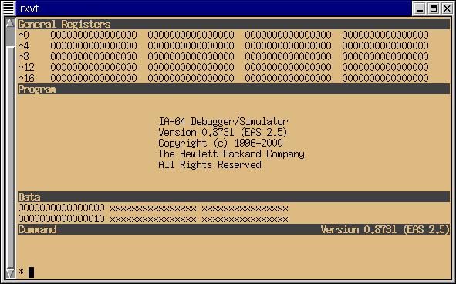Illustration 1: The Curses-based ski Interface
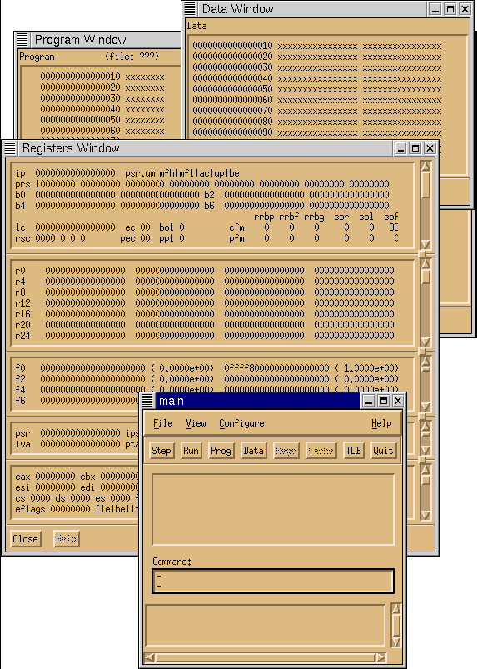Illustration 2: The X Window System, Motif-based xski Interface
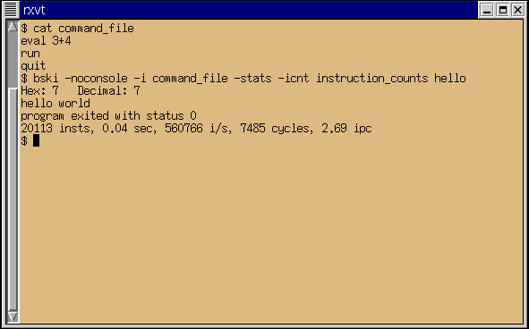Illustration 3: The Command-Line bski Interface

Starting Ski
To start the Ski simulator, type its name (ski, xski, or bski) and any necessary command line options and file redirections, just as you would start any other Linux program. (Command line options are described in "Command Line Flags".) The simplest invocation of the simulator is:
ski
This starts the (curses-based) ski version of the simulator with no program loaded: a "bare" IA-64 emulation is ready for you to use.
A more sophisticated invocation would be:
xski my_program
This starts the (X/Motif-based) xski version of the simulator and loads the IA-64 executable file my_program, ready to run. The program will not receive any command line arguments (via the argc/argv mechanism) when you run it.
To run the simulator as a batch job in the background on an all-night run, you might execute this command line:
bski -noconsole -stats -i my_commands my_program foo bar <test_data >out_stuff 2>bad_news &
This invokes the (batch) bski version of the simulator and loads the IA-64 executable file my_program, ready to run. The -noconsole flag tells bski not to create a separate console window for the program's standard I/O. The program will receive the command line arguments foo and bar via the argc/argv mechanism when bski runs it. Both the simulator and the program being simulated will have standard in, standard out, and standard err redirected from/to test_data, out_stuff, and bad_news, respectively, and the simulator will execute the commands in my_commands. (Ski never reads from standard in, so there is no possibility of confusion.) The -stats flag specifies that at the end of the run, collected statistics will be output to standard out (which is redirected). The ampersand ("&") runs the job in the background.

Command Line Flags
The simulator accepts certain flags on the command line when you start it up. The flags are passed on the command line in standard Linux fashion. The Ski command line syntax is shown below. The -i, -rest, -icnt, and -stats flags can appear in any order.
ski [-help] [-i filename] [-rest filename] [program_filename [args]+]
xski [-help] [-noconsole] [-i filename] [-rest filename] [program_filename [args]+]
bski [-help] [-noconsole] [-i filename] [-rest filename] [-icnt filename] [-stats] [program_filename [args]+]

Summary of Flags and Parameters
-help
A list of flags accepted by this variety of Ski (ski, xski, or bski) is printed out. No other processing is done and Ski terminates.
-i filename
The specified file is run as a command file before the first prompt to the user. If an program_filename is provided on the same command line, the program_filename is loaded before the command file is run. This provides a convenient way to load a program, initialize other machine state, and then turn control over to the user.
-icnt filename
For bski only: This flag specifies instruction counts should be saved in the specified file. For each kind of instruction executed during the simulation, the instruction count file shows five fields of information:
- The instruction mnemonic
- The total number of times the instruction was executed
- The number of executions that were predicated on
- The number of executions that were predicated off
- The number of executions that were predicated on predicate register 0, which is "hardwired" on
The value in the second field equals the sum of the values in the last three fields.
-noconsole
For xski and bski only: This flag tells Ski not to create a separate console window for the simulated program's standard I/O. Instead, Ski will use the existing console window's for standard I/O purposes in the simulated program.
-rest filename
Restore the simulator run saved in filename. See "" on page . This flag cannot be combined with an program_filename. If combined with a -i flag, the -i flag is accepted and the -rest flag is silently ignored.
-stats
For bski only: specifies execution run-time and instruction rate information should be send to standard out (stdout) at the end of the run. This information is normally displayed in the Main/Command Window of xski and ski. The -stats flag allows users of bski to get the same information.

The XSki File
xski's screen presentation is substantially controlled by the contents of the XSki file, which uses the X Window System's resource mechanism to provide information to xski. You can edit this file to change xski's use of graphic buttons, described in "" on page . The XSki file is part of the standard Ski distribution and you should put this file in your X Window System's app-defaults directory or in your home directory. If there is no valid XSki file, the simulator will not be usable. You can find more information on installing xski in the release notes that come with each Ski distribution.

Quitting Ski
The quit command causes the simulator to exit. If a numeric operand or expression is supplied, the value is returned to the shell as Ski's exit status. This can be particularly useful with bski and command files (see "" on page ), for automated testing and regression testing. The exit status from Ski becomes the new value of your shell's $? variable (for most shells) and can also be retrieved automatically by the make program, if you use makefiles to control batch runs.

Summary of the Quit Command
quit [expression]
Terminates the simulator and returns control to the system, setting the exit status to expression (default is 0).

