Screen Presentation

Ski's Use of Windows
xski and ski generally divide the screen into four windows. (bski doesn't create any windows because it has no user interface, only a command line interface.) xski uses Motif windows which you can move and resize using the mechanisms provided by your window manager (WindowMaker, Englightenment, fvwm, twm, etc.) xski creates additional windows as necessary.
ski uses the curses package to create four windows on the terminal screen. Because ski uses curses, it runs on nearly any terminal or terminal emulator, including xterm. When ski needs to show data that isn't appropriate for one of its four windows, it uses a pager such as "more" or "less" instead and restores the curses windows when the pager completes.
Ski uses three of the windows to display information to you. The fourth window is shared between you and Ski: You enter commands that control Ski and Ski reports errors and other immediate information to you. You control the windows using Ski commands (see "" on page "") and the simulator updates the windows whenever necessary to maintain consistency with the internal state of the simulator engine. The four windows are described in more detail below.

The Register Window
Ski divides the IA-64 processor registers into five sets. In xski, all five sets are displayed in one window, the Register Window, with each set in its own subwindow or "pane". The panes show user registers, general registers, floating point registers, system registers, and IA-32 registers respectively, as shown in Illustration 1:The Register Window in xski The five panes share screen space and, unless you have a very large screen, it's not possible to see all five panes at full size simultaneously. xski shows portions of all five panes by default, but you can toggle any panes off with commands described in "" on page ).
xski understands the Page Up and Page Down keys and the up-arrow and down-arrow keys found on most keyboards. These keys operate on the current pane, which is usually highlighted with a bright border. When the Register Window has the X Window System focus, the Page Up and Page Down keys scroll the current pane one "pane-full" less one line of overlap. The up-arrow and down-arrow keys scroll the current pane one line. The Tab and Shift+tab keys change the current pane highlight to the next or previous pane, respectively, "wrapping around" the top and bottom of the Register Window.
Illustration 1:The Register Window in xski
ski shows only a portion of a register set at a time and you use the commands described in "" on page to select which portion of which set to see. The sets are described below in the order they appear in the Register Window. Their xski realizations are shown as well.

The User Registers Pane
The user registers pane (see Illustration 2: The xski User Registers Pane) displays the Predicate Registers (prs) in binary, the Application Registers in hexadecimal, and the Branch Registers (b0-b7) and the Instruction Pointer (ip) symbolically if possible, otherwise in hexadecimal. Symbolic displays are limited to sixteen characters; when more than sixteen characters are needed, the first fifteen are displayed and an asterisk ("*") is added to indicate that the symbolic display has been abbreviated. The fields of the Current Frame Marker (cfm) register and subfields of the Previous Frame Marker field (pfm) are displayed in decimal. For bit-encoded registers, some bits are displayed individually using their IA-64 mnemonics. If a bit name is displayed in uppercase, the bit is currently set, and if the name is displayed in lowercase, the bit is currently clear. For example, the psr.be bit is shown as "BE" in Illustration 2: The xski User Registers Pane, indicating that the bit is set. The User Mask bitfield (psr.um) from the Processor Status Register (psr) is displayed in this pane; the entire psr is shown in the System Registers pane, described in "The System Registers Pane". Predicate Registers pr16-pr63 are displayed in their rotated form, as indicated by the rrbp field of the Current Frame Marker (cfm) register.
At the middle of the pane, the line starting "clean" shows, in decimal, the values in the internal registers that control the Register Save Engine (rse). The IA-64 architecture requires that these registers exist but provides no program-visible access to them.
Illustration 2: The xski User Registers Pane

The General Registers Pane
The general registers pane shows the current values of the 64-bit general (integer) data registers, four to a line, in hexadecimal. Registers whose corresponding NaT bits are set are displayed with a leading asterisk ("*") to indicate this. The display reflects IA-64 register stacking and rotation: only the 32 static registers and the stacked registers allocated to a function are displayed. The allocated rotating registers are displayed in their rotated form, as indicated by the rrbg field of the cfm register, displayed in the user registers pane. The general registers pane is shown in Illustration 3: The xski General Registers Pane
Illustration 3: The xski General Registers Pane

The Floating Point Registers Pane
The floating point registers pane shows the current values of the 82-bit floating point data registers, two to a line displayed in hex and scientific decimal notation. Floating point registers f32-f127 are displayed in their rotated form, as indicated by the rrbf field of the cfm register, displayed in the user registers pane. The floating point registers pane is shown in Illustration 4: The xski Floating Point Registers Pane with various values in the registers.
Due to the nature of floating point arithmetic on the host computer, the scientific decimal displays may be inaccurate for very large and very small numbers, positive and negative. The hexadecimal display is always correct, as are all calculations done by the simulated program.
Illustration 4: The xski Floating Point Registers Pane

The System Registers Pane
The system registers pane shows the Processor Status Register (psr), Control Registers, Region Registers (rr0-rr7), Protection Key Registers (pkr0-pkr15), Data Breakpoint Registers (dbr0-dbr15), Instruction Breakpoint Registers (ibr0-ibr15), and Performance Monitor Configuration Registers (pmc0-pmc15), in hexadecimal. Application programs have limited access to these registers. Addresses are displayed symbolically when possible. Symbolic displays are limited to sixteen characters; when more than sixteen characters are needed, the first fifteen are displayed and an asterisk ("*") is added to indicate that the symbolic display has been abbreviated. The iva register shown on the second text line in Illustration 5: The xski System Registers Pane is an example of this.
Illustration 5: The xski System Registers Pane

The IA-32 Registers Pane
The IA-32 registers pane shows IA-32 registers in hexadecimal. For bit-encoded registers, the bits are named individually using their IA-32 mnemonics. If a name is displayed in uppercase, the corresponding bit is currently set, and if the name is displayed in lowercase, the bit is currently clear, as shown in Illustration 6: The xski IA-32 Registers Pane.
Illustration 6: The xski IA-32 Registers Pane

Resizing Register Window Panes with xski
As mentioned above, even a large X Window System screen is too small to display all the registers simultaneously, so you may have to scroll a pane to see the registers you want, or resize the pane by dragging Pane Resizer, the small resize square on the right side of the dividing line between each pair of panes, as shown in Illustration 7: An xski Pane Resizer: The Small Box Between the Scroll bars.
Illustration 7: An xski Pane Resizer: The Small Box Between the Scroll bars

The Register Window and ski
The ski simulator, as noted above, uses curses to display multiple windows on non-graphic (text) terminals and terminal emulators. These windows are fixed in size and are not big enough to display all the data at the same time. On a conventional, twenty four line screen, ski uses five lines for the Register Window, as shown in Illustration 8: The ski Register Window (at Top). Because of this lack of space, the Register Window shows only one of the five sets of registers at a time: user, integer, floating point, system, or IA-32, and then only a portion of each set. If your screen is larger than twenty four lines when you start ski, ski will make use of the extra space. (You can resize terminal emulators using command-line arguments or by using your window manager's standard mechanisms for window resizing.)
You use the ur, gr, fr, sr, and iar commands to tell ski which set of registers to display. To see the various registers in a set, you use the rf and rb commands to scroll the Register Window forwards and backwards, respectively. These commands are described in "" on page .
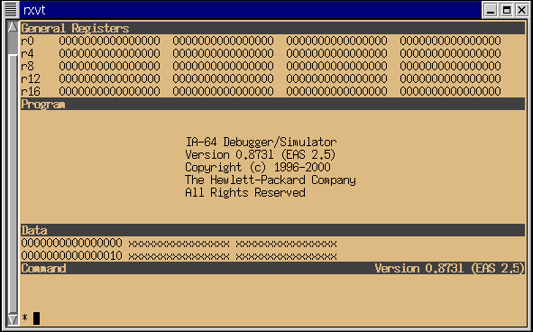Illustration 8: The ski Register Window (at Top)

The Program Window
The Program Window provides a view into the program space. Whether you load a program into the simulated processor's address space via the command line or using Ski's load, iaload, or romload commands, the program is displayed in a format resembling a compiler's assembler listing file. For IA-64 programs compiled from a high-level language such as ‘C' and linked with the appropriate options, the source code is displayed with line numbers, mixed in with the generated assembly language as shown in Illustration 9: xski's Program Window Showing Part of an IA-64 "hello world" Program. As an example, to compile the "hello world" program with the IA-64 compiler used in testing Ski, the command line is:
cc -o hello -g hello.c
Note that the -O (capital-O) "optimization" flag was not specified. Optimization, by definition, rearranges the object code. If you turn on optimization, the correspondence between source code and object code will be obscured and you may find the resulting display difficult to interpret.
IA-64 assembly code is displayed through disassembly; the original assembler source code is not displayed. Source code for IA-32 programs, high-level and assembly, is not displayed.
Ski chooses whether to interpret the instructions as IA-64 or IA-32 encodings based on the setting of the psr.is bit. If your program has a mix of IA-64 and IA-32 code, you may need to manually set or clear this bit when trying to view a part of the program that is in a different encoding from the encoding at the current ip location. You can set the bit with the Ski command "= psr.is 1" and you can clear the bit with "= psr.is 0". If the bit is set incorrectly, Ski will use the wrong instruction decoder and will show IA-64 code disassembled as if it was IA-32 code or vice-versa! Remember to set the bit back before resuming simulation.

IA-64 Instruction Display
Each IA-64 instruction bundle is labelled on the left with an hexadecimal byte-addressed offset from the nearest, preceding symbol up to 0xffff bytes away. If the symbol name and offset are longer than sixteen characters, the first fifteen are displayed and an asterisk ("*") is added to indicate that the symbolic display has been abbreviated. For each 128 bit bundle, the two or three instructions are displayed in the center of the window with operands to their immediate right. The template for the bundle is shown as a triplet of capital letters, such as "MII," to the right of the last operand of the first instruction in the bundle. The end of each instruction group (a unit of potentially parallel execution) is marked with a pair of semicolons (";;") after the last operand of the last instruction in the group.
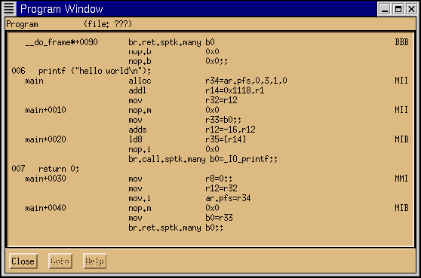Illustration 9: xski's Program Window Showing Part of an IA-64 "hello world" Program
Ski uses the first few columns for source code line numbers. Ski also uses the first column to show breakpoint locations for IA-64 assembly language instructions, numbering the breakpoints "0" through "9." IA-64 breakpoint commands include bs, bD, bd, and bl, and are described in "" on page . For the purpose of setting breakpoint addresses, Ski "pretends" that the slot 0 instruction in a bundle is located at the first byte of the bundle, the slot 1 instruction is located at the fourth byte, and the slot 2 instruction is located at the eighth byte. See "" on page .
Predication is an IA-64 feature that increases the usable parallelism of user programs and allows better utilization of functional units. Ski shows predication information in the second column of the Program Window, as shown in Illustration 10: xski's Program Window Showing IA-64 Predication and Breakpoints. If the second column of a given instruction line contains an exclamation mark ("!"), the instruction is predicated on a predicate register that is currently 0: the instruction is "predicated off". The predicate register is displayed in parenthesis immediately to the left of the instruction mnemonic. Ski uses a different encoding for the instruction pointed to by the ip register: an asterisk ("*") indicates that the instruction is predicated off and a greater-than symbol (">") indicates that the instruction is predicated on. (That is, the ">" symbol means "This is the next instruction to be simulated.")
Illustration 10: xski's Program Window Showing IA-64 Predication and Breakpoints

IA-32 Instruction Display
IA-32 instructions are displayed as shown in Illustration 11: xski's Program Window Showing IA-32 Code, the Instruction Pointer, and a Breakpoint, according to the conventions for Intel assembly code. As with IA-64 instruction display, Ski uses the first column of each assembly language instruction line to show breakpoint locations, numbering them "0" through "9." Except for the use of iabs rather than bs, IA-32 breakpoint commands are the same as IA-64 breakpoint commands and include iabs, bD, bd, and bl, as described in "" on page . In the second column, Ski puts a greater-than symbol (">") to point to the next instruction to be executed, i.e., the location pointed to by the ip register.
Because IA-32 instructions are variable in length, it is possible to set the ip to point into the middle of an instruction. This can happen, for example, when an instruction with prefix bytes is needed at the top of the first pass through a loop, and the same instruction without the prefix bytes is needed at the top of subsequent passes. When this happens, Ski uses a plus-sign ("+") in column two, rather than a greater-than symbol, to warn you that ip points somewhere in the middle of the line of code displayed on the screen. To update the display, use the command "pj ip". This will cause Ski to reinterpret the instruction stream and to display the variable length instructions with the new interpretation.
Illustration 11: xski's Program Window Showing IA-32 Code, the Instruction Pointer, and a Breakpoint

Changing the Range of Locations Shown in the Program Window
xski doesn't place a scroll bar in the Program Window. Instead, like ski, xski provides the pf and pb commands, described in "" on page . You use these commands to scroll the Program Window forwards and backwards, respectively, through the assembly language program display. Ski also provides the pj command which lets you "jump" the Program Window to any location in the address space. In addition, xski understands the Page Up and Page Down keys and the arrow keys. When the Program Window has the X Window System focus, the Page Up, Page Down, up-arrow, and down-arrow keys emit the "pb", "pf", "pb 1", and "pf 1" commands, respectively.
You can control the size of xski's Program Window using your window manager's standard mechanisms. If you are using ski, the window is fixed in size; on a twenty four line terminal, the window will be nine lines tall.

Invalid Code and the Program Window
Ski will disassemble the area of memory it is displaying in the program window, regardless of whether the area contains program code or data. If you tell Ski to display non-program memory, Ski attempts to display the (non-existent) instructions. When Ski finds bit encodings that don't represent valid instructions, it displays the word "illegalOp" instead, as shown in Illustration 12: xski's Program Window Showing Illegal Instructions. Sometimes, Ski may display x's, indicating that you asked Ski to show a page of memory that doesn't exist, as shown in Illustration 13: xski's Program Window Showing Unallocated Space or No Translation. There are three cases to consider:
- In application-mode, x's indicate a page of memory that hasn't been accessed by the program and therefore hasn't been allocated by Ski.
- In system-mode with instruction address translation enabled (the psr.it bit is on), x's indicate a page of memory for which no entry exists in the Translation Lookaside Buffer (TLB) or in the Virtual Hash Page Table (VHPT).
- In system-mode with instruction address translation disabled (the psr.it bit is off), x's indicate a page of memory that has not yet been accessed by the program.
Application-mode and system-mode programming are discussed in more detail in on page .
Illustration 12: xski's Program Window Showing Illegal Instructions
Illustration 13: xski's Program Window Showing Unallocated Space or No Translation

The Data Window
In the Data Window, xski and ski present data in hexadecimal format, sixteen bytes to a line, as shown in Illustration 14: xski's Data Window Showing Unallocated Space Followed by Data. The data are displayed as four groups of eight hexadecimal digits each, with an ASCII character translation on the right and the data address on the left. (The endianness of the displayed bytes is determined by the current value of the psr.be bit which may change by the time the simulated IA-64 processor actually loads the bytes.) The address is expressed as a symbol from the executable file's symbol table or as a sixteen digit hexadecimal number.
With the dbndl command, Ski can display data formatted as IA-64 instruction bundles in hexadecimal, as shown in Illustration 15: xski's Data Window Showing Data Interpreted as Instruction Bundles. (The figure was generated by loading a program and then issuing the command "dj main-10" followed by the dbndl command.) This is useful when you need to see the raw hexadecimal instruction encodings. The first column displays the address of each bundle. The second column displays the template field. The remaining three columns are the 41-bit instructions from slots 0, 1, and 2. Note: for the purpose of setting breakpoint addresses, Ski "pretends" that the slot 0 instruction is located at the first byte of the bundle, the slot 1 instruction is located at the fourth byte, and the slot 2 instruction is located at the eighth byte. See "" on page for more information.
Illustration 14: xski's Data Window Showing Unallocated Space Followed by Data
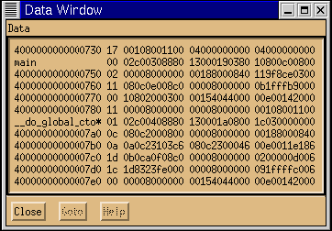Illustration 15: xski's Data Window Showing Data Interpreted as Instruction Bundles

Changing the Range of Locations Shown in the Data Window
As with the Program Window, xski doesn't place a scroll bar in the Data Window. Instead, like ski, xski provides the df, db, and dj commands, described in " on page . Use these commands to scroll the Data Window forwards and backwards and to "jump" the Data Window. In addition, xski understands the Page Up and Page Down keys and the arrow keys. When the Data Window has the X Window System focus, the Page Up, Page Down, up-arrow, and down-arrow keys emit the "db", "df", "db 1", and "df 1" commands, respectively.
You can control the size of xski's Data Window with your window manager's standard mechanisms. If you are using ski, the window is fixed in size; on a twenty four line terminal, the window will be two lines tall.

Invalid Code and the Data Window
If you tell Ski to display non-existent memory, Ski will display x's instead, as shown in Illustration 14: xski's Data Window Showing Unallocated Space Followed by Data. Non-existent memory is defined for the Data Window similarly to its definition for the Program Window, described in the "Invalid Code and the Program Window" section, except that the relevant bit for system-mode programs is psr.dt.

The Command/Main Window
xski and ski are command-driven simulators. Most of your interaction with them is done by typing commands. Your commands are typed in a window titled "main" in xski (see Illustration 16: xski's Main (Command) Window and "Command" in ski (see Illustration 17: ski's Command Window (at Bottom)).

The xski Main Window
xski divides the Main Window into five areas:
- Menus: File, View, Configure, and Help. The File menu provides a "Quit" selection for you to exit the program. The View menu lets you choose which windows to see. The Configure menu is currently non-functional. The Help menu provides a "Commands" selection that displays the commands Ski recognizes and a "Product Information" selection that displays information about xski.
- Buttons: Step, Run, Prog, Data, Regs, Cache, TLB, and Quit. Clicking on the Step button executes the command "step 1", single-stepping the simulated program. Shift-clicking the button executes the command "step 10", stepping the simulated program through ten instructions. The Run, Prog, Data, and TLB buttons execute the run, pj, dj, and sdt commands respectively. If the Program Window has been closed (removed from the screen, not merely minimized to an icon), the Prog button recreates it. The Data button operates similarly with respect to the Data Window. The Regs and Cache buttons are currently non-functional.
xski's buttons are configurable. Using the X Window System resource mechanism, you can change the number of buttons, the button labels, and the commands the buttons emit. The easiest way to do this is to edit the XSki file, described in "" on page . Much of xski's user interface behavior is controlled by this file but you should be careful in making changes to any elements other than button descriptions; xski may change in the future in ways that are not backwards-compatible with changes you make.
- Command History: commands you've already entered.
- Command: where you type commands to xski.
- Responses: responses and error messages from xski.
The Menu, Button, and Command History areas provide shortcuts for typing commands. The Step button is particularly useful: when you are single-stepping through a program, you can click on the Step button instead of repeatedly typing the "step" command. The Command History area provides another way to avoid typing: you can double-click on a command in the Command History to run the command again, or single-click on the command to move it to the Command area where you can edit and then re-run it. The Command area is where you type commands to the simulator, but, as mentioned above, you can use the menus, buttons, and Command History as shortcuts. Two useful commands to know are "help", which causes a window listing all the commands to be displayed, and "help command" which causes information about the command to be shown in the Responses area. The Responses area is also used by the simulator to give you feedback when it can't execute one of your commands.
xski understands the Prev and Next keys and the arrow keys found on many HP keyboards. When the Main Window has the X Window System focus, the current area is highlighted, usually with a bright outline. You can make a different area current with Tab and Shift-tab. The Prev, Next, up-arrow, and down-arrow keys scroll through the current area, allowing you to easily edit and re-run previous commands from the Command History and review previous messages in the Response area. In addition, you can use the Alternate key ("alt") like a Shift key, along with the underlined letter in each menu name as a shortcut to access the menu, rather than using the mouse. For example, Alt+F brings up the File menu. This lets you spend less time shuttling between the keyboard and mouse, and more time doing productive work.
Illustration 16: xski's Main (Command) Window

The ski Command Window
ski's Command Window is simpler, as shown in Illustration 17: ski's Command Window (at Bottom). There are no menus, buttons, or Command History. Instead, you enter commands when you see a * prompt in the 4-line Command Window at the bottom of the screen. ski displays its responses in this window as well. The window scrolls so that information lost off the top of the window may be recovered using the up and down arrows on your keyboard (for Emacs fans, Ctrl-P and Ctrl-N serve the same function). As a typing shortcut, if you hit the enter/return key, ski will repeat the last command you entered.
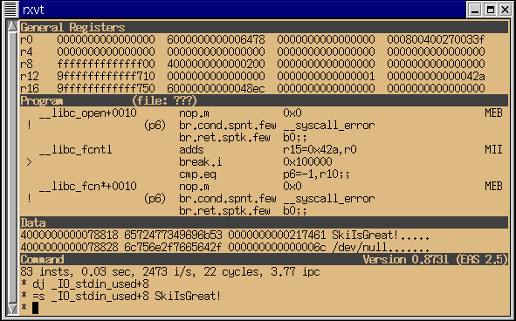Illustration 17: ski's Command Window (at Bottom)

Other Windows
Some commands, such as help, isyms, and symlist, cause xski and ski to create additional windows. When xski creates an additional window, it adds scroll bars if there is more information than will fit. As an example, the output window created by xski for the symlist command is shown in Illustration 18: xski's Symbol List Window. xski understands the Page Up and Page Down keys and the arrow keys. The Page Up and Page Down keys scroll through the window a windowful at a time, with one line of overlap. The up-arrow and down-arrow keys scroll through the window a line at a time.
When ski needs to display additional information, it does so by overwriting the four standard windows. ski sends the information through a pager, using less by default. When the pager finishes, ski refreshes the screen with the standard ski windows. If you prefer to use a different pager, for example more or page, set the PAGER environment variable accordingly, before starting the simulator.
Illustration 18: xski's Symbol List Window

