Getting Started - A Ski Tutorial
In this chapter, you learn how to use Ski by executing a brief tutorial. At the end of the tutorial, you will learn where to look in this manual for detailed descriptions of Ski's operation and commands. Introductory information on Ski is presented in the "" on page .

The Ski Simulator
Ski simulates the IA-64 architecture and also has limited support for simulating IA-32 programs. Ski runs on IA-32 Linux host systems. You can use Ski for many purposes, as described in the "" on page . One of the most common uses of Ski is to test an IA-64 program in a Linux environment, and in this chapter, you will learn how to use xski, the X Window System version of Ski, by "walking through" a sample session, in about ten minutes. Ok, twenty minutes.
You should already be familiar with the IA-64 architecture and the C programming language, have xski installed on your Linux system, and have the XSki file in your home directory or in your X Window System app-defaults directory, typically /usr/lib/X11/app-defaults. You will also need to have an executable Linux IA-64 program such as the classic "hello world" program.

How to Run an IA-64 Application Program
Ski provides a Linux application environment in which an IA-64 program you provide can be simulated. The release notes provide the most up-to-date information on Ski's support for the Linux Application Binary Interface (ABI). The following sections provide a short tutorial which leads you through an IA-64 program session with xski. You will learn how to use the most common Ski commands.

Starting xski
As shown in Illustration 1: Starting xski From the Command Line1, start xski by typing its name to the Linux shell, just like any other Linux program. When running inside the IA-64 Linux Native User Environment (NUE), make sure that the environment variable DISPLAY is set to a string of the form hostname:display (e.g., ‘‘myhost:0'', values such as ‘‘unix:0'' or ‘‘:0'' won't work) before invoking xski. If you have never run the simulator before, it will first prompt you to read and accept the software license it is distributed under. After accepting the license, the four primary xski windows will be displayed on your screen, as shown in Illustration 2: The Four Primary xski Windows. No IA-64 program is loaded yet, so the Program Window and Data Window are empty. Scroll the various panes of the Register Window and note that with few exceptions, the registers are set to zero.
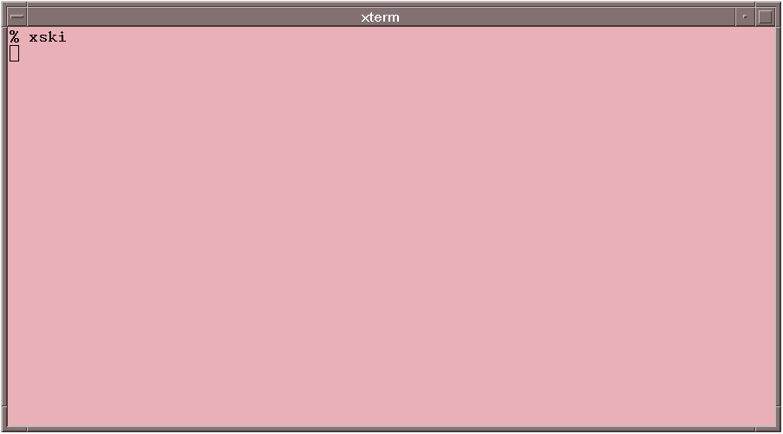Illustration 1: Starting xski From the Command Line
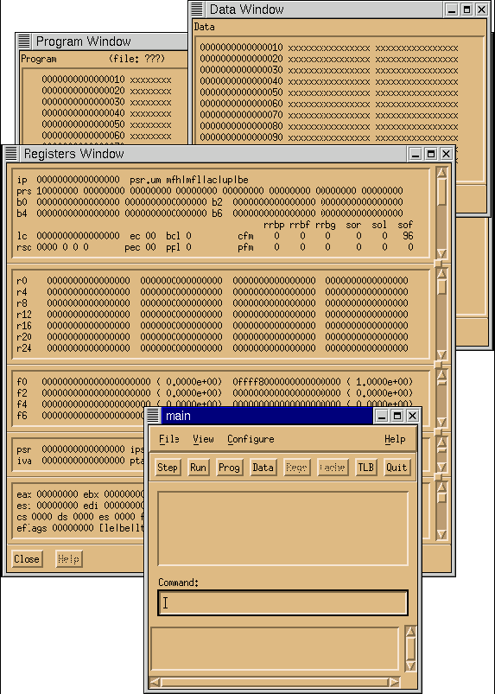Illustration 2: The Four Primary xski Windows

Exiting Ski
You can quit xski and this tutorial with the Quit button, with the File->Quit menu selection, or with the "quit" command. All are in the Main Window. (Don't quit now; you are just beginning!)

Loading Your Program
Use the "Command" area of the "main" Window to load your program. For example, let's say your program is the famous "Hello, world" program, the executable file is named "hello", and the source code file is named "hello.c". Type "load hello" in the Command area to load it into Ski, as you see in Illustration 3: Loading the "hello" Program. After a moment, the other three windows will change appropriately: the Program Window will show the program code in assembly language form as shown in Illustration 4: The xski Program Window, the Data Window will show global and static data as shown in Illustration 5: The xski Data Window, and the Register Window will show, in r12 the value of the stack pointer, as shown in Illustration 6: The xski Register Window. (You may need to use the scrollbar in the general registers pane of the Register Window to see these registers.)
Illustration 3: Loading the "hello" Program
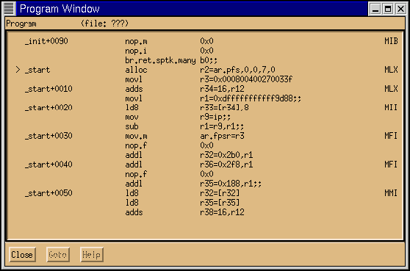Illustration 4: The xski Program Window
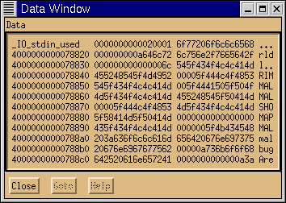Illustration 5: The xski Data Window
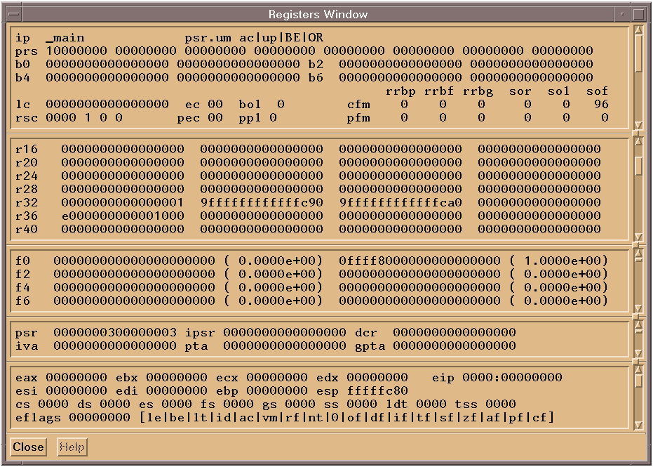Illustration 6: The xski Register Window

Inspecting Data
To look at the argv and envp strings, you need to use the Data Window. Linux passes argc, argv, and envp on the memory stack (r12). To look at this memory area, use the "dj" command ("data jump") in "Command" area of the Main Window. Supply, as an operand, the address of the memory stack. For example, if r12 is set to 9ffffffffff780, you can type "dj r12" or "dj 9ffffffffff780", as shown in Illustration 7: Changing the Data Window Display and the Data Window changes to display the hexadecimal data stored at the location, as shown in Illustration 8: The Data Window Showing the argv and envp Vectors. Find the value of r12 in your program and use "dj" now. (You might wonder why "dj" exists, instead of a simple scroll bar. Imagine scrolling through the entire IA-64 address space– it would take a long, long time!)
Illustration 7: Changing the Data Window Display

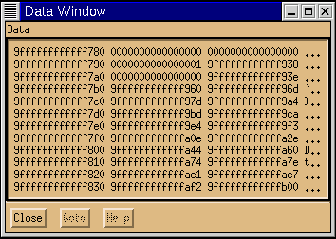Illustration 8: The Data Window Showing the argv and envp Vectors
Looking at the Data Window, you can see that the first 16 bytes of the stack are all zeros. This is a scratch storage area. The next 8-byte word contains argc, the argument count. It has a value of 1 as the only argument passed to the program is the program name itself. The argc count is then followed by the argv and envp vectors. All C programs receive the same kind of data structure for argv: a variable-length vector of char * pointers whose end is marked with a NULL pointer. In Illustration 8: The Data Window Showing the argv and envp Vectors, the first of the char * pointers is 9ffffffffffff938. (The first char * pointer may be in a different place on your system. Adjust the following instructions accordingly.) Jump the Data Window there using the command "dj 9ffffffffffff938" (12 f's) and you will see Illustration 9: The Data Window Showing argv and envp Strings in Hexadecimal, showing the hexadecimal codes for the null-terminated ASCII character strings of argv and envp. (In a moment, you'll learn how to see data in ASCII translation.)
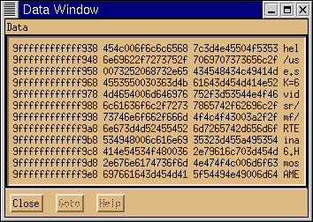Illustration 9: The Data Window Showing argv and envp Strings in Hexadecimal
Typing hexadecimal numbers is error-prone, and Ski provides several shortcuts to avoid it. The first is xski's Command History, an unlabeled window pane just above the "Command" area in the Main Window. As you execute commands, they move up to the Command History. Later, you can bring them back into the Command area. A single click brings a command back for you to edit. A double click brings the command back and re-executes it immediately. Try the Command History by doing this: Type "dj 0" to jump the Data Window to location 0. The Main Window should look like Illustration 10: The Main Window Showing Commands in the Command History. Then click on the "dj 9ffffffffffff938" command in the Command History. Hit the enter/return key to execute it.
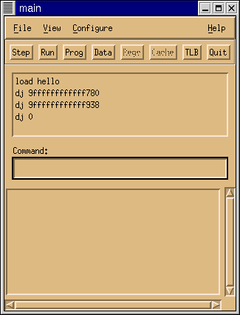Illustration 10: The Main Window Showing Commands in the Command History
Another shortcut is the * pointer-dereference operator for indirect addressing. Type "dj 0" to jump the Data Window to location 0. Then type "dj *(r12+18)". Ski will take the contents of r12 (9ffffffffff780, remember?), add 18 (hex) and use that as the address of the operand. The * operator fetches the contents of *(r12+18) and uses that value, 9ffffffffff938, as the address to jump to. Compare the Data Window display resulting from "dj r12+18" with the display resulting from "dj *(r12+18)".
You will use the * operator a lot in debugging C programs because it performs the same function as C's * operator: it dereferences pointers. Unlike C's *, however, Ski's * operator is not type-specific: you can use it in any context where any kind of address is needed and you can use it to dereference registers like r12, memory locations, or anything that has a value. (This doesn't always make sense, of course. For example, dereferencing a floating-point register is rarely useful because floating-point registers don't hold pointers.)

Viewing Data in ASCII
Hexadecimal is no fun. To expose the ASCII translation, use your window manager's standard mechanism to make the Data Window wider. (How you do this depends on the window manager you're using, but generally this can be accomplished by grabbing the edge of the Data Window with your mouse cursor and dragging it to the right.) You should see approximately Illustration 11: The Data Window Showing argv and envp Strings in ASCII. Now click on the Main Window, to make it the active window again. Try the "df" ("data forwards") and "db" ("data backwards") commands without operands to move forwards and backwards in the Data Window, one screenful each time.
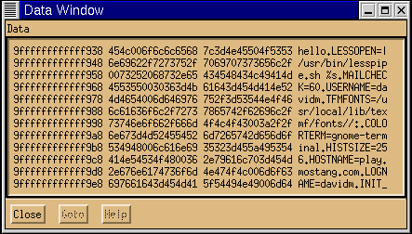Illustration 11: The Data Window Showing argv and envp Strings in ASCII

Looking at Code
Initially, the Program Window shows the beginning of the program. For C programs, this isn't the first line of user code, it's the start-up routine from crt1.o that provides an interface between the operating system environment and the ANSI C environment. This routine is named "_start" and the ELF header in hello names it as the start of the program. That's what Ski shows in the Program Window by default: the start of the program according to ELF.
You use the "pj" command ("program jump") to jump the program window elsewhere. For example, jump it to the first instruction in the user's main(), as shown in Illustration 12: Jumping the Program Window to the Beginning of main(). The Program Window now looks like Illustration 13: The Program Window Showing Code at the Beginning of main(). You can move the Program Window forwards and backwards through program code with the "pf" ("program forwards") and "pb" ("program backwards") commands, respectively. Try these commands, and then try using "pj" without an operand: note how it jumps you back and forth between the previous and current locations. The "dj" command does the same thing in the Data Window. Handy, eh?
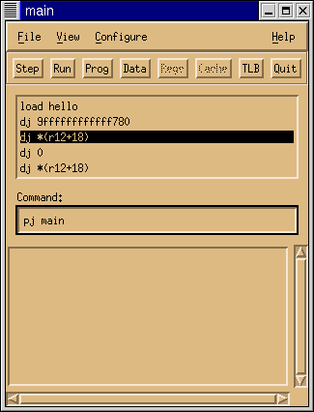Illustration 12: Jumping the Program Window to the Beginning of main()
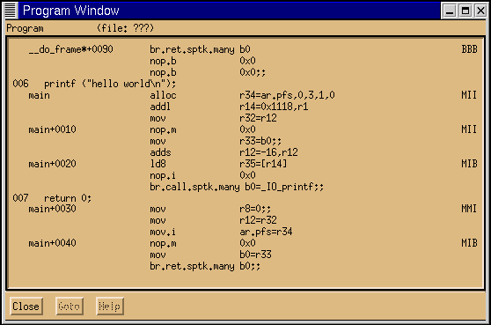Illustration 13: The Program Window Showing Code at the Beginning of main()

Viewing Source Code Mixed In with Assembly Code
The Program Window shows the C source code intermixed with the IA-64 assembly code. You can turn the source code display off or on using the pa ("program assembly") and pm ("program mixed") commands, respectively. Mixed code display only works if you have the source code to the program available to Ski; the source code isn't embedded in the ELF file. Also, you must compile your code with the appropriate compiler flags, for example, with the -g flag used by many C compilers to generate debug line record information. If your program is composed of multiple object files, for example "cc -o test foo.o bar.o baz.o", Ski can only show source code from the files compiled with the -g flag. Make sure the Program Window is in mixed mode for now.

Controlling Breakpoints
You can think of Ski as a debugger that happens to work on a simulated processor rather than a real processor. Like any good debugger, Ski provides breakpoints. To set a breakpoint in an IA-64 program, use the "bs" command ("breakpoint set"). In the example that follows, you will want to have the Program Window display the area of code near main(). Use the command "pj main", as you learned above.
To set a breakpoint at the beginning of main(), type "bs main" in the Main Window. The Program Window shows a "0" in the first column of the window at the breakpoint location (the ‘‘alloc'' instruction), because you just used breakpoint #0, as Illustration 14: The Program Window Showing a Breakpoint at main() shows. (The first three columns are also used for line numbers.) Set a breakpoint at main+10 and another at main+20. Ski lets you set up to ten breakpoints.
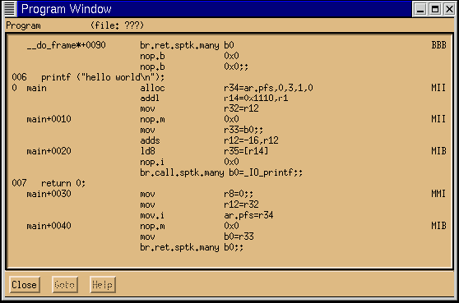Illustration 14: The Program Window Showing a Breakpoint at main()
Use the "bl" command ("breakpoint list") to see a list of the breakpoints, as shown in Illustration 15: The Breakpoint List Window. If you prefer using a mouse, use the "Breakpoints" item on the View menu instead of the "bl" command. When you are finished viewing the breakpoint list, click its Close button to dismiss the window.
To delete breakpoints individually, use the "bd" command ("breakpoint delete"). Use the "bD" command ("breakpoint Delete all") to delete all breakpoints at once. Delete all your breakpoints before continuing this tutorial.
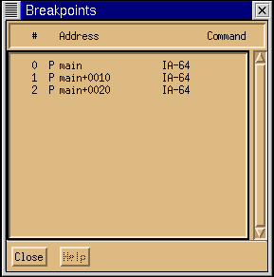Illustration 15: The Breakpoint List Window

Running a Program
To run your program, type the "run" command or click the Run button in the Main Window. Ski will start the simulation and connect the program's standard I/O ports (stdin, stdout, and stderr) to Ski's standard ports. For example, assuming there are no breakpoints still set in hello, you will see "hello world" printed out when you run it, as Illustration 16: The Terminal Window After the "hello" Program is Run shows, and run statistics will appear in the Main Window, as Illustration 17: The xski Main Window after the "hello" Program is Run shows. The statistics tell you how many instructions were simulated and how much time it took, the instructions-per-second rate, the number of IA-64 processor cycles that were consumed on the simulated CPU, and the average number of instructions per cycle, which provides an indication of the best-case effective parallelism of the program. (Ski simulates all the instructions in an instruction group in one cycle; a hardware implementation may not be as capable.)
Ski will stop the simulation for three reasons: if a breakpoint is reached, if the IA-64 program attempts to access privileged resources or non-existent memory, or if the program ends normally by calling exit() or similar functions. If simulation stops due to a breakpoint, you can continue simulation with the "cont" command ("continue") or you can step through the simulation with the "step" command or Step button. You cannot re-run a program, nor can you re-load it and start over. You must exit and re-enter xski and then reload your program.
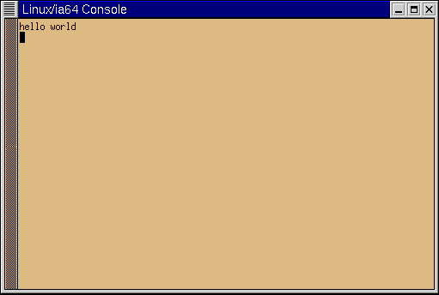Illustration 16: The Terminal Window After the "hello" Program is Run
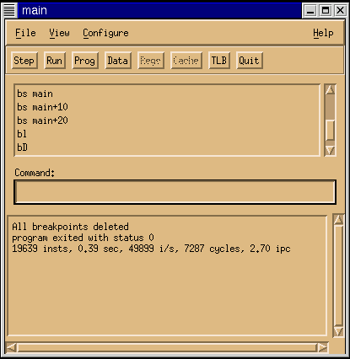Illustration 17: The xski Main Window after the "hello" Program is Run

Single-stepping a Program
To try single-stepping (and no, this is not a kind of ethnic dance), set a breakpoint at main+10. Then use the "run" command or Run button to simulate the program up to the breakpoint. (If you receive the error message "Nothing to run", stop and reread the last sentence in the previous paragraph.) Ski stops at the breakpoint and notifies you with a message in the Main Window. Ski tells you why it stopped and gives you statistics about program execution up to this point, as you can see in Illustration 18: The Main Window After Reaching the Breakpoint at main+10. The Program Window marks the next instruction to be fetched with a greater-than symbol in the second column. If the instruction is predicated off, Ski uses an asterisk instead of a greater-than symbol, and shows the predication register in parentheses.
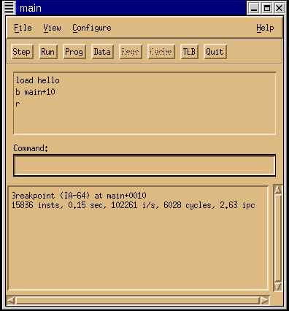Illustration 18: The Main Window After Reaching the Breakpoint at main+10
Move and resize your windows so the Main Window and Program Window don't overlap. Now use the "step" command or Step button to execute one instruction. Note that the greater-than symbol moves down one line: Ski keeps track of IA-64 bundles and groups but it simulates individual instructions. You can follow the "step" command with a (decimal) number to specify how many steps Ski should take, for example, "step 10" to execute ten instructions. As a shortcut, shift-clicking on the Step button causes Ski to take ten steps. Most Ski commands can be abbreviated, as described in "" on page . The step command can be abbreviated as "s".

Changing Registers and Memory
To debug a program, you usually need to inspect and alter registers and memory. The first three panes in the Register Window shows the registers of most concern to application programmers: user registers in the first pane, general registers in the second pane, and floating point registers in the third pane, as you can see in Illustration 19: The xski Register Window After Stopping at a Breakpoint at main+10.
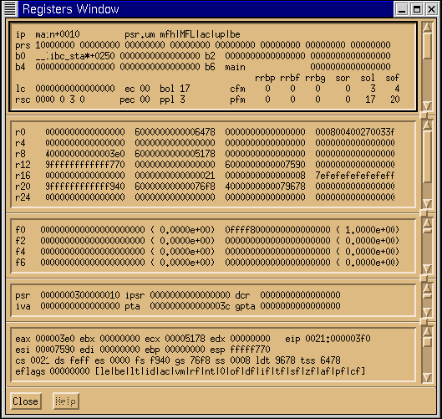Illustration 19: The xski Register Window After Stopping at a Breakpoint at main+10
By changing the value of the ip register, you can change where in the program Ski will resume simulation. Enter the command "= ip main+20" in the Main Window and observe the first line of the first pane in the Register Window: notice that the ip register changes to reflect your command, as Illustration 20: The xski Register Window After Changing the ip Register shows. (You may need to left-click in the Main Window to make it active.) You can make similar changes to all of the architecturally-visible, non-hardwired IA-64 registers, which helps you debug your program. You can test your program's behavior in exceptional cases, such as handling unusual errors.
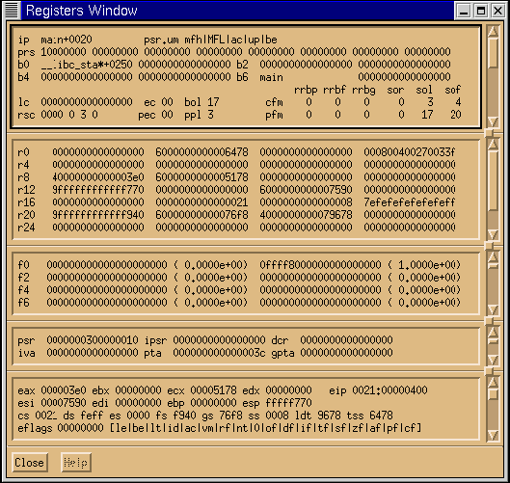Illustration 20: The xski Register Window After Changing the ip Register
Changing registers isn't enough to debug most programs, however. Often, you need to change values in memory as well. Ski provides several commands for this, differing in whether they modify one-byte chunks, two-byte chunks, four-byte chunks, eight-byte chunks, or variable-length C-language text strings. For example, instead of "hello world", you can have the program output "Ski!Ski!Ski!". You can do this by using the "=s" command ("= string") to modify the data stored at the address "_IO_stdin_used+8". (The string may be stored at a different address in your program. If so, use the Data Window to locate the string and then use the corresponding address instead.) Here's what to do:
First, make sure the Data Window is wide enough to show ASCII translations along with hexadecimal, as in Illustration 21: The xski Data Window Widened to Show ASCII. To avoid confusion, make sure the Data Window doesn't overlap the Main Window.
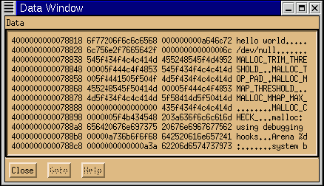Illustration 21: The xski Data Window Widened to Show ASCII
Next, issue the command "=s _IO_stdin_used+8 Ski!Ski!Ski!" in the Main Window. (You may need to left-click in the Main Window to make it active.) Observe how the Data Window changes: the hexadecimal values at, and after, _IO_stdin_used+8 have changed, as have their corresponding ASCII translations, and a null byte (the value zero) has been added to the end of your string to make it a valid C-language string. Compare Illustration 21: The xski Data Window Widened to Show ASCII and Illustration 22: The xski Data Window After Changing the "Hello, world" String.
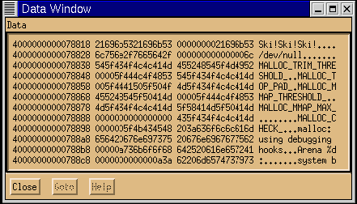Illustration 22: The xski Data Window After Changing the "Hello, world" String
The commands to change one, two, four, and eight byte quantities are =1, =2, =4, and =8, respectively. They are described in detail in "" on page and in " on page .
Often, you will need to evaluate formulas. For example, to find the address of the first envp string, you would need to compute the sum of the contents of r12 and 18 (hex) and then add the length of the argv vector (argc+1) multiplied by eight (the size of a char * on IA-64). To do this, you use the "eval" command in the Main Window, as shown in Illustration 23: The xski Main Window Showing an eval Command and Its Result. (The use of the "*" operator was discussed in "Inspecting Data" on page 6.) As you see, the result is shown in decimal and hexadecimal.
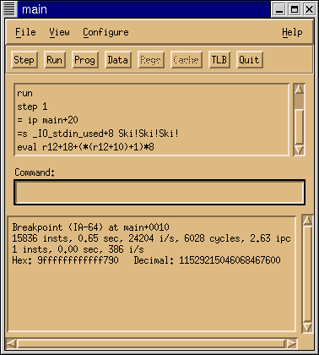Illustration 23: The xski Main Window Showing an eval Command and Its Result

Getting Help
To see what commands are available, type "help" in the Main Window or use the Help->Commands menu selection. To see the syntax of a specific command, type "help" followed by the command name, as in "help eval".

Next Steps
Congratulations! You now know how to use xski to test an IA-64 program. In the rest of this manual, you'll find out how to use ski and bski and the many additional commands and facilities not covered in this brief tutorial.

- The "" chapter, presents the capabilities of Ski, how to start it and stop it, and a brief discussion of installation issues. The chapter also shows how to use bski for batch simulation.
- The "" chapter, discusses the various screen displays of xski and ski in depth.
- The "" chapter, defines the syntax of the language you use to control Ski's operation.
- The "" chapter, presents the Ski commands for controlling Ski's screen displays.
- The "" chapter, introduces the concepts of Ski program simulation, shows you how to load programs, and presents the Ski commands for simulating a program. Much of the information needed to use Ski for firmware development and operating system simulation is in this chapter.
- The "" chapter, discusses the Ski mechanisms and support for simulating application programs. If you are using Ski for to develop system software, such as bootstrap firmware or operating systems, you can skip this chapter.
- The "" chapter, presents Ski commands and facilities that are useful in debugging and tuning programs.
- The "" chapter, introduces command files, a mechanism that lets you extend Ski to meet your particular needs.
- The remaining chapters contain summaries of the Ski command set, a list of the registers and internal variables Ski recognizes, a description of the Ski error and status messages, their causes, and any possible solutions., and any applicable licenses.

