**Databases Laboratory Work Nr 1**

**Title: Installation and configuration of SQL Server**

**Prerequisites:**

Microsoft SQL Server 2017, SQL Server 2017 Configuration Manager

**Objectives:**

The installation of MS SQL Server 2017 and the administration of security and access to database

**Tasks:**

1. To install SQL Server 2017, following the instructions.
2. To register the server on the available computer, setting SQL Authentication.
3. To create 3 logins with SQL Authentication
4. To allocate access for 1st user to HumanResources scheme from AdventureWorks2017 database. User can read and edit the data from corresponding tables.
5. To allocate access for 2nd user to Sales scheme from AdventureWorks2017 database. User can only read the data. He can also manage any object and its content from AdventureWorks2017.
6. The 3rd can create new databases and grant access to them.

**Implementation:**

1. Installation of SQL Server.
2. Registering the server.

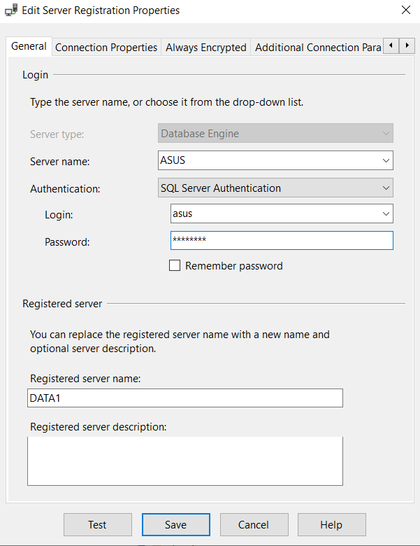

1. Creating the logins.
2. Allocating access for 1st user to HumanResources scheme.  
   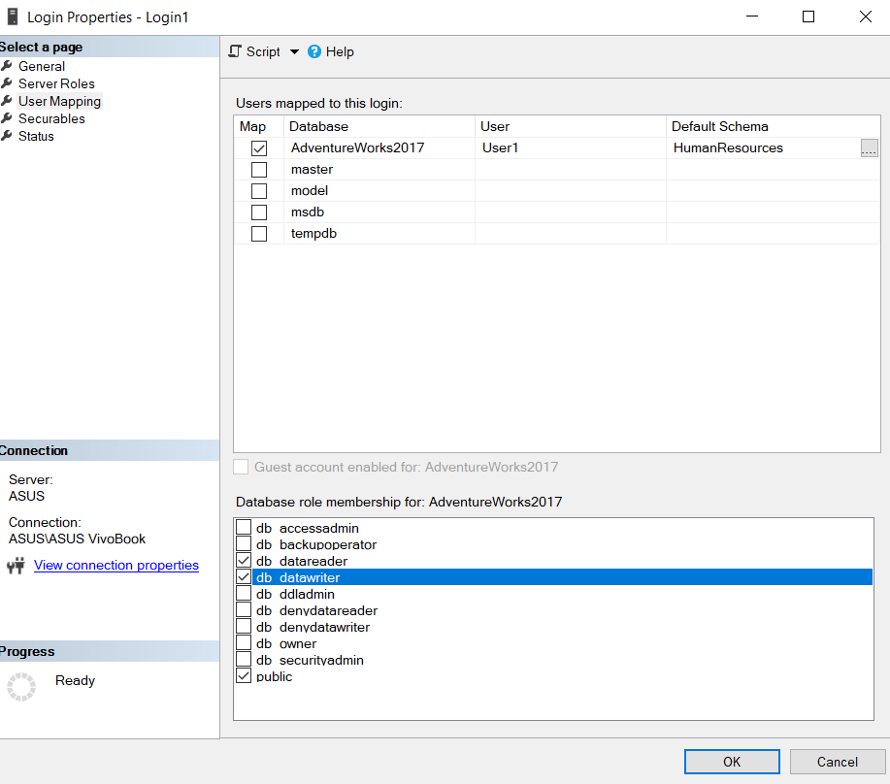
3. Allocating access for 2nd user to Sales scheme.  
   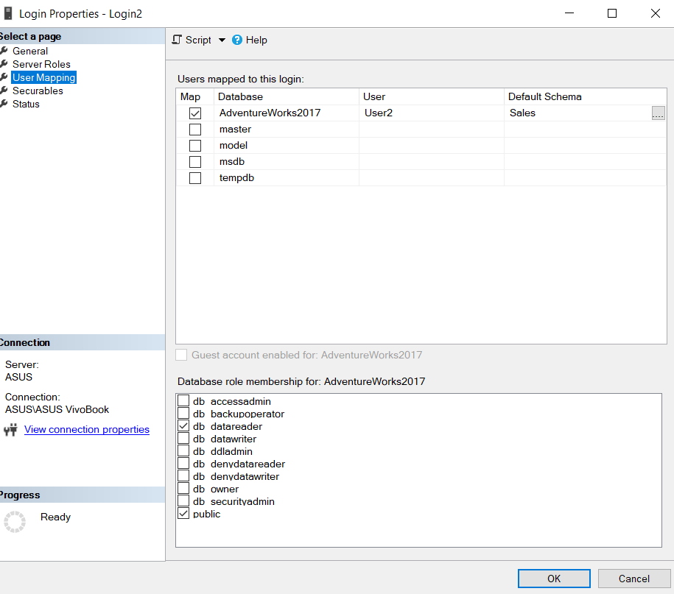
4. Enabling the 3rd user to create new databases and grant access to them  
   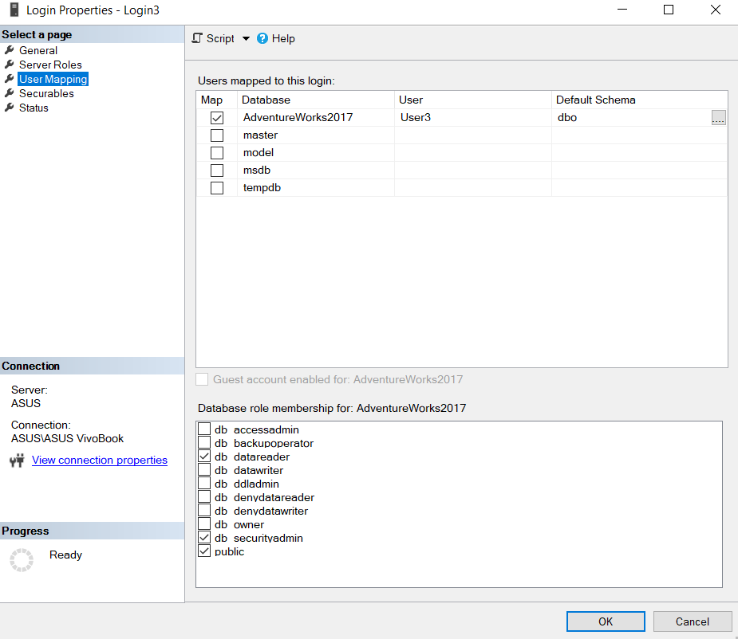

**Conclusion:**

During this laboratory, we were able to install MS SQL 2017 and to configure it to meet the security and access requirements. Using the AdventureWorks2017 as a template we created 3 new logins and changed the User Mapping in order to grant different access to different tables from the database.