**Databases Laboratory Work Nr 2**

**Title: Creation and maintenance of databases**

**Prerequisites: SQL Management Server 2017**

**Objectives: To create 2 databases and set configure the maintenance plan for them.**

**Tasks:**

1. **To create a database, placed physically in *MyDocuments/Data* and to fix a growing of primary file of 16MB, with growing limit of 128MB and with a 64MB – log, with a growing limit of 1024MB. To define a new *Filegroup*, for secondary files with 64MB growing and a limit of 1024MB.**
2. **To create a database, where log file is placed in MyDocuments/Log. The database should be accessible only to one user in a specific moment of time.**
3. **To create maintenance plan for 1st Database. Unutilized space by data files should be removed when it reaches 2000Mb. This operation should be executed every Friday at 12 AM. The report would be saved in MyDocuments/SQL_event_logs.**
4. **To create a maintenance plan for 2nd Database, called “Index reconstruction”. During this plan the system should reconstruct the indexes from main tables. Free space on page should be 10%. The sorting should be stored in tempdb and it should follow statistics collection. Lastly the plan would delete the history older than 6 weeks.**

**This plan would be executed every Sunday of the month with the report file saved in MyDocuments/SQL_reports.**

**Implementation**

**1. Creating 1st Database.**

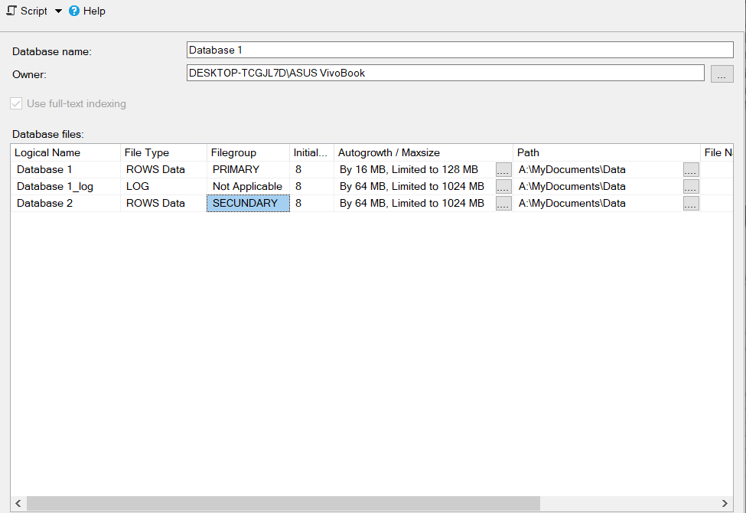

**2. Creating 2nd Database.**

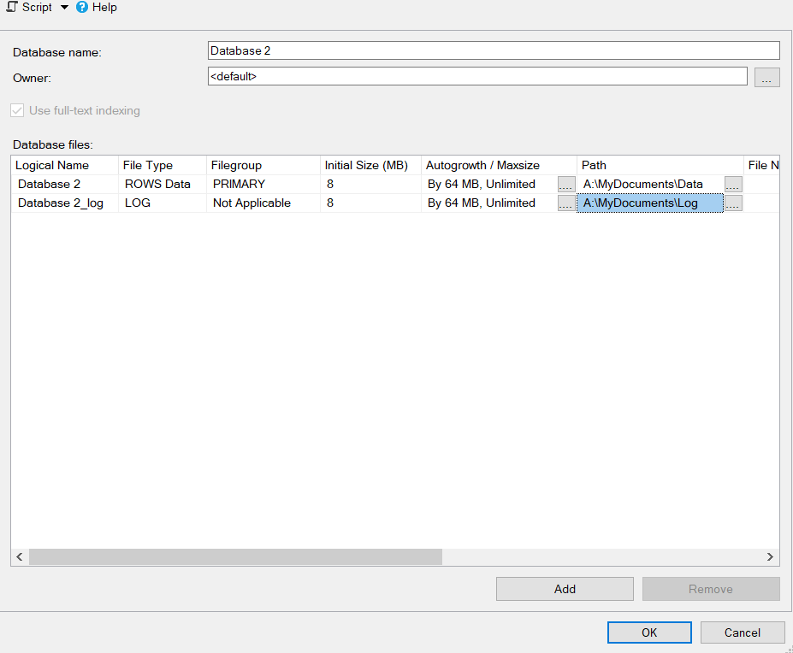

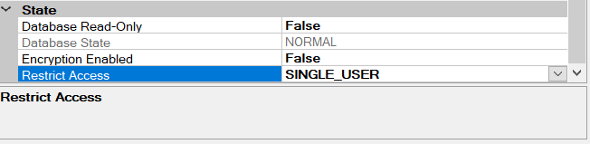

**3. Creating the maintenance plan for 1st Database.**

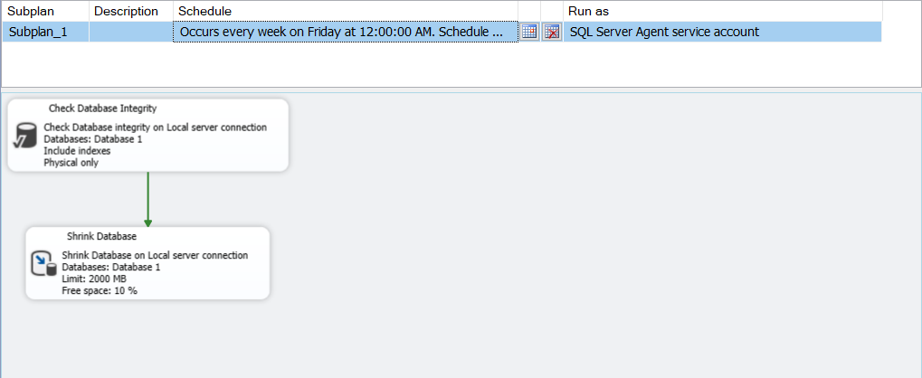

**4. Creating the maintenance “Reconstruire index”.**

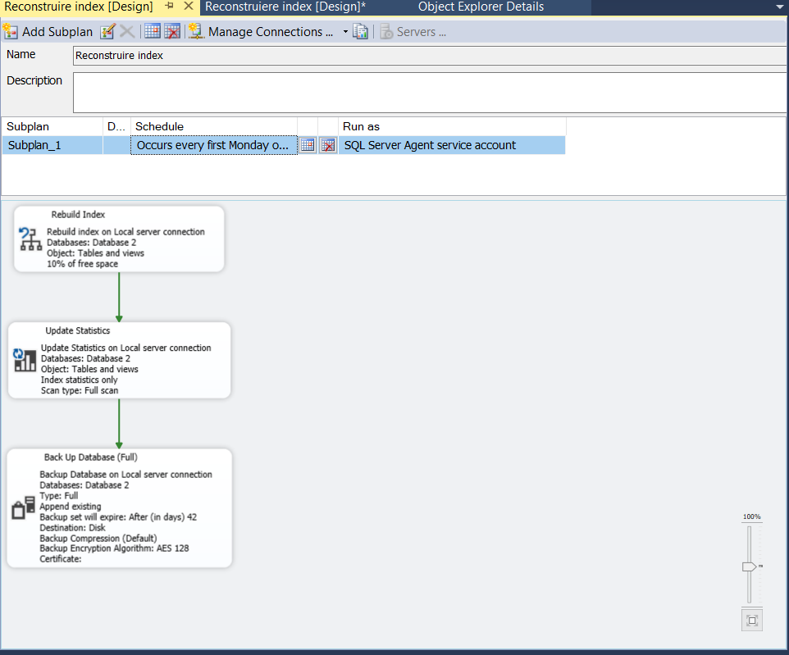

**Conclusion:**

**In this Laboratory we created 2 Databases and set their growing limits and primary and secondary filegroups. Afterwards we scheduled the maintenance plan for each of this databases. We set the plan to manage the Shrink of Database, Index Building, Statistics Update and Backup Options.**