Multi Agent District simulation
Alaa Bakhti
Thibaut Barroyer
Xavier Yvonne
Ilan Dubois

- Introduction

For out multi agent simulation class, we have to make the simulation of a neighbourhood using the Repast library. This simulation is interesting because it allows us to understand better what a multi-agent program can be and it teaches us how to use Repast.

- How to use

The tests directory at the root of the project contains a file named ‘big.map’. In this file, there is the map of the district to simulate. There are several elements in this map:

- H: House.
- O: Office.
- P: Park.
- S: School.
- B: Bus station.
- ` `(Space): Nothing

- Simulation logic

At the initialization of the simulation, each house receives an adult and a child. They are each others family. Each adult will be assigned a random office from all the offices of the map. Every morning, adults will bring their child to the school, and then go to work. They will work in the office and then go back to school to pick the children up. Finally they go back home. Two days a week out of seven they all go together to the park and randomly walk in it.

For all their travels, each agent check what is the fastest way to get to their destination. If going to a bus station , wait for it and walk from the nearest bus station to the destination is faster, then they will do it. This way, the agent makes some kind of Dijkstra’s algorithm to know what is the best option to save time. This strategy is comparable to the strategy real humans would have with a perfect knowledge of transportations map and a way to know how much time to wait at the bus station.

In this simulation, we can observe rush hours at the moment everyone go to the office or park. So we thought it was relevant that they all know transportations as office workers of a district would. During the week-end, activities are quite limited: the park.

- Project architecture

The following figures is the UML diagram of the simulation.

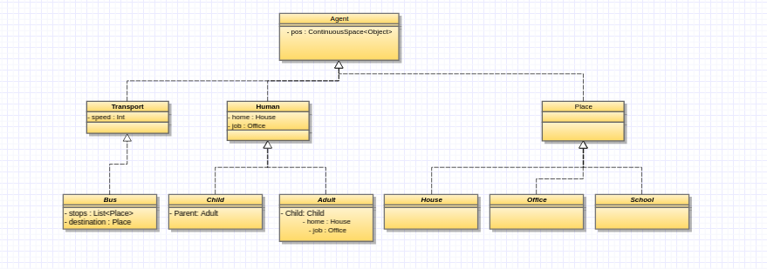
As shown above, the simulation has 3 main classes of agents. The first one is human that is composed with adults and parents. Transportation that is only composed by buses. If we wants to ass more transportations to the map we could add more classes here. Last but not least, the Place class exposes all kinds of facilities represented on the map.

The ‘big.map’ file is read at initialization time line by line and counts all the informations we need such as the number of houses, the size of the map etc… After the instantiation of all agents, the file is read a second time to place all places at the right place in the map.

- Graphical content

The following figures are the sprites used in the simulation.

Those sprites are quite simple but allow a good visualization of the simulation.

- Conclusion

For this project, we have made a simple district multi-agent simulation. This simulation is interesting to observe the effects of rush hour and to see how transportations are handled in real life.

