UN ID-17425092 Chiranjibi Lawati

MY CV

Contents

* Getting Started pg-1
* Designs pg-1

1. Wireframes pg-1
   * + - * Wireframe for my homepage pg-1
         * Wireframe for my cv pg-2
         * Wireframe for my bio pg-3
         * Wireframe for my contact pg-4
2. Sketches pg-5
   * + - * Sketches homepage pg-5
         * Sketches cv pg-5
         * Sketches bio pg-6
         * Sketches contact pg-6
3. Evidence of how I have used Models of Good Practice pg-6
   * + - * Page Load Speed pg-7
         * Visual Appeal pg-8
         * Navigation pg-8
4. Progression of website over 12 weeks pg-8
   * + - * Week 1-4 pg-9
         * Week 4-8 pg-10
         * Week 8-12 pg- 11

* References pg-12

Getting Started

Before starting to create my webpage I went through lots of personal webpage to gain some knowledge and concept that how webpage should look like and what contents it should contain. Mostly, I found that they have used Html5 and Bootstrap for creating webpage. But, I decided to use only Html5 and CSS3 for creating my webpage and made a theme of webpage which will take 12 week time period to complete. To have some knowledge about webpage I went through some of this website:-

* + <http://www.garysheng.com/>
  + <https://rafaelderolez.be/>
  + <http://www.bobbyjkane.com/>
  + <https://www.wix.com/my-account/sites/>
  + Designs

Wireframes

Wireframe for my homepage

Welcome Note

Bar

Navigation

My Image

Detail about me

Footer with Social site link

Footer with address

Pg-1

Wireframe for my CV

Navigation

Bar

Footer with social site link

Footer with address

Detail about education, relevant coursework, skill and experiences

Title

My image

Pg-2

Wireframe for my bio

Footer with address

Footer with social site link

Short information about myself

My Image

Navigation

Bar

Title

Pg-3

Wireframe for my Contact

Bar

Navigation

My Image

Contact Form

Footer with social site link

Footer with address

Pg-4

Sketches

Homepage Sketch

In order to help user I want to make my homepage simple so that they can easily use it. For, easy navigation across webpage I will make navigation bar at the top of page with welcome note. The navigation bar will be orange in color but on hover it will change to white one. For good looks I will add my one image at the left side and little detail on right side of middle portion. The detail part will continuously move from left to right. There will be footer with contact address and social site link. To make my design consistent I will keep navigation and footer part on each page.

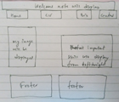

CV Sketch

CV page will also have same navigation bar at the top and footer at the end. But, the middle part will have information about my education, relevant course work, skill and experience along with my passport size image.

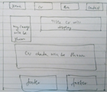

Pg-5

Biography Sketch

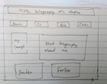My biography page will have two division on middle part of the page .One part will be for my image and another will be for my short biography. It will also have same navigation bar and footer as like homepage and CV for consistent design.

Contact Sketch

As like other page contact page will also have same navigation bar and footer at the top and at the end. But, page will have a simple contact form on middle of it where user can write feedback about page and also with the help of social site option can connect with me through any of the site.

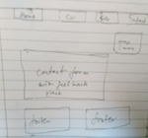

Evidence of how I have used Models of Good Practice

Page Load Speed

We all know that the important part of Internet is Internet speed. Everyone who are familiar to the Internet wants fast net. So, keeping in mind that webpage need to load as fast it can I have design my webpage. I have checked my webpage speed by loading it in https://www.webpagetest.org/ and in <https://tools.pingdom.com.The> speed of my webpage in pingdom.com is 488ms which is 97% faster than other webpage. Again after compressing image properly my webpage load speed will increase.

Pg-6

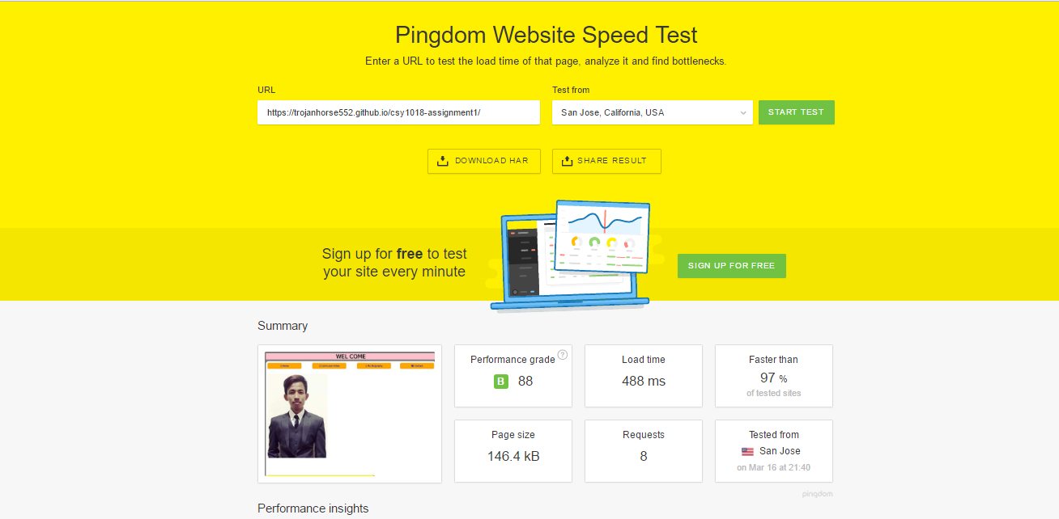

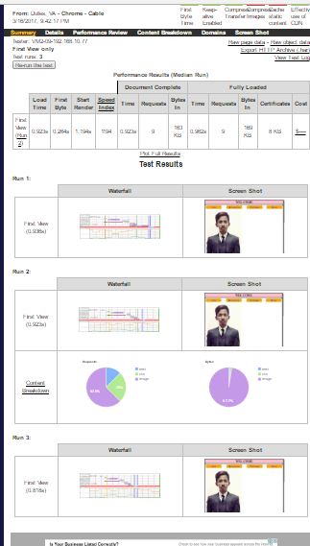

Pg-7

Visual Appeal

After the webpage loading speed in Internet the next important thing is webpage look or webpage color. To make my webpage look user attractive. I have tried my best to use suitable color in webpage for that I ask opinion for color of webpage with my friends, family, and teacher.

Navigation

Webpage best part is always webpage navigation system. The navigation should be always simple so, that user can easily identify and use it. If the navigation bar is complex then user will leave the page without using the page. I have kept my navigation bar at the top of the page so that it can be easily notice to user. I have also made navigation bar system easy one so anyone can use it easily. Client can access each page by clicking any one option of menu.

Pg-8

Progression of webpage over 12 weeks

Week 1 – 4

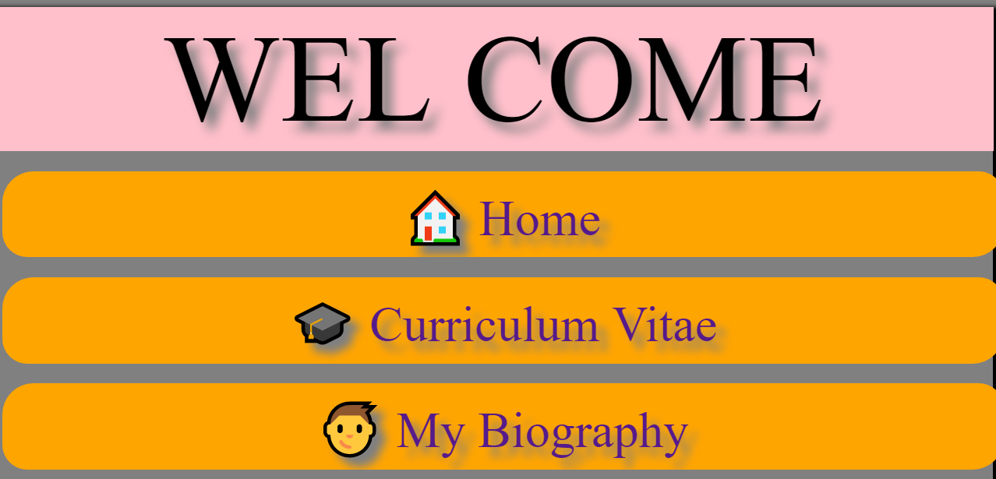

This is the picture of my webpage homepage at the beginning of the week 1-4. The page looks incomplete and simple but later I have modified it by using Html5&CSS3. To make page complete I have added my image and footer with social site links. By clicking the various menu of navigation bar user can access to any page of my webpage and by clicking the social site icon like Facebook, twitter they can connect with me through social network. Later, I have added other page on my webpage.

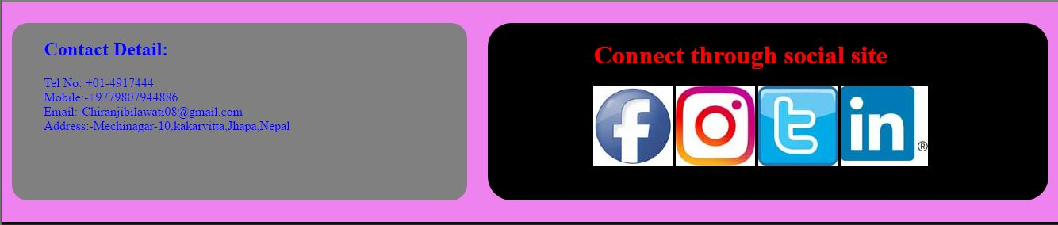

Pg-9

Progression over 4 – 8 week

Week 4 – 8

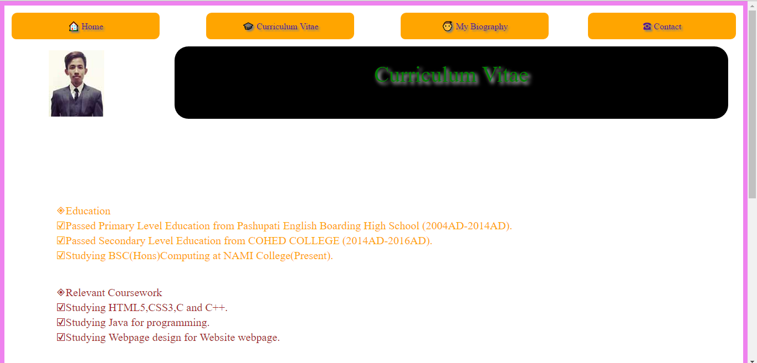

At the end of 4 week I have completed my homepage which was responsive too. After that between4-8 week I did CV page. In CV page I have added CV content like education, skills, relevant course work and experience. I did coloring of webpage with suitable color for webpage and also made webpage responsive.

The final 4 week I did other part of webpage like Bio and Contact.

Pg-10

Progression over 8 – 12 week

Week 8 - 12

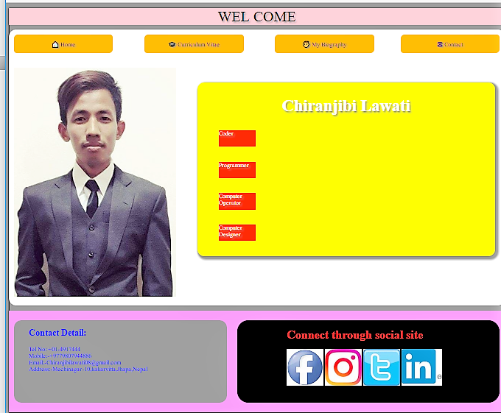

Finally, at the end of 12th week I have completed my webpage with other three page (CV, Bio and Contact) and all pages are responsive too. I have added Google font to the pages. I did validation check of Html5 and CSS3 of all webpage by checking file in Html validator and CSS validator.

Pg-11

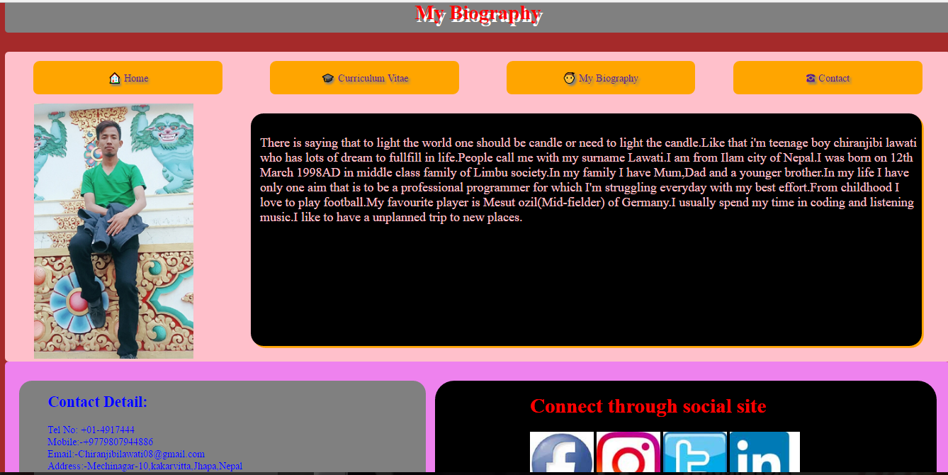

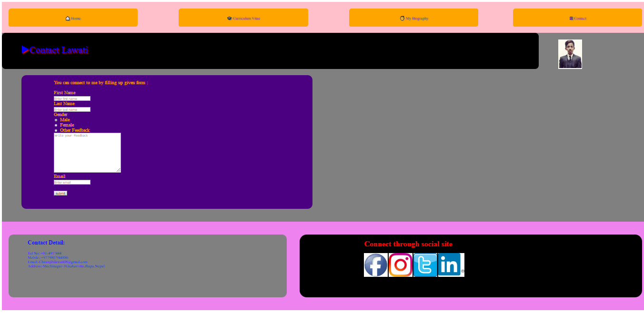

* References:-
* <https://www.w3schools.com/>
* <https://www.wix.com/my-account/sites/5374c23c-76cb-4580-a6c9-d6fce682ebad>

pg - 12