**SUMMARY**

## USC ID/s: 2806674386, 3549958057, 4389700845

|  |  |  |  |  |
| --- | --- | --- | --- | --- |
| M+N | Time in MS (Basic) | Time in MS (Efficient) | Memory in KB (Basic) | Memory in KB (Efficient) |
| 16 | 0.30 | 0.48 | 12508 | 12544 |
| 64 | 0.94 | 1.88 | 12508 | 12544 |
| 128 | 3.56 | 6.30 | 12508 | 12544 |
| 256 | 11.70 | 26.28 | 13036 | 12544 |
| 384 | 26.57 | 50.90 | 13892 | 12544 |
| 512 | 47.65 | 88.62 | 13784 | 12544 |
| 768 | 110.76 | 192.43 | 13292 | 12544 |
| 1024 | 206.67 | 335.60 | 13840 | 12544 |
| 1280 | 324.60 | 518.76 | 14388 | 12544 |
| 1536 | 467.30 | 737.70 | 14832 | 12544 |
| 2048 | 866.36 | 1350.48 | 16876 | 12544 |
| 2560 | 1350.40 | 2146.67 | 15956 | 12808 |
| 3072 | 1940.63 | 3005.74 | 22408 | 12808 |
| 3584 | 2641.00 | 4183.75 | 22540 | 12808 |
| 3968 | 3308.58 | 5126.91 | 22776 | 12808 |

## Datapoints

## Insights

### Graph1 – Memory vs Problem Size (M+N)

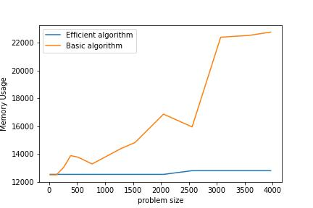

#### Nature of the Graph (Logarithmic/ Linear/ Exponential)

Basic: Polynomial

Efficient: Linear

#### Explanation: The efficient solution takes only O(N * 2) space every time whereas basic algorithm uses O(N * M) space every single instance. The sudden memory usage blips are because of python’s memory management processes which trigger garbage disposal only after certain points

### Graph2 – Time vs Problem Size (M+N)

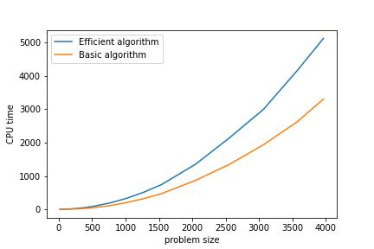

#### Nature of the Graph (Logarithmic/ Linear/ Exponential)

Basic: Polynomial

Efficient: Polynomial

#### Explanation: Both algorithms run for O(N * M) time. The efficient algorithm is slightly higher because it has the extra overhead of shifting column values to maintain O(N * 2) memory consumption

## Contribution

2806674386: Equal Contribution

3549958057: Equal Contribution

4389700845: Equal Contribution