## **What is Data?**

Data is a collection of a distinct small unit of information. It can be used in a variety of forms like text, numbers, media, bytes, etc. it can be stored in pieces of paper or electronic memory, etc.

Word 'Data' is originated from the word 'datum' that means 'single piece of information.' It is plural of the word datum.

In computing, Data is information that can be translated into a form for efficient movement and processing. Data is interchangeable.

## **What is Database?**

A database is a collection of data that is organized, which is also called structured data. It can be accessed or stored in a computer system. It can be managed through a Database Management System (DBMS), a software used to manage data. Database refers to related data in a structured form.

## **Database Management System**

* Database management system is a software which is used to manage the database. For example: [MySQL](https://www.javatpoint.com/mysql-tutorial), [Oracle](https://www.javatpoint.com/oracle-tutorial), etc are a very popular commercial database which is used in different applications.
* DBMS provides an interface to perform various operations like database creation, storing data in it, updating data, creating a table in the database and a lot more.
* It provides protection and security to the database. In the case of multiple users, it also maintains data consistency.

**DBMS allows users the following tasks:**

* **Data Definition:** It is used for creation, modification, and removal of definition that defines the organization of data in the database.
* **Data Updation:** It is used for the insertion, modification, and deletion of the actual data in the database.
* **Data Retrieval:** It is used to retrieve the data from the database which can be used by applications for various purposes.
* **User Administration:** It is used for registering and monitoring users, maintain data integrity, enforcing data security, dealing with concurrency control, monitoring performance and recovering information corrupted by unexpected failure.

## **Characteristics of DBMS**

* It uses a digital repository established on a server to store and manage the information.
* It can provide a clear and logical view of the process that manipulates data.
* DBMS contains automatic backup and recovery procedures.
* It contains ACID properties which maintain data in a healthy state in case of failure.
* It can reduce the complex relationship between data.
* It is used to support manipulation and processing of data.
* It is used to provide security of data.
* It can view the database from different viewpoints according to the requirements of the user.

## **Advantages of DBMS**

* **Controls database redundancy:** It can control data redundancy because it stores all the data in one single database file and that recorded data is placed in the database.
* **Data sharing:** In DBMS, the authorized users of an organization can share the data among multiple users.
* **Easily Maintenance:** It can be easily maintainable due to the centralized nature of the database system.
* **Reduce time:** It reduces development time and maintenance need.
* **Backup:** It provides backup and recovery subsystems which create automatic backup of data from [hardware](https://www.javatpoint.com/hardware) and [software](https://www.javatpoint.com/software) failures and restores the data if required.
* **multiple user interface:** It provides different types of user interfaces like graphical user interfaces, application program interfaces

## **Disadvantages of DBMS**

* **Cost of Hardware and Software:** It requires a high speed of data processor and large memory size to run DBMS software.
* **Size:** It occupies a large space of disks and large memory to run them efficiently.
* **Complexity:** Database system creates additional complexity and requirements.
* **Higher impact of failure:** Failure is highly impacted the database because in most of the organization, all the data stored in a single database and if the database is damaged due to electric failure or database corruption then the data may be lost forever.

**INSTALLATION OF MYSQL STEPS:**

**Step 1**: Go to <http://www.mysql.com/downloads/> and download MySQL Community Server. Choose your appropriate Operating System/X64/X86 as shown in the below Screenshot.

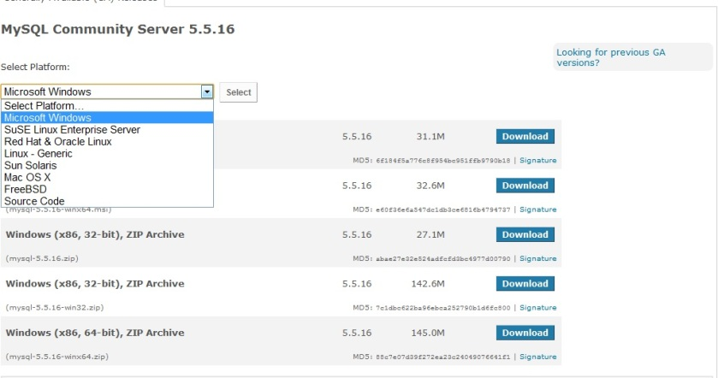

**Step 2:** I’ve downloaded 64-Bit Windows msi file. Double Click on the msi file, you’ll be welcomed with the Installation screen as seen below.

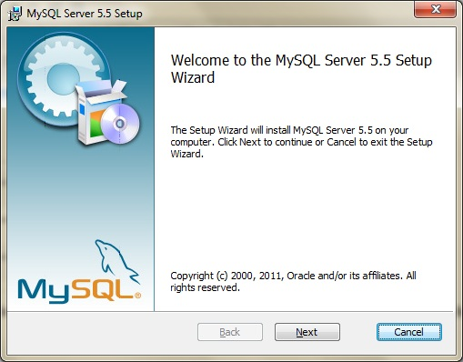

->Next -> Read the License agreement -> Next. Choose Custom(to change the defaults and control what exactly we need to be Installed) as shown below.

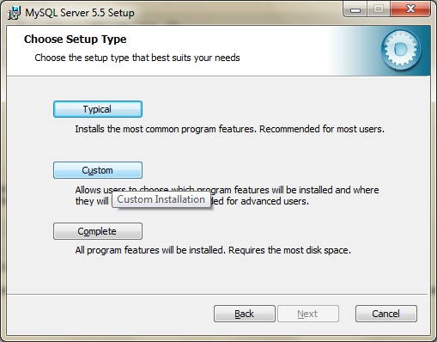

**Step 3:** Change the Default Paths(Optional). You can see the default Paths selected by MySQL as “C:|Program files\MySQL\MySQL Server 5.5\”.

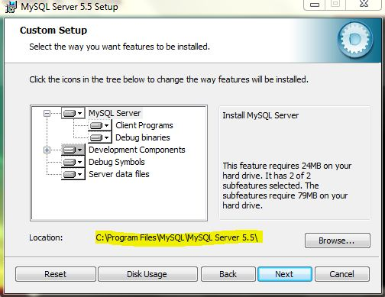

I’ve changed the path to “C:\MySql\” to keep it simple. Make sure that you changed both for MySQLServer and Server Data Files.

Next -> Install as you can see below.

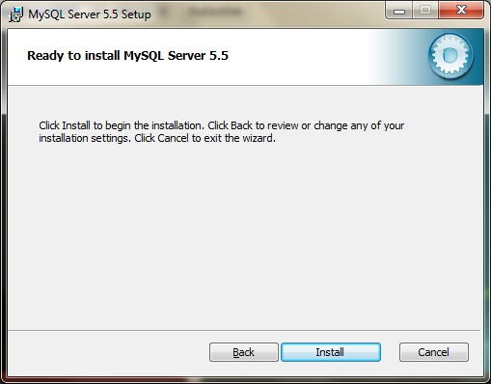

Now, you should be getting a window with “Next Button” as the only option to select as shown below.

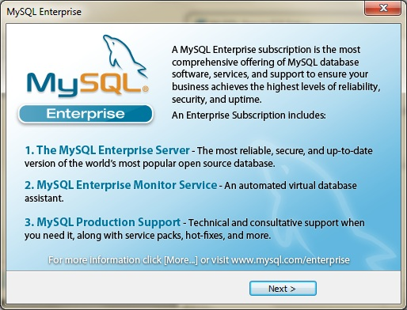

Click Next ->Next and now you should see “Completed MySQL Server 5.5 Setup Wizard” window. Keep the “Launch the MySQL Instance Configuration Wizard” button checked as shown below.

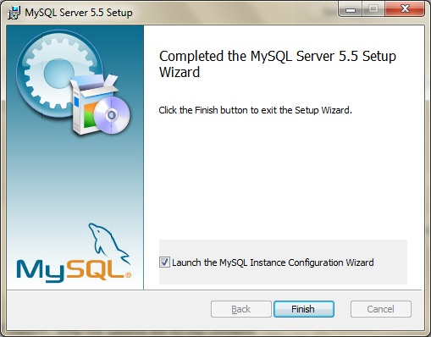

**Step 4:** Now you will be welcomed with Instance Configuration Wizard as shown below.

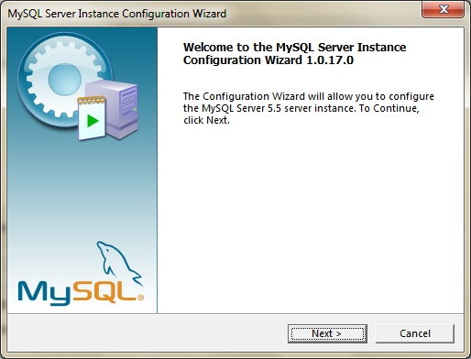

Choose “Detailed Configuration” as shown below

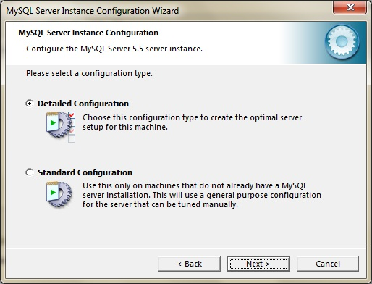

Now, I selected “Developer Machine” considering many SQL Server Instances already I’ve on this machine!. It’s your choice, all it matters is how your CPU/Memory resources are consumed my MySql Server. You can see this in the below Screenshot.

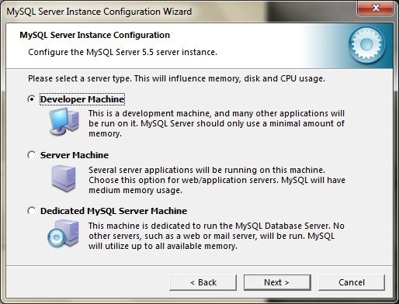

**Step 5:** This is a crucial decision now! If you want only Databases, which are not necessarily needed to obey ACID Properties, you can choose “Non-Transactional Database only”.( With this Option, InnoDB Storage Engine will not be Installed). If you want truly ACID Database, you can choose “Transactional Database Only” (This will make InnoDB Storage Engine as the Main Storage Engine). If you want both, with no exceptions/issues, Choose “Multi Functional Database”.

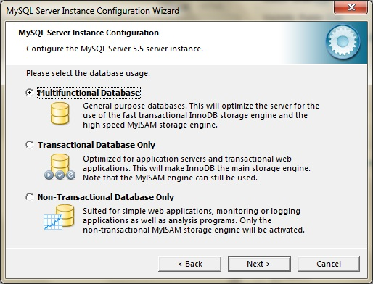

This is a huge huge difference from Installing MS SQL Server Database Engine!

**Step 6:** Now, Choose where you want your InnoDB TableSpace (Data files) to be Placed. See the below Screenshot.

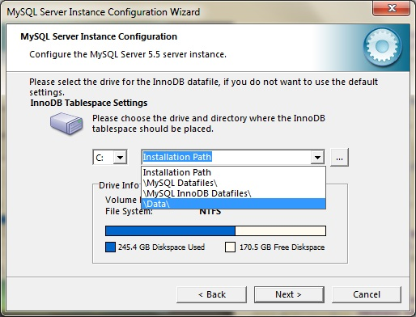

**Step 7:** Now, choose how many concurrent connections you would want to allow to connect to your MySql Instance. You can choose either DSS(OLAP) or OLTP or also you can define your Own number. I’ve chosen OLTP as you can see below.

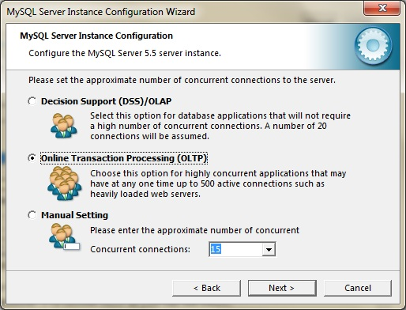

**Step 8:** Network/TCP IP Settings. By default MySQL TCP Port for communications is 3306(Remember, it’s 1433 for SQL Server). You can change it if needed, make sure that you’ve checked “Add an exception to this Port” Button as shown below.

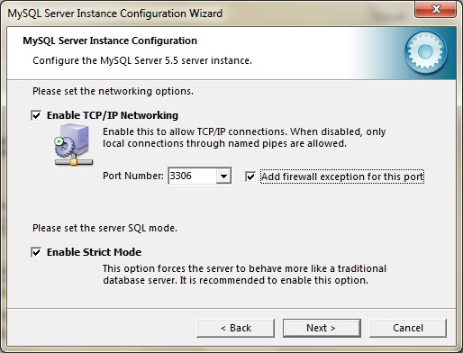

**Step 9:** Now, Collation. Leave it to default unless you really understand what you are trying to do by changing character set!! You can see below.

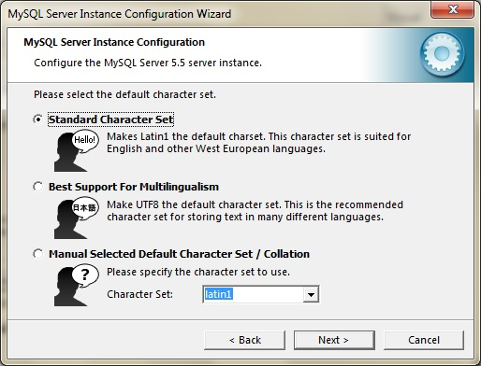

**Step 10:** Choose Install MySQL as a Windows Service and Check “Include BIN Directory in Windows Path” checked as shown below.

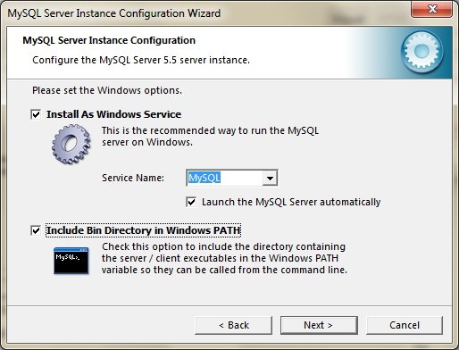

**Step 11:** Choose “Root” User password. This is similar to “sa” in SQL Server. Choose a very strong and Secure Password. You can see below!

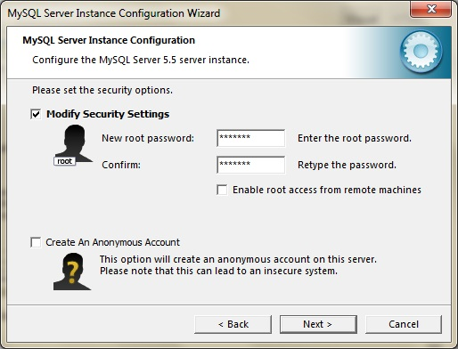

**Step 12:** Click Execute and Keep your Fingers Crossed 🙂 If everything goes well, it should be pretty quick and you will be getting the below Screen!

