**PROCEDURE**

1.Write a PL/SQL program to perform banking operations using procedures.

create table account(account_no number,accountholder_name varchar(20),balance number);

**Program**

create table account(acno number,name varchar(20),amount number);

insert into account values(&acno,'&name',&amount);

create or replace procedure deposit(ac number,bal number) is

begin

update account set amount=amount+bal where acno=ac;

end;

/

create or replace procedure withdraw(ac number,bal number) is

begin

update account set amount=amount-bal where acno=ac;

end;

/

create or replace procedure display is

cursor c is select * from account;

begin

for i in c

loop

dbms_output.put_line(i.acno||' '||i.name||' '||i.amount);

end loop;

end;

/

declare

ac number;

am number;

ch number;

begin

ac:=&acno;

am:=&amount;

ch:=&ch;

if ch=1

then

deposit(ac,am);

elsif ch=2

then

withdraw(ac,am);

elsif ch=3

then

display();

end if;

end;

/

**Output**

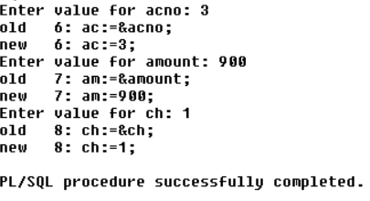

2. Selected record's price is incremented by 100, executing the procedure created & displaying the updated table(use user defined Exception).

create table product(product_id int,product_name varchar(20),price int);

**Program**

create table product(pid int primary key,pname varchar(20),price int);

insert into product values(&pid,'&pname',&price);

create or replace procedure record(pi number,pr number) is

ex exception;

begin

update product set price=price+pr where pid=pi;

if sql%notfound then

raise ex;

end if;

exception

when ex then

dbms_output.put_line('product id invalid');

end;

/

declare

pid int:=&pid;

price int:=&price;

begin

record(pid,price);

end;

/

**Output**

