# Report quality (10)

## Clearly stating project objectives

## inpaint the picture with missing area, try to make it contextually consistent

## gain some understandings on GAN

## catch up with cutting edge technologies regarding deep learning

## Clearly stating prior work and what was used as a basis

## talking about the architecture in the paper *

## mention another brief model/paper description (if necessarily)

## training set used (pictures etc.)

## modified model (modifications made)

1. Clearly stating accomplishments (see quality above)

## training processes (compare the previous one, approaches we tried including the global)

## result before and after revision (put some good ones) and compare

1. Clearly describing future work (if you were to continue on this or if another team picked up from where you left off)
2. Proper references (included any figures you did not create)

Report Outline

1. Project objectives
2. Prior work and model architecture
3. Dataset collection
4. Modifications
5. Accomplishments
6. Future works
7. **Project objectives**

The objective of our project is to build a GAN which can inpaint landscape images with a missing area. The landscape picture will be covered by a square blank mask and our model will recover the original picture by making the missing area as real and natural as possible, as well as contextually consistent with the rest of the picture. We were able to accomplish this by taking as reference an existing model that does this task in [1] and by proposing and evaluating modifications to that model in order to get the results we desire.

In addition, through our research on the existing GAN models and our work on building a GAN, our objective is to gain more understanding as well as experience on GANs. GAN being a relatively new and exciting topic in deep learning, we were able to further build on the knowledge on GANs presented in class and learn first hand all the challenges that come with training a GAN. Furthermore, we got familiar with cutting edge technologies and applications regarding deep learning while in the process of choosing our project topic.

1. **Prior work and model architecture**

In paper [1], it mentioned a model that worked well in inpainting. The author involved training two networks which are completion network (generator) and discriminator. As it is shown below, the model for the paper is the one that we are referring.

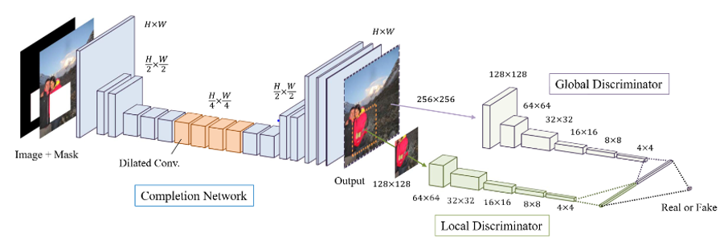

As the figure shows, the original image will be applied with the mask and later the 3 channels RGB image with missing part will be taken along with the mask as the whole input to the generator network. Briefly, the input image data will be processed by convolutional layers in CNN to be resized to quarter of the original size. Specifically, the data will go through 4 dilated convolutional layers which help the network gain a better receptive field of the picture as a whole. In other words, the kernel is applying on more pixels far away from center to enable the network to see more. Lastly the completion network will restore the size of the processed data.

For discriminator part, the original model contains two discriminators which are global discriminator and local discriminator. They are considered together to improve the contextual consistency of the generated pictures. The filled part of the image and the full-size generated image will be the input to local and global discriminator respectively. In the end for classification, the two part will be resized, flatten and then combined as the input of the fully connected network.

According to the description, the table given below shows more details of the original model.

Based on the model mentioned above, we made some changes to make the new model fit to the project. Basically, the generator setting is the same according to layers design but MSE loss is instead used for generator training.

And for discriminator, rather than considering two we only keep the local discriminator. Moreover, instead of doing classification we use the real and fake partial image to calculate the Wasserstein distance as the loss function. The goal of the process is to try to fit the real context of the image.

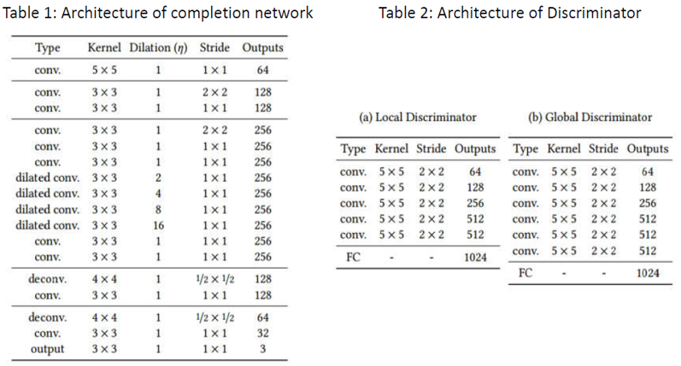

1. **Dataset collection:**
2. **Modifications**
3. **Accomplishments**
4. **Future works**