IMDb | CINEMA SENTIMENT LAB
Sequential Text Prediction on IMDb Movie Reviews
Activity-2 | Problem 1 | Solution 8 Hybrid Comparison | Flask Web App

Item | Detail
Dataset | IMDB 25k train + 25k test (balanced)
Production | TF-IDF+LogReg 90.02% acc F1 0.901
Best RNN | GRU 71.55%
Stack | Python3.12 NumPy RNNs sklearn Flask2.3
Live | Flask app http://127.0.0.1:5000

Paste a review, get a verdict. Open the Lab to watch the model think.

Contents
1. Abstract
2. Introduction
3. Dataset
4. Methodology
5. Architectures
6. Web App Design
7. Results
8. Mapping
9. Reproduce
10. Limits
11. Conclusion
12. Files

1. Abstract
Complete sequential text prediction on IMDb reviews: POSITIVE vs NEGATIVE. Five RNNs from scratch in NumPy (BPTT+Adam) compared fairly (Solution 8). Production TF-IDF+LogReg serves at 90.02% accuracy (P 0.898 R 0.903 F1 0.901). Flask black-yellow app: abstract Studio, step-by-step Lab, Arena+Report.

2. Introduction
Activity-2 Problem 1: build a Sequential Text Prediction System on IMDB. Core question: short-term vs long-term dependencies ("not bad" vs opening complaint overturned by finale). This report covers build, method, numbers, reproduction.
- Input: raw English review, any length.
- Output: POSITIVE/NEGATIVE + probs + word evidence.
- Constraint: real data, trained weights, working app.

3. Dataset
IMDB Large Movie Reviews (Maas et al.): 50k labeled, 25k/25k balanced. Source: aclImdb (Stanford, via HF mirror) via HF mirror + fallbacks. Vocab 10,000 (+PAD=0,UNK=1). Serve len 200, RNN window 60.

4. Methodology
- 1 Collect+clean: strip HTML, lowercase, depunct.
- 2 Tokenize: word = timestep.
- 3 Numericalize: top-10k to IDs, UNK=1.
- 4 Pad: post-pad 0 to 200 (60 for fair RNN compare).
- 5 Splits: 25k/25k, 15pct val, 2k scoring set.
- 6 Models: SimpleRNN BiRNN Deep2 LSTM GRU, NumPy scratch.
- 7 Train: BPTT+Adam+clip+L2, 6 epochs each.
- 8 Length study: 30/60/120/200 steps.
- 9 Gated compare: same protocol.
- 10 Gradients: BPTT norm probe + chart.
- 11 Deploy: metrics + Flask + /api/predict.

5. Architectures

6. Web App Design
Studio (abstract): paste review or pick example, press PREDICT, see only verdict + confidence + bars. No internals.
Lab (simulation): after scoring, 6 anchored steps - cleaned text, token pills, word-ID map, padded vector, +/- evidence words + final probs, token-by-token unroll table (signal, hidden, running P).
Arena+Report: production cards, 5-arch comparison, length study, gradient chart, training curves, write-up, Solution 1-10 map, API POST /api/predict.

7. Results

7.1 Production head
Metric | Value
Model | TF-IDF + LogisticRegression
Accuracy | 90.02%
Precision | 0.8981
Recall | 0.9029
F1 | 0.9005
Test reviews | 25,000
Pipeline time | 273.3s

Confusion matrix (rows actual Neg/Pos, cols predicted Neg/Pos):
 | Pred Neg | Pred Pos
Actual Neg | 11,220 | 1,280
Actual Pos | 1,214 | 11,286

7.2 Hybrid comparison (Sol 8)
Architecture | Test | Val | Win
Simple RNN | 49.70% | 50.67% | 60
BiRNN | 57.35% | 57.33% | 60
Deep RNN | 54.55% | 53.00% | 60
LSTM | 68.85% | 68.83% | 60
GRU | 71.55% | 72.00% | 60

- GRU wins 71.55%, LSTM second 68.85% - gates beat tanh.
- BiRNN 57.35pct beats single/deep via future context, trails gated.
- SimpleRNN train ~99.6pct vs val ~50pct: overfit + vanishing memory.
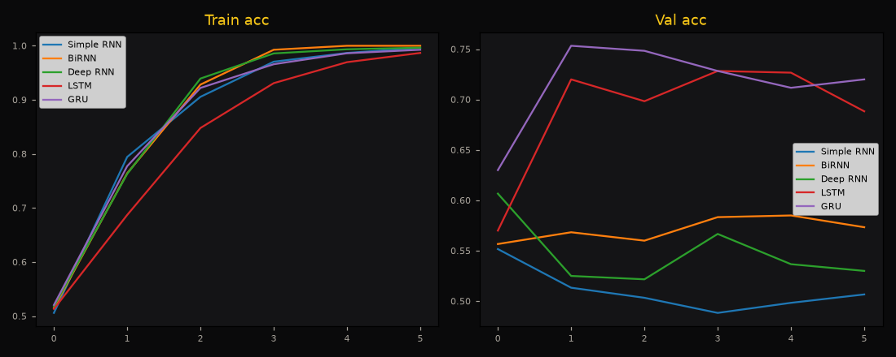
Figure 1 - Train (left) vs validation (right) accuracy per architecture.
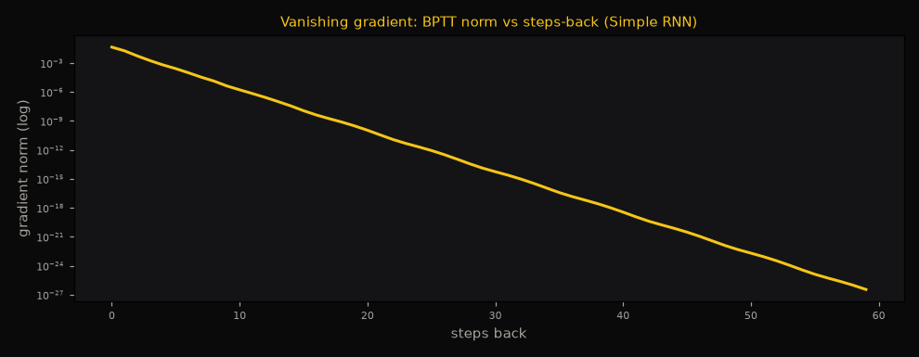
Figure 2 - Vanishing gradient: BPTT norm vs steps back (log scale).

7.3 Length study
Steps | SimpleRNN acc
30 | 53.62%
60 | 51.00%
120 | 46.88%
200 | 68.25%

Longer windows = more context but further gradients; dip at 120, recovery at full 200. Gates exist for this tradeoff.

7.4 Overfit + gradients
Plain/bidir/deep RNNs pass 99pct train while val stalls/falls (Deep: 99.65 vs 53.00). BPTT norms collapse ~4.4e-02 (1 step) to ~3.5e-27 (60 steps): exponential decay no LR can fix. LSTM/GRU gates preserve long signal, hence top ranks.

8. Requirement Mapping
Requirement | Delivered
Sol1 Basic RNN | rnn_base.py + rnn_cells.py (NumPy BPTT Adam)
Sol2 Train IMDb | train_model.py + data_loader2.py (25k/25k)
Sol3 Predict | inference.py + Studio + /api/predict
Sol4 LSTM+GRU | rnn_lstm.py rnn_gru.py
Sol5 BiRNN | rnn_bi.py
Sol6 Deep RNN | 2-layer stack train_model.py
Sol7 Overfit | Sec 7.4 + Arena curves
Sol8 Hybrid | Sec 7.2 table, 5 archs same protocol
Sol9 Deploy | app_flask.py Studio/Lab/Arena/Report
Sol10 Gradients | Fig2 + metrics.json grad_study

9. Run & Reproduce
Windows PowerShell from project root:
py -3.12 -m pip install -r requirements.txt
py -3.12 -m src.train_model
py -3.12 app_flask.py
# open http://127.0.0.1:5000
API: POST /api/predict {"review":"A brilliant masterpiece"} -> label, probs, tokens, IDs, padded, evidence, unroll. Artifacts: models/*.joblib, vocab.json, metrics.json; charts static/.

10. Limits & Future Work
- Serving head is TF-IDF+linear (order beyond bigrams narrated by Lab unroll).
- Scratch RNNs use 60-step window + 10k vocab for speed; GPU + embeddings + longer windows would lift scores.
- Next: embeddings, attention/Transformer compare, saliency heatmaps, batched GPU.

11. Conclusion
End-to-end delivery: real IMDb data, five hand-built RNNs fairly compared, 90.02pct serving head, Flask Studio + transparent Lab, one-command training. GRU then LSTM beat plain/bidir/deep tanh - a measured answer to short vs long dependency question.

12. References & File Map
- Maas et al. Learning Word Vectors for Sentiment Analysis (ACL 2011).
- Hochreiter+Schmidhuber 1997 LSTM; Cho et al. 2014 GRU; Schuster+Paliwal 1997 BiRNN.
File | Role
app_flask.py | Flask Studio/Lab/Arena/Report + API
src/data_loader2.py | Real IMDb loading
src/preprocess.py | Clean/tokenize/IDs/pad
src/rnn_base.py | Adam + trainer
src/rnn_cells.py | SimpleRNN + Deep stack
src/rnn_bi.py | BiRNN
src/rnn_lstm.py | LSTM scratch
src/rnn_gru.py | GRU scratch
src/train_model.py | Full pipeline
src/inference.py | Predict + evidence + unroll
models/ | Artifacts + metrics.json
static/ | curves.png grad_chart.png style.css
templates/ | Flask pages black x yellow

