
EV_JPEG_ENC IP Core
Specification

Author: Michal Krepa

Rev. 1.5
Krakow, PL

Version | Date | Author | Comment
1.0 | 15.02.2009 | Michal Krepa | Initial Creation.
1.1 | 13.03.2009 |  | Huffman description updated.
1.2 | 17.03.2009 |  | Huffman design restored to use two stage VLI/VLC handler to achieve better timing. Simulation HOWTO chapter added.
1.3 | 19.03.2009 |  | BUF_FIFO fifo almost full signal changed.
1.4 | 20.03.2009 |  | Added C_MEMORY_OPTIMIZED configuration constant to reduce memory footprint at expense of performance. Look at BUF_FIFO description for details.
1.5 | 23.03.2009 |  | BUF_FIFO now uses single RAM which is used for all SubFIFOs. Added description of divider used in Quantizer block.

1.1 EV_JPEG_ENC 5
1.1.1 General description 5
1.1.2 Architecture 5
1.1.3 Features 5
1.1.4 Example throughput 6
1.1.5 Open points / TODO list / Limitations 6
1.1.6 Control State Machine 6
1.1.7 MAIN_SM 8
1.1.8 MAIN_SM details 10
1.1.9 BUF_FIFO 11
1.1.10 Output Mux 13
1.2 Host IF 14
1.3 FDCT 17
1.3.1 RAM Read Controller 17
1.3.2 FRAM1 18
1.3.3 RGB to YCbCr conversion 18
1.3.4 Write Counter / DCT matrix transpose 18
1.3.5 Mux1 19
1.3.6 MDCT 19
1.3.7 FIFO1 and FIFO RD CTRL 19
1.3.8 DBUF 19
1.4 ZIGZAG 20
1.4.1 ZIGZAG Core 21
1.4.2 FIFO ctrl 22
1.4.3 DBUF 23
1.4.4 QUANTIZER 23
1.5 RLE 24
1.5.1 RLE Core 25
1.5.2 Entropy Coder 26
1.5.3 Read counter 26
1.5.4 EOB Detector / Write Counter 26
1.5.5 Double FIFO 27
1.6 HUFFMAN Encoder 28
1.6.1 General Description 28
1.6.2 Operation 28
1.6.3 Double FIFO 28
1.6.4 Variable Length Processor 30
1.6.5 DC Luminance ROM 34
1.6.6 AC Luminance ROM 35
1.7 Byte Stuffer 37
1.7.1 CTRL_SM 37
1.7.2 Write Counter 38
1.7.3 Byte Stuff Detector 38
1.7.4 bs_buf_sel 38
1.7.5 last_addr 38
1.8 JFIF Header Generator 39
1.8.1 Header RAM Programming 39
1.8.2 JFIF Generator 40
1.8.3 EOI Writer 40
1.8.4 Mux1/Mux2 40
1.8.5 Generic Header 40
1.9 Programming Interface 43
1.9.1 General 43
1.9.2 Core address map 43
1.9.3 Register Descriptions 43
1.10 Users Manual 45
1.11 Simulation 46
1.11.1 OPB Master BFM 46
1.12 Performance / Area 47
1.12.1 General 47
1.12.2 Area 47

EV_JPEG_ENC

General description

EV_JPEG_ENC core is intended to encode raw bitmap images into JPEG compliant coded bit stream. JPEG baseline encoding method is used.

Architecture

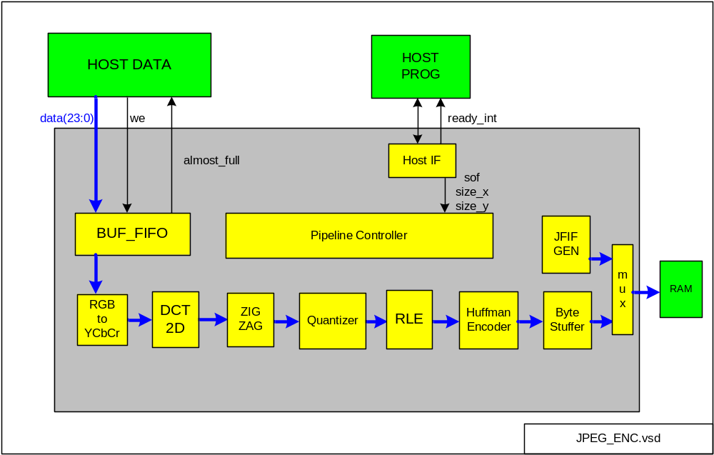Figure 1

General system architecture consist of encoding chain started by Host Programming interface. Host Data interface shall continuously write BUF_FIFO until FIFO almost full signal is received. Then, it should stop and wait for signal FIFO almost full to deassert. When this is the case it should continue writing and so on.

Encoding is governed by Controller and is a pipelined process where each pipeline stage process 8x8 block of samples at a time (8x8 block is so called “data unit”).

Finally, encoded bit stream is byte stuffed and then stored to output (RAM or FIFO).

Following steps are performed: Line Buffering, RGB to YCbCr conversion, Discrete Cosine Transform 2-dimensional, followed by Quantizer, Zig Zag scan, Run Length Encoding and Huffman coding followed by byte stuffing and JFIF header is also generated at the beginning of encoding and with EOI marker closing image.

Features

- JPEG baseline encoding JPEG ITU-T T.81 | ISO/IEC 10918-1
- Standard JFIF header v 1.01 automatic generation
- Color images only (3 components, RGB input)
- One programmable Quantization table
- Hardcoded Huffman tables
- 4 clock cycles per one input 24 bit pixel @ 50% quantization
- OPB programming and data Host interface
- No subsampling, means 4:4:4 system used
- Source code target independent, synthesizable RTL VHDL code

Example throughput

Measured from JPEG encoding start till encoding done:

- Input image 800x600 24 bit RGB color. New sample loaded every cycle until FIFO full.
- Quantization table 50% quality setting
- 21.6 ms processing time @ 100 MHz clock
- 1000/18.4=54 frames per second @ 100 MHz
- Input file size = 1.44 MB. Output file size = 187 kB (depends on image of course)

Open points / TODO list / Limitations

- Create stallable design on the output side
- Use different quantization table for chroma than for luminance
- Add subsampling
- replace OPB interface used for programming with PLB or Wishbone interface
- JFIF Generation should hold off Host before it starts loading data!!!

Control State Machine

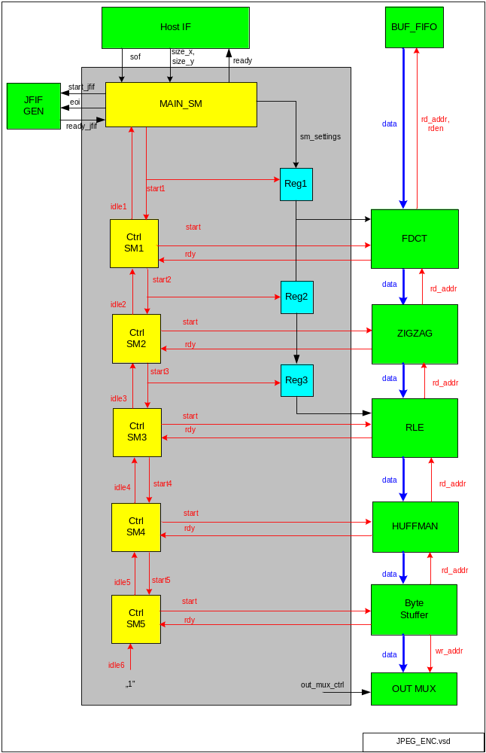
Figure 2

Description:

- EV_JPEG_ENC is main control state machine for JPEG encoding process. It gets uncoded raw image samples and transforms it into JPEG encoded bit stream.
- First, Host asserts “sof” (start of frame) single pulse along with size_x (image width) and size_y (image height) signals valid (programming registers are used for that purpose).
- After this is done, Host starts loading raw image to Host Data interface
- Then EV_JPEG_ENC process image in 8x8 pixels blocks following horizontal order, from left to right and vertically from top to bottom of the image. When color image is encoded, 3 components (Y, Cb, Cr) are interleaved 8x8 block wise.
- Limitation: Currently, only image sizes (length, width) multiple of 8 samples are supported
- Finally, coded bit stream is stored to output RAM.
- Ready signal to Host is asserted when all 8x8 blocks are processed and all pipeline state machines are idle. Also, ready_int interrupt to Host is generated.

MAIN_SM

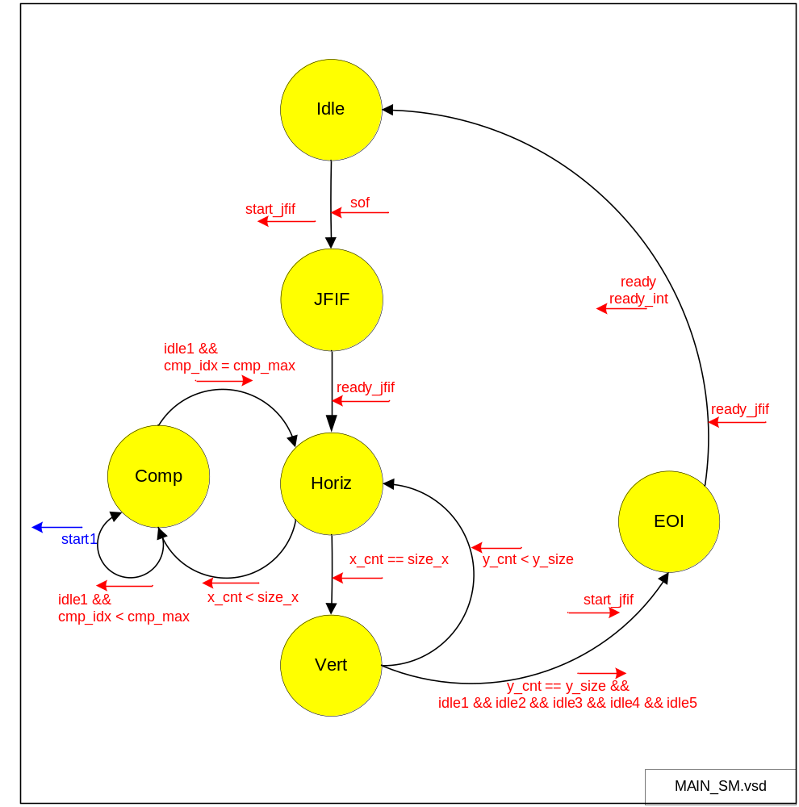
Figure 3

MAIN_SM state machine is responsible for control of whole encoding process.

Some variables/signals are defined

Name | description | range
x_cnt | count samples in horizontal direction. Incremented in steps of 8 samples. (16 bits) | 0..image_width-8  warning: image width must be multiple of 8 samples
y_cnt | count lines in vertical direction. Incremented in steps of 8 samples. (16 bits) | 0..image_height-8  warning: image height must be multiple of 8 samples
cmp_idx | Component index. Indicates currently processed color component (Y, Cb, Cr). | 0..2
sof | start of frame. Asserted by Host after raw (uncoded) image is loaded. | 0/1
size_x | image width (16 bits) | 8...65536-8
size_y | image height (16 bits) | 8...65536-8
start1 | starts first stage of pipeline (FDCT) | 0/1
ready | ready pulse signal to Host – JPEG encoding complete | 0/1
cmp_max | Maximum number of components. | 3
eoi | generation of EOI marker to end coded image data. Sampled when jfif_start is high. | 0/1

States description

Name | description
Idle | JPEG encoder is inactive waiting to be started by Host
Horiz | encoding process blocks of 8x8 samples until horizontal counter reaches width of image.
Vert | Reset horizontal counter and advance vertical counter by 8. Check if end of image reached.
Comp | Component processing. Process one 8x8 block from each component in interleaved fashion.
JFIF | Generation of JFIF header.
EOI | Generation of EOI marker (End Of Image)

SM_SETTINGS

SM_SETTINGS is record passed through pipeline from main state machine. When start1 asserts sm_settings from MAIN_SM are latched to Reg1.

SM_SETTINGS | description
x_cnt | current sample coordinate starting point in horizontal direction
y_cnt | current sample coordinate starting point in vertical direction
cmp_idx | Component index. We have three components in color image and only one in grayscale.

Order of processing:

0 | 1 | 2 | 3 | 4 | 5 | 6 | 7 | 8 | 9
10 | 11 | 12 | 13 | 14 | 15 | 16 | 17 | 18 | 19
20 | 21 | 22 | 23 | 24 | ... | ... | ... | ... | ...

Each cell in table above represents block 8x8 pixels (“data unit”). Blocks are processed in direction of increasing numbers.

MAIN_SM details

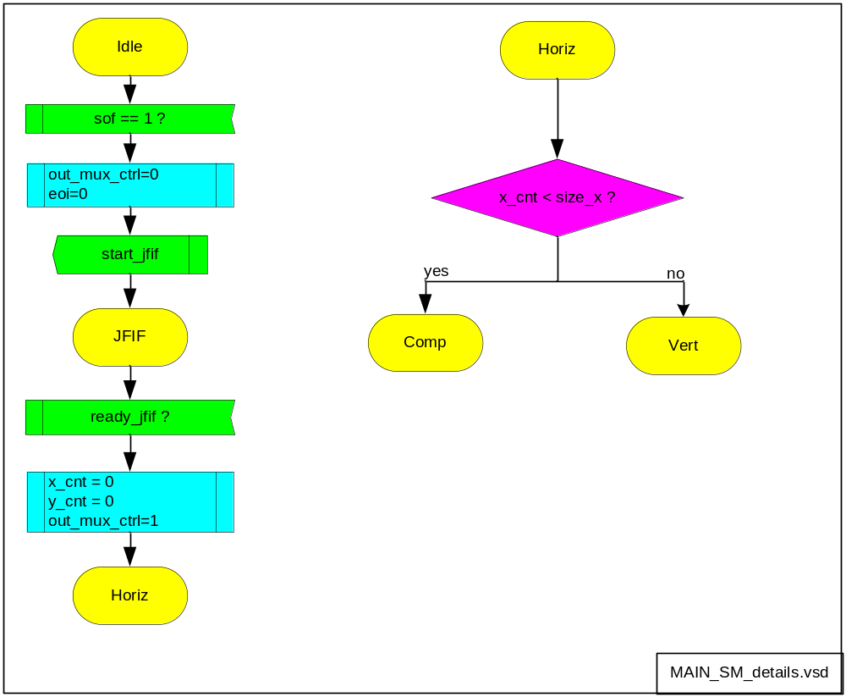
Figure 4

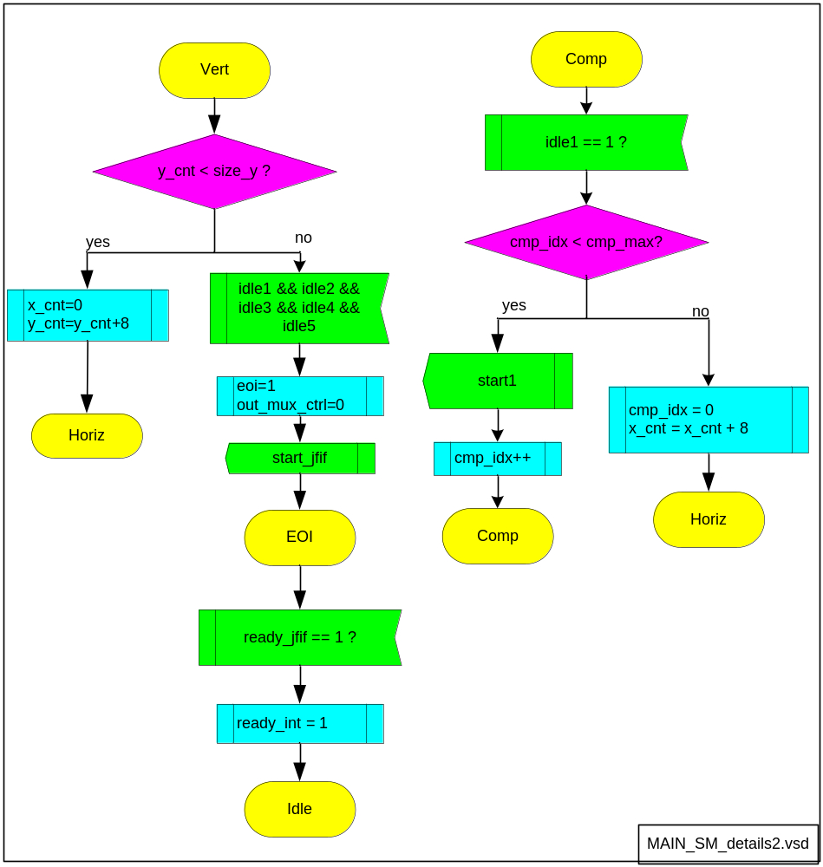
Figure 5

BUF_FIFO

Host Data interface writes input image line by line to BUF_FIFO. This FIFO is intended to minimize latency between raw image loading and encoding start.

BUF_FIFO is actually a number of sub-FIFOs. Number ot them depends on maximum_image_width:

num_fifos = max_image_width / 8

Note: Maximum supported image width must be configured by constant in JPEG_PKG.VHD to fix FIFO size before synthesis.

Default C_MAX_LINE_WIDTH = 640

Warning: This parameter heavily affects size of used memory (block ram etc).

BUF_FIFO must be able to store at least 8 lines of input image, so that JPEG encoding can be started for 8x8 blocks.
BUF_FIFO depth = 16 lines is selected to keep pipeline full at all times.

Signal FIFO almost full asserts when 14 eight-pixel lines are occupying FIFO number 2 before last (n-1-2) so that no overflow happens.
That is, for FIFO(num_fifos-1-2) is checked if number of FIFO used words exceeds 128-2*8. 128=FIFO size, 16=arbitrary selected safety margin.
FIFO 2 before last was selected from safety_margin/pixels_written_per_fifo_in_one_line = 16/8=2.
Such selection of FIFO almost full signal allows to keep pipeline full at all times and also avoid overflow.

NOTE: It is be possible to reduce FIFO memory size required by half as 64 words is enough for operation instead of 128. That however reduces performance by about 18% as found in simulations, because pipeline drain happens from time to time. In reduced memory size scheme FIFO almost full signal is in fact FIFO full signal.

To reduce memory size footprint please adjust parameter C_MEMORY_OPTIMIZED in JPEG_PKG.VHD package.

One SubFIFO size is (16x8) x 24 bits.

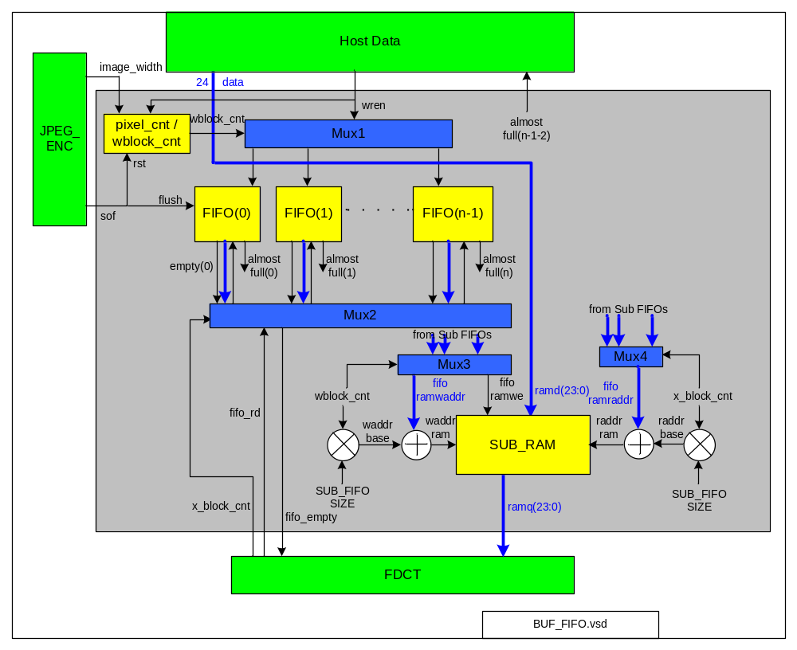
Figure 6

FIFO write

- Host writes image data line by line.
- FIFOs are written from 0 to n-1 (left to right) with 8 pixels in each line written per FIFO
- pixel_cnt(15:0) is incremented every write enable from Host and is reset when end of line is reached (equal to image_width-1).
- wblock_cnt(12:0) is pixel_cnt shifted right by 3 bits (divide by 8).
- wblock_cnt controls Mux1 and selects to which Sub FIFO data should be written to
- FIFO number last-2’s almost full signal is routed back to Host Data interface to indicate that Host should hold off with writing for a moment to prevent FIFO overflow. When almost full disappears Host can continue with writing.

FIFO read
- FDCT indicates by x_block_cnt which horizontal 8x8 block (sub FIFO) it wants to read
- read is performed only if FIFO is half full (at least 64 words) so that burst of 64 words is read each time. When FIFO is empty reading is stalled and FDCT waits until FIFO has new data.

General

When SOF asserts
- pixel_cnt, wblock_cnt are reset

SUB_RAM

SUB_RAM is memory shared between all SubFIFOs. This is possible as at any given time only one SubFIFO is being read and (another) one is being written. Instead of using separate memory for every SubFIFO one central memory block allows for more efficient usage of FPGA resources.

Mux3 and Mux4 are used to properly construct SUB_RAM write and read address. Write address consist of base address plus offset. Base address comes from index of currently written SubFIFO multiplied by single FIFO depth. Offset comes from internal FIFO write counter increased every time new sample is written to Sub FIFO. Similar approach is used to construct SUB_RAM read address.

Output Mux

Output Mux is used to switch data path to JFIF Generator for the time of JFIF header writing. After JFIF header is written to output, mux is switched to “normal” data processing path.
Switch is realized by means of signal out_mux_ctrl toggle.

Host IF

Host IF is an interface block between host (CPU) and JPEG encoder IP core.
Xilinx OPB v2.1 has been selected as Host communication protocol. JPEG encoder core will act as OPB slave device.

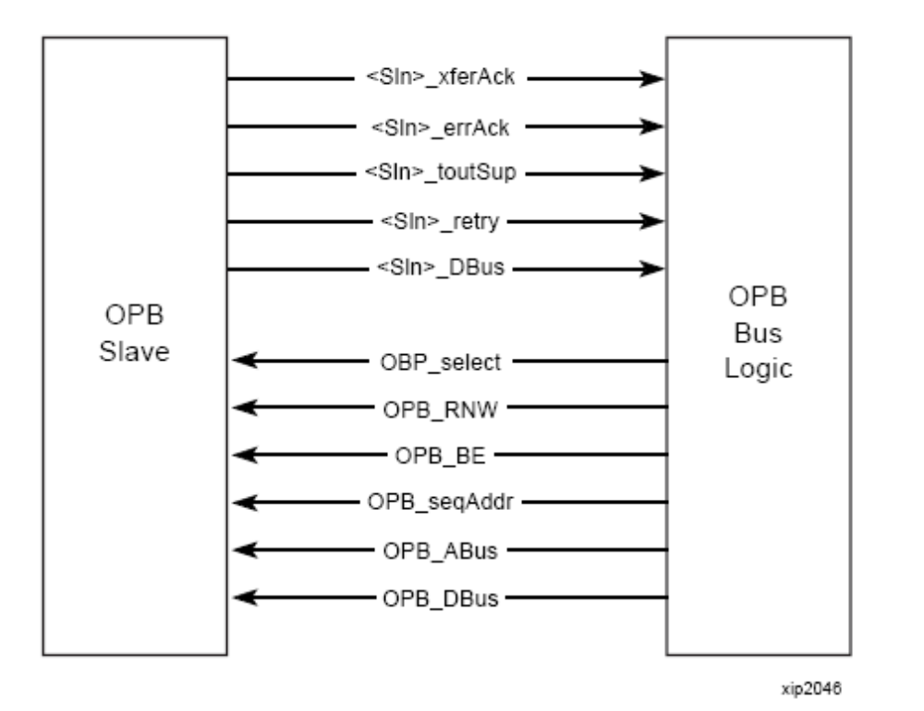
Figure 7

More information on interface can be found in OPB v2.1 specification.

On figure below OPB read transaction is shown
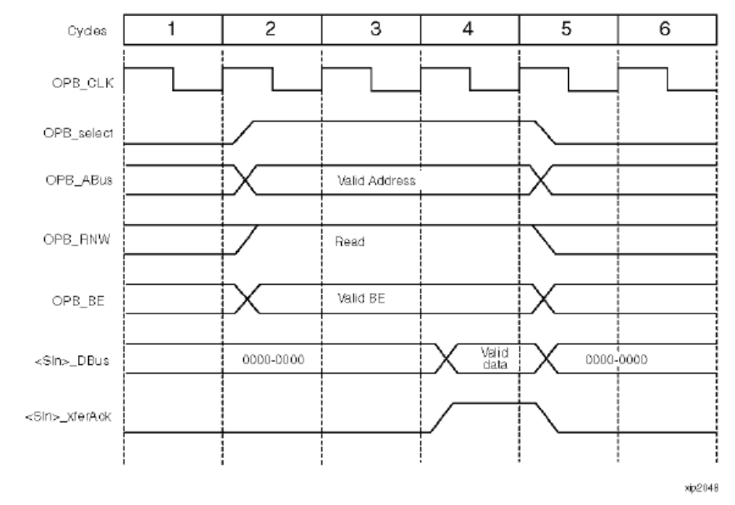
Figure 8

On figure below OPB write transaction is shown.

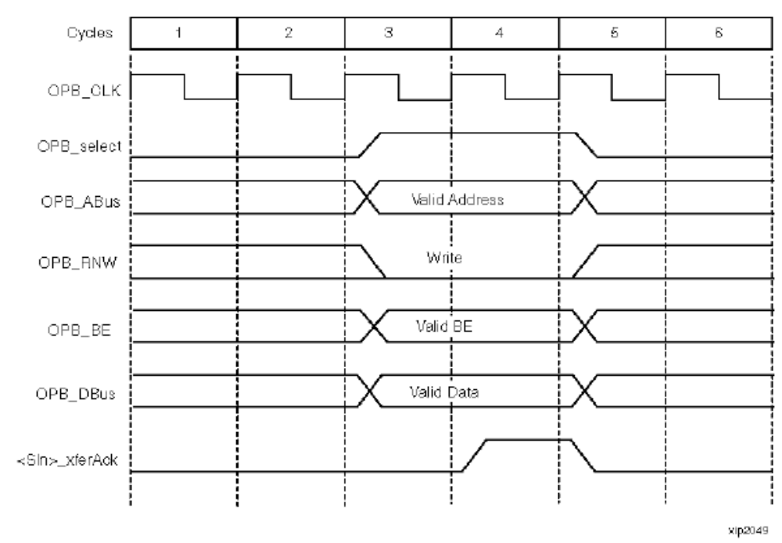
Figure 9

Note: Above images are taken from “Designing Custom OPB Slave Peripherals for MicroBlaze” Xilinx tutorial.

FDCT

FDCT is intended to perform functions: RGB to YCbCr conversion, input level shift and DCT (discrete cosine transform).

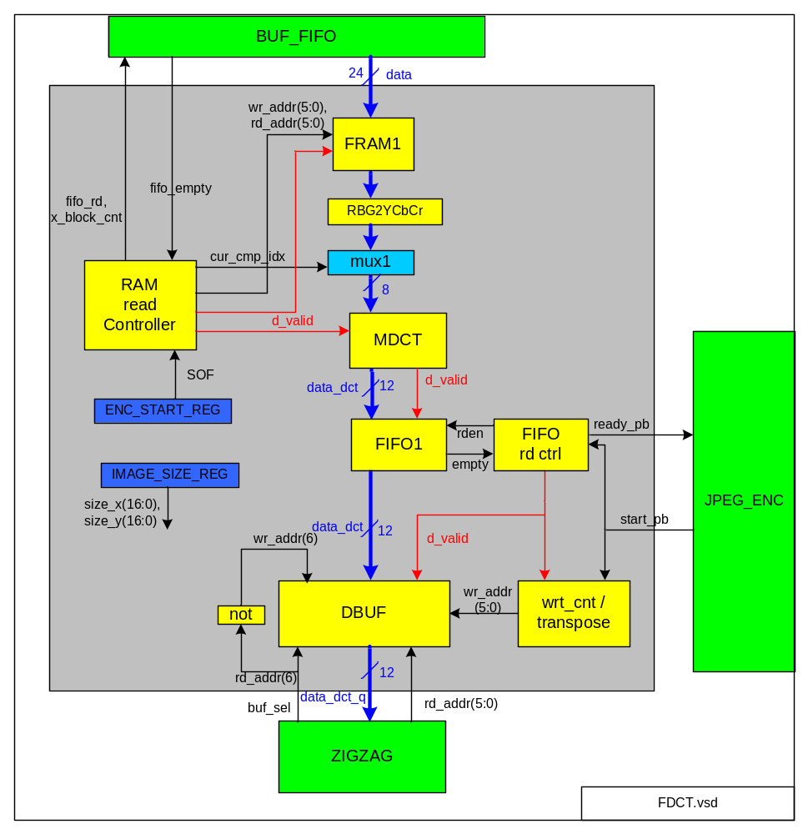 Figure 10

When sof asserts
- size_x and size_y are latched internally
- RAM Read Ctrl is started

RAM Read Controller

This submodule performs reading of input samples fom RAM. To maximize performance this block operates “almost” independently from EV_JPEG_ENC pipeline control processing chain.

- When SOF asserts, Read Controller starts reading data from BUF_FIFO given it is not empty.
- Read Ctrl has its own horizontal, vertical and component counters to point into currently processed 8x8 block and know end of image. These counters operate similarly to ones in Pipeline Controller FSM.
- Independent counters are necessary as Read Ctrl can operate at higher rate than rest of processing chain.
- Data read from BUF_FIFO is given to MDCT core
- Read Ctrl stalls reading when FIFO1 has less space than 64 words (aka FIFO1 almost full signal). This is necessary to prevent FIFO1 overflow, because MDCT output results in burst of 64 words.
- Rad Ctrl stalls reading when BUF_FIFO is empty
- Read_ctrl is started once by SOF and then it does self-trigger internal start after reading of one 8x8 block.
- When all 8x8 blocks are read out internal self-start mechanism is stopped and Read Ctrl goes to idle.
- Reading of one 8x8 block proceeds like follow: read one 8x8 block of pixels from BUF_FIFO and store it to FRAM1. Read FRAM1 3 times one per each component to perform DCT on each component seperately.
- cur_cmp_idx is counter modulo 3. It is incremented every time RAM RD CTRL is started for new 8x8 block.
- x_block_cnt is incremented every 8 samples in horizontal direction and reset when end of line is reached. y_block_cnt is incremented every 8 lines.

Reading details:
- 64 image samples are read from FRAM1 using rd_addr as read address. These contain R,G,B 8 bit values per one sample. This is done 3 times, one per each component. At each pass, different data (R,G or B) is taken to DCT processing.
- First, 64 R values undergo DCT (increment cur_cmp_idx), then 64 G (increment cur_cmp_idx), and finally 64 B. Thus 3 x 64 x 8 bit data from Image RAM is level shifted and DCT encoded

FRAM1

FRAM1 is dual port memory with size 64x24 bits. Used to store one 8x8 block read from FIFO. Since one 8x8 block read from FIFO contains data already for all 3 components and 3 components are processed in 3 consecutive read passes, it means reading 3 times the same 24 bit data is necessary, just use different byte from it each time. As from FIFO we cannot read 3 times same data, intermediate RAM=FRAM1 is used.

RGB to YCbCr conversion

Following equation is implemented by means of multipliers and adders to perform conversion:

Y = (0.299*R)+(0.587*G)+(0.114*B)
Cb = (-0.1687*R)-(0.3313*G)+(0.5*B)+128
Cr = (0.5*R)-(0.4187*G)-(0.0813*B)+128

Constants used in this equation have Q14.1 format (14 bits of precision plus 1 sign bit).

Saturation to 255 is not implemented. Not necessary it seems???

Warning: EV_JPEG_ENC design assumes that hardware multipliers are available on target FPGA!

Write Counter / DCT matrix transpose

- wrt_cnt is write counter used to count number of samples (0..63
- Every time d_valid output from MDCT asserts, wrt_cnt is post incremented by 1.
- Wrt_cnt is reset by start_pb to zero.
- When all words are written (wrt_cnt == 63) ready_pb asserts to signal block processing complete to EV_JPEG_ENC chain control.

- It is necessary to transpose MDCT output as it is column wise output while row wise is needed.
- For that purpose two 3 bit counters are created. yw_cnt counts vertically and xw_cnt counts horizontally. Normally, yw_cnt counts from 0..7, when 7 is reached xw_cnt is incremented and yw_cnt reset. xw_cnt is wrap around type of counter. Write address to DBUF: wraddr(5:3) = yw_cnt, wraddr(2:0) = xw_cnt

Mux1

Mux1 is used to select currently processed image component. It routes proper byte from 24 bits input data. Data(7:0) is used for cur_cmp_idx=0, data(15:8) for cur_cmp_idx=1, data(23:16) for cur_cmp_idx=2.

MDCT

2D Discrete cosine transform core combined with level shift. Works on block of 64 samples. Take 8 bit input and produces 12 bit output.

First, uncoded image is level shifted from unsigned integers with range [0, 2^P - 1] to signed integers with range [-2^(P-1), 2^(P-1)-1]. x^p means here x to power of p.

Then 2D DCT is performed using following equation:

2N
1)v
(2j
cos
2N
1)u
(2i
cos
j)
x(i,
C(v)
C(u)
N
2
v)
X(u,
1
j=0
1
N
π
π
+
⋅
+
⋅
⋅
⋅
⋅
=
∑
∑
Ν−
−
i=0
- where C(u),C(v) = 2^{-1/2} for u=0,v=0
= 1 otherwise
- x(i,j) – input sample at position (i,j) in 8x8 block
- X(u,v) – output sample at position (u,v) in 8x8 block
- N=64

MDCT takes data row-wise but outputs column-wise. To get row-wise order it is necessary to transpose output DCT matrix.

FIFO1 and FIFO RD CTRL

FIFO1 has space for 4 8x8 block DCT results. Its size = 4x64x12 bit.
FIFO read controller has internal counter fifo_cnt(5:0) to count number of words read per one start_pb.
When start_pb asserts:
- fifo_cnt is reset and starts FIFO reading.
- if fifo_cnt is less than 64 and FIFO is not empty -> read FIFO and increment fifo_cnt
- when fifo_cnt is = 64-1 FIFO reading is disabled until next start_pb

DBUF

Dual port RAM 2x64x12 bit. Double Buffer necessary for pipeline operation. Buf_sel signal is used as MSB in read address of DBUF. ~buf_sel (inverted) is used as MSB of write address to DBUF. Thus, while FDCT is writing
next block of data, ZIGZAG is reading previous block.

ZIGZAG

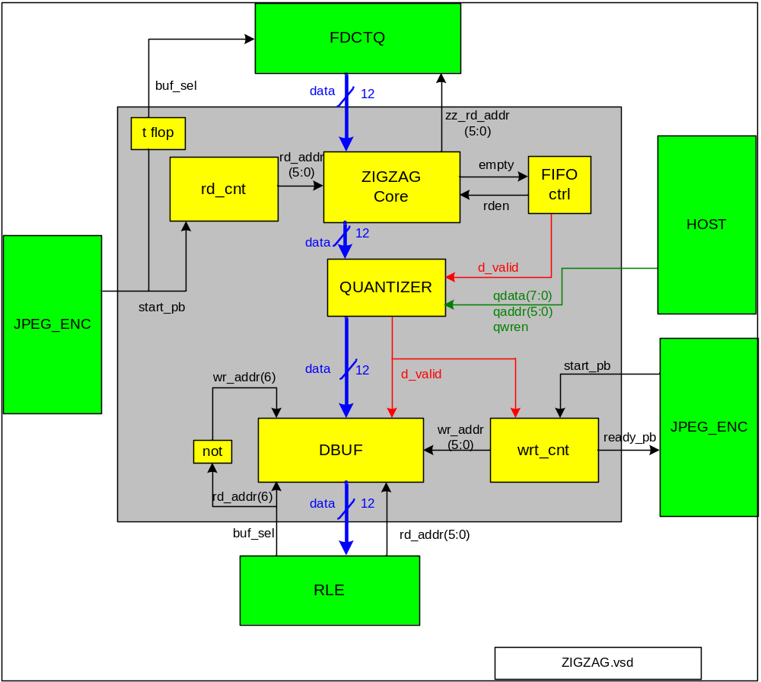
Figure 11

Zig-Zag block is responsible to perform so called zig-zag scan. It is simply reorder of samples positions in one 8x8 block according to following tables. Moreover, Quantization of ZIGZAG output is done here to achieve trade off between maximum compression and high quality by using different quantization tables.

input order (natural):

0 | 1 | 2 | 3 | 4 | 5 | 6 | 7
8 | 9 | 10 | 11 | 12 | 13 | 14 | 15
16 | 17 | 18 | 19 | 20 | ... | ...
 |  |  |  | ... | ... | 62 | 63

Zig-zag output order:

0 | 1 | 5 | 6 | 14 | 15 | 27 | 28
2 | 4 | 7 | 13 | 16 | 26 | 29 | 42
3 | 8 | 12 | 17 | 25 | 30 | 41 | 43
9 | 11 | 18 | 24 | 31 | 40 | 44 | 53
10 | 19 | 23 | 32 | 39 | 45 | 52 | 54
20 | 22 | 33 | 38 | 46 | 51 | 55 | 60
21 | 34 | 37 | 47 | 50 | 56 | 59 | 61
35 | 36 | 48 | 49 | 57 | 58 | 62 | 63

It means for example that first sample (position 0) is mapped to the same output position 0. Sample 2 is mapped to output position 5, etc.

When start_pb asserts:
- buf_sel toggles
- wrt_cnt is reset
- rd_cnt is reset to 0 and starts counting 0..63. -> 64 values are read from FDCT.
- ZIGZAG scanning is performed
- reordered data is written to DBUF using wr_addr generated from write counter (wrt_cnt)
- after 64 values are written to DBUF ready_pb is asserted
- Wrt_cnt can be implemented as simply delayed version of rd_cnt as ZIGZAG scan processing latency is constant.

ZIGZAG Core

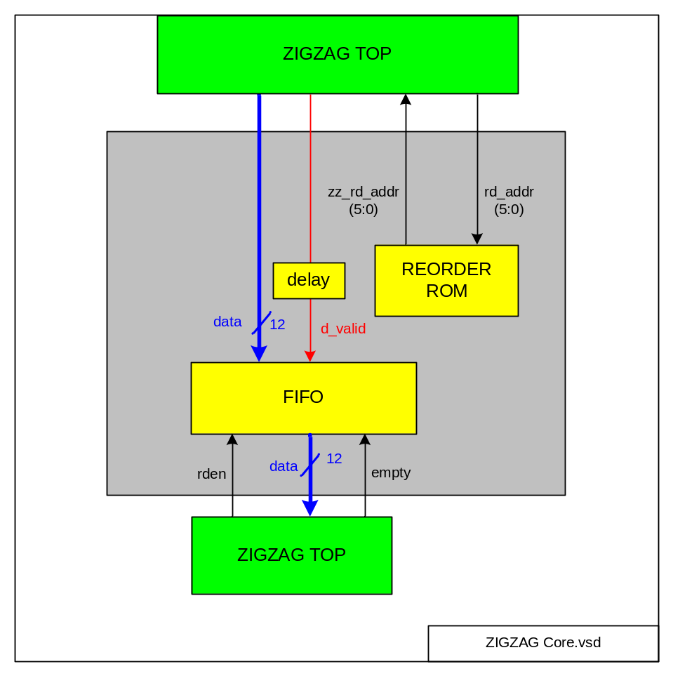
ZigZag Core is performing reordering of input samples according to zig-zag sequence. For that purpose REORDER ROM is used.
This ROM should be filled with following values written from address 0 to address 63:

0,1,8,16,9,2,3,10,
17,24,32,25,18,11,4,5,
12,19,26,33,40,48,41,34,
27,20,13,6,7,14,21,28,
35,42,49,56,57,50,43,36,
29,22,15,23,30,37,44,51,
58,59,52,45,38,31,39,46,
53,60,61,54,47,55,62,63

Note: This table is reverse from JPEG std spec table.
FIFO is used to store reordered samples for next processing step. FIFO size 64x12 bit.

FIFO ctrl

FIFO CTRL is read controller for FIFO. It reads FIFO output as long as it is not empty. Also it generates data valid signal which is simply delayed FIFO read req.

DBUF

Dual port RAM size 2 x 64 x 12 bits.

QUANTIZER

Quantizer performs division of input samples by defined quantization values. Works sample wise. Host can fill in 64 different quantization coefficients to internal RAM (64x8 bits)

Following equation is implemented:

FOUT(u, v) = round( FINPUT(u,v)/Q(u,v) )

- u,v –rectangular coordinates
- FINPUT – input sample to quantizer
- FOUTPUT – output sample from quantizer.
- Rounding to nearest integer

Default quantization table: All ones, i.e. no quantization at all.

Quantizer was merged with ZIGZAG in one processing block because it works sample wise and not block wise thus extra pipeline stage is not necessary.

Divider

Divider for quantizer uses precomputed reciprocals stored in ROM at 16 bits accuracy. Thus input dividend is actually multiplied with reciprocal of divisor to obtain quotient. Quotient is then rounded to nearest integer. No remainder is produced and used.

- Reciprocal ROM has 256 elements where one element is 16 bit number.
- Reciprocals of 8 bit numbers from 0 to 255 are stored in this ROM.
- Since reciprocals are almost all fractional numbers and internal arithmetic is integer all reciprocal are multiplied by constant factor CK=256*256
- This gives enough accuracy
- After multiplication dividend with reciprocal only 12 MSBs of result are taken to final quotient. 16 LSBs are thrown away.
- Bit 15 of multiplier result is if thinking in fractional numbers first digit after decimal dot. This is good indication if rounding is necessary. Number >0.5 is rounded to 1.0 and number <0.5 is rounded to 0.0.
- During rounding special care must be taken for negative dividend. For negative numbers to round up 1 must be subtracted from quotient. For positive numbers rounding up 1 must be added to quotient.
- Divider is quite fast and need only 4 cycles to divider 12 bit signed number by 6 bit unsigned number with rounding included

RLE

RLE core performs run-length encoding of data. For input block 8x8 samples, multiple symbol outputs are created consisting of RUNLENGTH, SIZE and AMPLITUDE.

- RUNLENGTH is the number of consecutive zero-valued AC coefficients in the zig-zag sequence preceding the nonzero AC coefficient being represented. For DC coefficient RUNLENGTH is always zero.
- SIZE is the number of bits used to encode AMPLITUDE. SIZE value is between 1 and 10 for AC coefficient. SIZE value is between 1 and 11 for DC coefficient.
- AMPLITUDE is two complement’s signed integer. Value ranges from -2047 to 2047 for DC coefficient and from -1023 to 1023 for AC coefficient.

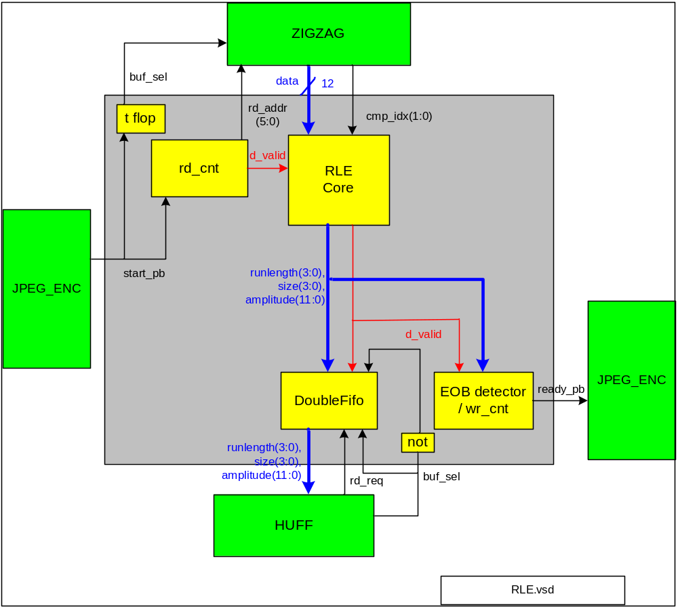
Figure 12

When start_pb asserts:
- buf_sel used by ZIGZAG toggles
- rd_cnt is reset to 0 and starts counting 0..63. -> 64 values are read from FDCT.
- wr_cnt is reset to 0.
- RLE encoding is done on 8x8 block
- RLE encoded data is written to DoubleFIFO

RLE Core

RLE Core perform encoding of 64 input samples to variable number of output symbols. Input data to RLE consists of 64 words. First word is DC coefficient, words 1..63 are AC coefficients

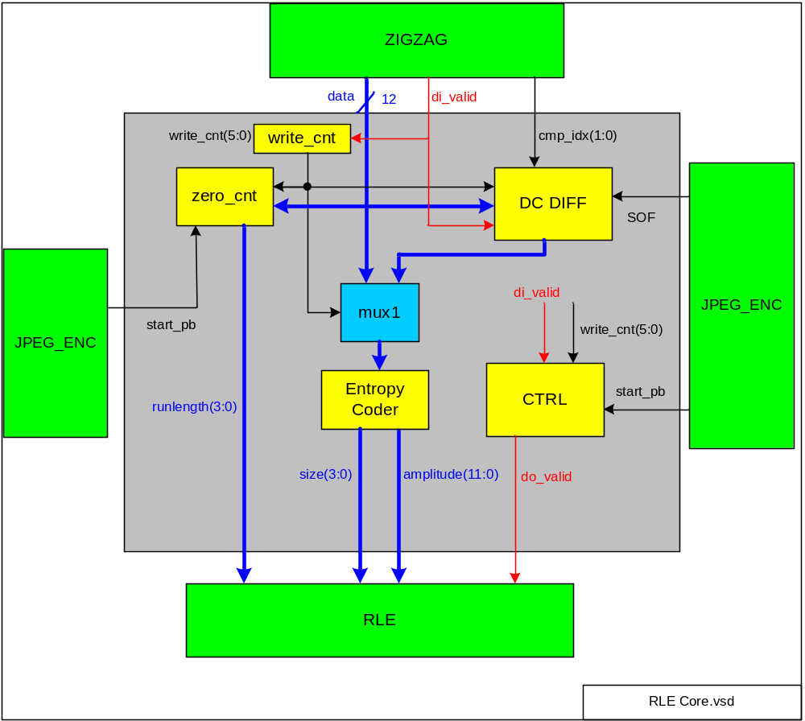

- zero_cnt(3:0) – counts number of zeros preceding non-zero AC coefficient. When start_pb asserts zero_cnt is reset to 0. Output of zero_cnt is used as RUNLENGTH.
- DC DIFF – performs differential encoding of DC coefficient. Also latches current DC value to register to use in next 8x8 block. This latch is reset when SOF asserts.
- MUX1 – switches between DC and AC path depending on write_cnt value. When write_cnt == 0, DC path is used, AC path used otherwise.
- CTRL – controls encoding flow and data valid generation.
- write_cnt is 6 bit counter incremented every time divalid is high. Reset on start_pb.

Encoding of input coefficients to output symbols

- DC coefficient (write_cnt == 0) is differentially encoded with DC coefficient from previous 8x8 block for the same color component. That is, RLE_DC = DC(current_block of component x) – DC(last block of component x). To distinguish which component is currently handled sm_settings.cmp_idx input is used.

- On each non-zero input AC coefficient exactly one output symbol is generated with RUNLENGTH=zero_cnt. Zero_cnt is then reset to 0. Output data valid asserts for 1 cycle.

- On each input AC coefficient equal to zero:
  - and zero_cnt < 15 and AC coefficient is not last in 8x8 block: no output symbol is generated, zero_cnt is incremented by 1.
  - and zero_cnt = 15: one “extension symbol is generated” with RUNLENGTH=15, SIZE=0, AMPLITUDE=0. After that zero_cnt is reset to 0. Output data valid asserts for 1 cycle.
  - and AC coefficient is last in 8x8 block (write_cnt == 63) EOB output symbol is generated: RUNLENGTH=0, SIZE=0, AMPLITUDE=0. Output data valid asserts for 1 cycle.

Entropy Coder

Encodes data sample into pair of symbols: AMPLITUDE (encoded as 2’s complement signed integer) and SIZE according to following table:

SIZE | AMPLITUDE
1  2  3  4  5  6  7  8  9  10  11 | -1,1  -3,-2,2,3  -7..-4,4..7  -15..-8,8..15  -31..-16,16..31  -63..-32,32..63  -127..-64,64..127  -255..-128,128..255  -511..-256,256..511  -1023..-512,512..1023  –2 047..–1 024,1 024..2 047

Note: Encoded amplitude MSB bit is ‘1’ for positive numbers and ‘0’ for negative numbers!

Read counter

rd_cnt counting is triggered by start_pb assertion.

EOB Detector / Write Counter

- RLE encoding returns variable number of words between 2..63. Final word in case of zero run is called EOB (End Of Block) which is simply runlength=size=amplitude=0 and sample is not DC! EOB detects this and asserts ready_pb pulse.
- Moreover wr_cnt(6:0) is incremented by (1+RUNLENGTH) on every d_valid signal incoming to EOB block. Counter is necessary when EOB code is bypassed (If the last coefficient is not zero).
- assumption: there is always single DC symbol at the beginning. Shortest combination: DC + EOB = 2 symbols.
- It can happen that there are zero runs but no EOB. wr_cnt must adjust its value basing on any zero runs encountered (accumulate RUNLENGTHs) so that when all words are handled counter value = 64 and ready_pb pulse can be asserted.
- Zero run extension. If RUNLENGTH=15 and SIZE=0 this means special Zero Extension symbol was encountered which indicates zero run of 16. In this case write counter must be incremented by 16.

Double FIFO

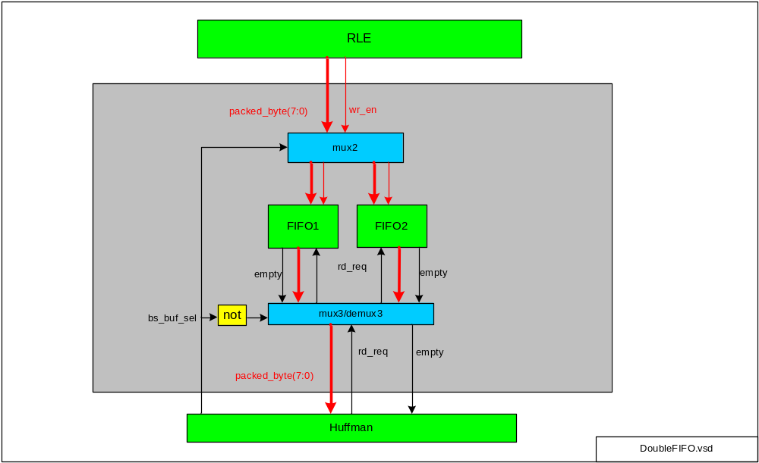
Huffman encoded data are stored to output FIFO. Two FIFOs with size is 64x20 bits each.

Double FIFO block is simply double buffer using two FIFOs.

FIFO is used instead of RAM because RLE encoder can write variable number of encoded words to FIFO thus in this case FIFO implementation is easier than using RAM.

data content in DoubleFIFO:

Q(19:16) | Q(15:12) | Q(11:0)
RUNLENGTH | SIZE | AMPLITUDE

HUFFMAN Encoder

General Description

Huffman block performs Huffman encoding operation. It converts parallel data into serial bit stream. Serial bit stream output is packed into bytes which are stored in output FIFO.

Operation

- When start_pb asserts processing is started.
- AC/DC ROMs are used to translate RUNLENGTH/VLI size into variable length code (VLC).
- Variable Length Processor is main FSM logic governing Huffman encoding process.
- buf_sel alternates when start_pb asserts. It is used for double buffering of RLE output buffer, it is to be connected to rd_addr(6) in RLE.
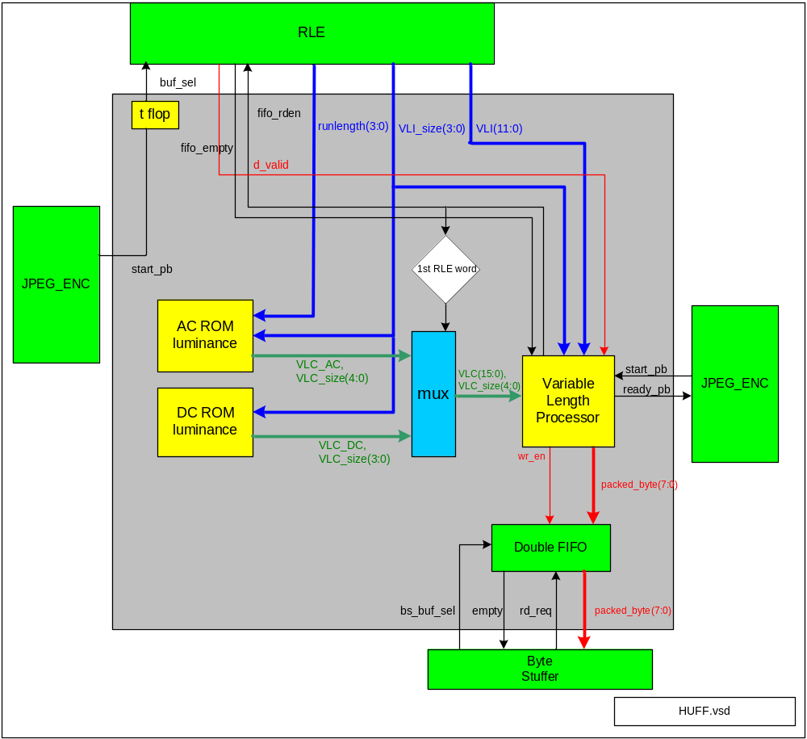 Figure 13

Double FIFO

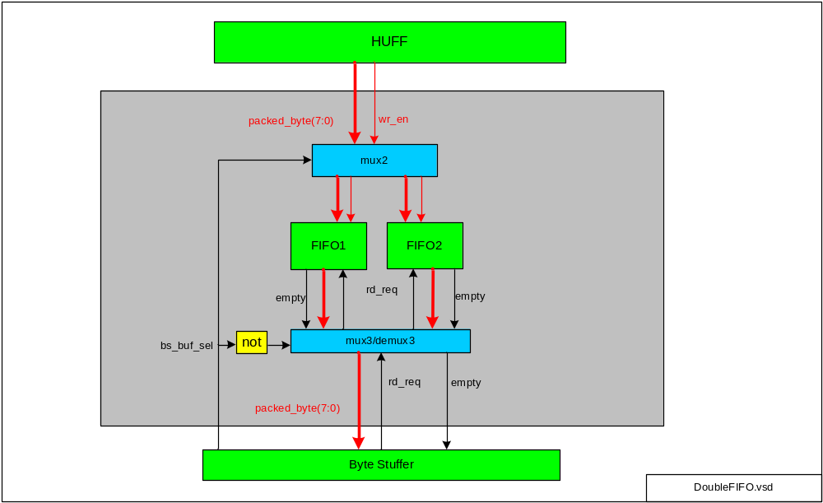
Huffman encoded data are stored to output FIFO. Two FIFOs with size is 2x64x8 bits each.2x 64x8 for assumption that JPEG encoded stream is no more size than 2x of input unencoded stream.

Double FIFO block is simply double buffer using two FIFOs. The idea is that while Huffman writes data for next block Byte Stuffer can read encoded data for previous block.

FIFO is used instead of RAM because Huffman encoder can write variable number of encoded words to FIFO thus FIFO implementation is easier than using RAM.

Variable Length Processor

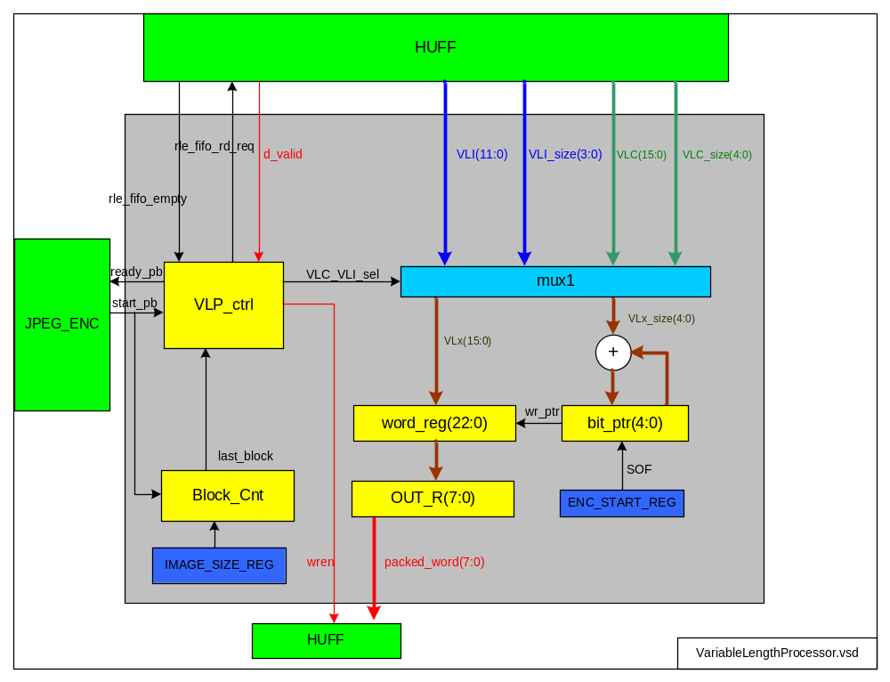 Figure 14

General Description

- VLP is Huffman Encoder main state machine and core processing logic. Processing is driven by VLP_ctrl FSM.
- When start_pb asserts all variables are moved into known state and FSM moves to processing state (Run_VLC).
- variable number of words are read from RLE by issuing read_req command until RLE fifo is empty
- Data read from RLE consists of so called RUNLENGTH and VLI (Variable Length Integer code).
- RUNLENGTH (and VLI_SIZE for AC ROM) is then transformed into VLC (Variable Length Code) using luminance DC and AC ROMs
- One RLE data symbol can be seen as pair of {VLC,VLI} words.
- DC ROM is used only for first word=0, words 1..63 use AC ROM.
- Since VLI and VLC codes are variable bit length, actual VLC/VLI bit size is given by 2nd argument VLC_size/VLI_size.

Serialization

- VLC/VLI encoded pair undergo serialization to bit stream. Serial bit stream is divided into number of output bytes.
- VLC is serialized first, then VLI.
- special bit pointer (bit_ptr(5:0)) is used to track pointer to first empty bit in word register (word_reg)
- VLC/VLI serial bits are mapped to word register (word_reg) starting from bit_ptr position. After that bit_ptr is moved to the right by number of bits in current VLC/VLI word. Bit pointer starts from LSB.
- After all VLC/VLI words from current block are serialized and stored to output FIFO ready_pb signal asserts

data valid
- input data valid d_valid can be simply delayed version of read_req.

1st RLE word detection
- set first_rle_word to 1 when start_pb asserts. Reset to zero on first fifo read request to RLE. This way for DC word DC-ROM will be used and for other RLE words AC-ROM will be used.

bit pointer
- bit_ptr(4:0) is used to track last used bit in word_reg. Bit_ptr is reset to zero when SOF asserts and is NOT reset when start_pb asserts!.

VLP State Machine
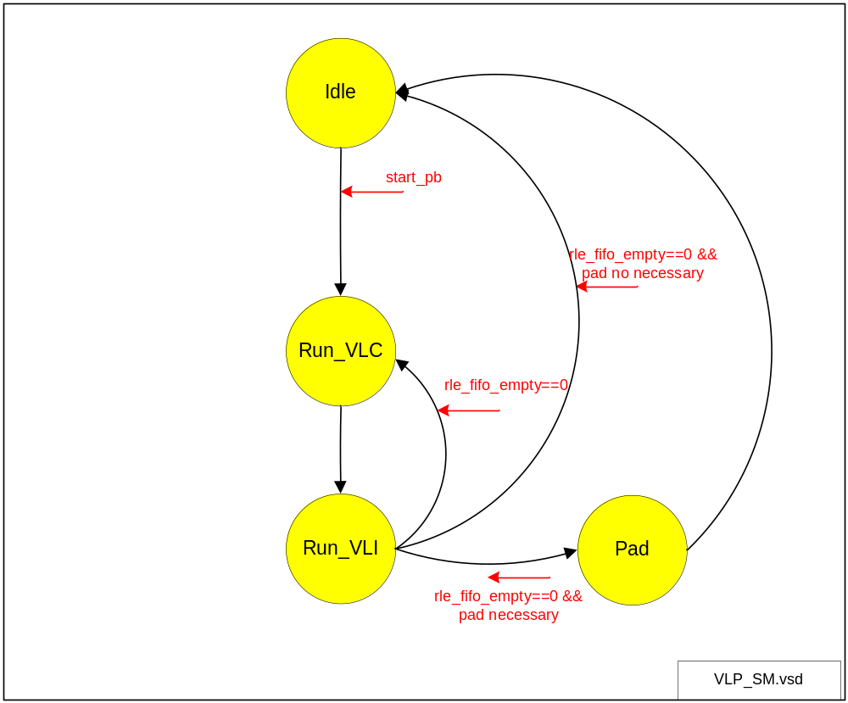
Figure 15

VLP SM details

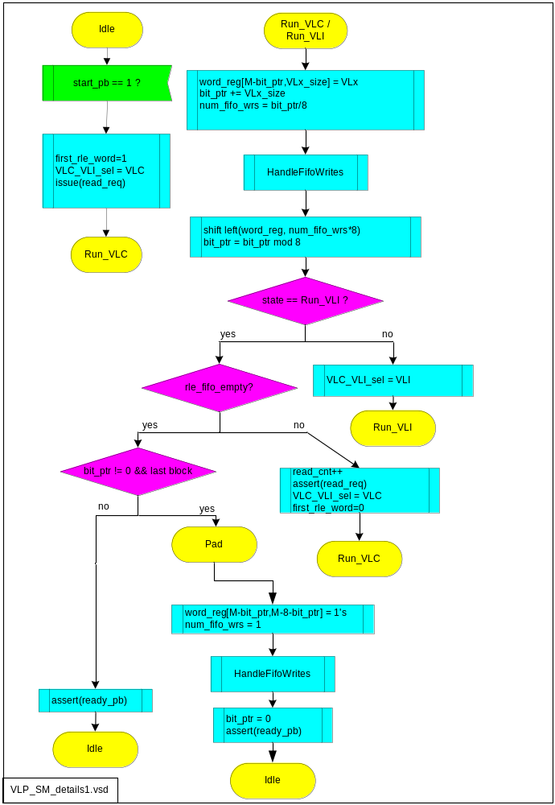
Figure 16

- Idea of above state machine is to write byte-wise Huffman encoded variable length bit stream to output FIFO
- It is assumed that single VLC or VLI serial “word” is no more than 16 bits and no less than 1 bit. 16 comes from: max VLC = max(max VLC DC=9, max VLC AC=16) = 16 bits. Max VLI is is 11 bits. Thus max VLx is 16 bits.
- Entropy-coded segments must be made an integer number of bytes. This is performed as follows: for Huffman coding, 1-bits are used, if necessary, to pad the end of the compressed data to complete the final byte of a segment.
- This means HUFFMAN block needs to know when last 8x8 block is being processed and then pad final byte with ones. Otherwise few last encoded bits (<8) would go lost.
- Last Block detection can be done by dividing known size of image (from programming register). Last Block = number_of_components * (image_width * image_height) / 64
- M = word_reg register bit size-1. Currently M=23-1=22.

Last_Block / Block_Cnt

It is necessary to know when last 8x8 block occurs to make entropy coded segment integer number of bytes. Last block detector works as follows:
- Block_Cnt is incremented every time start_pb asserts. Its maximum value = 3*(Max_image_width * max_image_height) / 64 = 65536 * 65536 / 64 = 201326592
- Thus bitwidth is ceil(log2(67108864)) = 28 bits necessary
- When Block_Cnt reaches last block [ (Block_Cnt == number_of_components*(image_width * image_height)/64 ] it signals it to VLP by asserting last_block signal.
- Block_Cnt is reset to 0 when SOF asserts

Word_Reg

- word_reg is intermediate processing register designed to be able to hold code word of maximum size
- Variable Length Code is stored to word_reg MSB first
- word_reg register is used to take incoming data. Its size must be 16+7=23 bits to handle worst case. (7 bits left from previous loop iteration and 16 bits from current loop iteration).

Procedure HandleFifoWrites

- This procedure is responsible to write output bytes to FIFO. As arguments it takes word_reg (data) and num_fifo_wrs (number of bytes to be written).
- number of bytes to write from single RLE word can vary between 0 and 2 per one VLx.
- Bytes to be written are taken starting from MSB of word_reg.

DC Luminance ROM

DC Luminance ROM is used to perform variable length encoding for 1st sample in single processing block (8x8 samples). For given input VLI_size value, VLC code is returned along with its bit width. VLI_size(3:0) is used as address to DC-ROM.

As per ITU-T81 Table K.3 – Table for luminance DC coefficient differences

Category | Code length | Code word
0 | 2 | 00
1 | 3 | 010
2 | 3 | 011
3 | 3 | 100
4 | 3 | 101
5 | 3 | 110
6 | 4 | 1110
7 | 5 | 11110
8 | 6 | 111110
9 | 7 | 1111110
10 | 8 | 11111110
11 | 9 | 111111110

Category here means VLI_size. Code length (VLC_DC_size) and Code word (VLC_DC) are mapped to “q” output of DC-ROM.
DC-ROM is 12 words x 13 bits.

One entry in DC-ROM is

Q(12:9) | Q(8:0)
VLC_DC_size(3:0) | zero padding(9-variable length) | VLC_DC(variable length)

size of leading zero padding = maximum(Code Length) - VLC_DC_size
From table above: maximum(Code Length)= 9

AC Luminance ROM

AC-ROM is similar in operation to DC-ROM. Address is constructed from RUNLENGTH(3:0) and VLI_Size(3:0):
AC_ROM_address(7:4) = RUNLENGTH(3:0)
AC_ROM_address(3:0) = VLI_Size(3:0)

From ITU-T81 Table K.5 – Table for luminance AC coefficients (sheet 1 of 4)

Few entries from Table K.5 given here as an example:

Run/Size | Code length | Code word
0/0 (EOB) | 4 | 1010
0/1 | 2 | 00
0/2 | 2 | 01
0/3 | 3 | 100
... | ... | ...
F/A | 16 | 1111111111111110

AC-ROM size is 150 words x 20 bits. 150 words comes from Run range 0..15, Size range 0..10.
20 bit width comes from: 4 bits are necessary to store Code Length and 16 bits are necessary to store Code Word (worst case).

Run/Size there means here RUNLENGTH/ VLI_Size. Code Length means VLC_AC_size and Code word means VLC_AC

One entry in AC-ROM is

Q(19:15) | Q(15:0)
VLC_AC_Size(4:0) | zero padding(16-variable length) | VLC_AC(variable length)

size of leading zero padding = maximum(Code Length) - (VLC_AC_size)
From table 5: maximum(Code Length)= 16

Byte Stuffer

In order to ensure that a false marker does not occur within an entropy-coded segment, any X’FF’ byte (generated by Huffman encoder, or an X’FF’ byte that was generated by the padding of 1-bits of final segment) is followed by a “stuffed” zero byte.

Byte Stuffer stuffs a zero byte whenever the addition of the carry to the data already in the entropy-coded segments creates a X’FF’ byte.

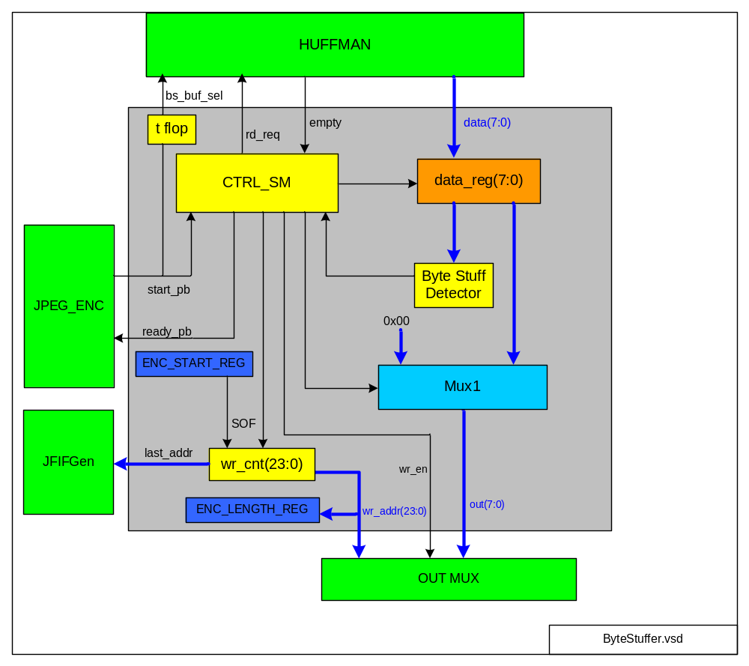 Figure 17

CTRL_SM

Control state machine operates as follows:

- When start_pb asserts Huffman output FIFO is started to being read until it becomes empty
- Every byte read from Huffman FIFO is checked against 0xFF value – this done by Byte Stuff Detector. If 0xFF byte is encountered, byte stuffing with value 0x00 must be performed
- For example: if following bytes are read from Huffman FIFO: AA BB CC FF 22 33, then after byte stuffing there is: AA BB CC FF 00 22 33
- When stuffing is necessary Mux1 is switched to 0x00 path after 0xFF from data path was written to output RAM. Thus, for every 0xFF on input 0xFF, 0x00 is written to output. Otherwise for every input one byte is written to output (the same data)
- When FIFO is empty it means all bytes were processed, ready_pb pulse can assert.

Write Counter

- Counter wr_cnt is used as address to output RAM
- Its current bitwidth is selected arbitrary to 24 bits however necessary size of coded image vary. Thus bitwidth with quite big margin was selected.
- wrt_cnt is preset when SOF asserts to JFIF header size. This is to put coded data byte stream after the JFIF header.
- wrt_cnt is incremented on every new byte written to output RAM (wren – write enable)
- Number of coded bytes stored to RAM (including header) can be read out by Host from ENC_LENGTH_REG

Byte Stuff Detector

- Simple comparator which checks if input byte is equal to 0xFF.

bs_buf_sel

Double buffer selector. Flips on every start_pb assertion.

last_addr

After all encoded bytes are written, EOI (End Of Image) marker must be written. JFIFGen which does that must know last address written by ByteStuffer to append EOI right after it.

JFIF Header Generator

Default JFIF header is generated from onchip RAM.

Most of header fields are hardcoded, however some are configurable and must be programmed by Host.

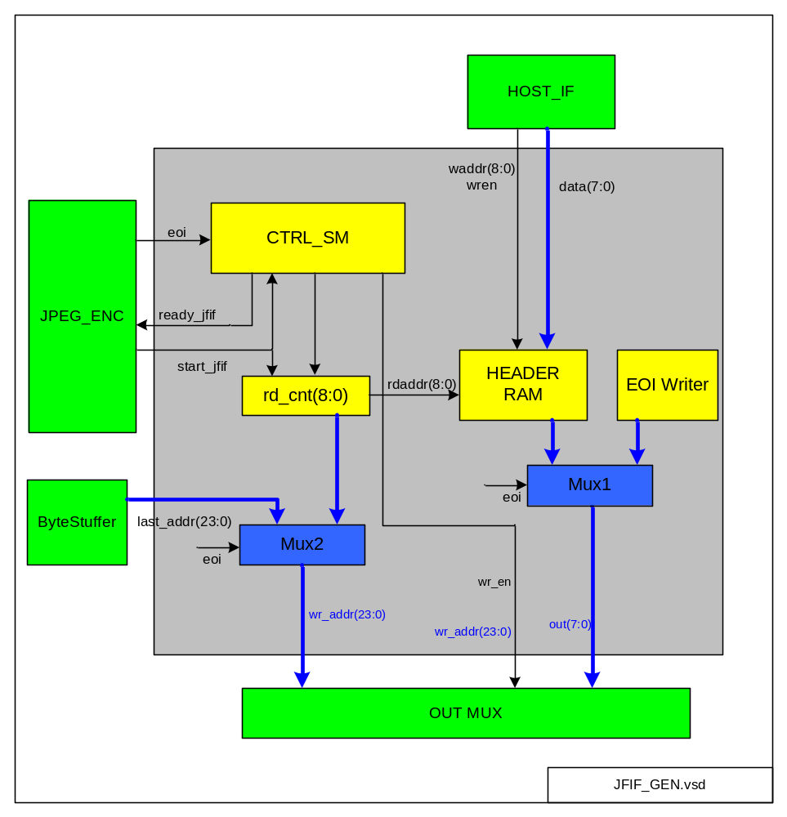

These are:

SIZE_Y_H, SIZE_Y_L – upper and lower byte of image height
SIZE_X_H, SIZE_X_L – upper and lower byte of image width
Number of components – 0=grayscale, 3=color. Currently fixed to 3.
Q0....Q63 – Quantization table in zig zag order

Header RAM Programming

When Host performs programming of JPEG coding parameters, some of them are also passed to JFIF generator module and are written to Header RAM:

- Image Height and Width: written when IMAGE_SIZE_REG is written by Host. Write addresses decimal 25, 26 for Height, 27, 28 for Width.
- Number of components: Written to Header RAM address 29 and 328. Note: this is fixed now to 03! Programming not supported, always 3 components used.
- Quantization table written from offset 44 decimal.

JFIF Generator

When start_jfif asserts and eoi = 0:
- rd_cnt is reset. rd_cnt then counts from 0..337 (JFIF header size=328). This reads Header RAM whose output is then saved to Output RAM.
- After all bytes from Header RAM are transmitted ready_jfif asserts.

When start_jfif asserts and eoi = 1:
- EOI marker “FF D9” is written after coded byte stream to “close” image.

EOI Writer

Writes two EOI marker bytes “FF D9” to signal end of image.

Mux1/Mux2

Switch path depending on eoi signal from JPEG CtrlSM. When eoi is high EOI marker is written, otherwise JFIF header is written to output.

Generic Header

Generic header defaults are stored in RAM using preinitialization. These defaults are (stored starting from address 0):

Description | Data (hex byte)
SOI, start of image marker | FF, D8
JFIF header
Marker APP0 | FF, E0
Length (16 bytes) | 00, 10
“JFIF” ascii zero terminated | 4A, 46, 49, 46, 00
Version | 01, 01
Units | 00
XDensity | 00, 01
YDensity | 00, 01
XThumbnail (no thumbnail) | 00
YThumbnail (no thumbnail) | 00
Start Of Frame
Baseline DCT, SOF0 marker | FF, C0
Length (11 bytes) | 00, 11
Sample Precision | 08
Height | SIZE_Y_H, SIZE_Y_L
Width | SIZE_X_H, SIZE_X_L
Number of components (grayscale/color) | 03
Scan 1: 1:1 horiz, (byte) 1:1 vertical, (byte) use QT 0 | 01, 11, 00
Scan 2: 1:1 horiz, (byte) 1:1 vertical, (byte) use QT 0 | 02, 11, 00
Scan 3: 1:1 horiz, (byte) 1:1 vertical, (byte) use QT 0 | 03, 11, 00
Define Quantization table
marker | FF, DB
Length (67 bytes) | 00, 43
8 bit values, table 0 | 00
quantization 8-bit values (64 entries, zigzag order) | Q0....Q63
Define Huffman Table
Marker | FF, C4
Length (31 bytes) | 00, 1F
DC, Table 0 | 00
L1..L16 | 00, 01, 05, 01, 01, 01, 01, 01  01, 00, 00, 00, 00, 00, 00, 00
Symbol codes for L1..L16 (Vij) | 00, 01, 02, 03, 04, 05, 06, 07,  08, 09, 0A, 0B
Define Huffman Table
Marker | FF, C4
Length (181 bytes) | 00, B5
AC, table 0 | 10
L1..L16 | 00, 02, 01, 03, 03,  02, 04, 03, 05, 05,  04, 04, 00, 00, 01,
Symbol codes for L1..L16 (Vij) | 7D, 01, 02, 03, 00,  04, 11, 05, 12, 21,  31, 41, 06, 13, 51,  61, 07, 22, 71, 14,  32, 81, 91, A1, 08,  23, 42, B1, C1, 15,  52, D1, F0, 24, 33,  62, 72, 82, 09, 0A,  16, 17, 18, 19, 1A,  25, 26, 27, 28, 29,  2A, 34, 35, 36, 37,  38, 39, 3A, 43, 44,  45, 46, 47, 48, 49,  4A, 53, 54, 55, 56,  57, 58, 59, 5A, 63,  64, 65, 66, 67, 68,  69, 6A, 73, 74, 75,  76, 77, 78, 79, 7A,  83, 84, 85, 86, 87,  88, 89, 8A, 92, 93,  94, 95, 96, 97, 98,  99, 9A, A2, A3, A4,  A5, A6, A7, A8, A9,  AA, B2, B3, B4, B5,  B6, B7, B8, B9, BA,  C2, C3, C4, C5, C6,  C7, C8, C9, CA, D2,  D3, D4, D5, D6, D7,  D8, D9, DA, E1, E2,  E3, E4, E5, E6, E7,  E8, E9, EA, F1, F2,  F3, F4, F5, F6, F7,  F8, F9, FA
Start Of Scan
Marker | FF, DA
Length | 00, 0C
Number of Image components (grayscale/color) | 03
Component 1, use DC/AC huff tables 0/0 | 01, 00
Component 2, use DC/AC huff tables 0/0 | 02, 00
Component 3, use DC/AC huff tables 0/0 | 03, 00
Ss | 00
Se | 3F
Ah, Al | 00
Data Scan
JPEG encoded byte stream goes here
...
End of Image
Marker: EOI | FF, D9

NOTE: This header must be pre-programmed to FPGA memory for example using mif or hex files. For ModelSim simulation hex file can be used.

Programming Interface

General

JPEG core programming is done via OPB Host interface using for example Xilinx Microblaze processor.

Only 32 bit aligned accesses are supported. It means input address must be multiple of 4.

All registers are 32 bits wide. Although some bits may be unused.

Core address map

Address | Register
0x0 0000 | ENC_START_REG | WO
0x0 0004 | IMAGE_SIZE_REG | R/W
0x0 000C | ENC_STS_REG | RO
0x0 0010 | - | -
0x0 0014 | ENC_LENGTH_REG | RO
0x00 0100 ... 0x00 01FF | QUANTIZER_RAM | WO

Register Descriptions

ENC_START_REG | WO | Default: 0x0
- | D31..D3 | -
cmp_max | D2..D1 | Number of image components.  1=grayscale, 3=color RGB input, YUV output
SOF | D0 | Start Of Frame. Writing ‘1’ to this bit starts JPEG encoding process.

IMAGE_SIZE_REG | R/W | Default: 0x0
size_x | D31..D16 | Image width in pixels (must be multiple of 8)
size_y | D15..D0 | Image height in pixels (must be multiple of 8)

ENC_STS_REG | RO | Default: 0x0
- | D31..D2 | -
done | D1 | JPEG encoding complete
busy | D0 | JPEG encoding in progress

ENC_LENGTH_REG | RO | Default: 0x0
Header and data length included.

- | D31..D10 | -
length | D23..D0 | coded stream length (in bytes)

QUANTIZER_RAM | R/W | Default: 0x1
64 entries.

- | D31..D8 | -
q_coeff | D7..D0 | Quantization coefficient

Users Manual

To perform JPEG encoding of image Host must perform steps below:

- Write IMAGE_SIZE_REG with width and height of image to be encoded
- Fill in Quantizer table using QUANTIZER_RAM
- write SOF bit in ENC_START_REG to start encoding process
- Write raw bitmap image samples BUF_FIFO.
- Host either waits for interrupt ready_int (pulse) or polls for JPEG encoding done flag in ENC_STS_REG to know when encoding is complete
- Host can read ENC_LENGTH_REG to get length of encoded byte stream in output RAM
- Enjoy!

Simulation

- VHDL simulation can be run by executing sim.do TCL script under ModelSim.
- Input bitmap image is in text format and is called test.txt – must be in directory where sim.do is placed
- test.txt image text format can be generated using img2txt.m Matlab script
- img2txt.m is in ./testbench/matlab/img2txt. It takes as input test.bmp and converts it to test.txt
- test.bmp is 24 bit RGB bitmap
- image must have dimensions multiple of 8
- Image width must not be higher than JPEG_PKG.VHD constant C_MAX_LINE_WIDTH otherwise simulation error will occur. In this case increase this constant to support bigger input image width. Be warned that bigger this constant value is, the more memory FPGA will be needed when core is synthesized.
- JPEG encoded output byte stream is saved to file OUT_RAM.txt as hex byte string and also to test_out.jpg as regular JPEG format file.

OPB Master BFM

- OPB Master Bus Functional Model is used to drive OPB slave bus of EV_JPEG_ENC core to configure JPEG Core and also it loads image through fast FIFO-like interface.
- This BFM is in file HostBFM.vhd
- Quantization table can be modified in HostBFM.vhd file by changing qrom constant. There are 3 predefined quantization tables, just comment 2 of them and uncomment one to use 100%, 75% or 50%.

Performance / Area

General

Here is snapshot from Quartus II Fitter for Stratix II S90 device. This is based on really dummy project where JPEG encoder top entity is just mapped directly to pins. Anyway, area reported shall be quite accurate.

Area

Example below is given for configuration of (in JPEG_PKG.VHD):
C_MAX_LINE_WIDTH = 640 (maximum line width)
C_MEMORY_OPTIMIZED = 1 (try to favor area at expense of performance).
Fitter set to perform for best performance.

Fitter results

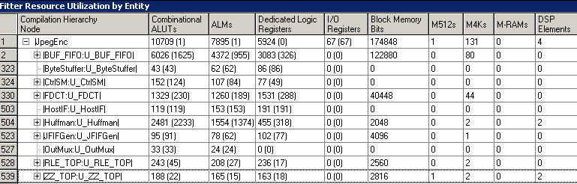

Number of memory bits really used is halved for BUF_FIFO but number of M4K blocks usage is the same as in performance optimized configuration because each FIFO needs separate RAM anyway. For different FPGA or even different RAM partitioning using more fine grained memory blocks and/or LUTs area optimized configuration constant could yield advantange however.

Performance

Design utilizes single clock for everything included Host interface.
For this clock CLK maximum achievable frequency is 115 MHz

