Copyright © <github.com/trondr> 2014 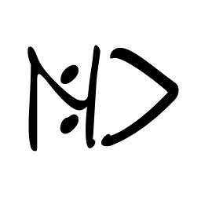
All rights reserved.
Redistribution and use in source and binary forms, with
or without modification, are permitted provided that the
following conditions are met:
* Redistributions of source code must retain the above
copyright notice, this list of conditions and the
following disclaimer.
* Redistributions in binary form must reproduce the above
copyright notice, this list of conditions and the
following disclaimer in the documentation and/or other
materials provided with the distribution.
* Neither the name of NCmdLiner.SolutionCreator nor the
names of its contributors may be used to endorse or
promote products derived from this software without
specific prior written permission.
THIS SOFTWARE IS PROVIDED BY THE COPYRIGHT HOLDERS AND
CONTRIBUTORS "AS IS" AND ANY EXPRESS OR IMPLIED WARRANTIES,
INCLUDING, BUT NOT LIMITED TO, THE IMPLIED WARRANTIES OF
MERCHANTABILITY AND FITNESS FOR A PARTICULAR PURPOSE ARE
DISCLAIMED. IN NO EVENT SHALL THE COPYRIGHT HOLDER OR
CONTRIBUTORS BE LIABLE FOR ANY DIRECT, INDIRECT,
INCIDENTAL, SPECIAL, EXEMPLARY, OR CONSEQUENTIAL DAMAGES
(INCLUDING, BUT NOT LIMITED TO, PROCUREMENT OF SUBSTITUTE
GOODS OR SERVICES; LOSS OF USE, DATA, OR PROFITS; OR
BUSINESS INTERRUPTION) HOWEVER CAUSED AND ON ANY THEORY OF
LIABILITY, WHETHER IN CONTRACT, STRICT LIABILITY, OR TORT
INCLUDING NEGLIGENCE OR OTHERWISE) ARISING IN ANY WAY OUT
OF THE USE OF THIS SOFTWARE, EVEN IF ADVISED OF THE
POSSIBILITY OF SUCH DAMAGE.

