Name: Trong-An Bui
Student ID: 107323903
Homework 2 and 3

This section addresses basic image manipulation and processing using the core scientific modules NumPy and SciPy. Some of the operations covered by this tutorial may be useful for other kinds of multidimensional array processing than image processing. In particular, the submodule scipy.ndimage provides functions operating on n-dimensional NumPy arrays.

1. Opening and writing to image files
from scipy import misc
f = misc.face()
misc.imsave('face.png', f) # uses the Image module (PIL)

import matplotlib.pyplot as plt
plt.imshow(f)
plt.show()
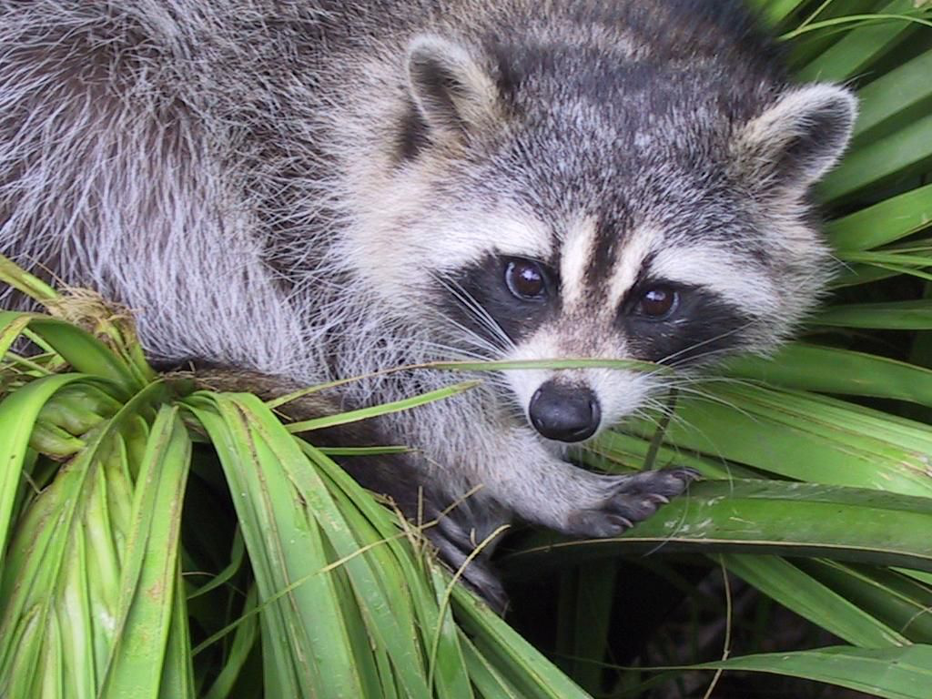

2. Displaying images
f = misc.face(gray=True) # retrieve a grayscale image
import matplotlib.pyplot as plt
plt.imshow(f, cmap=plt.cm.gray)
Increase contrast by setting min and max values
plt.imshow(f, cmap=plt.cm.gray, vmin=30, vmax=200)
# Remove axes and ticks
plt.axis('off')
Draw contour lines:
plt.contour(f, [50, 200])
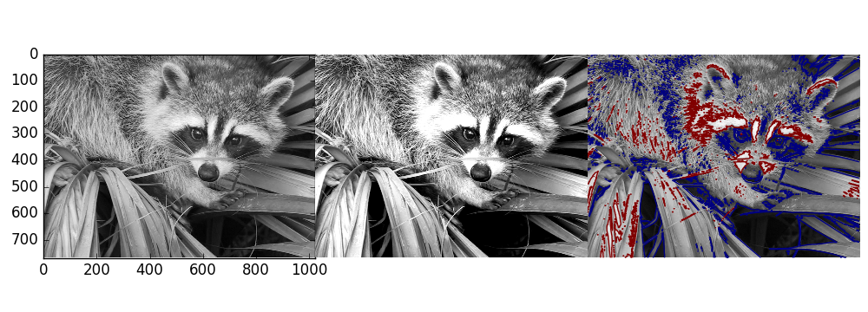

3. Image filtering
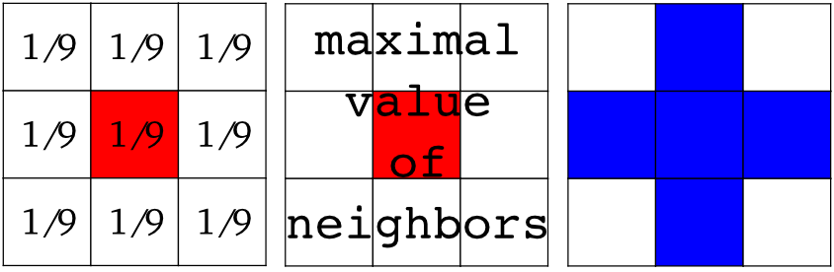
Gaussian filter
from scipy import misc
face = misc.face(gray=True)
blurred_face = ndimage.gaussian_filter(face, sigma=3)
very_blurred = ndimage.gaussian_filter(face, sigma=5)
Uniform filter
local_mean = ndimage.uniform_filter(face, size=11)
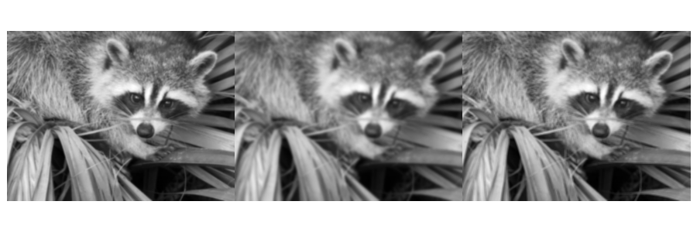
4. Denoising
from scipy import misc
f = misc.face(gray=True)
f = f[230:290, 220:320]
noisy = f + 0.4 * f.std() * np.random.random(f.shape)
A Gaussian filter smoothes the noise out
gauss_denoised = ndimage.gaussian_filter(noisy, 2)
A median filter preserves better the edges:
med_denoised = ndimage.median_filter(noisy, 3)
Median filter: better result for straight boundaries (low curvature):
im = np.zeros((20, 20))
im[5:-5, 5:-5] = 1
im = ndimage.distance_transform_bf(im)
im_noise = im + 0.2 * np.random.randn(*im.shape)
im_med = ndimage.median_filter(im_noise, 3)

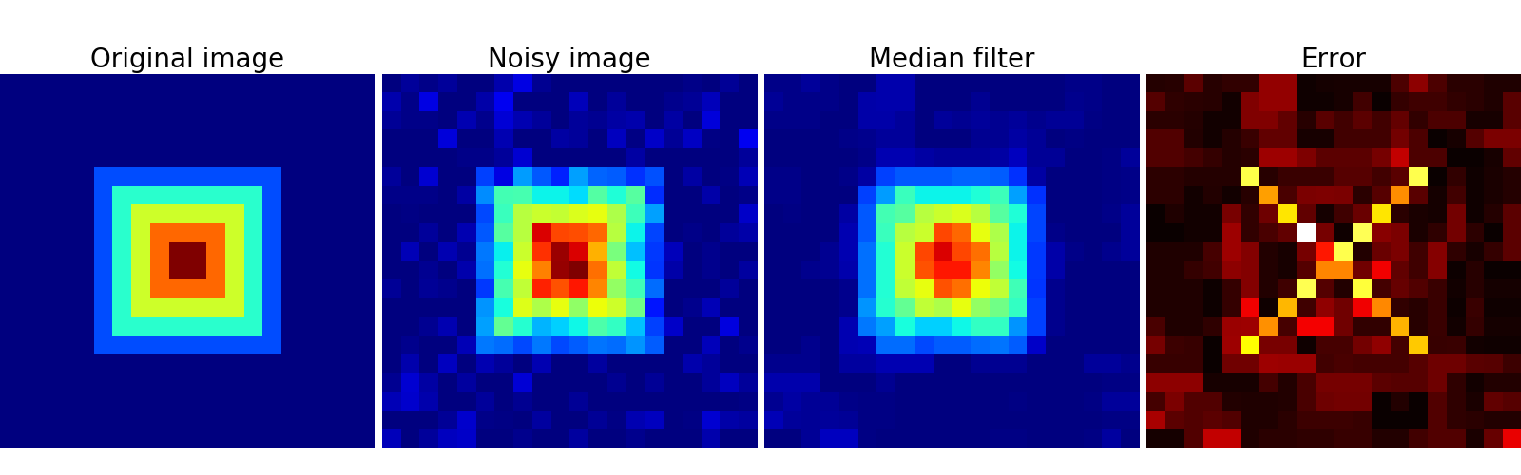
5. Mathematical morphology
Erosion = minimum filter. Replace the value of a pixel by the minimal value covered by the structuring element.:
a = np.zeros((7,7), dtype=np.int)
a[1:6, 2:5] = 1
ndimage.binary_erosion(a).astype(a.dtype)
#Erosion removes objects smaller than the structure
ndimage.binary_erosion(a, structure=np.ones((5,5))).astype(a.dtype)
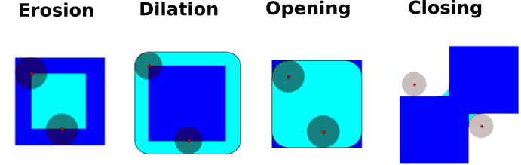
Dilation: maximum filter:
a = np.zeros((5, 5))
a[2, 2] = 1
ndimage.binary_dilation(a).astype(a.dtype)
np.random.seed(2)
im = np.zeros((64, 64))
x, y = (63*np.random.random((2, 8))).astype(np.int)
im[x, y] = np.arange(8)

bigger_points = ndimage.grey_dilation(im, size=(5, 5), structure=np.ones((5, 5)))

square = np.zeros((16, 16))
square[4:-4, 4:-4] = 1
dist = ndimage.distance_transform_bf(square)
dilate_dist = ndimage.grey_dilation(dist, size=(3, 3), \
structure=np.ones((3, 3)))
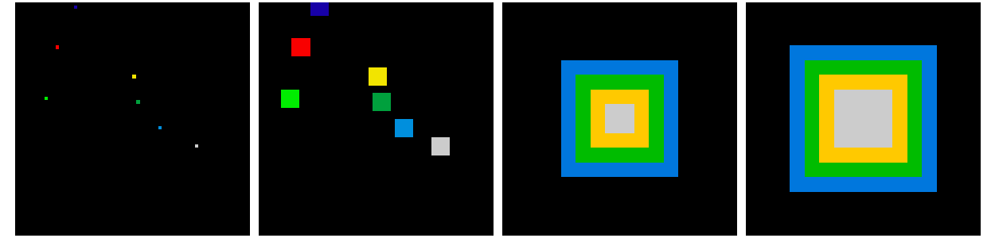
Opening: erosion + dilation:
a = np.zeros((5,5), dtype=np.int)
a[1:4, 1:4] = 1; a[4, 4] = 1
# Opening removes small objects
ndimage.binary_opening(a, structure=np.ones((3,3))).astype(np.int)
# Opening can also smooth corners
ndimage.binary_opening(a).astype(np.int)
Application: remove noise:
square = np.zeros((32, 32))
square[10:-10, 10:-10] = 1
np.random.seed(2)
x, y = (32*np.random.random((2, 20))).astype(np.int)
square[x, y] = 1

open_square = ndimage.binary_opening(square)

eroded_square = ndimage.binary_erosion(square)
reconstruction = ndimage.binary_propagation(eroded_square, mask=square)
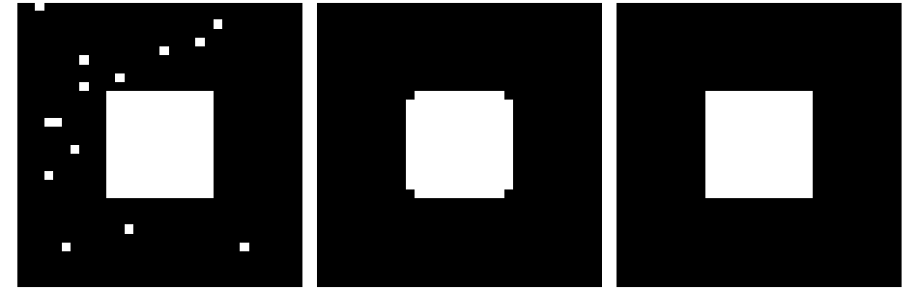

6. Feature extraction
6.1. Edge detection
Synthetic data:
im = np.zeros((256, 256))
im[64:-64, 64:-64] = 1
im = ndimage.rotate(im, 15, mode='constant')
im = ndimage.gaussian_filter(im, 8)
Use a gradient operator (Sobel) to find high intensity variations:
sx = ndimage.sobel(im, axis=0, mode='constant')
sy = ndimage.sobel(im, axis=1, mode='constant')
sob = np.hypot(sx, sy)

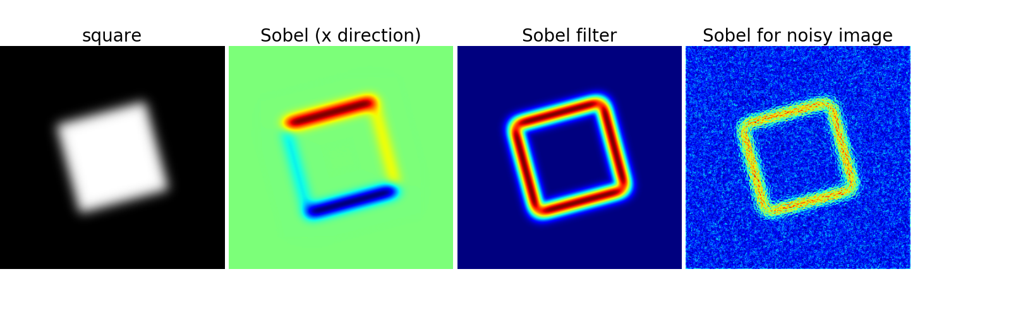
6.2. Segmentation
Histogram-based segmentation (no spatial information)
n = 10
l = 256
im = np.zeros((l, l))
np.random.seed(1)
points = l*np.random.random((2, n**2))
im[(points[0]).astype(np.int), (points[1]).astype(np.int)] = 1
im = ndimage.gaussian_filter(im, sigma=l/(4.*n))

mask = (im > im.mean()).astype(np.float)
mask += 0.1 * im
img = mask + 0.2*np.random.randn(*mask.shape)

hist, bin_edges = np.histogram(img, bins=60)
bin_centers = 0.5*(bin_edges[:-1] + bin_edges[1:])

binary_img = img > 0.5
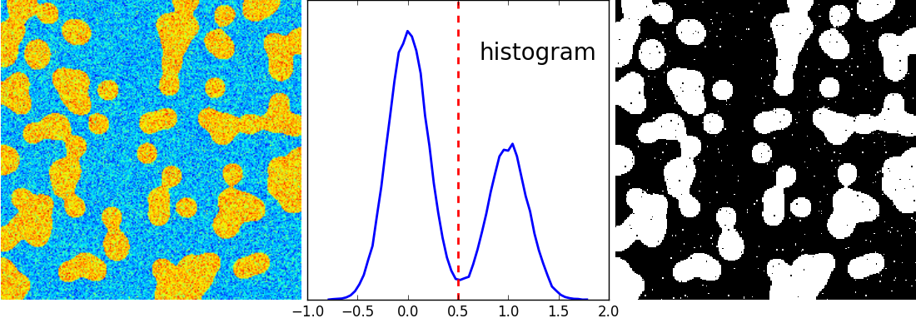
Use mathematical morphology to clean up the result:
# Remove small white regions
open_img = ndimage.binary_opening(binary_img)
# Remove small black hole
close_img = ndimage.binary_closing(open_img)
