Solution:

* Seperate the filter and sort function into difference ones

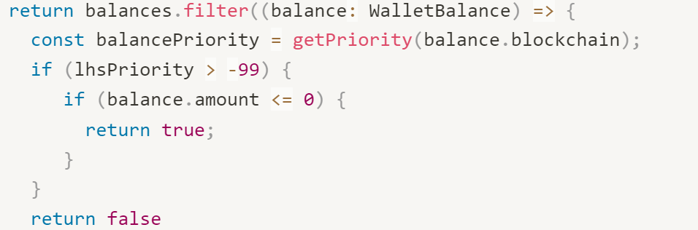

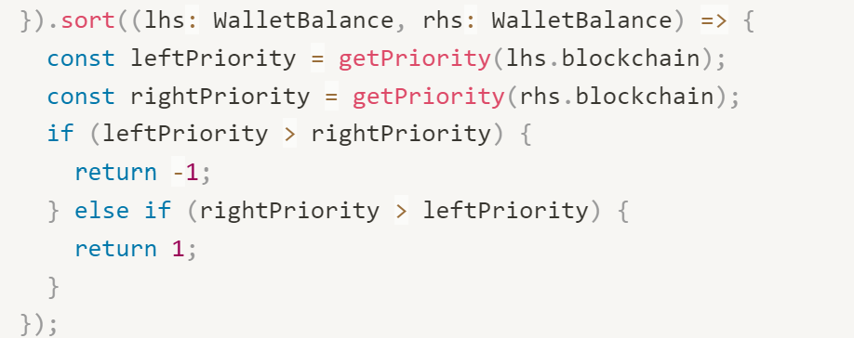

* Remove the formatted:string from interface FormattedWalletBalance and move it to interface Props extends BoxProps

interface Props extends BoxProps{

formatted:string

}