Conversion factors: 1 L = 33.8 fluid oz; 1 L = 1.06 qt; 1 cup = 8 fluid oz

### User information requirements

**Date of birth** để tính tuổi, **Body weight** để tính số lượng nước cần per kg, **usage**: daily water intake/weight loss, **working condition**: easy/moderate/hard work

### Adequate intake - Set default water intake goal per day

Fluids (drinking water and beverages) provided **3.0 L** (101 fluid oz; ≈ 13 cups) and **2.2 L** (74 fluid oz; ≈ 9 cups) per day for 19- to 30-year-old **men** and **women**[1].

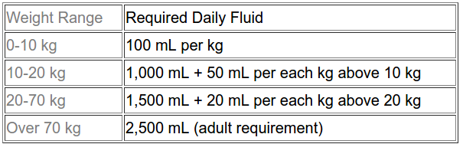

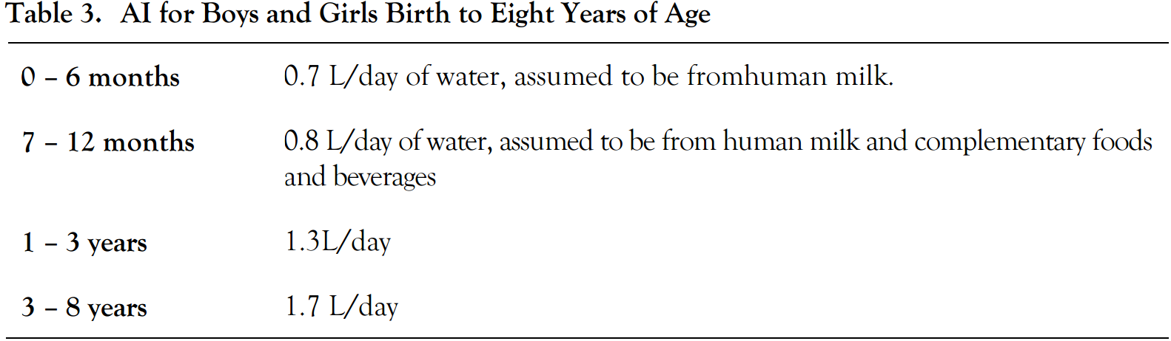

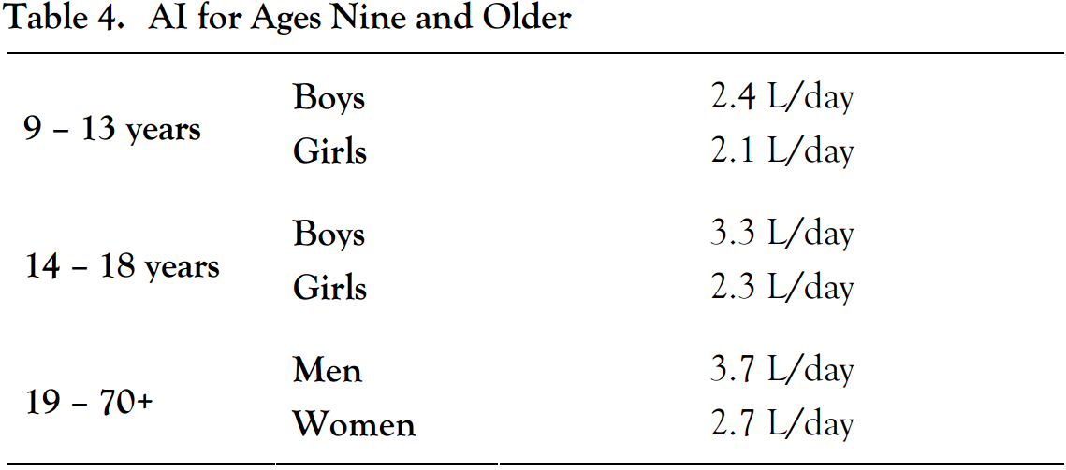

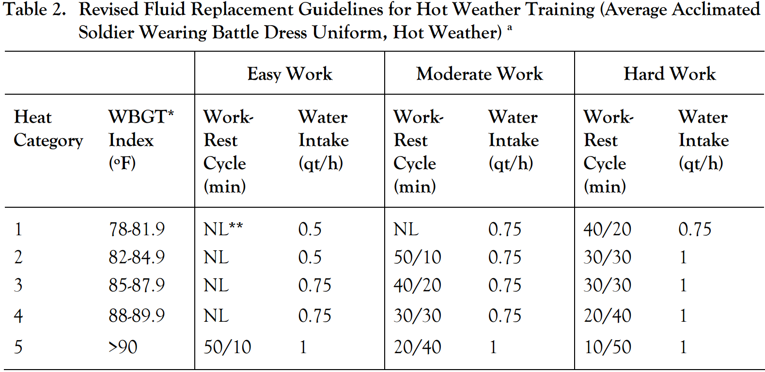

### Water losses measurements and calculations

Daily respiratory **water loss averages** about **250 to 350 mL/day** for **sedentary** persons,

but can increase to **500 to 600 mL/day** for **active persons living in temperate** climates at sea level

Ambient air temperature and humidity modify respiratory water losses. Breathing hot, dry air during intense physical exercise can increase respiratory water losses by **120 to 300 mL/day**

**Fluid loss at 1%** of body weight impairs thermoregulation and, **thirst occurs** at this level of dehydration[2]

1. "4 Water | Dietary Reference Intakes for Water, Potassium, Sodium ...." <https://www.nap.edu/read/10925/chapter/6>. Accessed 18 Apr. 2017.
2. "3. water requirements, impinging factors, and recommended intakes." <http://www.who.int/water_sanitation_health/dwq/nutrientschap3.pdf>. Accessed 19 Apr. 2017.