

**Fashion Shop SYStem**

**Software Requirement Specification**

– Hanoi, February 11–

Record of changeS

|  |  |  |  |
| --- | --- | --- | --- |
| Date | A* M, D | In charge | Change Description |
|  |  |  |  |
|  |  |  |  |
|  |  |  |  |
|  |  |  |  |
|  |  |  |  |
|  |  |  |  |
|  |  |  |  |
|  |  |  |  |
|  |  |  |  |
|  |  |  |  |
|  |  |  |  |

*A - Added M - Modified D - Deleted

**Table of Contents**

I. Overview 4

1. Introduction 4

2. System Functions 5

3. Entity Relationship Diagram 6

II. Functional Requirements 7

1. <<Feature Name 1>> 7

a. <<Function Name 1>> 7

b. <<Function Name 2>> 7

2. <<Feature Name 2>> 7

# I. Overview

## 1. Introduction

The Fashion Shop System is a web application that using for viewing, ordering and managing goods for User, Shop Manager. The System helps for user checking and ordering goods faster and more actively, manager for managing goods correctly beside real-shopping. Fashion Shop System has authorization system to identify user/manager for authorizing functions more security.

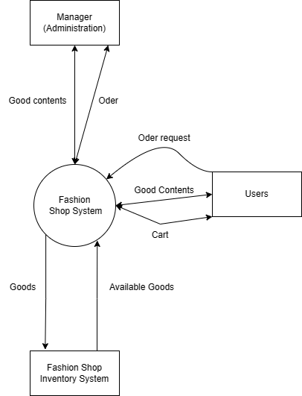

## 2. System Functions

#### a. Screen Flow

#### b. Screen Details

|  |  |  |  |
| --- | --- | --- | --- |
| **#** | **Feature** | **Screen** | **Description** |
| 1 | Home Page | Home Page | Appear newest/best sell items, product/shop marketing |
| 2 | Filter | Category Page(s) | Searching Product by filter |
| 3 | Product Detail | Product Detail | Appear details of product (can order if logged in) |
| 4 | Login | Login | Authorize functions for user (depends on role) |
| 5 | Manage goods | Manage-login | CRUD of product |
| 6 | Manage Order | Manage-login | List, update of order |
| 7 | Manage Agent | Manage-login | CRUD of Agent |
| 8 | Cart | User-login | CRUD of order |
| 9 | Payment | User-login | Execute payment for an order |

#### c. User Authorization

|  |  |  |
| --- | --- | --- |
| **Screen** | **Admin** | **User** |
| Manage-login |  |  |
| Manage Goods | X |  |
| Manage Order | X |  |
| Manage Agent | X |  |
| User-login |  |  |
| Cart |  | X |
| Payment |  | X |
| … |  |  |

## 3. Entity Relationship Diagram

*[Provide the entity relationship diagram and the entity descriptions in the table format as below]*

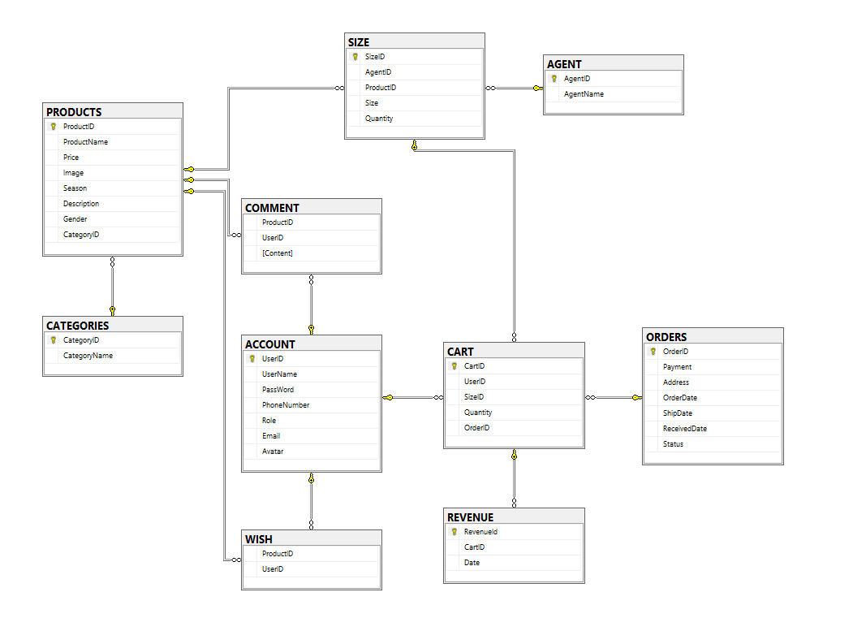

**Entities Description**

|  |  |  |
| --- | --- | --- |
| **#** | **Entity** | **Description** |
| 1 | Account | Account (for Authenticazing) |
| 2 | Wish | Wish list (Role User) |
| 3 | Comment | Comment (depends on account) |
| 4 | Cart | Cart (Role User) |
| 5 | Order | Order details |
| 6 |  |  |

# II. Functional Requirements

## 1. Homepage

### a. Homepage

* *Function trigger: Access to the Fashion Shop Home Page (or click to Home Page Logo of Navigation bar)*
* *Function description: The main selling page of system, providing newest products, best-selling products, categories.*
* *Role: Guest, customer*

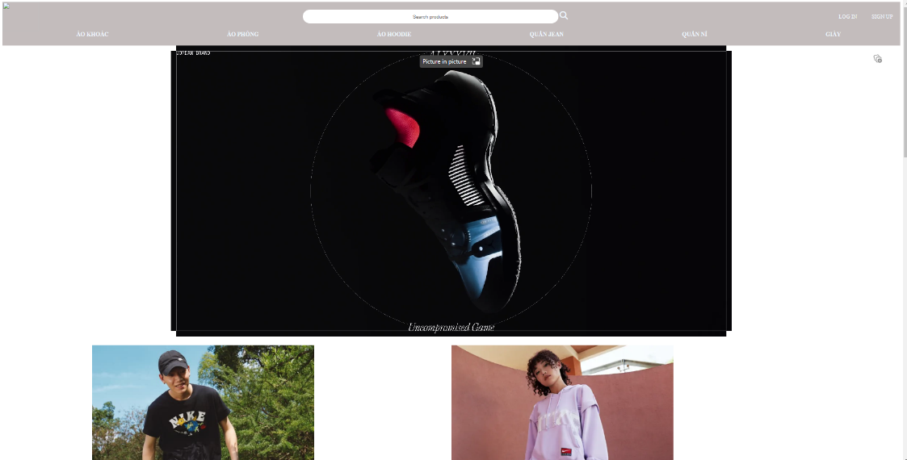

* *Function Details:*
* *Best-selling: get 4 products that have highest number of ordered (count quantity of order having this product)*
* *Newest products: get 4 newest products*
* *Category bars: get all products that having the selected category name (category names are in the Category table)*

### b. Category pages

* *Function trigger: Click on a category name in navigation bar.*
* *Function description: Providing all product of a category.*
* *Role: Guest, customer*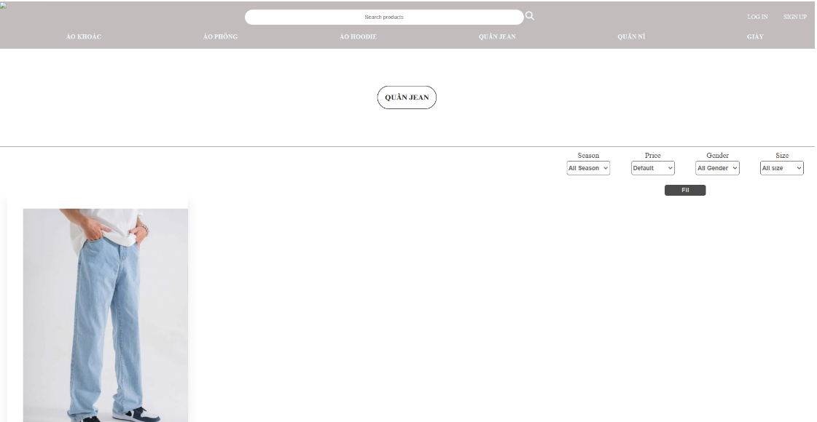
* *Function Details:*
* *Get all product in category by filters (Data get depends on Filters)*

## 2. <<Feature Name 2>>

…