# TabLayout

<https://www.androidhive.info/2015/09/android-material-design-working-with-tabs/>

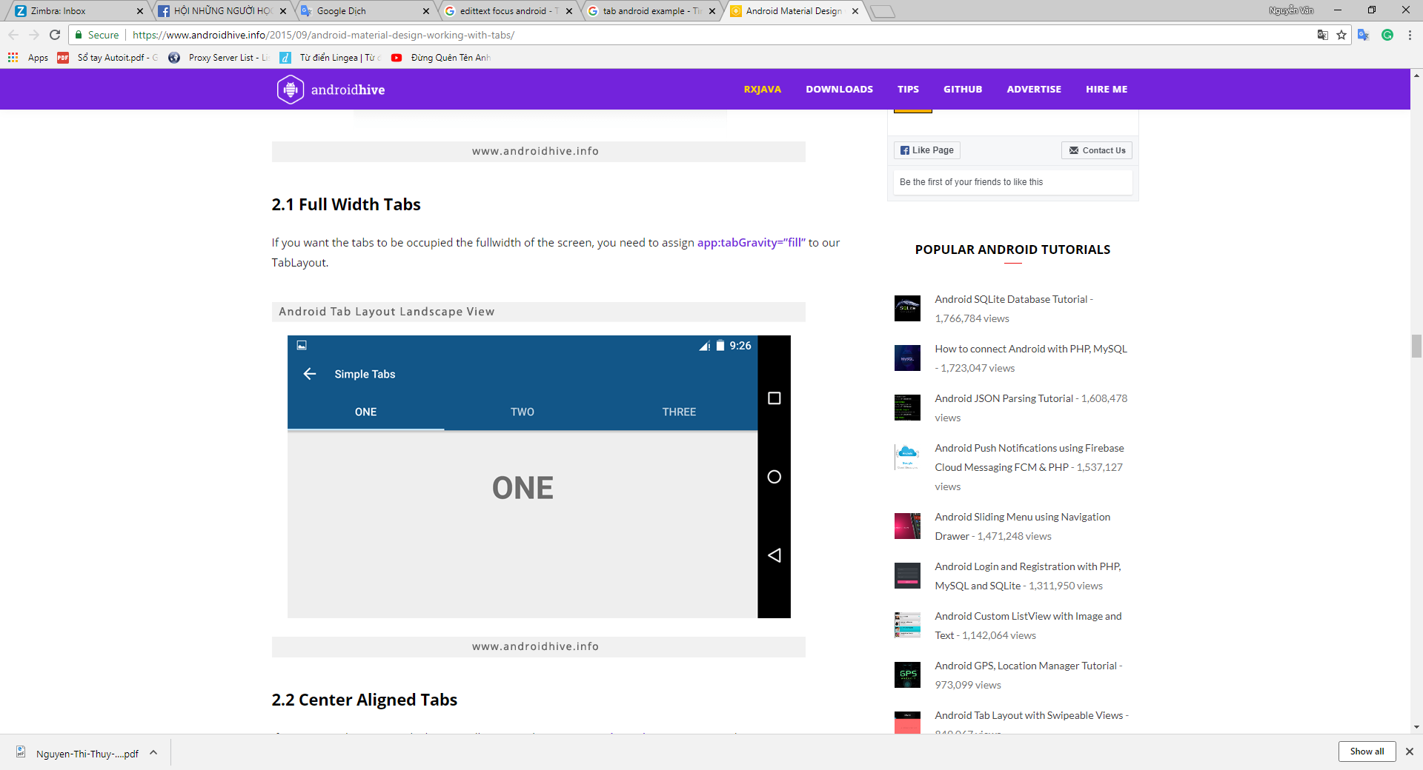

# Realm database

<https://realm.io/docs/java/latest#installation>

