**Đề tài:**  ***Quản lí nhà trẻ mẫu giáo***

**GVHD:**   *Hoàng Thị Mỹ Lệ*

**SVTH:**  *Nguyễn Trọng Khang*

**Lớp HP:** *220LTTQ01*

**Nhóm:** *11*

**Stt:** *11*

1. Form Design
2. HomePage-11-11

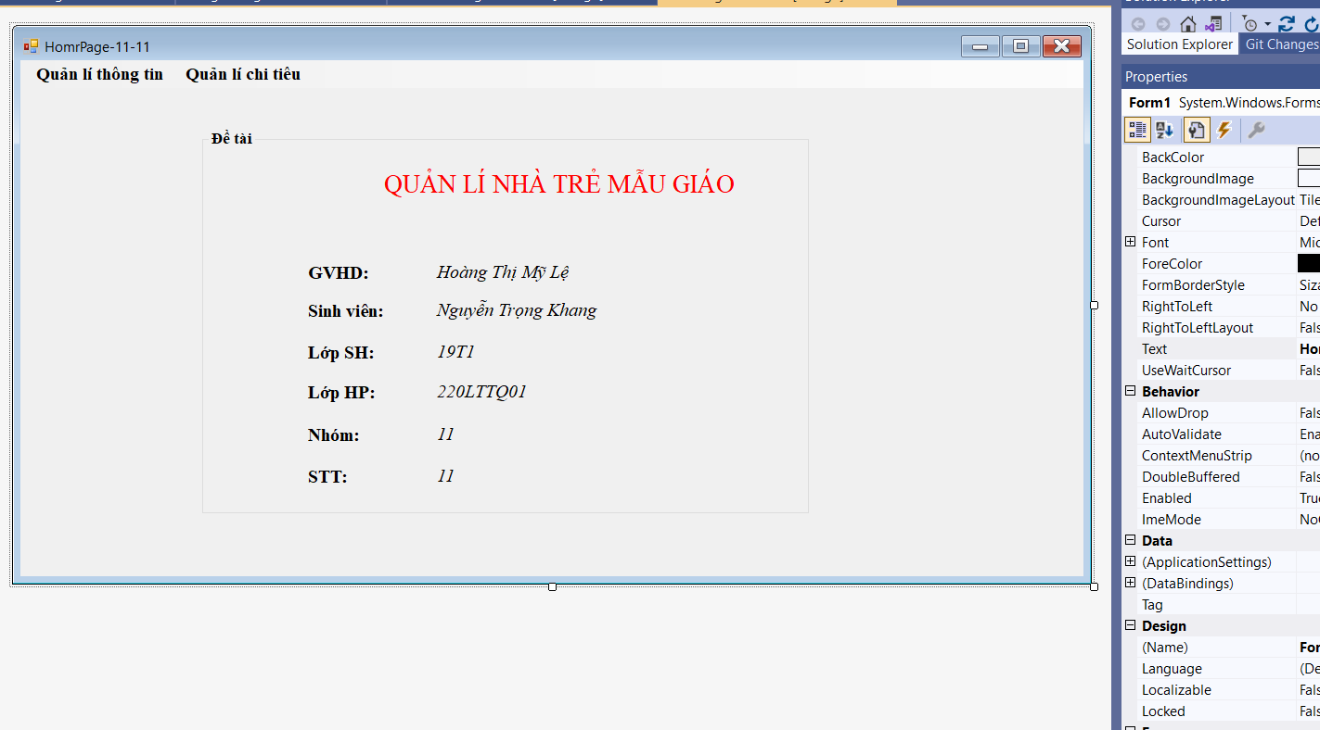

1. YoungManage-11-11

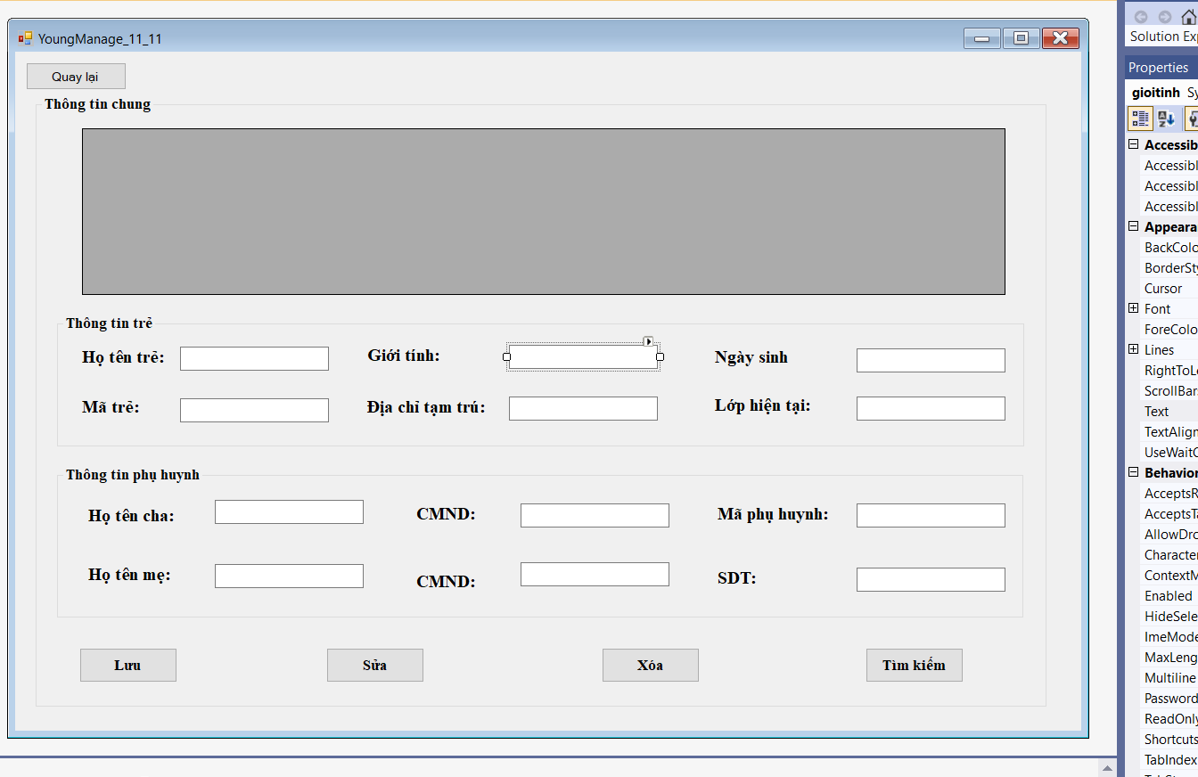

1. TeacherManage-11-11

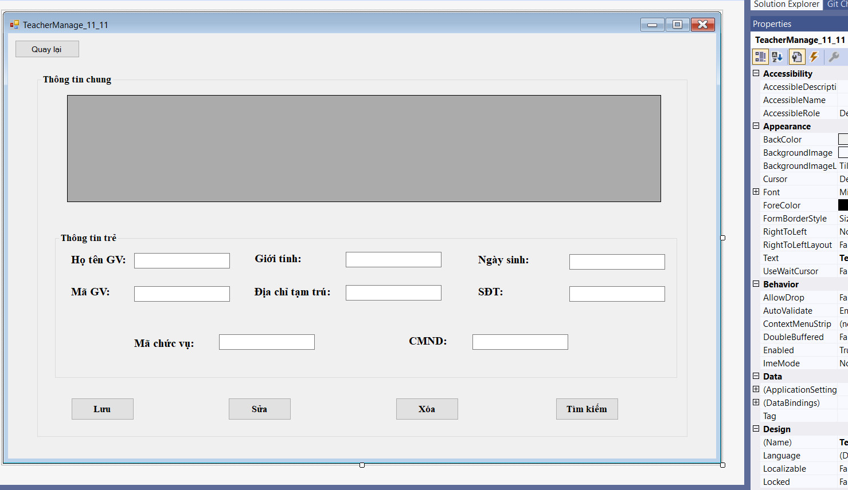

1. Form Code
2. HomePage

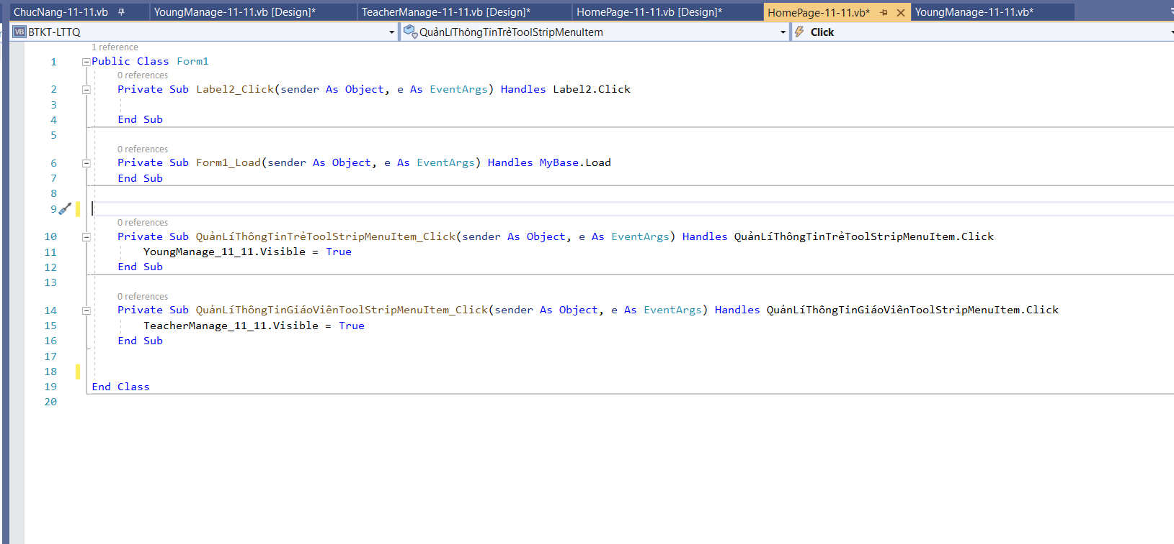

Code:

Public Class Form1

Private Sub Label2_Click(sender As Object, e As EventArgs) Handles Label2.Click

End Sub

Private Sub Form1_Load(sender As Object, e As EventArgs) Handles MyBase.Load

End Sub

Private Sub QuảnLíThôngTinTrẻToolStripMenuItem_Click(sender As Object, e As EventArgs) Handles QuảnLíThôngTinTrẻToolStripMenuItem.Click

YoungManage_11_11.Visible = True

End Sub

Private Sub QuảnLíThôngTinGiáoViênToolStripMenuItem_Click(sender As Object, e As EventArgs) Handles QuảnLíThôngTinGiáoViênToolStripMenuItem.Click

TeacherManage_11_11.Visible = True

End Sub

End Class

1. YoungManage
   1. Kết nối CSDL (SQL Sever)
      * Để kết nối với SQL Sever bằng ngôn ngữ VB.NET ta cần phải:

+ Khai báo thư viện: Imports System.Data.SqlClient

+ Khởi tạo phương thức kết nối:

* Tạo một biến để chứa đường dẫn kết nối
* Lấy đướng dẫn bằng cách:
  + - Chọn View ->  Chọn Sever Explorer ->  Chọn Connect to Database -> chọn Microsoft SQL Server (SqlClient) -> Nhập Sever Name ( Nếu bạn dùng SQL Sever Authentication thì nhập User Name và PassWord) -> chọn Database cần kết nối tới ( Chọn Test Connection để kiểm tra thử có thành công hay không ) -> Chọn Advance -> Coppy đường dẫn ở cuối hộp thoại.
* Khỏi tạo biến kết nối: Biến kết nối= new SqlConnection (Biến chưa đường dẫn)

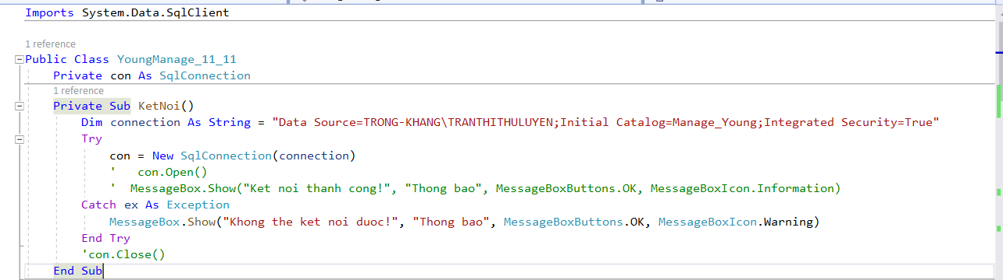

Code:

Imports System.Data.SqlClient

Public Class YoungManage_11_11

Private con As SqlConnection

Private Sub KetNoi()

Dim connection As String = "Data Source=TRONG-KHANG\TRANTHITHULUYEN;Initial Catalog=Manage_Young;Integrated Security=True"

Try

con = New SqlConnection(connection)

' con.Open()

' MessageBox.Show("Ket noi thanh cong!", "Thong bao", MessageBoxButtons.OK, MessageBoxIcon.Information)

Catch ex As Exception

MessageBox.Show("Khong the ket noi duoc!", "Thong bao", MessageBoxButtons.OK, MessageBoxIcon.Warning)

End Try

'con.Close()

End Sub

* 1. Code chức năng:

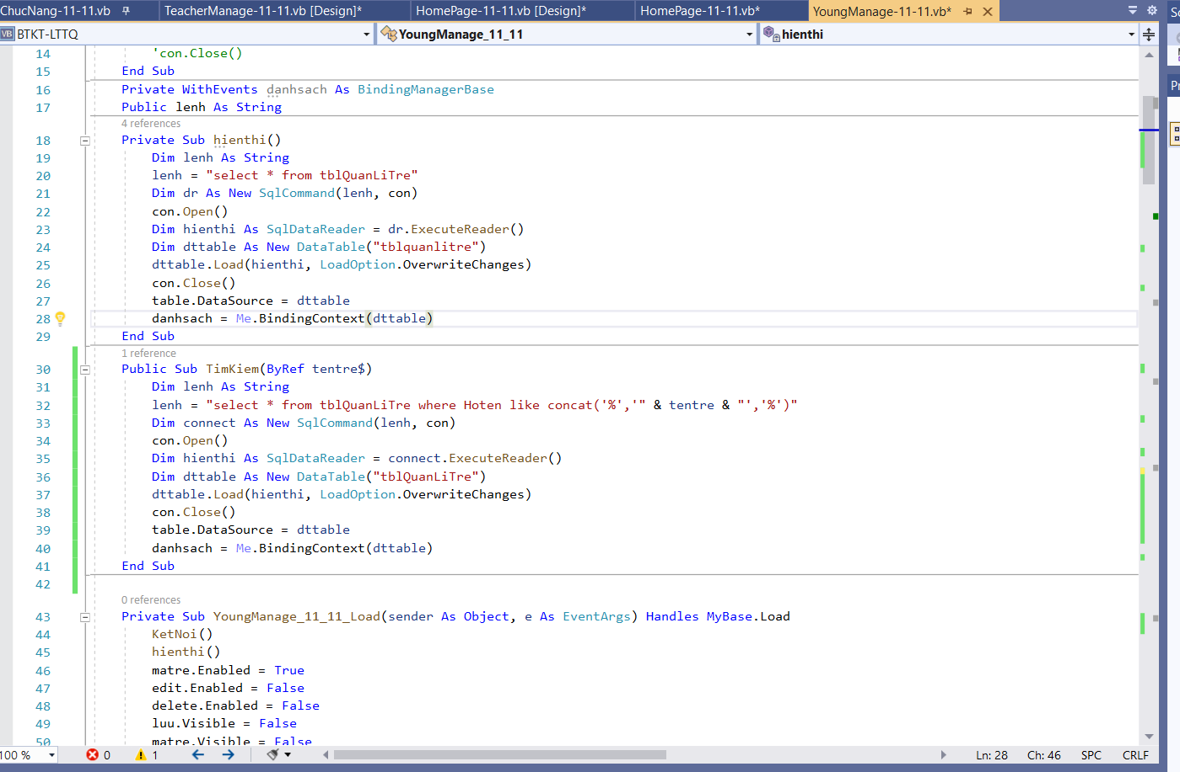

Code:

Private WithEvents danhsach As BindingManagerBase

Public lenh As String

Private Sub hienthi()

Dim lenh As String

lenh = "select * from tblQuanLiTre"

Dim dr As New SqlCommand(lenh, con)

con.Open()

Dim hienthi As SqlDataReader = dr.ExecuteReader()

Dim dttable As New DataTable("tblquanlitre")

dttable.Load(hienthi, LoadOption.OverwriteChanges)

con.Close()

table.DataSource = dttable

danhsach = Me.BindingContext(dttable)

End Sub

Public Sub TimKiem(ByRef tentre$)

Dim lenh As String

lenh = "select * from tblQuanLiTre where Hoten like concat('%','" & tentre & "','%')"

Dim connect As New SqlCommand(lenh, con)

con.Open()

Dim hienthi As SqlDataReader = connect.ExecuteReader()

Dim dttable As New DataTable("tblQuanLiTre")

dttable.Load(hienthi, LoadOption.OverwriteChanges)

con.Close()

table.DataSource = dttable

danhsach = Me.BindingContext(dttable)

End Sub

Private Sub YoungManage_11_11_Load(sender As Object, e As EventArgs) Handles MyBase.Load

KetNoi()

hienthi()

matre.Enabled = True

edit.Enabled = False

delete.Enabled = False

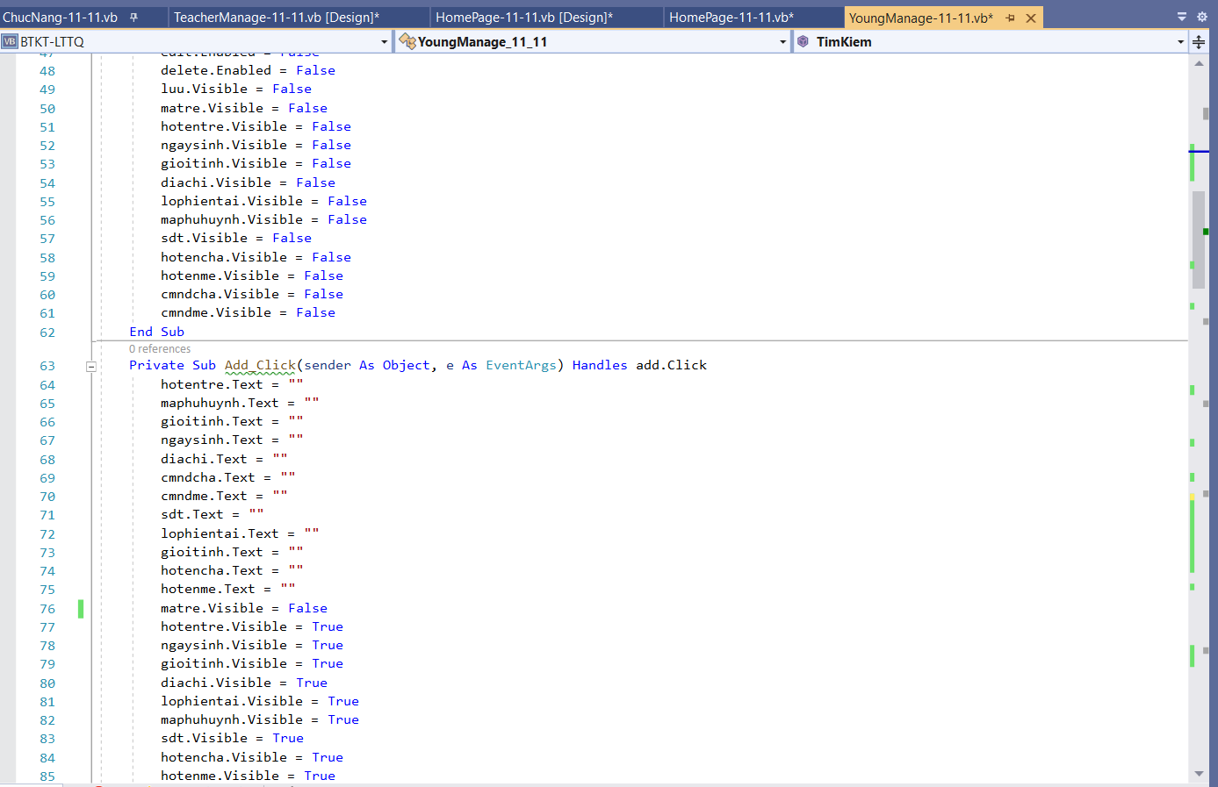

Code:

matre.Visible = False

hotentre.Visible = False

ngaysinh.Visible = False

gioitinh.Visible = False

diachi.Visible = False

lophientai.Visible = False

maphuhuynh.Visible = False

sdt.Visible = False

hotencha.Visible = False

hotenme.Visible = False

cmndcha.Visible = False

cmndme.Visible = False

End Sub

Private Sub Add_Click(sender As Object, e As EventArgs) Handles add.Click

hotentre.Text = ""

maphuhuynh.Text = ""

gioitinh.Text = ""

ngaysinh.Text = ""

diachi.Text = ""

cmndcha.Text = ""

cmndme.Text = ""

sdt.Text = ""

lophientai.Text = ""

gioitinh.Text = ""

hotencha.Text = ""

hotenme.Text = ""

matre.Visible = False

hotentre.Visible = True

ngaysinh.Visible = True

gioitinh.Visible = True

diachi.Visible = True

lophientai.Visible = True

maphuhuynh.Visible = True

sdt.Visible = True

hotencha.Visible = True

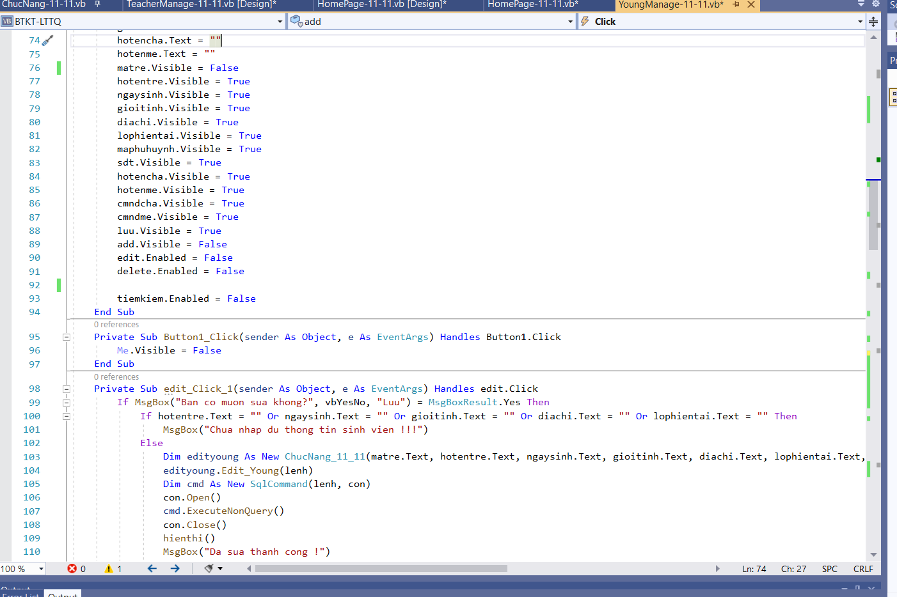

Code:

hotenme.Text = ""

matre.Visible = False

hotentre.Visible = True

ngaysinh.Visible = True

gioitinh.Visible = True

diachi.Visible = True

lophientai.Visible = True

maphuhuynh.Visible = True

sdt.Visible = True

hotencha.Visible = True

hotenme.Visible = True

cmndcha.Visible = True

cmndme.Visible = True

luu.Visible = True

add.Visible = False

edit.Enabled = False

delete.Enabled = False

tiemkiem.Enabled = False

End Sub

Private Sub Button1_Click(sender As Object, e As EventArgs) Handles Button1.Click

Me.Visible = False

End Sub

Private Sub edit_Click_1(sender As Object, e As EventArgs) Handles edit.Click

If MsgBox("Ban co muon sua khong?", vbYesNo, "Luu") = MsgBoxResult.Yes Then

If hotentre.Text = "" Or ngaysinh.Text = "" Or gioitinh.Text = "" Or diachi.Text = "" Or lophientai.Text = "" Then

MsgBox("Chua nhap du thong tin sinh vien !!!")

Else

Dim edityoung As New ChucNang_11_11(matre.Text, hotentre.Text, ngaysinh.Text, gioitinh.Text, diachi.Text, lophientai.Text, maphuhuynh.Text, sdt.Text, hotencha.Text, hotenme.Text, cmndcha.Text, cmndme.Text)

edityoung.Edit_Young(lenh)

Dim cmd As New SqlCommand(lenh, con)

con.Open()

cmd.ExecuteNonQuery()

con.Close()

hienthi()

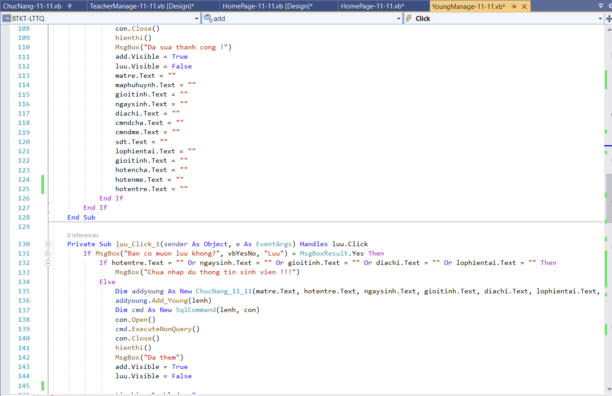

Code:

MsgBox("Da sua thanh cong !")

add.Visible = True

luu.Visible = False

matre.Text = ""

maphuhuynh.Text = ""

gioitinh.Text = ""

ngaysinh.Text = ""

diachi.Text = ""

cmndcha.Text = ""

cmndme.Text = ""

sdt.Text = ""

lophientai.Text = ""

gioitinh.Text = ""

hotencha.Text = ""

hotenme.Text = ""

hotentre.Text = ""

End If

End If

End Sub

Private Sub luu_Click_1(sender As Object, e As EventArgs) Handles luu.Click

If MsgBox("Ban co muon luu khong?", vbYesNo, "Luu") = MsgBoxResult.Yes Then

If hotentre.Text = "" Or ngaysinh.Text = "" Or gioitinh.Text = "" Or diachi.Text = "" Or lophientai.Text = "" Then

MsgBox("Chua nhap du thong tin sinh vien !!!")

Else

Dim addyoung As New ChucNang_11_11(matre.Text, hotentre.Text, ngaysinh.Text, gioitinh.Text, diachi.Text, lophientai.Text, maphuhuynh.Text, sdt.Text, hotencha.Text, hotenme.Text, cmndcha.Text, cmndme.Text)

addyoung.Add_Young(lenh)

Dim cmd As New SqlCommand(lenh, con)

con.Open()

cmd.ExecuteNonQuery()

con.Close()

hienthi()

MsgBox("Da them")

add.Visible = True

luu.Visible = False

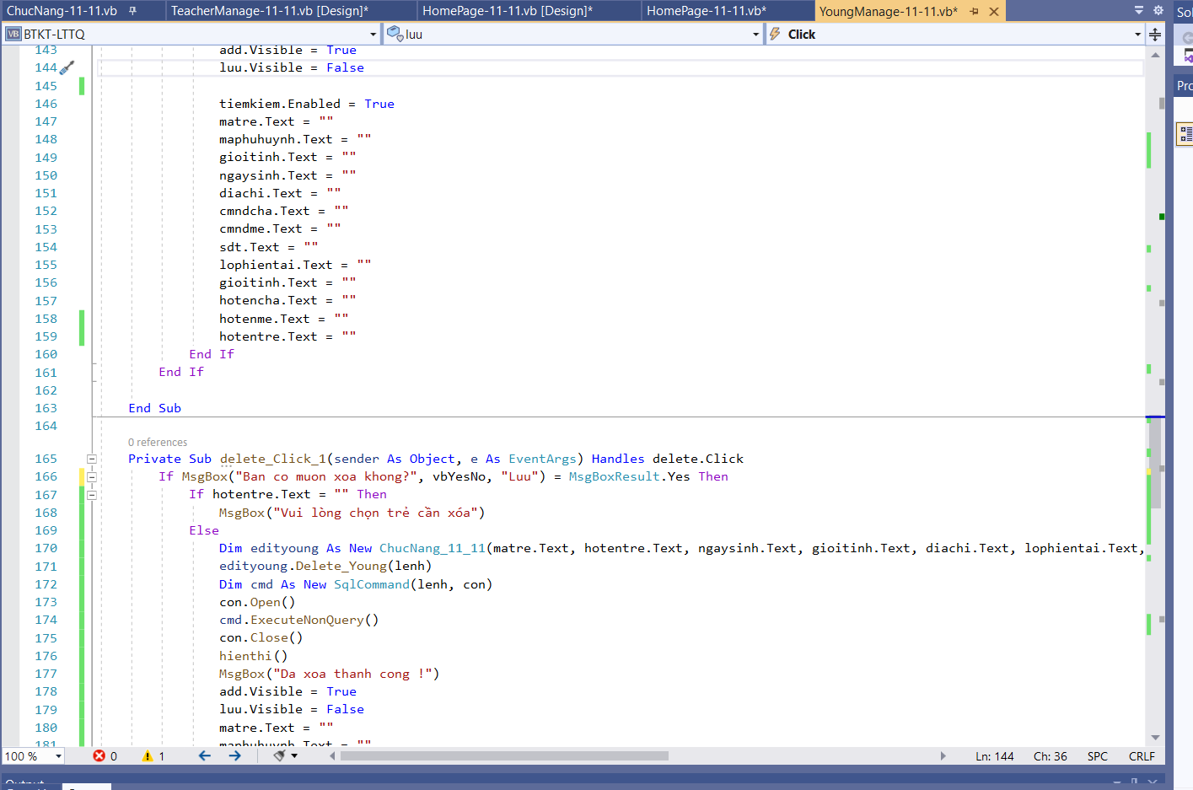

Code:

tiemkiem.Enabled = True

matre.Text = ""

maphuhuynh.Text = ""

gioitinh.Text = ""

ngaysinh.Text = ""

diachi.Text = ""

cmndcha.Text = ""

cmndme.Text = ""

sdt.Text = ""

lophientai.Text = ""

gioitinh.Text = ""

hotencha.Text = ""

hotenme.Text = ""

hotentre.Text = ""

End If

End If

End Sub

Private Sub delete_Click_1(sender As Object, e As EventArgs) Handles delete.Click

If MsgBox("Ban co muon xoa khong?", vbYesNo, "Luu") = MsgBoxResult.Yes Then

If hotentre.Text = "" Then

MsgBox("Vui lòng chọn trẻ cần xóa")

Else

Dim edityoung As New ChucNang_11_11(matre.Text, hotentre.Text, ngaysinh.Text, gioitinh.Text, diachi.Text, lophientai.Text, maphuhuynh.Text, sdt.Text, hotencha.Text, hotenme.Text, cmndcha.Text, cmndme.Text)

edityoung.Delete_Young(lenh)

Dim cmd As New SqlCommand(lenh, con)

con.Open()

cmd.ExecuteNonQuery()

con.Close()

hienthi()

MsgBox("Da xoa thanh cong !")

add.Visible = True

luu.Visible = False

matre.Text = ""

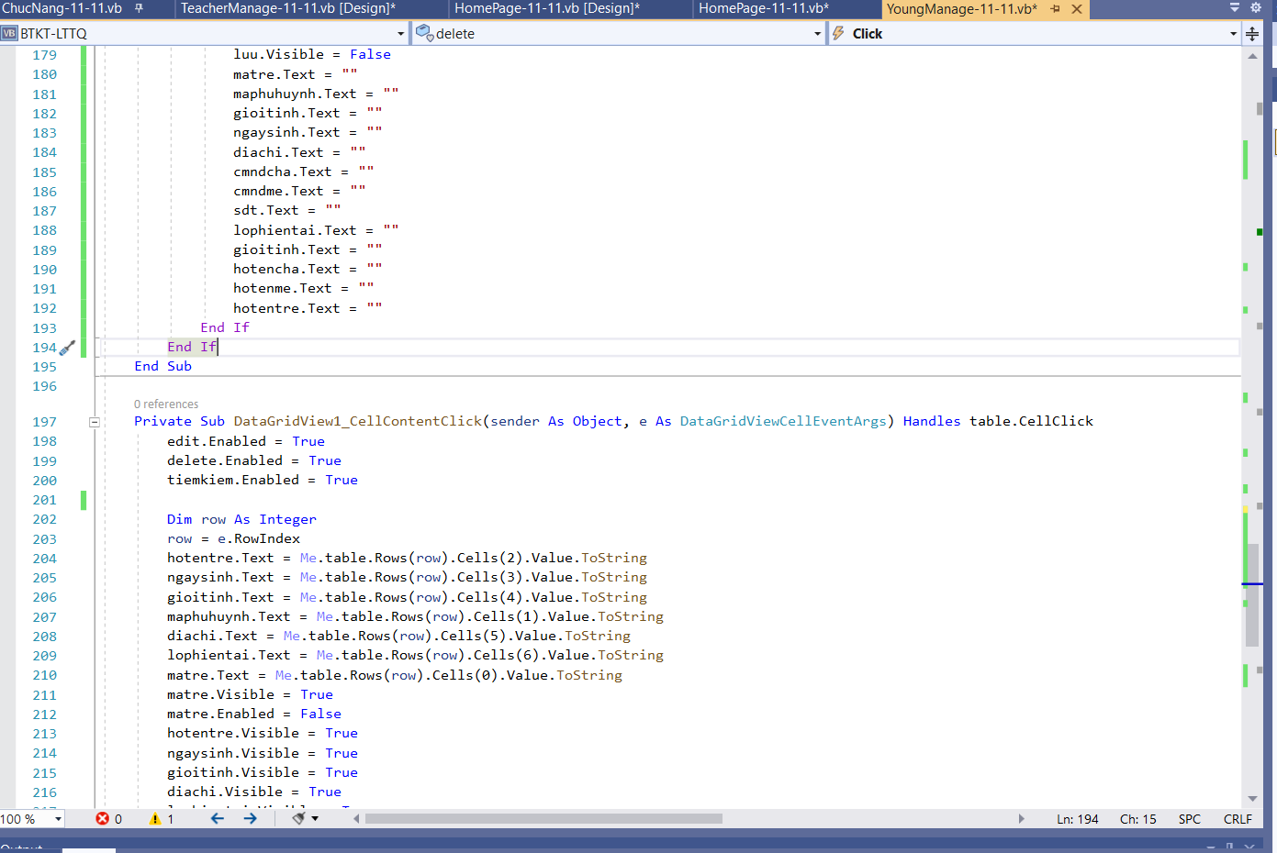

Code:

maphuhuynh.Text = ""

gioitinh.Text = ""

ngaysinh.Text = ""

diachi.Text = ""

cmndcha.Text = ""

cmndme.Text = ""

sdt.Text = ""

lophientai.Text = ""

gioitinh.Text = ""

hotencha.Text = ""

hotenme.Text = ""

hotentre.Text = ""

End If

End If

End Sub

Private Sub DataGridView1_CellContentClick(sender As Object, e As DataGridViewCellEventArgs) Handles table.CellClick

edit.Enabled = True

delete.Enabled = True

tiemkiem.Enabled = True

Dim row As Integer

row = e.RowIndex

hotentre.Text = Me.table.Rows(row).Cells(2).Value.ToString

ngaysinh.Text = Me.table.Rows(row).Cells(3).Value.ToString

gioitinh.Text = Me.table.Rows(row).Cells(4).Value.ToString

maphuhuynh.Text = Me.table.Rows(row).Cells(1).Value.ToString

diachi.Text = Me.table.Rows(row).Cells(5).Value.ToString

lophientai.Text = Me.table.Rows(row).Cells(6).Value.ToString

matre.Text = Me.table.Rows(row).Cells(0).Value.ToString

matre.Visible = True

matre.Enabled = False

hotentre.Visible = True

ngaysinh.Visible = True

gioitinh.Visible = True

diachi.Visible = True

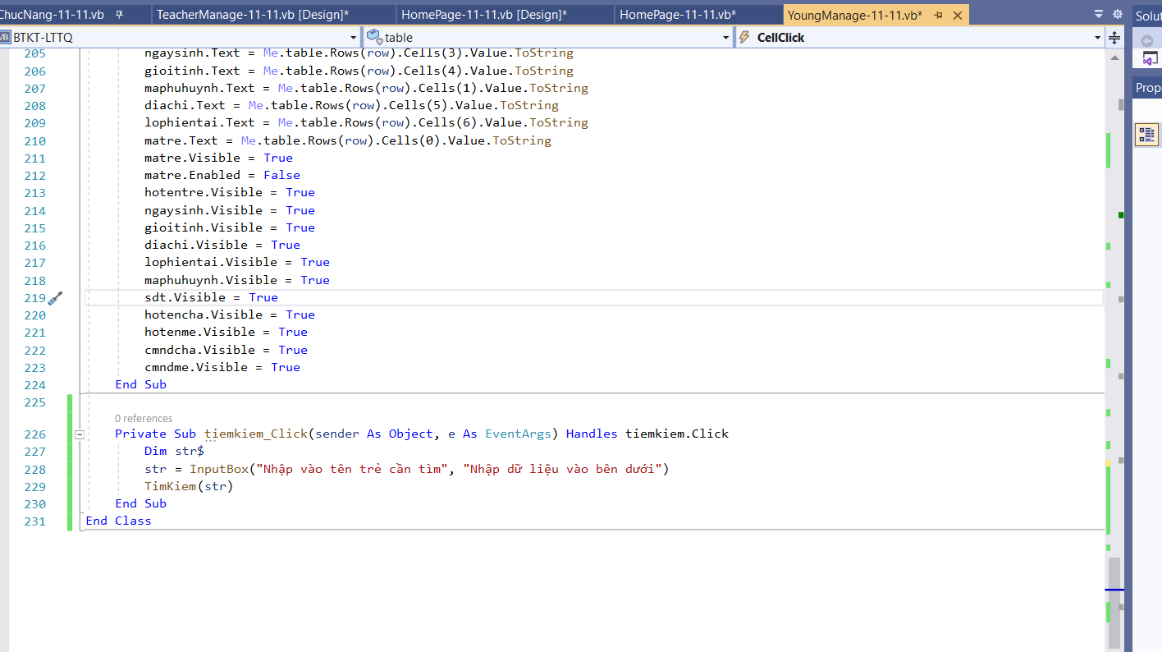

Code:

lophientai.Visible = True

maphuhuynh.Visible = True

sdt.Visible = True

hotencha.Visible = True

hotenme.Visible = True

cmndcha.Visible = True

cmndme.Visible = True

End Sub

Private Sub tiemkiem_Click(sender As Object, e As EventArgs) Handles tiemkiem.Click

Dim str$

str = InputBox("Nhập vào tên trẻ cần tìm", "Nhập dữ liệu vào bên dưới")

TimKiem(str)

End Sub

End Class

**Full code:**

Imports System.Data.SqlClient

Public Class YoungManage_11_11

Private con As SqlConnection

Private Sub KetNoi()

Dim connection As String = "Data Source=TRONG-KHANG\TRANTHITHULUYEN;Initial Catalog=Manage_Young;Integrated Security=True"

Try

con = New SqlConnection(connection)

' con.Open()

' MessageBox.Show("Ket noi thanh cong!", "Thong bao", MessageBoxButtons.OK, MessageBoxIcon.Information)

Catch ex As Exception

MessageBox.Show("Khong the ket noi duoc!", "Thong bao", MessageBoxButtons.OK, MessageBoxIcon.Warning)

End Try

'con.Close()

End Sub

Private WithEvents danhsach As BindingManagerBase

Public lenh As String

Private Sub hienthi()

Dim lenh As String

lenh = "select * from tblQuanLiTre"

Dim dr As New SqlCommand(lenh, con)

con.Open()

Dim hienthi As SqlDataReader = dr.ExecuteReader()

Dim dttable As New DataTable("tblquanlitre")

dttable.Load(hienthi, LoadOption.OverwriteChanges)

con.Close()

table.DataSource = dttable

danhsach = Me.BindingContext(dttable)

End Sub

Public Sub TimKiem(ByRef tentre$)

Dim lenh As String

lenh = "select * from tblQuanLiTre where Hoten like concat('%','" & tentre & "','%')"

Dim connect As New SqlCommand(lenh, con)

con.Open()

Dim hienthi As SqlDataReader = connect.ExecuteReader()

Dim dttable As New DataTable("tblQuanLiTre")

dttable.Load(hienthi, LoadOption.OverwriteChanges)

con.Close()

table.DataSource = dttable

danhsach = Me.BindingContext(dttable)

End Sub

Private Sub YoungManage_11_11_Load(sender As Object, e As EventArgs) Handles MyBase.Load

KetNoi()

hienthi()

matre.Enabled = True

edit.Enabled = False

delete.Enabled = False

luu.Visible = False

matre.Visible = False

hotentre.Visible = False

ngaysinh.Visible = False

gioitinh.Visible = False

diachi.Visible = False

lophientai.Visible = False

maphuhuynh.Visible = False

sdt.Visible = False

hotencha.Visible = False

hotenme.Visible = False

cmndcha.Visible = False

cmndme.Visible = False

End Sub

Private Sub Add_Click(sender As Object, e As EventArgs) Handles add.Click

hotentre.Text = ""

maphuhuynh.Text = ""

gioitinh.Text = ""

ngaysinh.Text = ""

diachi.Text = ""

cmndcha.Text = ""

cmndme.Text = ""

sdt.Text = ""

lophientai.Text = ""

gioitinh.Text = ""

hotencha.Text = ""

hotenme.Text = ""

matre.Visible = False

hotentre.Visible = True

ngaysinh.Visible = True

gioitinh.Visible = True

diachi.Visible = True

lophientai.Visible = True

maphuhuynh.Visible = True

sdt.Visible = True

hotencha.Visible = True

hotenme.Visible = True

cmndcha.Visible = True

cmndme.Visible = True

luu.Visible = True

add.Visible = False

edit.Enabled = False

delete.Enabled = False

tiemkiem.Enabled = False

End Sub

Private Sub Button1_Click(sender As Object, e As EventArgs) Handles Button1.Click

Me.Visible = False

End Sub

Private Sub edit_Click_1(sender As Object, e As EventArgs) Handles edit.Click

If MsgBox("Ban co muon sua khong?", vbYesNo, "Luu") = MsgBoxResult.Yes Then

If hotentre.Text = "" Or ngaysinh.Text = "" Or gioitinh.Text = "" Or diachi.Text = "" Or lophientai.Text = "" Then

MsgBox("Chua nhap du thong tin sinh vien !!!")

Else

Dim edityoung As New ChucNang_11_11(matre.Text, hotentre.Text, ngaysinh.Text, gioitinh.Text, diachi.Text, lophientai.Text, maphuhuynh.Text, sdt.Text, hotencha.Text, hotenme.Text, cmndcha.Text, cmndme.Text)

edityoung.Edit_Young(lenh)

Dim cmd As New SqlCommand(lenh, con)

con.Open()

cmd.ExecuteNonQuery()

con.Close()

hienthi()

MsgBox("Da sua thanh cong !")

add.Visible = True

luu.Visible = False

matre.Text = ""

maphuhuynh.Text = ""

gioitinh.Text = ""

ngaysinh.Text = ""

diachi.Text = ""

cmndcha.Text = ""

cmndme.Text = ""

sdt.Text = ""

lophientai.Text = ""

gioitinh.Text = ""

hotencha.Text = ""

hotenme.Text = ""

hotentre.Text = ""

End If

End If

End Sub

Private Sub luu_Click_1(sender As Object, e As EventArgs) Handles luu.Click

If MsgBox("Ban co muon luu khong?", vbYesNo, "Luu") = MsgBoxResult.Yes Then

If hotentre.Text = "" Or ngaysinh.Text = "" Or gioitinh.Text = "" Or diachi.Text = "" Or lophientai.Text = "" Then

MsgBox("Chua nhap du thong tin sinh vien !!!")

Else

Dim addyoung As New ChucNang_11_11(matre.Text, hotentre.Text, ngaysinh.Text, gioitinh.Text, diachi.Text, lophientai.Text, maphuhuynh.Text, sdt.Text, hotencha.Text, hotenme.Text, cmndcha.Text, cmndme.Text)

addyoung.Add_Young(lenh)

Dim cmd As New SqlCommand(lenh, con)

con.Open()

cmd.ExecuteNonQuery()

con.Close()

hienthi()

MsgBox("Da them")

add.Visible = True

luu.Visible = False

tiemkiem.Enabled = True

matre.Text = ""

maphuhuynh.Text = ""

gioitinh.Text = ""

ngaysinh.Text = ""

diachi.Text = ""

cmndcha.Text = ""

cmndme.Text = ""

sdt.Text = ""

lophientai.Text = ""

gioitinh.Text = ""

hotencha.Text = ""

hotenme.Text = ""

hotentre.Text = ""

End If

End If

End Sub

Private Sub delete_Click_1(sender As Object, e As EventArgs) Handles delete.Click

If MsgBox("Ban co muon xoa khong?", vbYesNo, "Luu") = MsgBoxResult.Yes Then

If hotentre.Text = "" Then

MsgBox("Vui lòng chọn trẻ cần xóa")

Else

Dim edityoung As New ChucNang_11_11(matre.Text, hotentre.Text, ngaysinh.Text, gioitinh.Text, diachi.Text, lophientai.Text, maphuhuynh.Text, sdt.Text, hotencha.Text, hotenme.Text, cmndcha.Text, cmndme.Text)

edityoung.Delete_Young(lenh)

Dim cmd As New SqlCommand(lenh, con)

con.Open()

cmd.ExecuteNonQuery()

con.Close()

hienthi()

MsgBox("Da xoa thanh cong !")

add.Visible = True

luu.Visible = False

matre.Text = ""

maphuhuynh.Text = ""

gioitinh.Text = ""

ngaysinh.Text = ""

diachi.Text = ""

cmndcha.Text = ""

cmndme.Text = ""

sdt.Text = ""

lophientai.Text = ""

gioitinh.Text = ""

hotencha.Text = ""

hotenme.Text = ""

hotentre.Text = ""

End If

End If

End Sub

Private Sub DataGridView1_CellContentClick(sender As Object, e As DataGridViewCellEventArgs) Handles table.CellClick

edit.Enabled = True

delete.Enabled = True

tiemkiem.Enabled = True

Dim row As Integer

row = e.RowIndex

hotentre.Text = Me.table.Rows(row).Cells(2).Value.ToString

ngaysinh.Text = Me.table.Rows(row).Cells(3).Value.ToString

gioitinh.Text = Me.table.Rows(row).Cells(4).Value.ToString

maphuhuynh.Text = Me.table.Rows(row).Cells(1).Value.ToString

diachi.Text = Me.table.Rows(row).Cells(5).Value.ToString

lophientai.Text = Me.table.Rows(row).Cells(6).Value.ToString

matre.Text = Me.table.Rows(row).Cells(0).Value.ToString

matre.Visible = True

matre.Enabled = False

hotentre.Visible = True

ngaysinh.Visible = True

gioitinh.Visible = True

diachi.Visible = True

lophientai.Visible = True

maphuhuynh.Visible = True

sdt.Visible = True

hotencha.Visible = True

hotenme.Visible = True

cmndcha.Visible = True

cmndme.Visible = True

End Sub

Private Sub tiemkiem_Click(sender As Object, e As EventArgs) Handles tiemkiem.Click

Dim str$

str = InputBox("Nhập vào tên trẻ cần tìm", "Nhập dữ liệu vào bên dưới")

TimKiem(str)

End Sub

End Class

1. TeacherManage
   * + Kết nối CSDL và chức năng tương tự nhau:

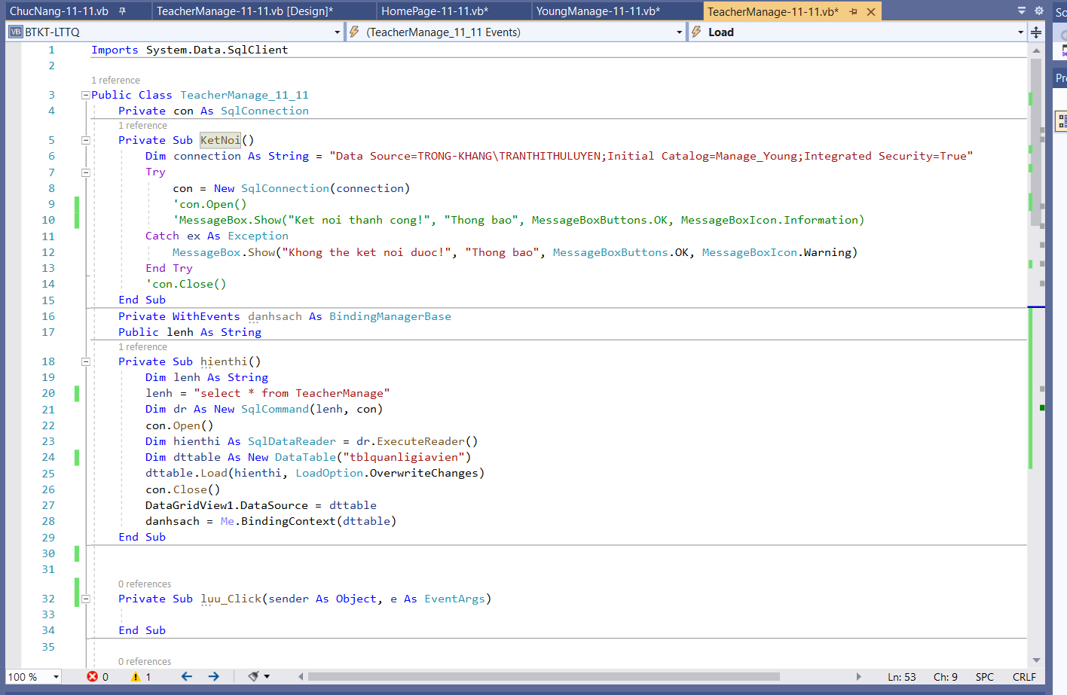

Code:

Imports System.Data.SqlClient

Public Class TeacherManage_11_11

Private con As SqlConnection

Private Sub KetNoi()

Dim connection As String = "Data Source=TRONG-KHANG\TRANTHITHULUYEN;Initial Catalog=Manage_Young;Integrated Security=True"

Try

con = New SqlConnection(connection)

'con.Open()

'MessageBox.Show("Ket noi thanh cong!", "Thong bao", MessageBoxButtons.OK, MessageBoxIcon.Information)

Catch ex As Exception

MessageBox.Show("Khong the ket noi duoc!", "Thong bao", MessageBoxButtons.OK, MessageBoxIcon.Warning)

End Try

'con.Close()

End Sub

Private WithEvents danhsach As BindingManagerBase

Public lenh As String

Private Sub hienthi()

Dim lenh As String

lenh = "select * from TeacherManage"

Dim dr As New SqlCommand(lenh, con)

con.Open()

Dim hienthi As SqlDataReader = dr.ExecuteReader()

Dim dttable As New DataTable("tblquanligiavien")

dttable.Load(hienthi, LoadOption.OverwriteChanges)

con.Close()

DataGridView1.DataSource = dttable

danhsach = Me.BindingContext(dttable)

End Sub

Private Sub luu_Click(sender As Object, e As EventArgs)

End Sub

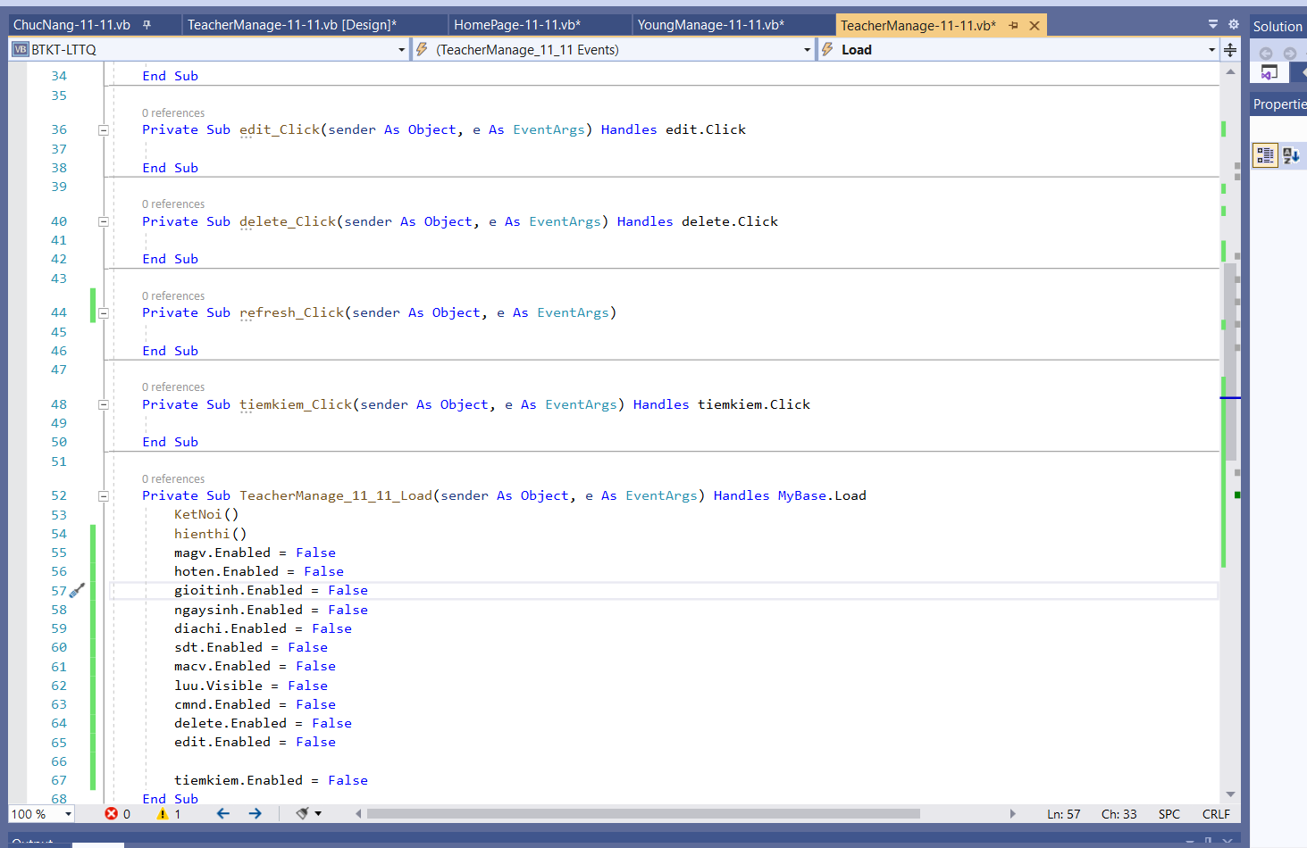

Code:

Private Sub edit_Click(sender As Object, e As EventArgs) Handles edit.Click

End Sub

Private Sub delete_Click(sender As Object, e As EventArgs) Handles delete.Click

End Sub

Private Sub refresh_Click(sender As Object, e As EventArgs)

End Sub

Private Sub tiemkiem_Click(sender As Object, e As EventArgs) Handles tiemkiem.Click

End Sub

Private Sub TeacherManage_11_11_Load(sender As Object, e As EventArgs) Handles MyBase.Load

KetNoi()

hienthi()

magv.Enabled = False

hoten.Enabled = False

gioitinh.Enabled = False

ngaysinh.Enabled = False

diachi.Enabled = False

sdt.Enabled = False

macv.Enabled = False

luu.Visible = False

cmnd.Enabled = False

delete.Enabled = False

edit.Enabled = False

tiemkiem.Enabled = False

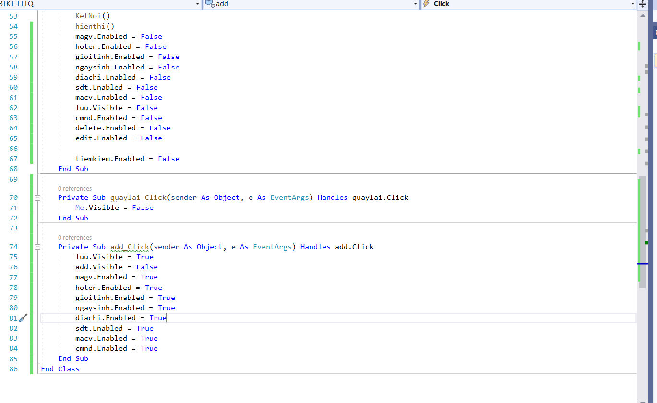

Code:

End Sub

Private Sub quaylai_Click(sender As Object, e As EventArgs) Handles quaylai.Click

Me.Visible = False

End Sub

Private Sub add_Click(sender As Object, e As EventArgs) Handles add.Click

luu.Visible = True

add.Visible = False

magv.Enabled = True

hoten.Enabled = True

gioitinh.Enabled = True

ngaysinh.Enabled = True

diachi.Enabled = True

sdt.Enabled = True

macv.Enabled = True

cmnd.Enabled = True

End Sub

End Class

**Full code**

Imports System.Data.SqlClient

Public Class TeacherManage_11_11

Private con As SqlConnection

Private Sub KetNoi()

Dim connection As String = "Data Source=TRONG-KHANG\TRANTHITHULUYEN;Initial Catalog=Manage_Young;Integrated Security=True"

Try

con = New SqlConnection(connection)

'con.Open()

'MessageBox.Show("Ket noi thanh cong!", "Thong bao", MessageBoxButtons.OK, MessageBoxIcon.Information)

Catch ex As Exception

MessageBox.Show("Khong the ket noi duoc!", "Thong bao", MessageBoxButtons.OK, MessageBoxIcon.Warning)

End Try

'con.Close()

End Sub

Private WithEvents danhsach As BindingManagerBase

Public lenh As String

Private Sub hienthi()

Dim lenh As String

lenh = "select * from TeacherManage"

Dim dr As New SqlCommand(lenh, con)

con.Open()

Dim hienthi As SqlDataReader = dr.ExecuteReader()

Dim dttable As New DataTable("tblquanligiavien")

dttable.Load(hienthi, LoadOption.OverwriteChanges)

con.Close()

DataGridView1.DataSource = dttable

danhsach = Me.BindingContext(dttable)

End Sub

Private Sub luu_Click(sender As Object, e As EventArgs)

End Sub

Private Sub edit_Click(sender As Object, e As EventArgs) Handles edit.Click

End Sub

Private Sub delete_Click(sender As Object, e As EventArgs) Handles delete.Click

End Sub

Private Sub refresh_Click(sender As Object, e As EventArgs)

End Sub

Private Sub tiemkiem_Click(sender As Object, e As EventArgs) Handles tiemkiem.Click

End Sub

Private Sub TeacherManage_11_11_Load(sender As Object, e As EventArgs) Handles MyBase.Load

KetNoi()

hienthi()

magv.Enabled = False

hoten.Enabled = False

gioitinh.Enabled = False

ngaysinh.Enabled = False

diachi.Enabled = False

sdt.Enabled = False

macv.Enabled = False

luu.Visible = False

cmnd.Enabled = False

delete.Enabled = False

edit.Enabled = False

tiemkiem.Enabled = False

End Sub

Private Sub quaylai_Click(sender As Object, e As EventArgs) Handles quaylai.Click

Me.Visible = False

End Sub

Private Sub add_Click(sender As Object, e As EventArgs) Handles add.Click

luu.Visible = True

add.Visible = False

magv.Enabled = True

hoten.Enabled = True

gioitinh.Enabled = True

ngaysinh.Enabled = True

diachi.Enabled = True

sdt.Enabled = True

macv.Enabled = True

cmnd.Enabled = True

End Sub

End Class

1. Class chức năng insert/delete/update

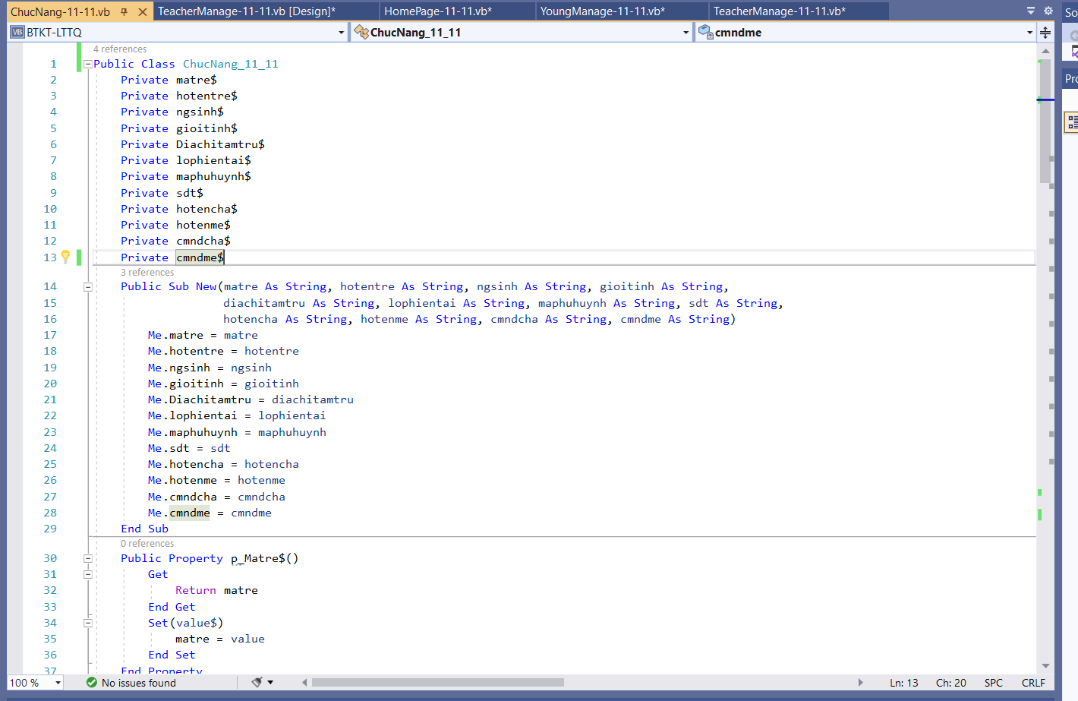

Code:

Public Class ChucNang_11_11

Private matre$

Private hotentre$

Private ngsinh$

Private gioitinh$

Private Diachitamtru$

Private lophientai$

Private maphuhuynh$

Private sdt$

Private hotencha$

Private hotenme$

Private cmndcha$

Private cmndme$

Public Sub New(matre As String, hotentre As String, ngsinh As String, gioitinh As String,

diachitamtru As String, lophientai As String, maphuhuynh As String, sdt As String,

hotencha As String, hotenme As String, cmndcha As String, cmndme As String)

Me.matre = matre

Me.hotentre = hotentre

Me.ngsinh = ngsinh

Me.gioitinh = gioitinh

Me.Diachitamtru = diachitamtru

Me.lophientai = lophientai

Me.maphuhuynh = maphuhuynh

Me.sdt = sdt

Me.hotencha = hotencha

Me.hotenme = hotenme

Me.cmndcha = cmndcha

Me.cmndme = cmndme

End Sub

Public Property p_Matre$()

Get

Return matre

End Get

Set(value$)

matre = value

End Set

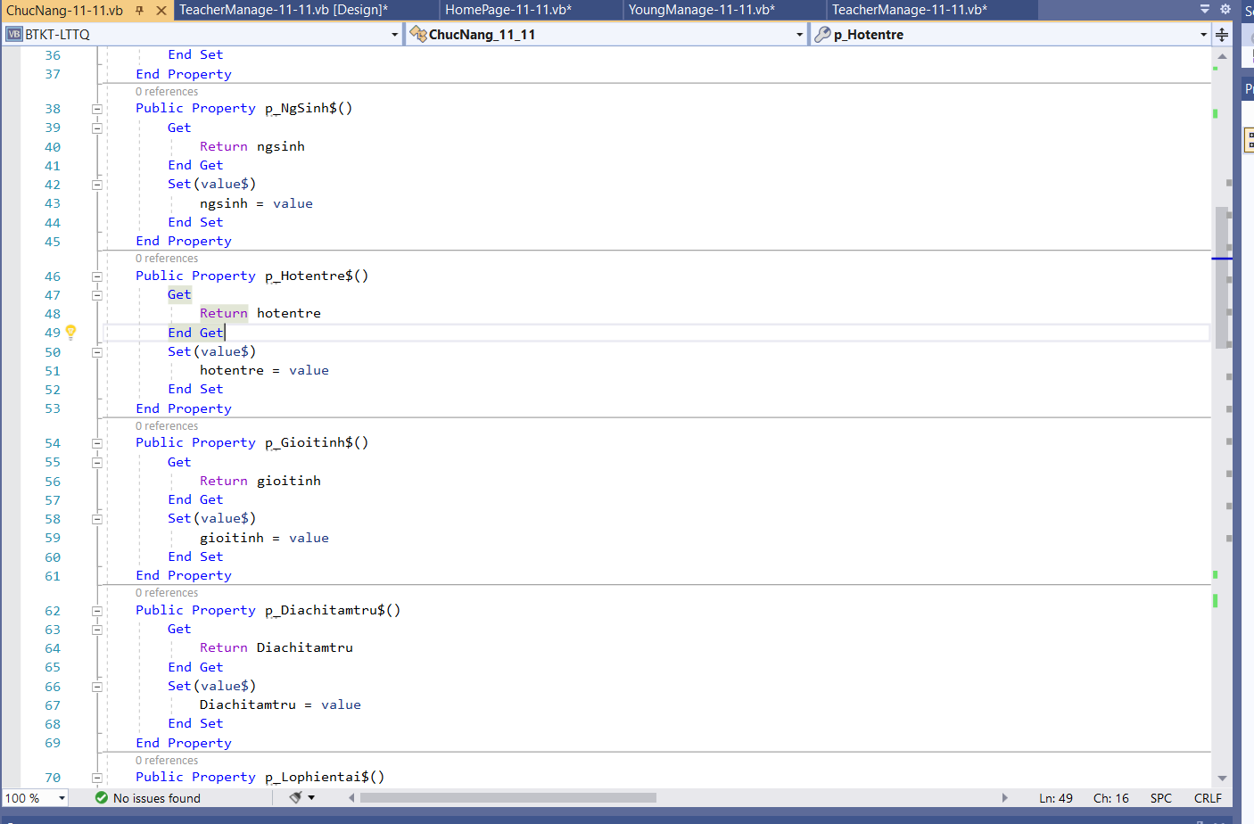

Code:

End Property

Public Property p_NgSinh$()

Get

Return ngsinh

End Get

Set(value$)

ngsinh = value

End Set

End Property

Public Property p_Hotentre$()

Get

Return hotentre

End Get

Set(value$)

hotentre = value

End Set

End Property

Public Property p_Gioitinh$()

Get

Return gioitinh

End Get

Set(value$)

gioitinh = value

End Set

End Property

Public Property p_Diachitamtru$()

Get

Return Diachitamtru

End Get

Set(value$)

Diachitamtru = value

End Set

End Property

Public Property p_Lophientai$()

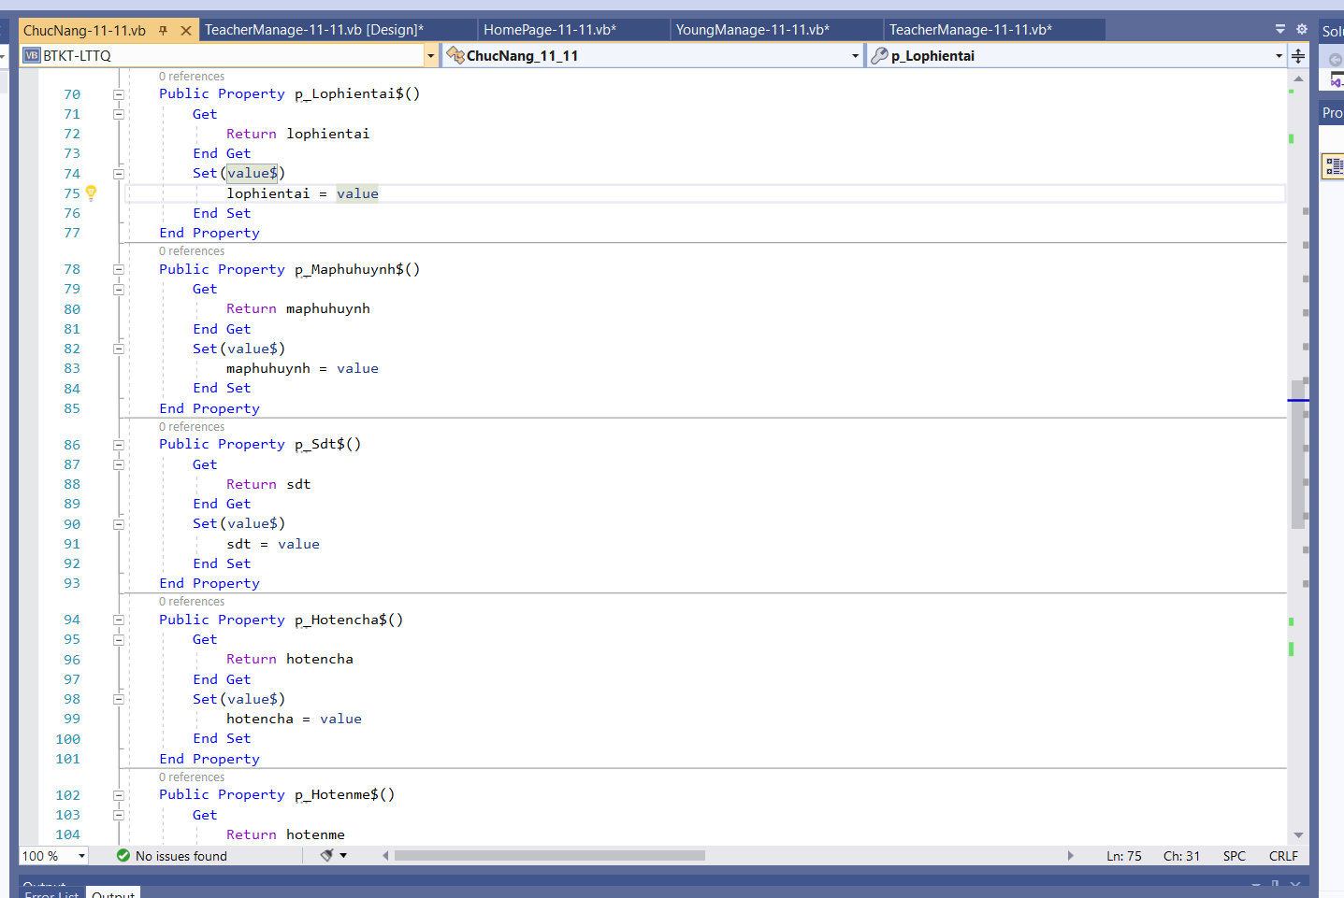

Code:

Get

Return lophientai

End Get

Set(value$)

lophientai = value

End Set

End Property

Public Property p_Maphuhuynh$()

Get

Return maphuhuynh

End Get

Set(value$)

maphuhuynh = value

End Set

End Property

Public Property p_Sdt$()

Get

Return sdt

End Get

Set(value$)

sdt = value

End Set

End Property

Public Property p_Hotencha$()

Get

Return hotencha

End Get

Set(value$)

hotencha = value

End Set

End Property

Public Property p_Hotenme$()

Get

Return hotenme

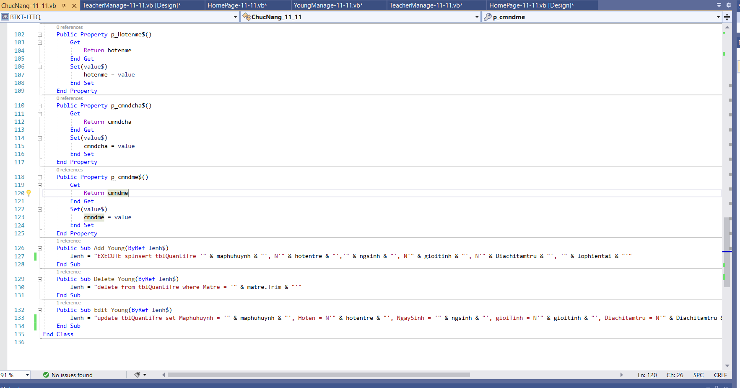

Code:

End Get

Set(value$)

hotenme = value

End Set

End Property

Public Property p_cmndcha$()

Get

Return cmndcha

End Get

Set(value$)

cmndcha = value

End Set

End Property

Public Property p_cmndme$()

Get

Return cmndme

End Get

Set(value$)

cmndme = value

End Set

End Property

Public Sub Add_Young(ByRef lenh$)

lenh = "EXECUTE spInsert_tblQuanLiTre '" & maphuhuynh & "', N'" & hotentre & "','" & ngsinh & "', N'" & gioitinh & "', N'" & Diachitamtru & "', '" & lophientai & "'"

End Sub

Public Sub Delete_Young(ByRef lenh$)

lenh = "delete from tblQuanLiTre where Matre = '" & matre.Trim & "'"

End Sub

Public Sub Edit_Young(ByRef lenh$)

lenh = "update tblQuanLiTre set Maphuhuynh = '" & maphuhuynh & "', Hoten = N'" & hotentre & "', NgaySinh = '" & ngsinh & "', gioiTinh = N'" & gioitinh & "', Diachitamtru = N'" & Diachitamtru & "', Lophientai = '" & lophientai & "' where Matre= '" & matre & "'"

End Sub

End Class

**Full Code**

Public Class ChucNang_11_11

Private matre$

Private hotentre$

Private ngsinh$

Private gioitinh$

Private Diachitamtru$

Private lophientai$

Private maphuhuynh$

Private sdt$

Private hotencha$

Private hotenme$

Private cmndcha$

Private cmndme$

Public Sub New(matre As String, hotentre As String, ngsinh As String, gioitinh As String,

diachitamtru As String, lophientai As String, maphuhuynh As String, sdt As String,

hotencha As String, hotenme As String, cmndcha As String, cmndme As String)

Me.matre = matre

Me.hotentre = hotentre

Me.ngsinh = ngsinh

Me.gioitinh = gioitinh

Me.Diachitamtru = diachitamtru

Me.lophientai = lophientai

Me.maphuhuynh = maphuhuynh

Me.sdt = sdt

Me.hotencha = hotencha

Me.hotenme = hotenme

Me.cmndcha = cmndcha

Me.cmndme = cmndme

End Sub

Public Property p_Matre$()

Get

Return matre

End Get

Set(value$)

matre = value

End Set

End Property

Public Property p_NgSinh$()

Get

Return ngsinh

End Get

Set(value$)

ngsinh = value

End Set

End Property

Public Property p_Hotentre$()

Get

Return hotentre

End Get

Set(value$)

hotentre = value

End Set

End Property

Public Property p_Gioitinh$()

Get

Return gioitinh

End Get

Set(value$)

gioitinh = value

End Set

End Property

Public Property p_Diachitamtru$()

Get

Return Diachitamtru

End Get

Set(value$)

Diachitamtru = value

End Set

End Property

Public Property p_Lophientai$()

Get

Return lophientai

End Get

Set(value$)

lophientai = value

End Set

End Property

Public Property p_Maphuhuynh$()

Get

Return maphuhuynh

End Get

Set(value$)

maphuhuynh = value

End Set

End Property

Public Property p_Sdt$()

Get

Return sdt

End Get

Set(value$)

sdt = value

End Set

End Property

Public Property p_Hotencha$()

Get

Return hotencha

End Get

Set(value$)

hotencha = value

End Set

End Property

Public Property p_Hotenme$()

Get

Return hotenme

End Get

Set(value$)

hotenme = value

End Set

End Property

Public Property p_cmndcha$()

Get

Return cmndcha

End Get

Set(value$)

cmndcha = value

End Set

End Property

Public Property p_cmndme$()

Get

Return cmndme

End Get

Set(value$)

cmndme = value

End Set

End Property

Public Sub Add_Young(ByRef lenh$)

lenh = "EXECUTE spInsert_tblQuanLiTre '" & maphuhuynh & "', N'" & hotentre & "','" & ngsinh & "', N'" & gioitinh & "', N'" & Diachitamtru & "', '" & lophientai & "'"

End Sub

Public Sub Delete_Young(ByRef lenh$)

lenh = "delete from tblQuanLiTre where Matre = '" & matre.Trim & "'"

End Sub

Public Sub Edit_Young(ByRef lenh$)

lenh = "update tblQuanLiTre set Maphuhuynh = '" & maphuhuynh & "', Hoten = N'" & hotentre & "', NgaySinh = '" & ngsinh & "', gioiTinh = N'" & gioitinh & "', Diachitamtru = N'" & Diachitamtru & "', Lophientai = '" & lophientai & "' where Matre= '" & matre & "'"

End Sub

End Class

1. Form chạy
2. HomePage

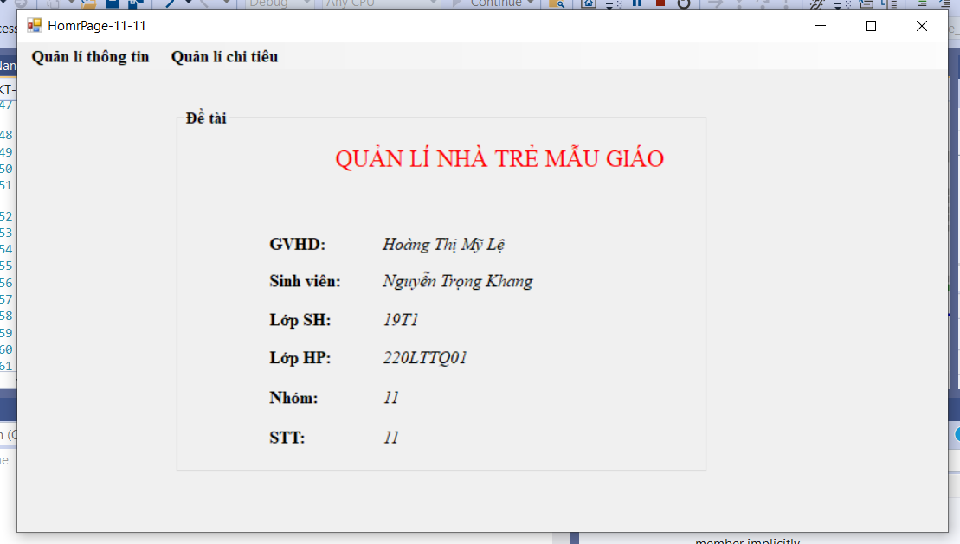

1. YoungManage

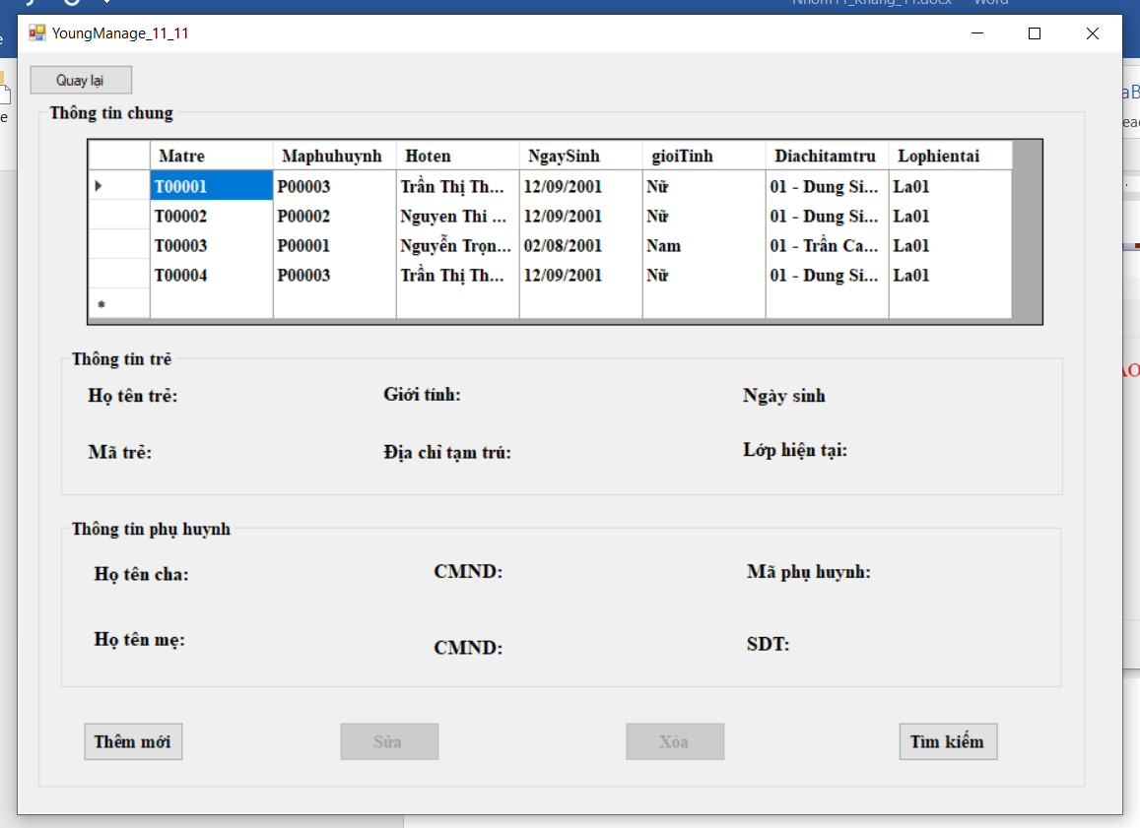

* 1. Thêm mới trẻ:

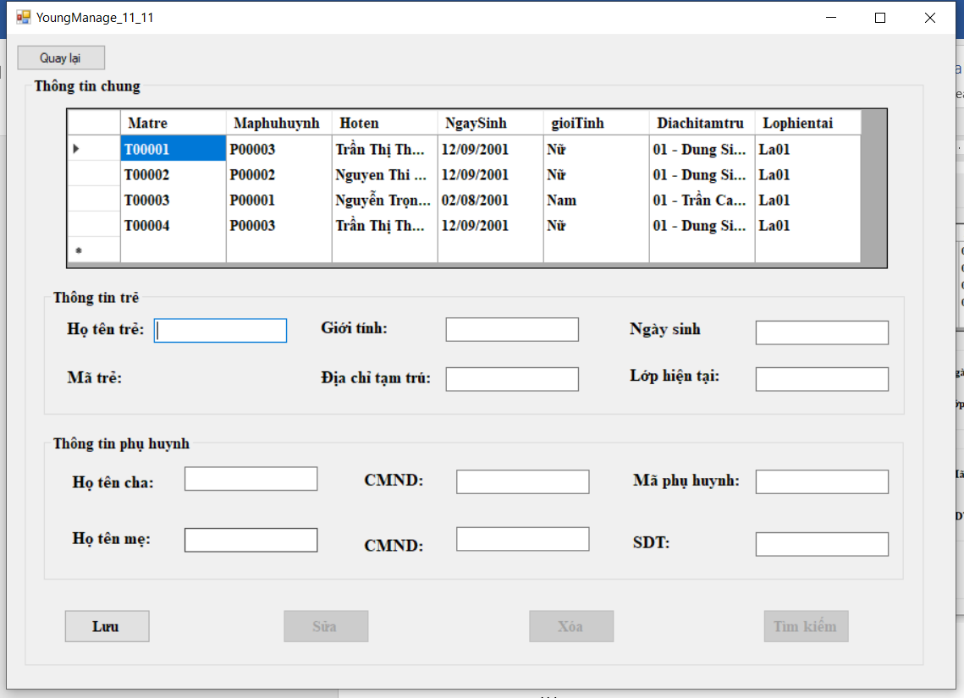

Nhập thông tin

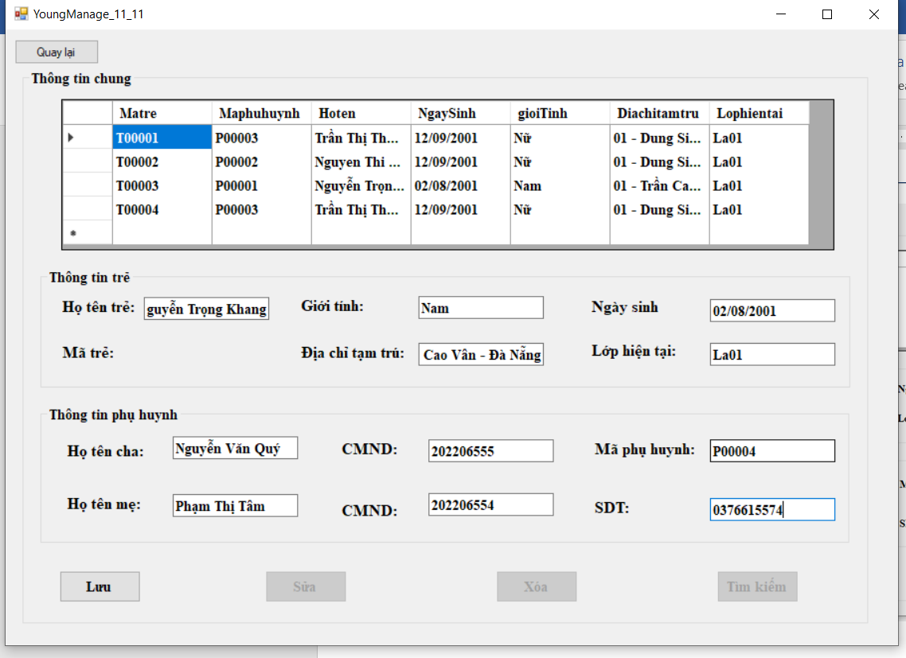

Xác nhận muốn lưu:

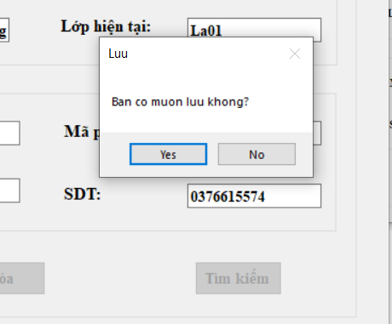

Thông báo thành công nếu trẻ đã được lưu:

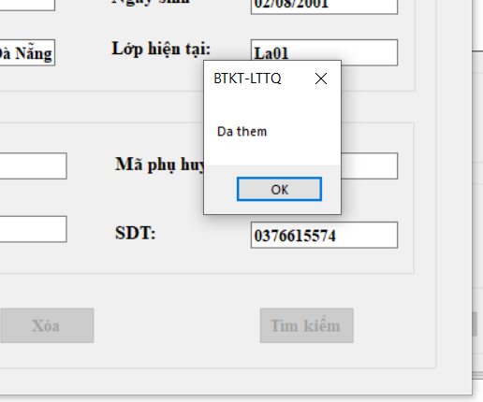

* 1. Sửa

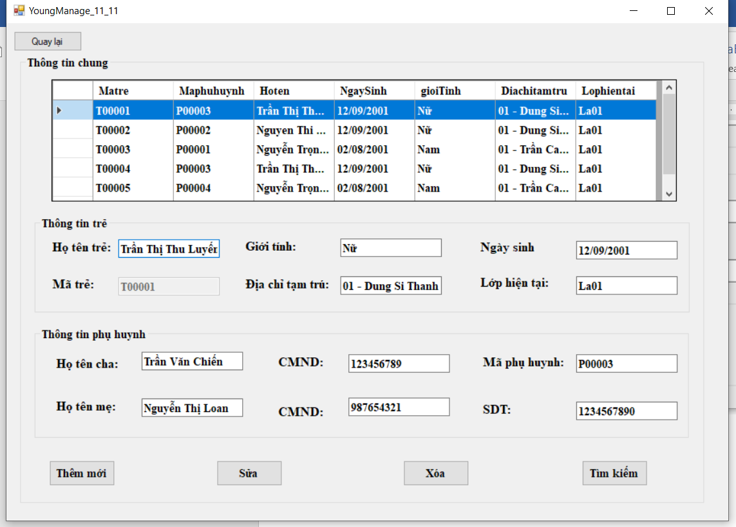

Thông báo muốn sửa hay không

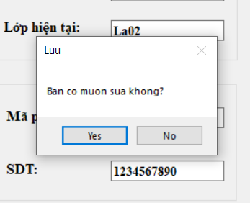

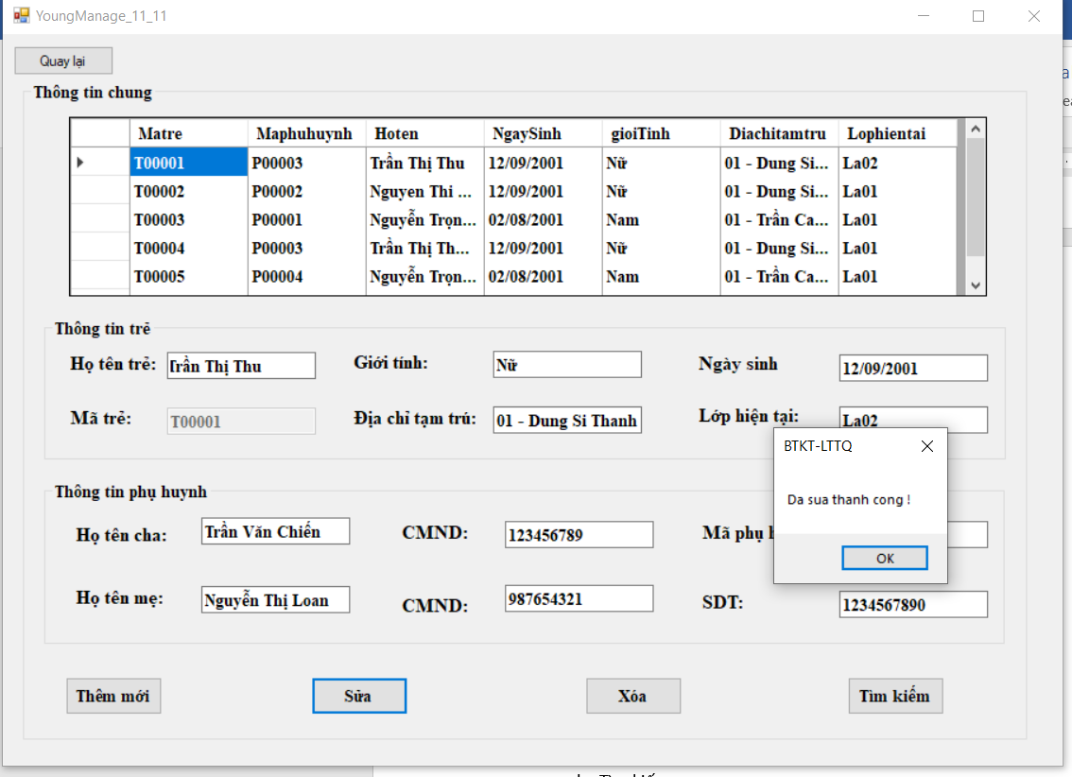

* 1. Xóa

Nếu chưa chọn trẻ cần xóa thì sẽ hiện thị thông báo:

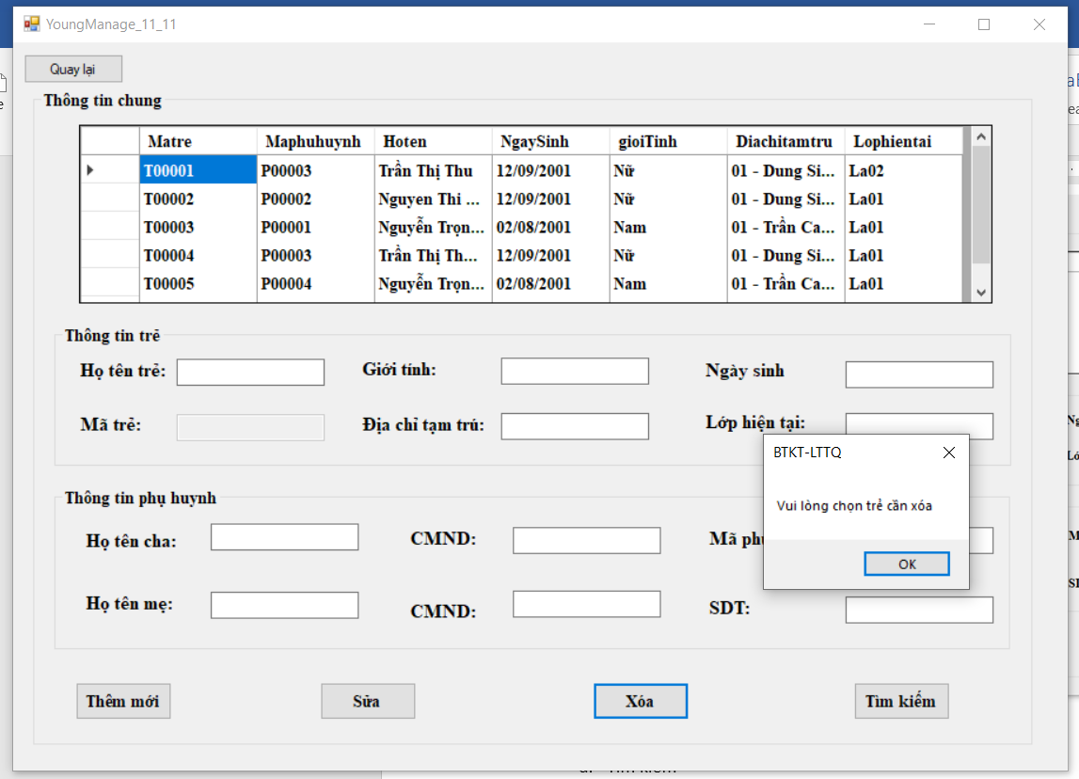

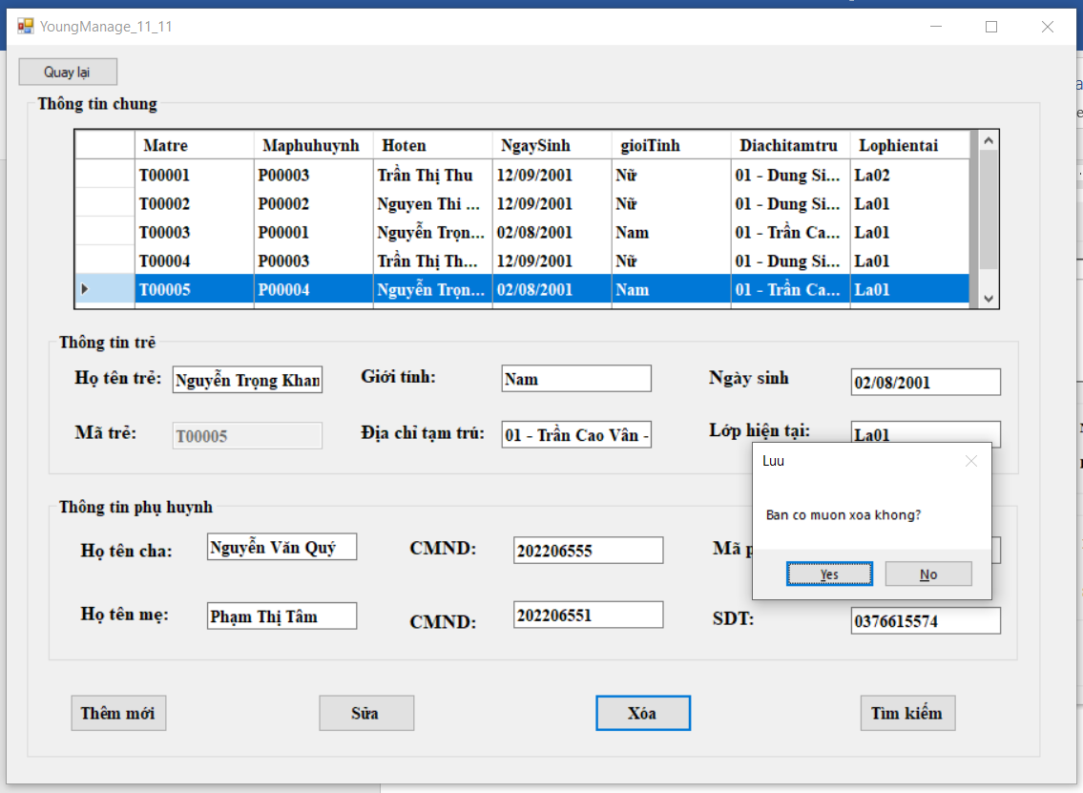

Thông báo có muốn xóa không

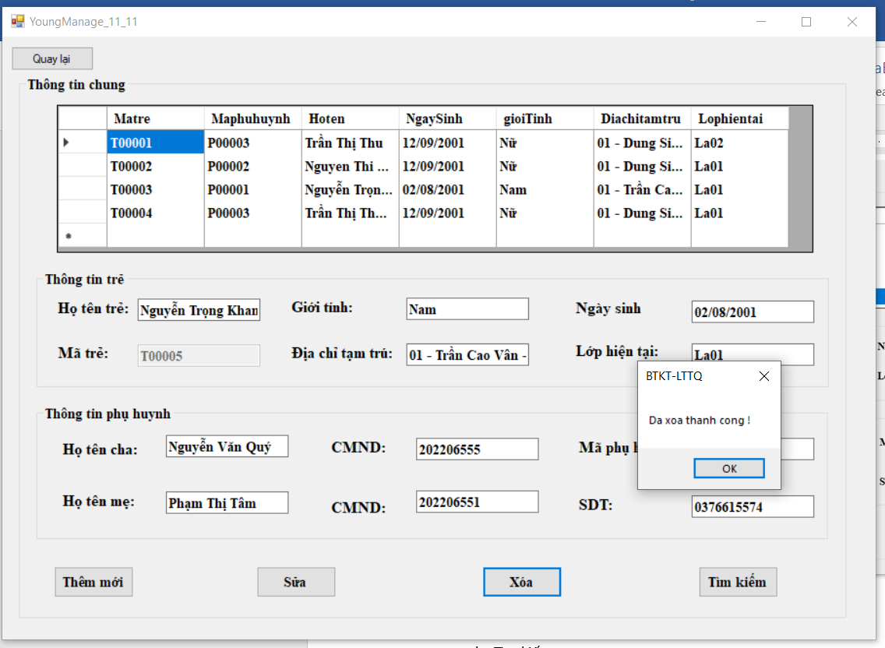

* 1. Tìm kiếm

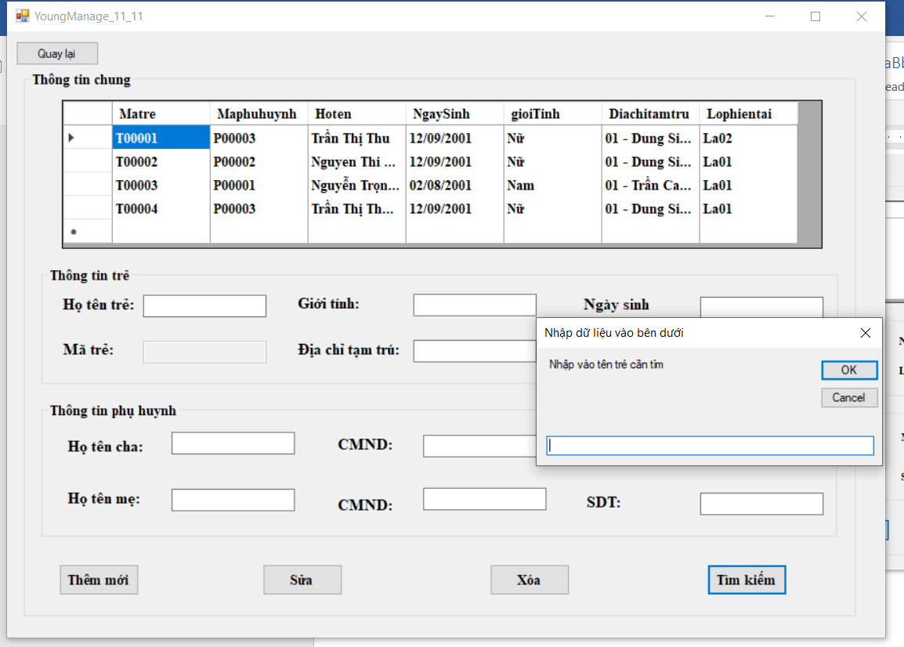

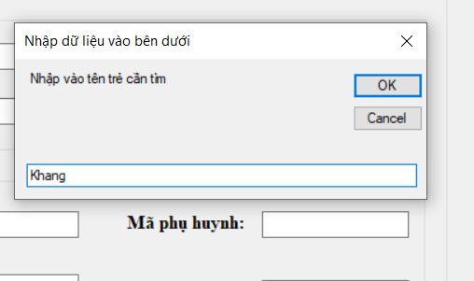

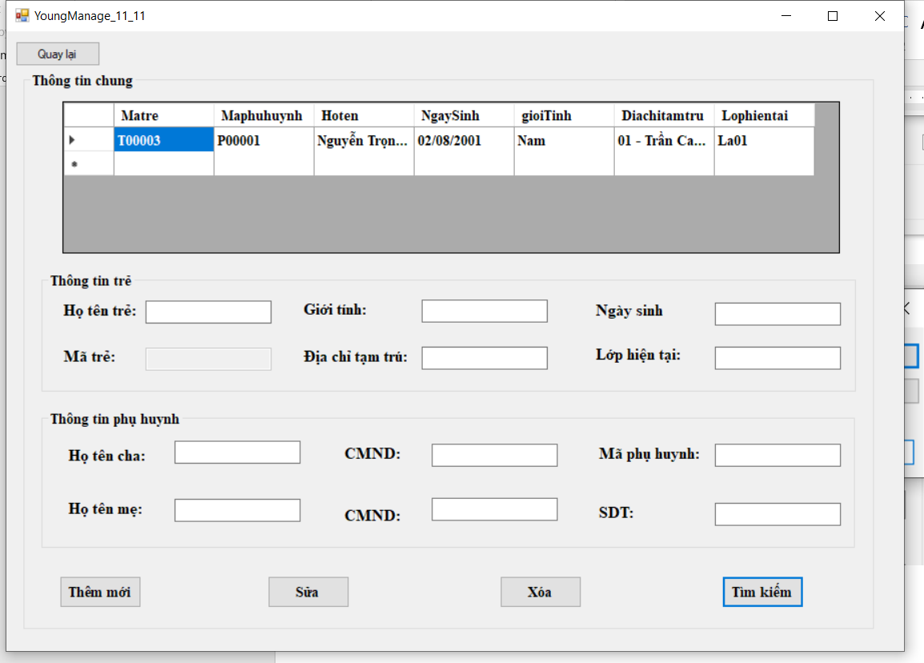

1. TeacherManage