**High level mandatory requirements**

Prepared by:

Mike Brown

AMTEK Engineering Services Ltd. 1676 Bank Street

Ottawa

ON K1V 7Y6

Contract Scientific Authority:

Ben Taylor 613-996-3415

Contract Number: W7714-4501099498

The scientific or technical validity of this Contract Report is entirely the responsibility of the Contractor and the contents do not necessarily have the approval or endorsement of the Department of National Defence of Canada.

## Contract Report

DRDC-RDDC-2014-C183

April 2015

© Her Majesty the Queen as represented by the Minister of National Defence, 2014

© Sa Majesté la Reine, représentée par le ministre de la Défense nationale, 2014

**HIGH LEVEL MANDATORY REQUIREMENTS**

Page1

# Introduction

This document defines and clarifies the meaning and use of High Level Mandatory Requirements (HLMRs) in the genesis of major projects in DND. It identifies inputs, outcomes, considerations and limitations of HLMRs, and explains how they are used and the standards against which they are measured.

# Definition

High Level Mandatory Requirements (HLMRs) describe a set of capabilities which a project under consideration must achieve. Essentially, they define the expected outcomes, effects or services to be delivered by the project – what the Force Employer wants the project to deliver. Failure to achieve or deliver any one of these requirements constitutes project failure. These critical requirements are based upon and are consistent with the Force Employer’s concept of how the solution will likely be employed, and must be clearly linked to a capability gap (which may already be extant, which may be developing due to a changing strategic environment or which may be the result of the impending end of life of an existing system). HLMRs must also link to a specific element of the approved CBP capability framework.

HLMRs are required of all projects, be they driven by Joint Force Development (top‐down) or Force Generator initiated (bottom‐up), and are developed during the ID stage of the prospective project. They are critical to successful completion of Step 2 of the BCA, which leads to the Strategic Context Document. Identification and approval of the HLMRs early in the process ensures the alignment of the proposal with the current and projected strategic environments, strategic objectives, and drivers for change.

The value and need for HLMRs apply equally to Unforecasted Operational Requirements. A clear and concise statement of the HLMRs, paying particular attention to the Capability Attributes, should assist in ensuring that UORs are processed as swiftly as possible.

When developing HLMRs, whether for a top‐down or bottom‐up project, it is critical to consider and include, where appropriate, any joint implications of the project, and to develop HLMRs to address those implications.

HLMRs must be solution independent, but must also reflect a priori constraints placed on the prospective project. These constraints may include such limitations as time, budget, technology, locale, related projects, etc, and must be clearly identified in the HLMR document.

Well defined HLMRs are critical to the success of the Project, and are the bedrock on which the Statement of Operational Requirements stands.

# Capability Measures

HLMRs are expressed in terms of capabilities, and must include a method of measuring the effectiveness1 of that capability, along with an explanation of the metrics, how they were derived, and

1. Measures of Effectiveness specify the intended results/effects and are presented in the context of the project – the ‘what’ of the capability – and will be found in the CBA.

Measures of Performance are used to measure the required parameters of the solution, and are non‐contextual. That is, they measure the ‘how’ of the capability, and are found in the SOR.

Thus, a Measure of Effectiveness may state that there is a requirement to detect and destroy over‐the‐horizon targets with a confidence level of 90% +/‐ 5%., while the associated Measure of Performance may state that the equipment must have an over‐the‐horizon radar system

their significance to the overall project. It is preferred that the Force Generator provide an Effectiveness Envelope, including both target (the ideal) and minimum thresholds (the minimum acceptable) measures of effectiveness. The target value for a capability is applicable when a higher level of effectiveness comes with a significant increase in operational utility, but at higher cost, schedule, and/or technology risk. Effectiveness above the target value does not justify additional expense whereas effectiveness below the threshold value is neither operationally effective nor suitable and may not provide any improvement over current capabilities.

Page2

Advances in technology or changes in the strategic environment may result in changes to threshold and target values in future iterations of the CBA. As a measure’s values change (as a result of staff discussions, or as part of the CORA validation), superseded values must be identified in current and future documents for reference purposes.

The use of an Effectiveness Envelope, rather than a single measure of Effectiveness, is preferred as it provides for a trade space for DCB members at the Options Analysis stage. For Example:

*The Force Employer has determined that, in order to support a Naval Task Group of up to five CPFs and one DDG, without negatively impacting the operational capability of the NTG, the Vessel must have:*

|  |  |  |  |
| --- | --- | --- | --- |
| **Capability** | | **Minimum**  **Requirement** | **Target Requirement** |
| **Maximum Sustained Speed** | | 20 kts | 27 kts |
| **Aviation** | Number of Helicopters | 2 | 3 |
| Flight Deck Spots | 1 | 2 |

A properly defined set of HLMRs could be depicted as shown below:

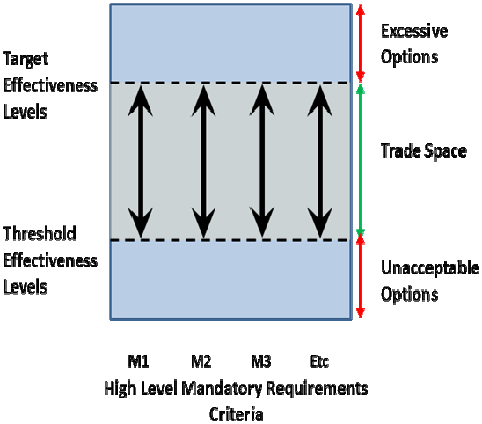

**Figure A ‐ HLMR Environment**

coupled to a weapons system, capable of simultaneously detecting and engaging at least five and as many as ten discrete moving or still targets.

Typical HLMRs for a weapon system, for example, might include some or all of the following HLMRs:

Page3

* **Lethality**. The ability of the system to detect, target, engage and destroy threats. With respect to the CBP process, this is considered in conjunction with threat types and the levels of precision/low‐ yield weaponry required to minimize collateral damage when required.
* **Survivability**. The ability to sustain operations within the mission operational area. This considers opponent’s capabilities and environmental threats to a force element and its ability to withstand them.
* **Reach**. The ability of a force element to operate autonomously or deliver effect at distance.
* **Persistence**. The operational endurance of a force element.
* **Responsiveness**. The ability to be effective when and where required. This includes the agility of force element to change tasks (tempo) and re‐orientate in mid‐operation (synchronization).
* **Interoperability**. This describes a force element’s ability to operate and share information. In context of a mission this could include other CAF force elements and headquarters, other governmental departments and allied forces.
* **Awareness**. The ability to gather, fuse and display information. Within context of the mission this information could be military‐specific information or environmental type data.

Each HLMR must have the following attributes:

|  |  |
| --- | --- |
| ***Attribute*** | ***Description*** |
| Clear and Concise | The language and structure must be such that the meaning will be interpreted the same way by all parties, especially including those who will work with the requirement at some later date. |
| Feasible | A realisable solution must be possible within any natural physical constraints and the expected financial and schedule constraints of the acquisition. |
| Solution Independent | The requirements must state what the expected outcome must be, rather than how to achieve that outcome. |
| Unambiguous | There must be only one meaning or interpretation which can reasonably be drawn from the definition, and qualitative or subjective words or descriptions must be avoided. |
| Singular | Each requirement must capture a single concept which cannot be subdivided into two or more separate requirements. |
| Verifiable | There must be a feasible and objective method to verify the conformance of the solution with the requirement. |
| Standardised Terminology | The requirement must use the same (standardised) terminology as the Concept of Operational Employment for the capability or the terminology used in the relevant scenario analysis conducted under CBP. |
| Complete | The requirements must address all reasonable and probable scenarios. |
| Traceable | Each requirement must be traceable to the specific CFDS mission(s) and Capability Framework elements to which it applies, including the appropriate Tier 3 activity. |

Page4

|  |  |
| --- | --- |
| Measurable | The requirement must include a method to measure the Effectiveness / Effectiveness Envelope. Measures of Effectiveness should be a single effectiveness measure derived from CORA analyses or other approved studies. Effectiveness Envelopes define threshold (minimum viable) and target (ideal) levels of effectiveness. |

**Table 1 ‐ HLMR Attributes**

DRDC CORA may be requested to assist in the development of the HLMRs, particularly in ensuring that the requirements:

* Are reflective of applicable technology maturity, timeframe the capability is required, and supported by analysis.
* Comply with the standard format.
* Are internally consistent across all parts.
* Are complete, recording all of the justifiable needs of all the identified users, and all the unavoidable constraints from all identified users and stakeholders.
* Are not over‐engineered.
* Are not over‐prescriptive.
* Are free of system requirements or solution specifications.
* Are well structured and organised.
* Are correctly understood by, and satisfy the needs of, its target audience.
* Do not presume the solution
* Are truly mandatory, in that failure to achieve the requirement will jeopardise the project and prevent a successful outcome.
* Validation of the requirements against the attributes listed in Table 1 above, and their threshold and target values, and
* Clarity of purpose: Confirmation that the HLMRs accurately and completely address the capability gap relative to the Concept of Operational Employment and CBP scenario analyses.

# Capability Attributes

In addition to HLMRs specific to the project being developed, all projects should address the following Capability Attributes (CA) to the fullest extent possible, depending on the current understanding of the potential solution.

Not all CAs will be applicable in all cases, although they should always be considered. If the Force Generator is of the opinion that the CA is not applicable to the Project, a statement to that effect should be included, with justification:

* **Force Protection (FP)**. All projects addressing a manned system, or any system designed to enhance personnel survivability, must address the requirement for Force Protection. Although an FP CA may include many of the same attributes as those that contribute to the Survivability CAs, the intent of the FP CAs is to address protection of the system operator or other personnel rather than protection of the system itself.
* **Survivability**: Survivability CAs are applicable to all projects addressing a manned system, and may also be applicable to projects addressing an unmanned system. The intent of the Survivability CAs includes reducing a system’s likelihood of being engaged by hostile fire, through attributes such as speed, manoeuvrability, detectability, and countermeasures; reducing the system’s vulnerability if hit by hostile fire, through attributes such as armour and redundancy of critical components; and allowing the system to survive and continue to operate in a CBRN environment, if required. It may also incorporate environmental considerations such as weather, climate and climate change.
* **Sustainment**: Sustainment CAs are applicable to all projects addressing potential capital equipment procurement or construction projects. The intent of the Sustainment CAs is to ensure that sustainment planning “upfront” enables the requirements and acquisition communities to provide a system with optimal availability and reliability at an affordable cost.

Page5

* **Information Interoperability**: Information Interoperability is applicable to all projects incorporating automated information systems used in the acquisition, storage, manipulation, management, movement, control, display, switching, interchange, transmission, or reception of data or information regardless of classification or sensitivity. The intent of the Information Interoperability CAs is to ensure new IS fit into the existing CF architectures and infrastructure to the maximum extent practicable. Information Interoperability CAs are not applicable to projects where communication with other systems is not required.
* **Training**: Training CAs are applicable to virtually all projects involving changes to operations, systems, policies, and procedures, or capital equipment procurement. The intent of the Training CAs is to ensure that training requirements are properly addressed as early on in the process as practicable, in parallel with the planning and material development, and updated throughout the program’s lifecycle. Given the status of the planned project at the time HLMRs and CAs are initially developed, knowledge of the solution may not allow for the development of Training CAs.
* **Energy**: Energy CAs are applicable to all projects addressing systems where the provision of energy, including fuel and electric power, to the system impacts operational reach, or requires protection of energy infrastructure or energy resources in the logistics supply chain. The intent of the Energy CAs is to optimise fuel and electric power demand in capability solutions as it directly affects the burden on the force to provide and protect critical energy supplies. The CAs include fuel and electric power demand considerations in systems, including those for operating “off grid” for extended periods when necessary. The Energy CAs may also include ‘green’ considerations, with the intent of reducing the CF’s carbon footprint and/or environmental impact.

# Process

The first step in developing the HLMRs is for the Force Employer’s staff to craft a Single Statement of User Need (SSUN) (see BC Guidance para 1.1.2). The SSUN sets the scope for the Preliminary Options Analysis (POA) and helps to keep the POA correctly focused. It consists of a single sentence or a short paragraph, capturing the fundamental essence of the user requirement.

The SSUN should:

* Be short – ideally one sentence, never more than a single paragraph of four sentences.
* Be focused – enough to uniquely characterise one capability gap.
* Have nouns and action verbs drawn from the relevant capability framework and any analyses that identify the capability gap.
* Be unclassified – if possible.
* Not be so detailed that it is likely to require amendment as a consequence of trade‐off activity.
* Not be quantified – unless the statement is meaningless without quantification. For example:

*The user requires a UK, deep and persistent ISTAR capability, providing timely collection, processing and dissemination, that is interoperable with joint and coalition forces and which is available to support the full range of military tasks.2*

1. Corbet, Gerry: Dabinet: A New Direction for ISTAR (London: 2011) http://www.consulting‐uk.com/attachedfiles/articles/GCorbet‐ DABINETT.pdf accessed 13 Nov 13

The next step is to list all the capabilities of the project that would be required to achieve success in each CBP scenario, along with at least one measurable effectiveness attribute and the relevant metrics for each. The capabilities that are most critical or essential to the proposed project (those where failure to achieve the minimum threshold will mean outright failure of the project) will be designated as HLMRs. The next step is to document how these HLMRs are responsive to changes in the desired mission outcomes and associated effects.

Page6

Once this is completed, threshold and target values should be assigned to each HLMR. Threshold values should be based on what is achievable given the current state of technology. Target values may be defined based on a goal for the end‐state of the project. During the Options Analysis stage, tradeoffs may made between the threshold and target values to optimise the outcome, given the availability of technology and potential competing demands introduced by combining subsystems into the overall system. A deeper review of trade‐offs at and around threshold values may be beneficial to explore the incremental value for dollar where particular thresholds are insensitive to small deviations. After the OA stage, these trade‐off decisions are essentially completed and a more precise determination of acceptable performance can be stated in the Statement of Operational Requirements.

Force Generators may add additional requirements where they are essential for providing the required capabilities/outcomes and where the definition of the requirements and the recommended threshold and target values are reflective of fiscal constraints and applicable technology maturity, and are supported by analysis.

Significant changes to threshold and target values after DCB approval will normally require revalidation by the DCB.

When selecting HLMRs, the Force Generator should answer all the following questions in the affirmative for each nominated HLMR:

* Is the requirement one of the Capability Attributes above, or is it essential for providing the required capabilities?
* Does the requirement contribute to significant improvement in war fighting capabilities, operational effectiveness, and/or operational suitability?
* Is it achievable?
* Is it measurable and testable?
* Are the definition of the attribute and the recommended threshold and target values reflective of fiscal constraints, applicable technology maturity, timeframe the capability is required, and supported by analysis?
* Is the Force Generator willing to consider restructuring the program if the HLMR is not met?

During development of the HLMRs, cost is not a consideration unless an upper limit has been provided as a constraint. Normally, costs are considered as part of the Options Analysis stage.

# HLMRs in Context

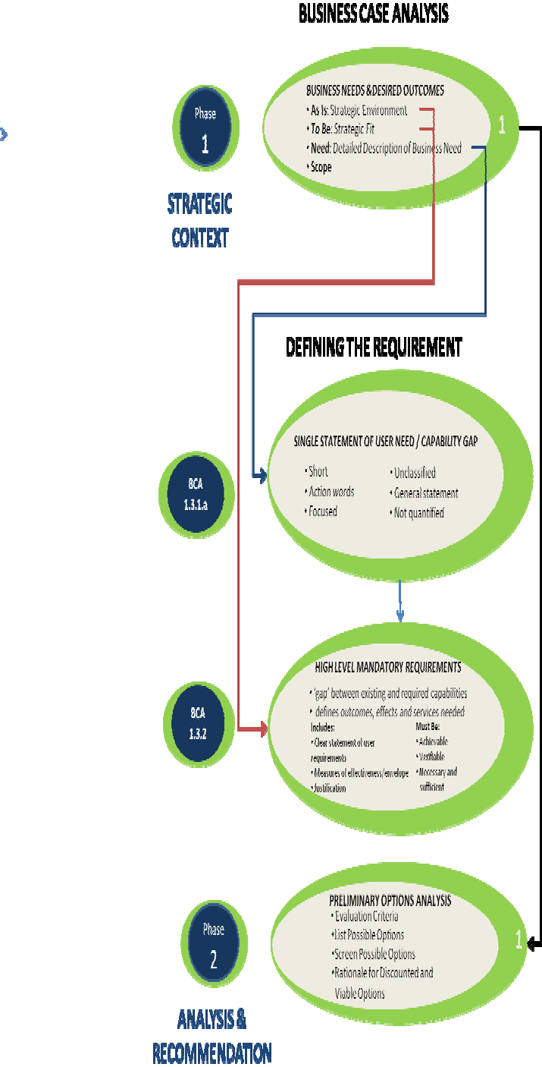

**Traceability**

**Figure B ‐ HLMRs and SSUN in Context3**

Page7

As discussed above, each HLMR must be traceable to the specific CFDS mission(s) and Capability Framework elements to which it applies. To do this, Force Generators must identify the element of the approved CBP capability framework to which the HLMR relates.

HLMRs may be summarised in a table such as the following:

|  |  |  |  |  |  |  |
| --- | --- | --- | --- | --- | --- | --- |
| **HIGH LEVEL MANDATORY REQUIREMENTS**  **TRACEABILITY MATRIX** | | | | | | |
| **SINGLE STATEMENT OF USER NEED:** | | | | | | |
|  | | | | | | |
| **Serial** | **HLMR Description** | **CBP Capability Element** | **Gap Description** | **As‐Is Source Document** | **Measure** | **Effectiveness**  **Envelope** |
|  |  |  |  |  |  |  |
|  |  |  |  |  |  |  |
|  |  |  |  |  |  |  |
|  |  |  |  |  |  |  |
|  |  |  |  |  |  |  |
|  |  |  |  |  |  |  |

**Table 2‐ HLMR Traceability Matrix**

1. cf: TBS: Business Case Guide (Ottawa: 2009), p. 10