Part 1: Account created.

Part 2: Installed Git bash.

Part 3: Github is a web hosting place where people can post, manage, edit and share projects (especially code) with other people. It was created in 2008 by Tom Preston-Werner, Chris Wanstrath, and PJ Hyett to simplify sharing code. Other platforms that are similar to GitHub include sourceForge, bitbucket, redmine, gitlab, launchpad, codeplex. gitweb…etc. Github has some really important features such as field-tested tools for any project, version control systems, and collaborative code review and easily to use and to manage teams within organizations.

Part 4:

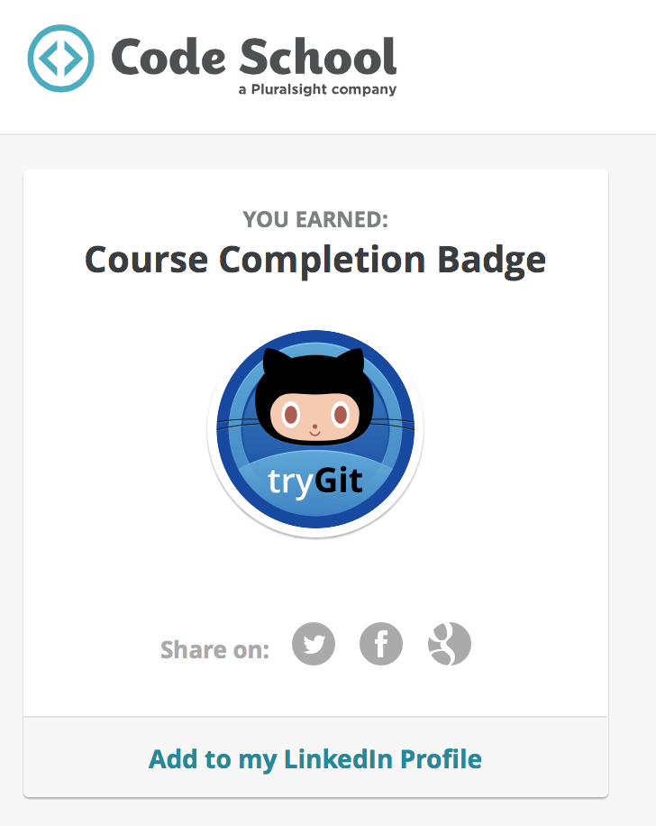

Part 5:

Repository is simple a folder to hold all of your projects. This folder stores each file’s revision’s history and it has access controls such as private and public.

Commit is a change to a file or files. An edited file will be saved with an ID that keeps track of what changes were made, when and by who.

Push is sending out your revision of a file to a public place so people can get access to it.

Branch is like a copy of a master file or project that allows other people to work freely on that copy file without disrupting to the original file or master file.

Fork is a personal copy of another user’s repository. You can make any change to that copy and can request to the original’s author to update with your changes to that copy.

Merge is putting all changes from one branch and applying them to another branch.

Clone is a copy of a repository that lives in your computer instead of on a server.

Pull is taking changes of files or projects which made by others and put them to your local copy so you can update them.

Pull request is a request to make changes to a repository submitted by a user. Collaborators can either accept or reject the request.

Part 6: Uploaded this file

Part 7: Added my name to READMe.md. Click on README.md. Above the file content, click edit icon. Make any changes you need to the file. Add description of your commit if needed. Click “Propose file change” button. Type a title and description for your pull request. Finally, click “Create pull request” button.

Part 8: Created a repository and added “GitHub training” issue.

Part 9: Created a wiki page with title: “CS 639 2015”

Part 10: First time user of GitHub.