let's create the folder structure for the project, as shown in the following screenshot, using the guidance provided earlier:

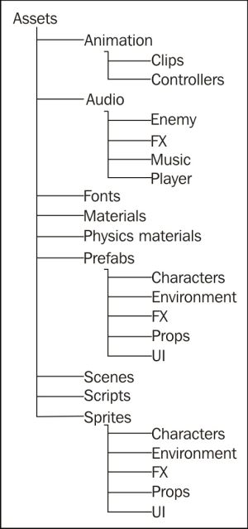

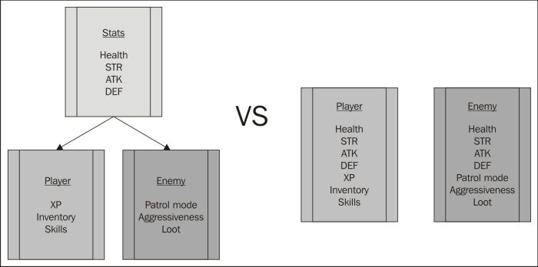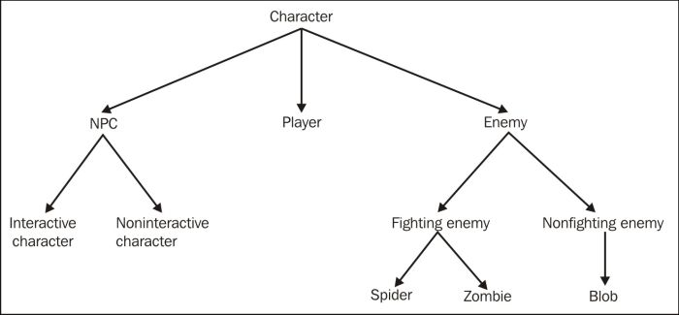

**The common game object**

As almost every entity in our game will have statistics and some basic behaviors, we start with a generic object (Entity) to define the attributes that all the entities in our game will have. As there is only one entity type, we don't need to set up an interface for this object as all the other game objects will just use this one definition, as shown in the following diagram:

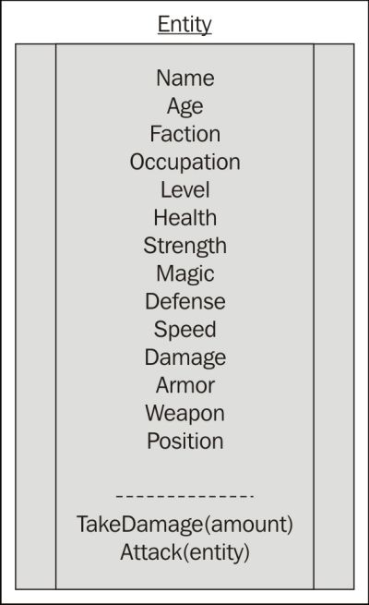

3. Putting it together