**Exercise 1** (1 mark) : Explain outputs:

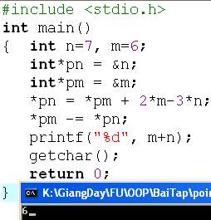

M=6

N=7

*pn = *pm +2*n-3*n <=> n = m +2*m -3*n => n =6+2*6-3*7=-3

* pm -= *pn <=> m = m-n = 6-(-3)=9

>>>>>>>>>> m+n= 9+-3=6

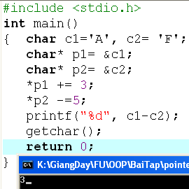

C1 = A

C2 = F

*p1 += 3 <=> c1= c1 + 3 = A + 3 = D

*p2 -= 5 <=> c2= c2 -5= F-5 =A

>>>>>>>>>>>> D-A=68-65=3

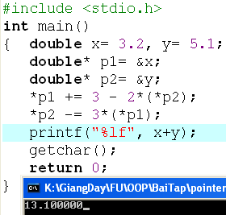

X=3.2

Y=5.1

*p1+= 3 - 2*(*p2) <=> x = 3.2+3-2*5.1 = 3.2+3-2*5.1 = -4.000000

*p2 -= 3*(*p1) <=> y = 5.1-3*-4 = 5.1-3*-4 = 17.100000

>>>>>>>>> x+y = 13.100000