**CẤU TRÚC GÓI TIN:**

TankMoveMsg.cs

BulletNewMsg.cs

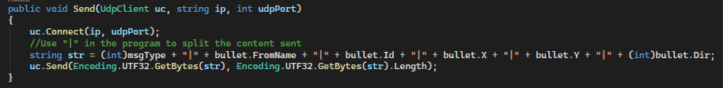

OrangeNewMsg.cs

TankNewMsg.cs

CoronaNewMsg.cs

CoronaMoveMsg.cs

