

**FPT UNIVERSITY**

SWE102 PROJECT DOCUMENT

**LUVRENT**

|  |  |
| --- | --- |
| **Group 4** | |
| **Group members** | Le Dac Hoang Phuc – SE140036  Nguyen Viet Bach – SE140033  Le Nguyen Gia Huy – SE140029  Nguyen Si Trong – SE140037  Tran Le Minh Duc – SE130432 |
| **Lecturer** | Nguyen The Hoang |

-Ho Chi Minh City, 13/11/2020-

**Table of Contents**

Table of Contents 3

A. Project Introduction 4

1. Project Information 4

2. Introduction 4

3. Proposed solution 4

3.1. Feature functions 4

4. Functional Requirements 4

4.1. View detail of a partner 4

4.2. Book a partner 5

4.3. Chat 5

4.4. Dating 5

4.5. Edit Profile 5

4.6. System Management 5

B. User Requirements Specification 6

1. Guest 6

2 Authenticated User 6

3. Customer 6

4. Partner 7

5. System Handler 7

6. Associated Company 7

7. Admin 7

C. ERD – Entity Relationship Diagram 8

1. Diagram 8

2. Data dictionary 8

**A. PROJECT INTRODUCTION**

**1. Project Information**

- Project name: LuvRent

- Product Type: Phone Application

**2. Introduction**

Nowadays, when the society is developing day by day, however, the issue of the difference in the number of men and women is still a big problem. For those who do not have a boyfriend or girlfriend or have a chance to date someone, we want to develop an app about booking fake boyfriends and girlfriends to help everyone get a date as a normal couple.

**3. Proposed Solution**

The application allows users to register as a partner or just a customer to book a partner. When users are partner, they can make money through being booked by the customer. As a customer, users can view a list of partners and choose one to book. By the ranking chart of partner, customer can see who stands out and is the most appreciated. By chatting with other people, they can know each other better. Users can also make their own outstanding profile. After dating, they can review or report each other.

**3.1. Feature functions**

- Users can view a list of partners.

- Users can see the details of a partner.

- Users can view the ranking chart.

- Users can book a partner to do all the activities like a real couple.

- Users can chat with each other.

- Users can track the status of dating.

- User can review or report the dating or other users.

- User can edit profile and upload media in the profile.

**4. Functional Requirements**

Function requirements of the application are listed as below:

**4.1. View details of a partner**

- User can choose to see the detail of a partner or go back to the list or the ranking chart.

- User can review the partner below his/her profile.

- User can click favorite to increase the favorites of partner.

- User can hire the partner if they like him/her.

**4.2. Book a partner**

- User can fill in the information about the activity that they want to do with their partner.

- User can use the vouchers when they make a date.

- User can chat with their partner if they want to agree on a date.

**4.3. Chat**

- User can chat with each other to make a date or just chat.

- User can use emoji in the chat.

- User can delete old chat.

**4.4. Dating**

- User can track the status of the dating.

- User can see the histories of dating.

- User can review or report each other after dating.

- User can rate stars to each other.

**4.5. Edit Profile**

- User can edit their profile.

- User can upload images or videos in their profile.

- User can edit avatar.

- User can view the reviews and reports of themselves.

**4.6. System Management**

- Admin can manage all data such as the vouchers, the ranking chart, reviews, reports, account of users…

**B. USER REQUIREMENT SPECIFICATION**

**1. Guest**

- Login

- Register

- View the ranking chart

- View a list of partner

- View detail a partner

**2. Authenticated User**

- Logout

- View profile

- Edit profile

- Post media (images, videos)

**3. Customer**

- Book a partner

- Fill in information booking

- Pay money

- Use the vouchers

- Deposit

- Review a partner

- Report a user

- View purchases

- Cancel dating

- View historical booking

- Chat

- Delete a chat

- Add emoji

**4. Partner**

- Chat

- Delete a chat

- Add emoji

- Report a user

- View purchases

- Cancel dating

- View historical booking

- Get the appointment notice

- Accept dating

- Deny dating

- View the profile of customer

**5. System Handler**

- Remind the dating time to users

- Notify users about vouchers

- Suggest a partner

**6. Associated Company**

- Make the vouchers

**7. Admin**

- Manage vouchers

- Edit ranking chart

- Remove the user’s account

- Hide the reviews of partners

- Get the reports

- Ban the user

**C. ERD – Entity Relationship Diagram**

**1. Diagram**

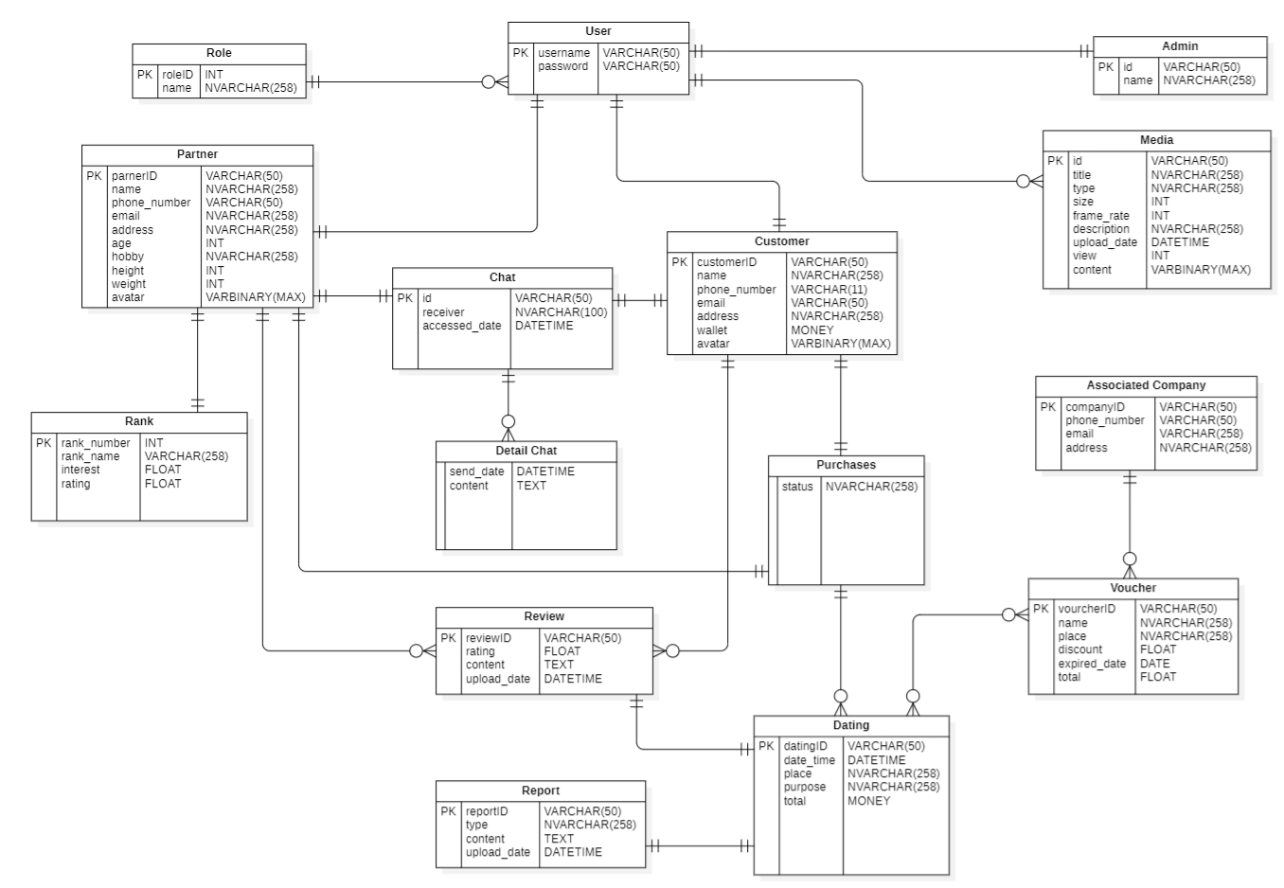

**2. Data Dictionary**

|  |  |  |
| --- | --- | --- |
| Name | Description | Main attributes/fileds with explanation |
| Role | Store the role of user | roleID (int), name (nvarchar258) |
| User | Store users in the system | username (varchar50), password (varchar50) |
| Partner | Store partners profiles | parnerID (varchar50), name (nvarchar258),  phone_number (varchar50), email (nvarchar258),  address (nvarchar258), age (int),  hobby (nvarchar258), height (int),  weight (int), avatar (varbinaryMAX) (will be edited if partner want to change) |
| Chat | Store customer messages with partners | id (varchar50), receiver (nvarchar100),  accessed_date (datetime – will be updated when user access to chat) |
| Detail Chat | Store the messages content with one partner | send_date (datetime), content (text – will be updated when user send new messages) |
| Rank | Store the list of partner ranking by ratings and interestes | rank_number (int – will be updated based on interest and rating), rank_name (varchar258),  interest (float), rating (float) (will be updated based on love from customers) |
| Customer | Store all customers profiles | customerID (varchar50), name (nvarchar258),  phone_number (varchar11), email (varchar50),  address (nvarchar258), wallet (money),  avatar (varbinaryMAX) (will be edited if customer want to change) |
| Purchases | Store the list of dating with status | status (nvarchar258) (have dated, on dating and waiting) |
| Review | Store the reviews made by customers and partners | reviewID (varchar50), rating (float),  content (text), upload_date (datetime) (will be updated if new user review directly not as dating) |
| Report | Store the reports made by customers and partners about the dating | reportID (varchar50), type (nvarchar258),  content (text), upload_date (datetime) |
| Admin | Store admins profiles | id (varchar50), name (nvarchar258) |
| Media | Store media information of users | id (varchar50), title (nvarchar258),  type (nvarchar258), size (int),  frame_rate (int), description (nvarchar258),  upload_date (datetime), view (int),  content (varbinaryMAX) |
| Associated Company | Store the list of companies that provide vouchers | companyID (varchar50), phone_number (varchar50), email (varchar258),  address (nvarchar258) |
| Voucher | Store all vouchers for dating | voucherID (varchar50), name (nvarchar258),  place (nvarchar258), discount (float – will be updated if associated company change it),  expired_date (date), total (float) |
| Dating | Store dating between customer and partner | datingID (varchar50), date_time (datetime),  place (nvarchar258), purpose (nvarchar258),  total (money) |