Hoàng Trọng Toàn
1250080202
12ĐH_CNTT4
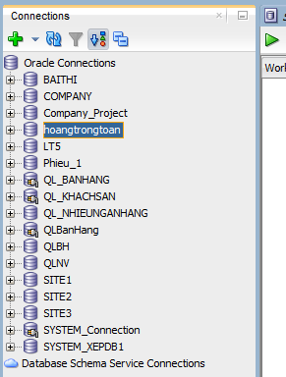
PHIẾU BÀI TẬP 1

a. Trigger INSERT bảng NHAP – trg_Nhap
CREATE OR REPLACE TRIGGER trg_Nhap
BEFORE INSERT ON Nhap
FOR EACH ROW
DECLARE
v_dem NUMBER := 0;
v_soluong NUMBER := 0;
BEGIN
-- kiem tra MaSP co ton tai khong
SELECT COUNT(*) INTO v_dem FROM SanPham WHERE MaSP = :NEW.MaSP;
IF v_dem = 0 THEN
RAISE_APPLICATION_ERROR(-20001, 'MaSP khong ton tai');
END IF;

-- kiem tra rang buoc du lieu
IF :NEW.SoLuongN <= 0 OR :NEW.DonGiaN <= 0 THEN
RAISE_APPLICATION_ERROR(-20002, 'SoLuongN va DonGiaN phai > 0');
END IF;

-- hop le -> cap nhat SoLuong
UPDATE SanPham SET SoLuong = SoLuong + :NEW.SoLuongN
WHERE MaSP = :NEW.MaSP;
END trg_Nhap
/

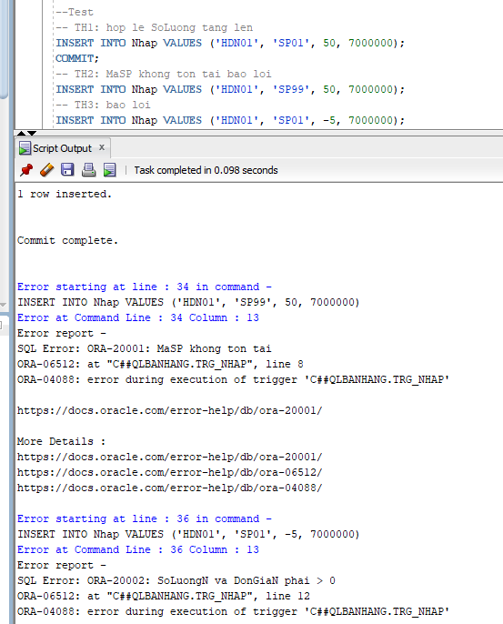

b. Trigger INSERT bảng XUAT – trg_xuat
CREATE OR REPLACE TRIGGER trg_Xuat
BEFORE INSERT ON Xuat
FOR EACH ROW
DECLARE
v_dem NUMBER := 0;
v_soluong NUMBER := 0;
BEGIN
-- kiem tra MaSP co ton tai khong
SELECT COUNT(*) INTO v_dem FROM SanPham WHERE MaSP = :NEW.MaSP;
IF v_dem = 0 THEN
RAISE_APPLICATION_ERROR(-20001, 'MaSP khong ton tai');
END IF;

-- kiem tra SoLuongX <= SoLuong trong SanPham
SELECT SoLuong INTO v_soluong FROM SanPham WHERE MaSP = :NEW.MaSP;
IF :NEW.SoLuongX > v_soluong THEN
RAISE_APPLICATION_ERROR(-20002, 'SoLuongX vuot qua so luong ton kho');
END IF;

-- hop le -> cap nhat SoLuong
UPDATE SanPham SET SoLuong = SoLuong - :NEW.SoLuongX
WHERE MaSP = :NEW.MaSP;
END trg_Xuat;
/
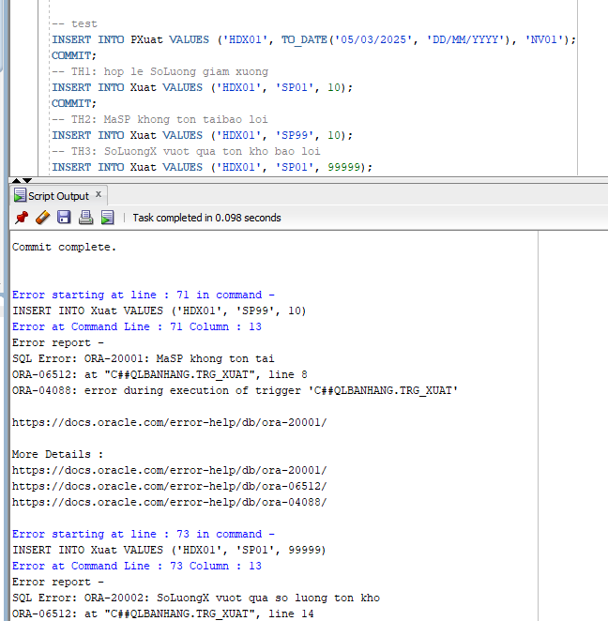

c. Trigger DELETE bảng XUAT – trg_XoaXuat
CREATE OR REPLACE TRIGGER trg_XoaXuat
AFTER DELETE ON Xuat
FOR EACH ROW
BEGIN
-- khi xoa phieu xuat hoan tra số lượng vao sản phẩm
UPDATE SanPham SET SoLuong = SoLuong + :OLD.SoLuongX
WHERE MaSP = :OLD.MaSP;
END trg_XoaXuat;
/
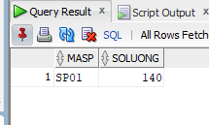
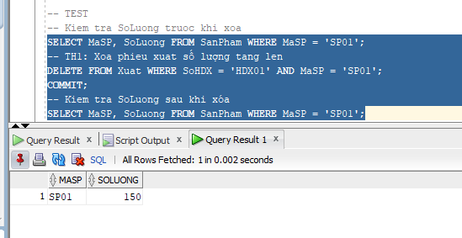

PHIẾU BÀI TẬP 2
a. Trigger UPDATE bảng XUAT – trg_CapNhatXuat
-- Buoc 1: Tao package luu bien dem
CREATE OR REPLACE PACKAGE pkg_state AS
g_row_count NUMBER := 0;
END pkg_state;
/

-- Buoc 2: Tao Compound Trigger
CREATE OR REPLACE PACKAGE pkg_state AS
g_row_count NUMBER := 0;
END pkg_state; /
CREATE OR REPLACE TRIGGER trg_CapNhatXuat
FOR UPDATE ON Xuat
COMPOUND TRIGGER
BEFORE STATEMENT IS
BEGIN
pkg_state.g_row_count := 0;
END BEFORE STATEMENT;
BEFORE EACH ROW IS
DECLARE
v_soluong NUMBER := 0;
BEGIN
-- dem so ban ghi bi thay doi
pkg_state.g_row_count := pkg_state.g_row_count + 1;
IF pkg_state.g_row_count > 1 THEN
RAISE_APPLICATION_ERROR(-20001, 'Chi duoc cap nhat 1 ban ghi');
END IF;

-- kiem tra SoLuong trong SanPham co du bu phan chenh lech khong
IF :NEW.SoLuongX <> :OLD.SoLuongX THEN
SELECT SoLuong INTO v_soluong FROM SanPham WHERE MaSP = :NEW.MaSP;
IF v_soluong < (:NEW.SoLuongX - :OLD.SoLuongX) THEN
RAISE_APPLICATION_ERROR(-20002, 'Khong du hang de xuat');
END IF;
-- hop le -> cap nhat SoLuong trong SanPham
UPDATE SanPham SET SoLuong = SoLuong - (:NEW.SoLuongX - :OLD.SoLuongX)
WHERE MaSP = :NEW.MaSP;
END IF;
END BEFORE EACH ROW;
END trg_CapNhatXuat;
/
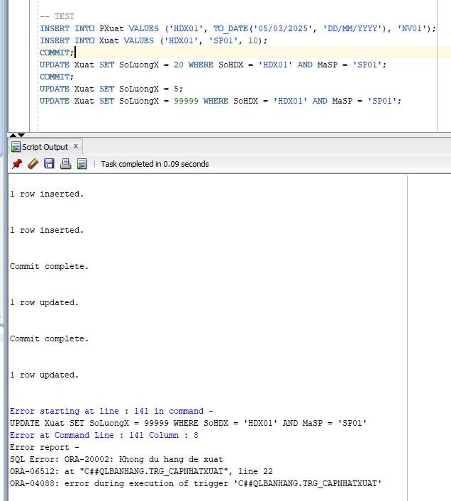
b. Trigger UPDATE bảng NHAP – trg_CapNhatNhap
CREATE OR REPLACE TRIGGER trg_CapNhatNhap
FOR UPDATE ON Nhap
COMPOUND TRIGGER
v_soluong NUMBER := 0;
BEFORE STATEMENT IS
BEGIN
pkg_state.g_row_count := 0;
END BEFORE STATEMENT;

BEFORE EACH ROW IS
BEGIN
pkg_state.g_row_count := pkg_state.g_row_count + 1;
IF pkg_state.g_row_count > 1 THEN
RAISE_APPLICATION_ERROR(-20001, 'Chi duoc cap nhat 1 ban ghi');
END IF;
IF :NEW.SoLuongN <> :OLD.SoLuongN THEN
UPDATE SanPham SET SoLuong = SoLuong + (:NEW.SoLuongN - :OLD.SoLuongN)
WHERE MaSP = :NEW.MaSP;
END IF;
END BEFORE EACH ROW;

END trg_CapNhatNhap;
/
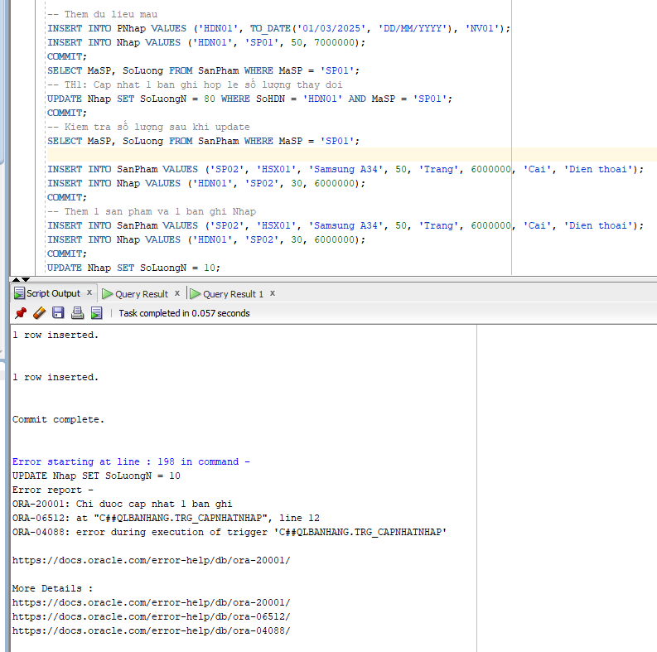
c. Trigger DELETE bảng NHAP – trg_XoaNhap
CREATE OR REPLACE TRIGGER trg_XoaNhap
AFTER DELETE ON Nhap
FOR EACH ROW
BEGIN
UPDATE SanPham SET SoLuong = SoLuong - :OLD.SoLuongN
WHERE MaSP = :OLD.MaSP;
END trg_XoaNhap;
/
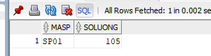

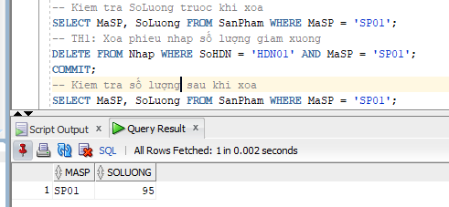

PHIẾU BÀI TẬP 3
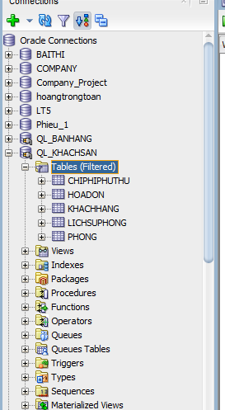
a. Trigger INSERT bảng HoaDon — trg_DatPhong
CREATE OR REPLACE TRIGGER trg_DatPhong
BEFORE INSERT ON HoaDon
FOR EACH ROW
DECLARE
v_dem_kh NUMBER := 0;
v_dem_phong NUMBER := 0;
v_trangthai VARCHAR2(20);
v_songuoi NUMBER := 0;
v_giatheonday NUMBER := 0;
BEGIN
SELECT COUNT(*) INTO v_dem_kh FROM KhachHang WHERE MaKH = :NEW.MaKH;
IF v_dem_kh = 0 THEN
RAISE_APPLICATION_ERROR(-20001, 'MaKH khong ton tai');
END IF;
SELECT COUNT(*) INTO v_dem_phong FROM Phong WHERE MaPhong = :NEW.MaPhong;
IF v_dem_phong = 0 THEN
RAISE_APPLICATION_ERROR(-20002, 'MaPhong khong ton tai');
END IF;
SELECT TrangThai, SoNguoiToiDa INTO v_trangthai, v_songuoi
FROM Phong WHERE MaPhong = :NEW.MaPhong;
IF v_trangthai <> 'TRONG' THEN
RAISE_APPLICATION_ERROR(-20003, 'Phong khong o trang thai TRONG');
END IF;
IF :NEW.SoNguoi > v_songuoi THEN
RAISE_APPLICATION_ERROR(-20004, 'SoNguoi vuot qua SoNguoiToiDa');
END IF;
IF :NEW.NgayNhan >= :NEW.NgayTra OR :NEW.NgayNhan < TRUNC(SYSDATE) THEN
RAISE_APPLICATION_ERROR(-20005, 'NgayNhan hoac NgayTra khong hop le');
END IF;
SELECT GiaTheoNgay INTO v_giatheonday FROM Phong WHERE MaPhong = :NEW.MaPhong;
:NEW.TongTien := (:NEW.NgayTra - :NEW.NgayNhan) * v_giatheonday;
UPDATE Phong SET TrangThai = 'DA_THUE' WHERE MaPhong = :NEW.MaPhong;
END trg_DatPhong;
/
TEST
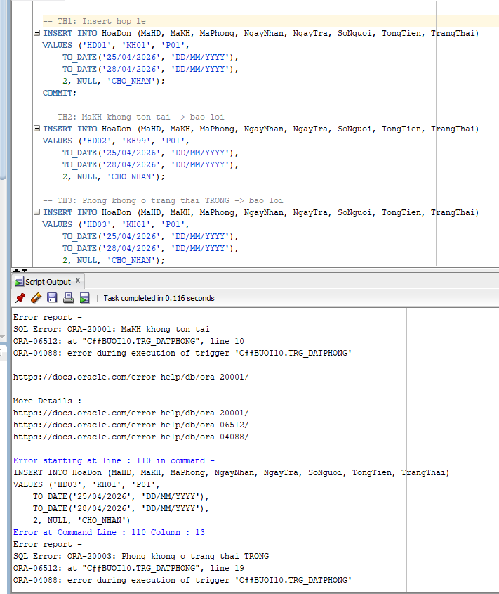
b. Trigger UPDATE TrangThai HoaDon — trg_CapNhatTrangThaiHD
CREATE OR REPLACE TRIGGER trg_CapNhatTrangThaiHD
BEFORE UPDATE OF TrangThai ON HoaDon
FOR EACH ROW
DECLARE
v_dem NUMBER := 0;
BEGIN
IF :OLD.TrangThai = 'CHO_NHAN' AND
:NEW.TrangThai <> 'DANG_O' AND :NEW.TrangThai <> 'HUY' THEN
RAISE_APPLICATION_ERROR(-20001, 'CHO_NHAN chi chuyen sang DANG_O hoac HUY');
END IF;

IF :OLD.TrangThai = 'DANG_O' AND :NEW.TrangThai <> 'DA_TRA' THEN
RAISE_APPLICATION_ERROR(-20002, 'DANG_O chi chuyen sang DA_TRA');
END IF;

IF :OLD.TrangThai = 'DA_TRA' OR :OLD.TrangThai = 'HUY' THEN
RAISE_APPLICATION_ERROR(-20003, 'DA_TRA va HUY khong the thay doi');
END IF;
IF :NEW.TrangThai = 'DA_TRA' THEN
UPDATE Phong SET TrangThai = 'TRONG' WHERE MaPhong = :OLD.MaPhong;

INSERT INTO LichSuPhong VALUES (
'LS' || TO_CHAR(SYSDATE, 'SSSSS'),
:OLD.MaPhong,
:OLD.MaHD,
:OLD.NgayNhan,
:OLD.NgayTra,
'Tra phong thanh cong'
);
END IF;
IF :NEW.TrangThai = 'HUY' THEN
UPDATE Phong SET TrangThai = 'TRONG' WHERE MaPhong = :OLD.MaPhong;
END IF;
END trg_CapNhatTrangThaiHD;
/
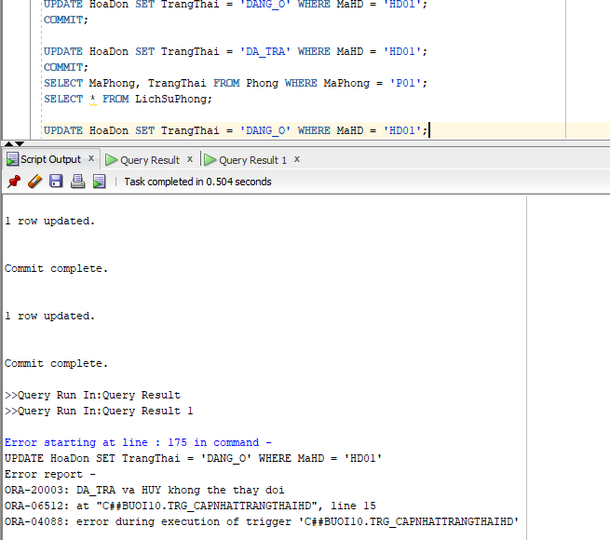
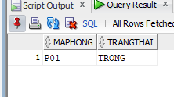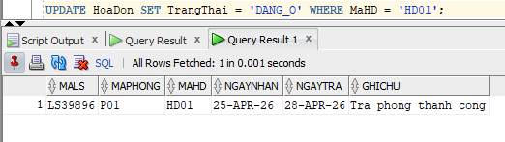
c. Compound Trigger UPDATE ChiPhiPhuThu — trg_SuaChiPhi
CREATE OR REPLACE TRIGGER trg_SuaChiPhi
FOR INSERT OR UPDATE ON ChiPhiPhuThu
COMPOUND TRIGGER

v_tongtien_goc NUMBER := 0;

BEFORE STATEMENT IS
BEGIN
pkg_state2.g_row_count := 0;
END BEFORE STATEMENT;

BEFORE EACH ROW IS
BEGIN

pkg_state2.g_row_count := pkg_state2.g_row_count + 1;
IF pkg_state2.g_row_count > 5 THEN
RAISE_APPLICATION_ERROR(-20001, 'Chi duoc INSERT/UPDATE toi da 5 chi phi');
END IF;

IF :NEW.SoTien <= 0 OR :NEW.SoTien >= 50000000 THEN
RAISE_APPLICATION_ERROR(-20002, 'SoTien phai > 0 va < 50,000,000');
END IF;
END BEFORE EACH ROW;

AFTER STATEMENT IS
BEGIN

UPDATE HoaDon H SET H.TongTien = (
SELECT NVL(SUM(C.SoTien), 0) FROM ChiPhiPhuThu C WHERE C.MaHD = H.MaHD
);
END AFTER STATEMENT;

END trg_SuaChiPhi;
/

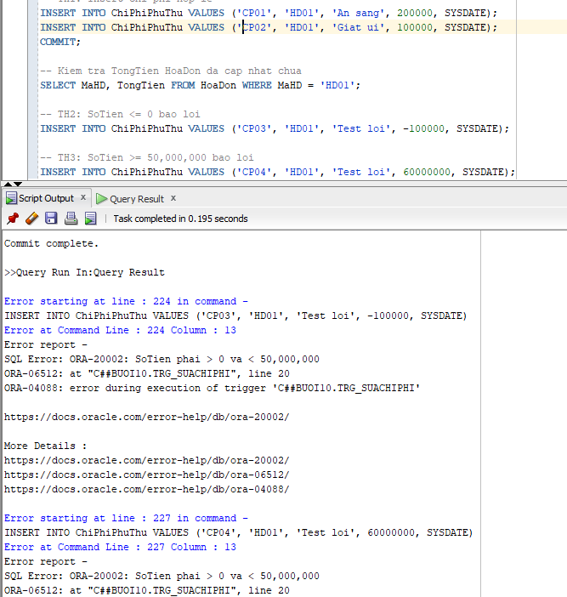
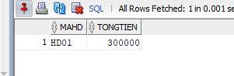
d. INSTEAD OF Trigger trên View — trg_vwPhongTrong_ins

CREATE SEQUENCE SEQ_HD START WITH 1 INCREMENT BY 1;

-- Buoc 2: Tao view vw_PhongTrong
CREATE OR REPLACE VIEW vw_PhongTrong AS
SELECT P.MaPhong, P.LoaiPhong, P.TrangThai,
P.GiaTheoGio, P.GiaTheoNgay, P.SoNguoiToiDa
FROM Phong P
WHERE P.TrangThai = 'TRONG';

-- Buoc 3: Tao INSTEAD OF Trigger
CREATE OR REPLACE TRIGGER trg_vwPhongTrong_ins
INSTEAD OF INSERT ON vw_PhongTrong
FOR EACH ROW
DECLARE
v_makh VARCHAR2(10);
v_mahd VARCHAR2(10);
v_dem NUMBER := 0;
BEGIN
SELECT MaKH INTO v_makh FROM KhachHang
WHERE ROWNUM = 1;
v_mahd := 'HD' || TO_CHAR(SEQ_HD.NEXTVAL, 'FM0000');

SELECT COUNT(*) INTO v_dem FROM Phong WHERE MaPhong = :NEW.MaPhong;
IF v_dem = 0 THEN
RAISE_APPLICATION_ERROR(-20001, 'MaPhong khong ton tai');
END IF;
INSERT INTO HoaDon (MaHD, MaKH, MaPhong, NgayNhan, NgayTra, SoNguoi, TongTien, TrangThai)
VALUES (v_mahd, v_makh, :NEW.MaPhong,
TO_DATE('25/04/2026', 'DD/MM/YYYY'),
TO_DATE('28/04/2026', 'DD/MM/YYYY'),
1, NULL, 'CHO_NHAN');
END trg_vwPhongTrong_ins;
/
TEST
