Hoàng Trọng Toàn
1250080202
12_ĐH_CNTT4
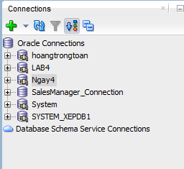
1. Tạo bảng
CREATE TABLE PHONGBAN (
MaPhong INT PRIMARY KEY,
TenPhong VARCHAR(50),
TruongPhong INT,
NgayNhanChuc DATE
);

CREATE TABLE NHANVIEN (
MaNV INT PRIMARY KEY,
HoNV VARCHAR(50),
TenNV VARCHAR(50),
NgaySinh DATE,
DiaChi VARCHAR(50),
Phai VARCHAR(50),
Luong INT,
MaNQL INT,
Phong INT,
FOREIGN KEY (Phong) REFERENCES PHONGBAN(MaPhong),
FOREIGN KEY (MaNQL) REFERENCES NHANVIEN(MaNV)
);

ALTER TABLE PHONGBAN ADD FOREIGN KEY (TruongPhong) REFERENCES NHANVIEN(MaNV);

CREATE TABLE DIADIEMPHONG (
MaPhong INT PRIMARY KEY,
DiaDiem VARCHAR(50),
FOREIGN KEY (MaPhong) REFERENCES PHONGBAN(MaPhong)
);

CREATE TABLE DEAN (
MaDA VARCHAR(50) PRIMARY KEY,
TenDA VARCHAR(50),
DdiemDA VARCHAR(50),
Phong INT,
FOREIGN KEY (Phong) REFERENCES PHONGBAN(MaPhong)
);

CREATE TABLE PHANCONG (
MaNV INT,
MaDA VARCHAR(50),
ThoiGian INT,
PRIMARY KEY (MaNV, MaDA),
FOREIGN KEY (MaNV) REFERENCES NHANVIEN(MaNV),
FOREIGN KEY (MaDA) REFERENCES DEAN(MaDA)
);

CREATE TABLE THANNHAN (
MaTN INT PRIMARY KEY,
HoTN VARCHAR(50),
TenTN VARCHAR(50),
Phai VARCHAR(50),
NgaySinh DATE
);

CREATE TABLE NVIEN_TNHAN (
MaNV INT,
MaTN INT,
QuanHe VARCHAR(50),
PRIMARY KEY (MaNV, MaTN),
FOREIGN KEY (MaNV) REFERENCES NHANVIEN(MaNV),
FOREIGN KEY (MaTN) REFERENCES THANNHAN(MaTN)
);
2. Thêm dữ liệu
-Phòng Ban
INSERT INTO PHONGBAN (MaPhong, TenPhong, TruongPhong, NgayNhanChuc)
VALUES (1, 'Hanh Chinh', NULL, NULL);

INSERT INTO PHONGBAN (MaPhong, TenPhong, TruongPhong, NgayNhanChuc)
VALUES (2, 'Tai Vu', NULL, NULL);

INSERT INTO PHONGBAN (MaPhong, TenPhong, TruongPhong, NgayNhanChuc)
VALUES (3, 'Kinh Doanh', NULL, NULL);
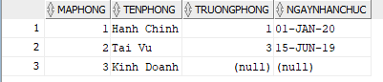
- Nhân Viên
INSERT INTO NHANVIEN (MaNV, HoNV, TenNV, NgaySinh, DiaChi, Phai, Luong, MaNQL, Phong)
VALUES (1, 'Nguyen Van', 'Huynh', TO_DATE('1990-01-15', 'YYYY-MM-DD'), '123 Le Loi', 'Nam', 8000000, NULL, 1);

INSERT INTO NHANVIEN (MaNV, HoNV, TenNV, NgaySinh, DiaChi, Phai, Luong, MaNQL, Phong)
VALUES (2, 'Tran Thi', 'Mai', TO_DATE('1992-05-20', 'YYYY-MM-DD'), '456 Nguyen Hue', 'Nu', 7000000, 1, 1);

INSERT INTO NHANVIEN (MaNV, HoNV, TenNV, NgaySinh, DiaChi, Phai, Luong, MaNQL, Phong)
VALUES (3, 'Le Van', 'Nam', TO_DATE('1988-03-10', 'YYYY-MM-DD'), '789 Hai Ba Trung', 'Nam', 9000000, NULL, 2);

INSERT INTO NHANVIEN (MaNV, HoNV, TenNV, NgaySinh, DiaChi, Phai, Luong, MaNQL, Phong)
VALUES (4, 'Pham Thi', 'Lan', TO_DATE('1995-07-25', 'YYYY-MM-DD'), '321 Tran Hung Dao', 'Nu', 6000000, 3, 2);

INSERT INTO NHANVIEN (MaNV, HoNV, TenNV, NgaySinh, DiaChi, Phai, Luong, MaNQL, Phong)
VALUES (5, 'Vo Van', 'Hung', TO_DATE('1991-11-30', 'YYYY-MM-DD'), '654 Le Duan', 'Nam', 450000, 1, 3);
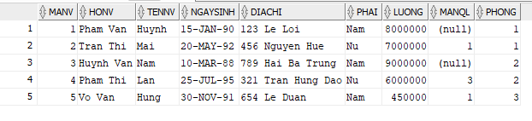
INSERT INTO DIADIEMPHONG (MaPhong, DiaDiem) VALUES (1, 'TP HCM');
INSERT INTO DIADIEMPHONG (MaPhong, DiaDiem) VALUES (2, 'Ha Noi');
INSERT INTO DIADIEMPHONG (MaPhong, DiaDiem) VALUES (3, 'Da Nang');
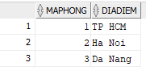
INSERT INTO DEAN (MaDA, TenDA, DdiemDA, Phong) VALUES ('DA01', 'Du an A', 'TP HCM', 1);
INSERT INTO DEAN (MaDA, TenDA, DdiemDA, Phong) VALUES ('DA02', 'Du an B', 'Ha Noi', 2);
INSERT INTO DEAN (MaDA, TenDA, DdiemDA, Phong) VALUES ('DA03', 'Du an C', 'Da Nang', 3);
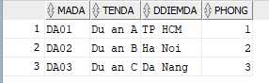
INSERT INTO PHANCONG (MaNV, MaDA, ThoiGian) VALUES (1, 'DA01', 35);
INSERT INTO PHANCONG (MaNV, MaDA, ThoiGian) VALUES (2, 'DA01', 25);
INSERT INTO PHANCONG (MaNV, MaDA, ThoiGian) VALUES (3, 'DA02', 40);
INSERT INTO PHANCONG (MaNV, MaDA, ThoiGian) VALUES (1, 'DA02', 20);
INSERT INTO PHANCONG (MaNV, MaDA, ThoiGian) VALUES (4, 'DA03', 30);
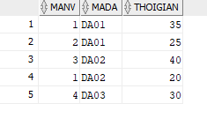
INSERT INTO THANNHAN (MaTN, HoTN, TenTN, Phai, NgaySinh)
VALUES (1, 'Nguyen Van', 'Huynh', 'Nam', TO_DATE('2015-01-01', 'YYYY-MM-DD'));
INSERT INTO THANNHAN (MaTN, HoTN, TenTN, Phai, NgaySinh)
VALUES (2, 'Tran Thi', 'Lan', 'Nu', TO_DATE('2018-05-15', 'YYYY-MM-DD'));
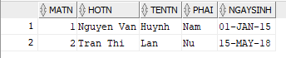
INSERT INTO NVIEN_TNHAN (MaNV, MaTN, QuanHe) VALUES (1, 1, 'Con');
INSERT INTO NVIEN_TNHAN (MaNV, MaTN, QuanHe) VALUES (2, 2, 'Con');
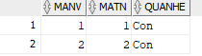
3. Truy vấn
Câu 1: SELECT * FROM NHANVIEN
WHERE HoNV LIKE '%Huynh%' OR TenNV LIKE '%Huynh%';
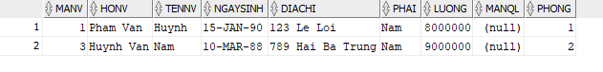
Câu 2: SELECT MaNV, HoNV, TenNV, DiaChi
FROM NHANVIEN
WHERE Phong = (SELECT MaPhong FROM PHONGBAN WHERE TenPhong = 'Hanh Chinh');
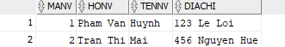
Câu 3: SELECT MaNV, HoNV, TenNV, DiaChi
FROM NHANVIEN
WHERE Phong IN (SELECT MaPhong FROM PHONGBAN WHERE TenPhong IN ('Hanh Chinh', 'Tai Vu'));
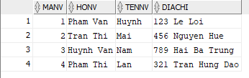
Câu 4: SELECT NV.MaNV, NV.HoNV, NV.TenNV, DA.TenDA
FROM NHANVIEN NV, PHANCONG PC, DEAN DA
WHERE NV.MaNV = PC.MaNV AND PC.MaDA = DA.MaDA;
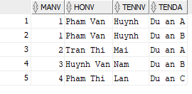
Câu 5: SELECT DA.MaDA, DA.TenDA, PB.TenPhong, NV.MaNV, NV.HoNV, NV.TenNV
FROM DEAN DA, PHONGBAN PB, NHANVIEN NV
WHERE DA.Phong = PB.MaPhong AND PB.TruongPhong = NV.MaNV;
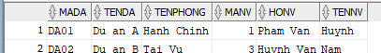
Câu 6: SELECT NV.MaNV, NV.HoNV, NV.TenNV
FROM NHANVIEN NV, PHANCONG PC
WHERE NV.MaNV = PC.MaNV AND PC.MaDA = 'DA01' AND PC.ThoiGian > 30;
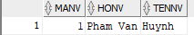
Câu 7: SELECT DISTINCT NV.MaNV, NV.HoNV, NV.TenNV
FROM NHANVIEN NV, NVIEN_TNHAN NT, THANNHAN TN
WHERE NV.MaNV = NT.MaNV AND NT.MaTN = TN.MaTN AND NV.TenNV = TN.TenTN;
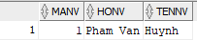
Câu 8: SELECT NV.MaNV, NV.HoNV, NV.TenNV
FROM NHANVIEN NV, PHONGBAN PB, NHANVIEN TP
WHERE NV.Phong = PB.MaPhong
AND PB.TruongPhong = TP.MaNV
AND (TP.HoNV LIKE '%Pham%' OR TP.HoNV LIKE '%Huynh%');
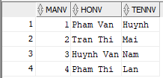\
Câu 9: SELECT NV.MaNV, NV.HoNV, NV.TenNV
FROM NHANVIEN NV, NHANVIEN QL
WHERE NV.MaNQL = QL.MaNV
AND (QL.HoNV LIKE '%Pham%' OR QL.HoNV LIKE '%Huynh%');
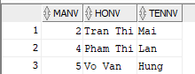
Câu 10: SELECT NV.MaNV, NV.HoNV, NV.TenNV
FROM NHANVIEN NV
WHERE NOT EXISTS (
SELECT MaDA FROM DEAN
WHERE MaDA NOT IN (
SELECT MaDA FROM PHANCONG WHERE MaNV = NV.MaNV
)
);
Câu 11: SELECT MaNV, HoNV, TenNV
FROM NHANVIEN
WHERE MaNV NOT IN (SELECT MaNV FROM PHANCONG);
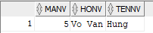
Câu 12: SELECT AVG(Luong) AS LuongTrungBinh
FROM NHANVIEN;
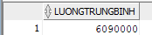
Câu 13: SELECT AVG(Luong) AS LuongTrungBinhNam
FROM NHANVIEN
WHERE Phai = 'Nam';
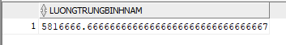
Câu 14: SELECT COUNT(*) AS TongSoDeAn
FROM DEAN;
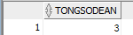
Câu 15: SELECT MaDA, COUNT(MaNV) AS SoNhanVien
FROM PHANCONG
GROUP BY MaDA;
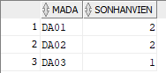
Câu 16: SELECT PC.MaDA, COUNT(NV.MaNV) AS SoNhanVienNu
FROM PHANCONG PC, NHANVIEN NV
WHERE PC.MaNV = NV.MaNV AND NV.Phai = 'Nu'
GROUP BY PC.MaDA;
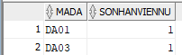
Câu 17: UPDATE PHANCONG
SET ThoiGian = ThoiGian + 4
WHERE MaNV IN (SELECT MaNV FROM NHANVIEN WHERE Phai = 'Nam');
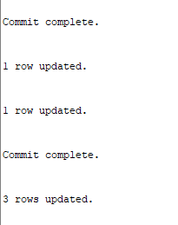
Câu 18: DELETE FROM NHANVIEN
WHERE Luong < 500000;
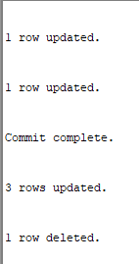
Các câu lệnh update:
UPDATE NHANVIEN SET HoNV = 'Pham Van' WHERE MaNV = 1;
UPDATE NHANVIEN SET HoNV = 'Huynh Van' WHERE MaNV = 3;
COMMIT;

